CNIB Accessible Election Guide for Local Governments
  - Last Updated: August 2026
Municipalities should verify current legislation, regulations, standards, and election technologies before each election cycle, as accessibility requirements and voting practices continue to evolve. This guide is intended to support planning and leading practices, but it should not replace legal advice or jurisdiction-specific election requirements.
Table of contents
How to use this guide 3
When to use this guide 3
How this guide is organized 4
Understanding voter needs and your legal responsibilities 4
Understanding blindness 4
A note about technology 6
Accessibility legislation 6
Voting legislation 7
Minimum legal requirements vs. leading practices 8
Planning and preparing for accessible elections 9
Advertising the election 9
Accessible election communications 10
Training for elections officials 11
After the election 12
Accessible voting experiences 13
Accessible voting locations 14
Consultation 16
Assistive voting terminals 18
Tactile and braille ballot templates 19
Magnifiers 20
Mobile phones and other assistive technology 21
Producing clear print documents 21
Providing ASL interpretation and intervenor services 22
Alternative voting options 23
Voting by special ballot 23
Home visits, curbside voting, and hospital voting 24
Voting with assistance from friends, family, or a support person 24
Telephone voting 25
Online voting 26
Other tools, resources, and leading practices 26
CNIB resources 26
CNIB programs and services 27
External election related resources 27

How to use this guide
This guide is designed to support local governments across Canada in planning and delivering accessible elections for voters who are blind, Deafblind, or have low vision. It offers practical guidance, examples, and considerations to help identify and remove barriers, creating a more inclusive voting experience.
While this guide focuses on voters who are blind, Deafblind, or have low vision, municipalities should recognize that voters may have multiple or intersecting disabilities. Accessible election planning should also consider cognitive, hearing, communication, mobility, and other accessibility needs where relevant. By adopting a universal design approach, municipalities can improve the voting experience for everyone.
This guide is intended for:
- Local election officials, including clerks and returning officers
- Accessibility and inclusion staff within local governments
- Election planners, procurement teams, and policy developers
- Community partners and advisory committees supporting accessible elections

When to use this guide
This guide can be used throughout the entire election cycle:
- Before the election: To inform planning, policy development, budgeting, procurement of accessible tools, and engagement with voters and community partners
- During the election: To support implementation, including accessible polling locations, trained staff, and the availability of assistive tools and accommodations
- After the election: To review outcomes, identify barriers, gather feedback from voters, and improve accessibility for future elections
Using this guide early in the planning process will help ensure that accessibility is built in from the outset, rather than added as an afterthought.

How this guide is organized
This guide is structured to provide both foundational knowledge and practical guidance.
- Understanding voter needs and your legal responsibilities
Provides an overview of blindness and outlines relevant accessibility legislation.
- Planning and preparing for accessible elections
Covers planning and training considerations.
- Accessible voting experiences
Outlines considerations for voting locations, assistive technologies, and voter accommodations.
- Alternative voting options
Covers different voting approaches, including mail-in voting, curbside voting, and home visits.
- Other tools, resources, and leading practices
Shares examples from local governments across Canada and links to additional resources
Throughout the guide, you will find practical examples, key points, and tips to support accessible election planning and delivery in your municipality.

Understanding voter needs and your legal responsibilities

Understanding blindness
Blindness is a spectrum, and every person is unique; each has different experiences, challenges, and abilities.
Blindness can be caused by eye conditions present at birth, later in life, or other factors. Blindness has many causes, and each affects eyesight differently:
- Certain retinal conditions can cause distortion or blind spots in a person’s central vision.
- Eye conditions like glaucoma and retinitis pigmentosa (RP) impact peripheral sight, creating “tunnel vision.”
- There are other eye conditions that can impact a person’s depth perception, sensitivity to light, and/or ability to see detail

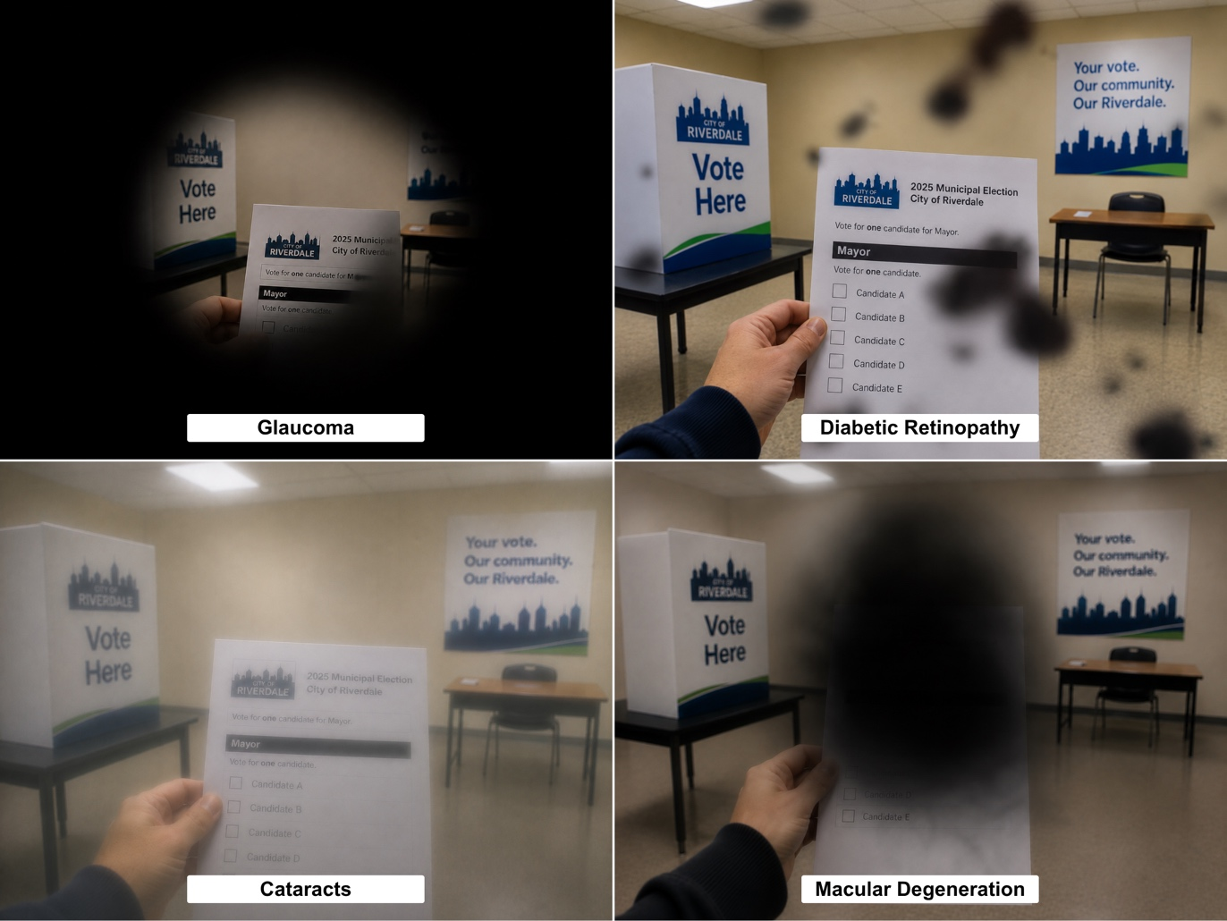

Not everyone who is blind, Deafblind, or has low vision will use or need a white cane or guide dog. Do not assume someone is not blind, Deafblind, or has low vision simply because they do not use a mobility aid.
There’s no “one-size-fits-all” solution to accessibility. What works well for one person may not work for another, so it's important to avoid making assumptions and ask how you can best support each voter.

Key points
- Blindness and sight loss affect everyone differently, even people with the same eye condition. What works for one voter may not work for another, so it's important to offer a range of accessible voting options.
- Never make assumptions about a person’s level of vision or the accommodations they may need. Instead, ask how you can best support them.

A note about technology
People who are blind, Deafblind, or have low vision use technology in many different ways to access information. Depending on their needs and preferences, they may use built-in accessibility features on smartphones and computers, assistive technology and software, wearable devices such as smart glasses, or accessible apps, including:
- Screen readers that read digital text aloud.
- Screen magnification and high-contrast display settings for people with low vision.
- Refreshable braille displays that convert digital text into braille.
- Object, colour, and currency identification apps, as well as apps that read printed documents aloud using a smartphone camera.
- GPS and other wayfinding apps

Accessibility legislation
While election rules and regulations vary across the country, several provinces have accessibility legislation that can help guide municipalities in planning and delivering accessible elections:
- British Columbia: Accessible British Columbia Act (2021)
- Manitoba: Accessibility for Manitobans Act (2013)
- New Brunswick: New Brunswick Accessibility Act (2024)
- Nova Scotia: Accessibility Act (2017)
- Ontario: Accessibility for Ontarians with Disabilities Act (AODA) (2005)
- Saskatchewan: Accessible Saskatchewan Act (2023)
- Federally: Accessible Canada Act (2019)

Voting legislation
Voting independently and privately is a right held by all Canadians embedded in Section 3 of the Canadian Charter of Rights and Freedoms.
Accessibility requirements for municipal elections vary across Canada, and each province has its own legislation and policies. As efforts to improve accessible voting continue, the examples below highlight some of the legislative requirements and accessibility provisions in place across different provinces.
In Alberta, the Local Authorities Election Act (2000), section 78(4.1) states: “If an elector requests a blind elector template by June 30 in a year in which a general election is to be held, a municipality must pass a bylaw setting out the blind elector template.”
This requirement means municipalities in Alberta must notify voters when the blind elector template is available and how it can be accessed. It also highlights the importance of planning ahead so accessible voting options are available and clearly communicated before election day.
In Ontario, the Municipal Elections Act (1996), requires municipalities to consider the accessibility needs of electors and candidates with disabilities throughout the election process:
- Section 12.1(1) states: "A clerk who is responsible for conducting an election shall have regard to the needs of electors and candidates with disabilities.”
- Section 12.1(2) requires preparation of a plan regarding the identification, removal, and prevention of barriers that affect electors and candidates with disabilities before election day.
- Section 12.1(3) requires a report summarizing this plan be published within 90 days of the election.
- And, more specifically, under section 41(3), the clerks must also provide ballots with reasonable changes that can allow electors with visual impairments to vote without the assistance of another person.
These are just two examples of provincial public policy related to municipal elections. Other provinces have similar legislation.
Legislation (where it exists) is often vague and does not address every barrier a voter may encounter. Meeting the minimum legal requirements is only the first step and does not, on its own, create a fully accessible election.

Minimum legal requirements vs. leading practices
Municipalities must meet the legal requirements for accessible voting that apply in their province or territory. However, meeting the minimum legal standard does not always create a fully accessible voting experience.
Minimum legal requirements for accessible voting may include:
- Providing accommodations required under provincial, territorial, or federal election legislation.
- Preparing accessibility plans or reports where required.
- Ensuring voters with disabilities have access to the voting process.
Leading practices may include:
- Consulting voters with disabilities before procurement of election equipment and materials and election day planning decisions are finalized.
- Offering multiple accessible voting options rather than relying on one accommodation.
- Testing voting tools, websites, documents, and communications with people who use assistive technology.
- Communicating accessible voting options well in advance and in alternate formats.
- Reviewing accessibility after each election and using the feedback to make improvements for future elections.
Key points
- The right to an accessible vote is enshrined in multiple pieces of legislation.
- Municipalities must be proactive and prepared to make voter accommodations
- As all Canadians have the right to vote privately and independently, it is not appropriate to ask someone to bring a support person or have elections staff assistance as the only accessibility option. Some voters may want assistance to vote, but it might be a choice rather than the only option.
- Local governments must clearly advertise to voters what options will be available to assist them in voting.

Planning and preparing for accessible elections
Everyone who is blind, Deafblind, or has low vision should be able to vote independently, safely, and with dignity. We all have a role to play in removing barriers and ensuring every voter has an equal opportunity to participate in the democratic process.
Accessibility should be approached as a proactive commitment to removing barriers, not only as a compliance checklist.

Advertising the election
Campaign materials often consist of printed flyers, brochures, and other materials that contain written text and images that cannot be independently accessed by people who are blind, Deafblind, or have low vision.
Many campaigns also rely heavily on digital content, such as infographics, posters, and videos, which may lack alternative text, described video, captions, or other accessibility features needed by people using screen readers or other assistive technology.
Even voter information cards present an accessibility barrier as the cards have historically been delivered in print and often include small font sizes, low-contrast text, and dense layouts that make them difficult to read for people with low vision or those using assistive technology.
There are several ways to address these accessibility barriers, and others like them, to ensure voters who are blind, Deafblind, or have low vision can independently and freely participate in elections.

Accessible election communications
- Review all print, digital, audio, and video election communications for accessibility before publication.
- Have election information produced in alternative formats simultaneously rather than upon request. This could include sharing printed materials in various formats such as braille, large print, and high-contrast text with simple, consistent formatting.
- Ensure websites, online voter lookup tools, PDFs, forms, and candidate information meet digital accessibility requirements, including compatibility with screen readers and screen magnification software. Campaign websites should comply with the Web Content Accessibility Guidelines (WCAG).
- Add alternative text to images, including those shared on social media, and provide meaningful descriptions for charts, maps, posters, and infographics used to communicate election information.
- Caption videos, provide transcripts for audio or video content, and use plain language to support voters with hearing, cognitive, or communication disabilities.
- Consult with disability groups to learn how election advertising can be made more accessible for everyone.
Sample communication language:
“Accessible voting supports are available for voters who are blind, Deafblind, have low vision, or have other disabilities. Please contact the Municipal Election Office to learn about available voting options, accessible formats, and accommodations.”
Key points
- Employ advertising practices for elections that allow for voters of all abilities to independently participate in elections.
- Ensure that advertising materials are available in various alternate formats.
- Consult with disability advocacy groups to better understand how electoral practices could be more accessible for all voters.

Training for elections officials
Providing comprehensive training to elections staff is crucial to making your election accessible for people who are blind, Deafblind, or have low vision.
- Election officials should deliver detailed staff understand how to best support people who blind, Deafblind, or who have low vision to cast their ballot independently and privately.
- Ensure staff understand that voters may have different accommodation needs and are trained to respond appropriately. They should avoid making assumptions and ask voters how they can best provide assistance.
- All polling staff should know what accessible voting tools are available to electors, have them readily on hand, and be trained on how to support people to use that specific tool.
CNIB has several resources to help prepare election staff to assist voters who are blind, Deafblind, or have low vision, including our Blindness Etiquette and Guiding Someone webpages. Additional information on creating accessible and inclusive voting experiences is available on our Accessible Communities webpage.
Employing elections staff with lived experience can also help identify barriers you may not be aware of and increase the diversity of your elections staff. CNIB’s Come to Work program can connect you with resources as well as members from our talent pool who are blind or have low vision that have invaluable skills to offer in your teams.
Key points
- Ensure that your staff are aware that electors may have varying accommodation needs and are trained on how to effectively assist them.
- Ensure that your staff are aware of all accommodation tools that will be on hand on voting day and how to use them.
- Consider hiring people with disabilities as elections staff.

After the election
An accessible election should not end on election day. Municipalities should evaluate accessibility outcomes and use lessons learned to improve future elections.
- Gather feedback from voters with disabilities through surveys, focus groups, community organizations, and Accessibility Advisory Committees.
- Review accessibility complaints, compliments, service requests, and staff observations.
- Identify which barriers were removed and which barriers still require action.
- Update accessibility plans, procurement documents, staff training, communication materials, and voting location selection criteria.
- Where required, publish an accessibility report and share lessons learned with relevant municipal departments, advisory committees, and community partners.
- Continue accessibility planning throughout the full four-year election cycle, including opportunities to pilot improvements during by-elections or other voting events.
After the election you will want to incorporate the accessibility of the vote into your overall evaluation of the election. For example, if you survey voters you could ask:
- Whether they identify as a person with a disability
- Whether they were able to cast their vote both in their preferred manner or at all.
It’s best practice to evaluate accessibility outcomes not just after the election, but also throughout the four-year election cycle.
- Evaluate budgets to ensure that sufficient resources for accessibility have been allocated.
- Engage with people with disabilities to determine complaints, barriers and service gaps.
- Review and update accessibility plans and procurement practices.
- Publish an accessibility report and share it with the appropriate governing organization in your provincial jurisdiction. For instance, in British Columbia and accessibility report must be sent to Access BC. Similarly, In Ontario, an accessibility report needs to be sent to the Accessibility Compliance Reporting Portal.
- By-elections are also a great opportunity to pilot test new accessibility initiatives before a general election.

Accessible voting experiences
Municipalities should determine early in the election planning process which accessible voting options will be available and communicate those options clearly well in advance of advance voting and election day.
Whenever possible, accessible voting options should be offered proactively rather than only after a voter encounters a barrier.
Remember: There’s no one-size-fits-all approach to accessibility because no single solution will meet every voter’s needs. Offering a range of accessible voting options helps ensure more voters can participate independently and with confidence.

Accessible voting locations
Making the voting location accessible is one of the most important aspects of election planning. When assessing a voting location, be sure to consider both the exterior and interior, as barriers can exist before voters even reach the entrance.
Many provinces have accessibility legislation that includes requirements or guidance for the built environment.
- British Columbia's Election Act (1996) states in section 81(1) that, “so far as reasonably possible, a voting place must be in a convenient location for a majority of the voters and must be easily accessible to individuals who have a physical disability or whose mobility is impaired.”
- Ontario's Election Act (1996) sets an important precedent by requiring returning officers to ensure polling location details are available at least six months before a provincial election and provide an opportunity for voters to comment on the proposed locations within the following month.

Consider transportation and travel routes
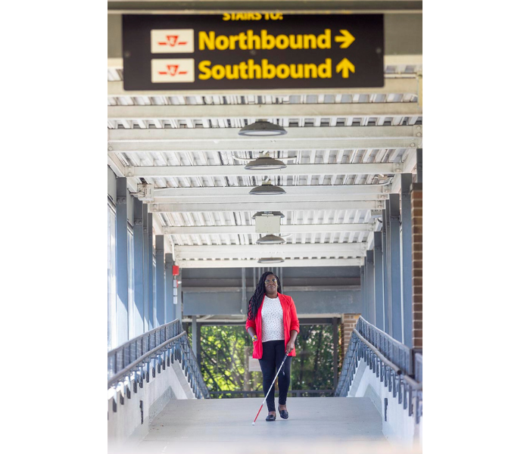
Many people who are blind, Deafblind, or have low vision rely on public transit to get to and from voting locations. It's important to choose locations that are easy to reach by transit and make sure there is a safe, accessible route from the nearest bus stop or transit station to the polling place. This includes accessible sidewalks, curb cuts, and pedestrian crossings.
CNIB’s Clearing Our Path resource outlines different elements in the built environment that make spaces more accessible for people who are blind, Deafblind, or have low vision. It provides practical guidance to help you assess whether a voting location is accessible. For example, directional signage should use high-contrast colours (such as white or yellow text on a black background), large print, and be placed in clear, prominent locations where it is easy to find.
Elections Canada also has an accessibility checklist that you can use to determine if a polling location is accessible.
Key points
- Understand the minimum legal requirements in your jurisdiction for accessible built environments.
- There are many components that make a building accessible, not just physical features like an accessibility ramp at a doorway or an accessible door opener.
- Think about how voters will arrive at the polling station such as public transit, paratransit or by car, and clearly describe how someone gets from their drop off point to where in the building they need to vote.
- Identify all areas of your voting location that voters will be using (ex. bathrooms, hallways, outdoor spaces, path of travel from bus stop to voter booth) and go through an accessibility checklist to ensure that all accessibility needs are determined and met at your voting location.

Consultation
Consulting people with disabilities is an essential part of planning accessible elections. Before procuring accessible voting tools, technologies, or services, municipalities should engage people with lived experience to help ensure that proposed voting tools, processes, and services meet the needs of voters on election day.
People with lived experience can provide valuable insight through user testing and practical feedback on voting tools, communication materials, and election processes. Their expertise will help municipalities to identify accessibility barriers that may not be apparent to product vendors or election administrators.
While vendors may specialize in accessibility products, they may not have lived experience using them. A product that appears accessible in theory may not be practical or usable in real-world voting situations without input from the people who will ultimately use it.
Municipalities should also engage a diverse group of people with disabilities. Accessibility needs vary widely, even among people with the same disability. For example, younger voters may have different accessibility preferences than older adults. Consulting people with a range of disabilities, ages, backgrounds, and lived experiences will help ensure that election services are inclusive and responsive to a broad range of needs.
There are many organizations that can help facilitate this engagement, such as CNIB Access Labs, your local accessibility advisory committee, or other disability organizations in your region.
Effective consultation requires municipalities to allocate sufficient time and resources. Consultation activities should be included in election budgets and begin well in advance of the election to allow meaningful input to inform procurement, planning, communications, and service delivery.
Sample consultation process:
- Identify local disability organizations, committees and community members with lived experience to consult with.
- Invite a range of participants, including people who are blind, Deafblind, have low vision, use mobility aids, use assistive technology, communicate in different ways, or have cognitive or hearing-related accessibility needs.
- Share proposed policies, voting tools, forms, communication materials, and voting location plans before decisions are finalized.
- Conduct user testing of voting equipment, ballot templates, websites, online voting platforms where permitted, voter information cards, and accessible format materials.
- Compensate participants for their time and expertise where possible.
- Document feedback received and explained how it influenced election planning, procurement, staff training, and communications.
For guidance on how to effectively and respectfully engage people with disabilities, please refer to the Government of Canada’s guide on consulting persons with disabilities.
Key points
- People with lived experience of disability are a key part of the procurement process and should be engaged early.
- Engage a range of people with different disabilities and demographics to provide their feedback.
- Compensate people with lived experience for their time and build this item into your budgeting process.
- Companies who sell accessibility products and services cannot replace the knowledge that people with lived experience have.

Assistive voting terminals
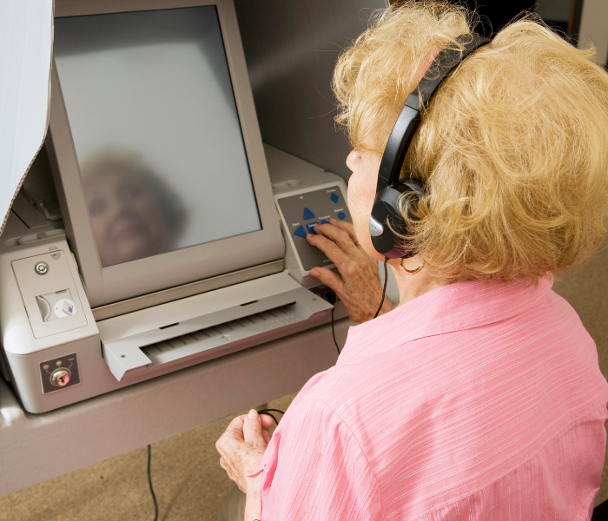
Assistive voting terminals can enable voters who are blind, Deafblind, or have low vision to vote independently and privately. They have an array of accessibility options such as voiceovers of candidate choices and instructions, braille markings on buttons, a touch screen, rocker paddles, and even a sip and puff tube for those who are unable to press buttons.
Please note: CNIB does not endorse one assistive voting terminal software over another, and municipalities should consult with people with disabilities and stakeholder organizations before procuring any device.
Key points
- Keep up to date on voting technology and its accessibility features.
- Ensure that multiple voting staff know how to operate assistive voting technology.

Tactile and braille ballot templates
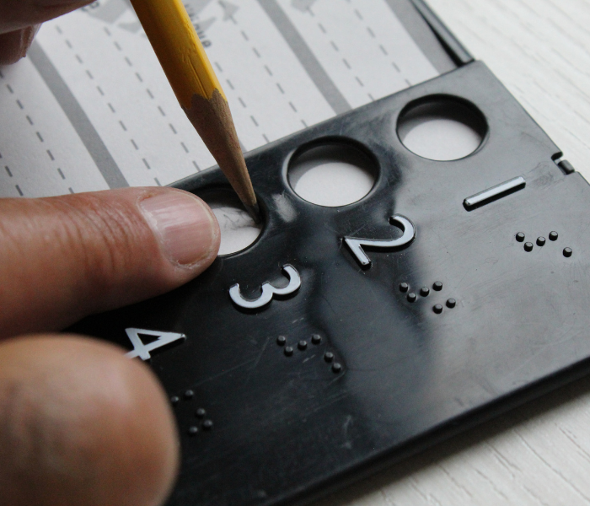
Tactile and braille ballot templates are accessible voting tools that help voters who are blind, Deafblind, or have low vision mark a paper ballot more independently. The ballot is inserted into a plastic template with cut-outs that align with the voting spaces on the ballot. The template may include tactile markings, braille, or both to help voters identify where to mark their choice on the ballot.
When selecting a tactile ballot template, make sure it fits the ballot securely. If the ballot slips within the template, a voter could unintentionally mark the wrong choice.
The template should match the ballot being used. Ensure the number of cut-outs or slots corresponds to the number of candidates or voting options. If there is more than one election question on the ballot, for example voting for both a mayor and a councillor, with a different number of options or a different format, ensure the template can accommodate each ballot.
If you have questions about accessible voter material, please contact our team at CNIB Beyond Print.
Key points
- Braille and raised tactile voting material must be available for electors.
- Ensure that the template design lines up correctly with the design of the printed ballot.
- Keep in mind that not all blind or low vision electors require braille.

Magnifiers
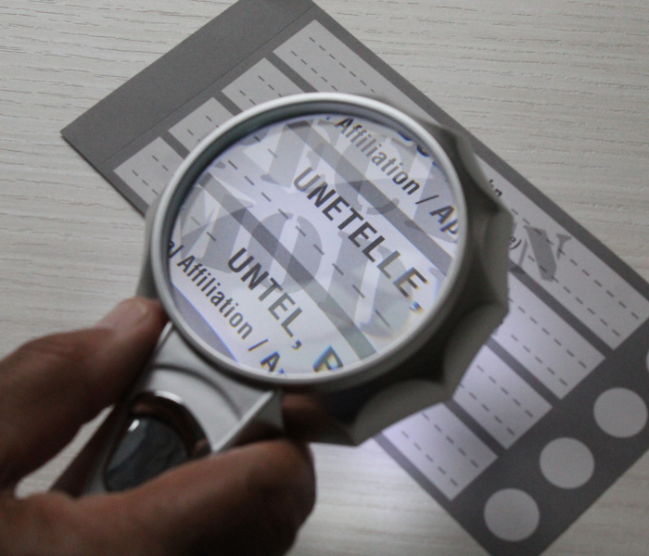
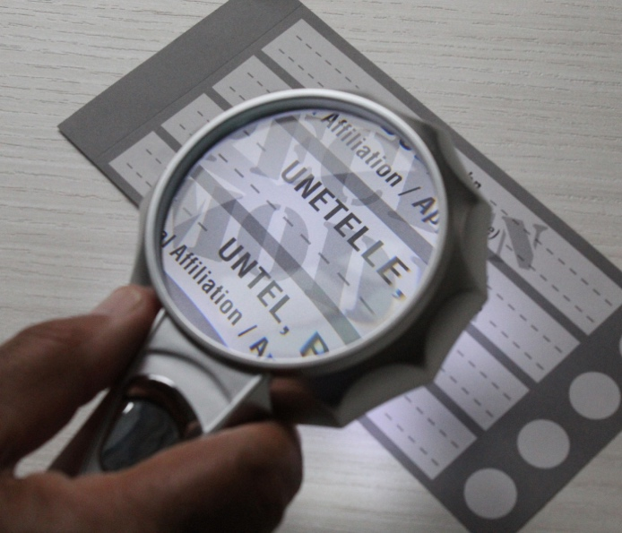
Many people with low vision use magnifiers to read and mark their ballot. Magnification needs vary from person to person, so while municipalities should provide magnifiers at voting locations, some voters may prefer to use their own magnifier or other assistive device.
Elections Canada, for example, provides an illuminated magnifier with 4x magnification at polling stations during federal elections and by-elections.
In addition to magnifiers, municipalities should provide good lighting, large-print information, and high-contrast materials. Election staff should also understand when and how voters may use their own assistive technology, including smartphone magnification or text-to-speech tools, while still following election rules related to ballot secrecy and photography.
You can find examples of magnifiers at our CNIB Smartlife website.

Key points
- Ensure that election staff are aware of the rules surrounding magnifier use while voting.
- Permit people to use technology to magnify their ballot, such as a camera on a smartphone, provided it does not contravene existing legislation.

Mobile phones and other assistive technology

Smartphones, tablets, wearable devices, and other assistive technologies continue to evolve. Voters may use built-in accessibility features such as magnification, screen readers, voice control, optical character recognition, contrast settings, and text-to-speech tools.
Municipalities should develop clear policies that allow assistive technology for accessibility purposes while protecting ballot secrecy and complying with election legislation.
- In the 2018 Ontario General Election, Elections Ontario allowed individuals to use their phones as an assistive device while voting.
- Elections Canada also allowed phones to be used as assistive devices in the 2025 Federal General Election.
A smartphone is more than just a phone. Applications can help with reading the ballot, such as a magnifier or screen reader.
Using a mobile phone does not mean that electors are excused from complying with all applicable election laws and regulations. It’s still a violation of the Elections Act to take a photo of a completed ballot.
Allowing voters to use their phone as an assistive device is one more way you can make the election process easier for electors who are blind, Deafblind, or have low vision.

Producing clear print documents
Clear print makes written information easier to read, particularly for people with low vision. Clear print standards are designed to maximise the legibility of printed materials, making them more accessible to a wider range of people.
When developing election materials, use clear fonts, high colour contrast, and layouts that are easy to read.
CNIB’s Clear Print Guidelines provide practical guidance on contrast, choosing fonts, colours, spacing, and other design elements to improve readability.
As Canada's population ages, using clear print is an important way to make election information more accessible.

Providing ASL interpretation and intervenor services
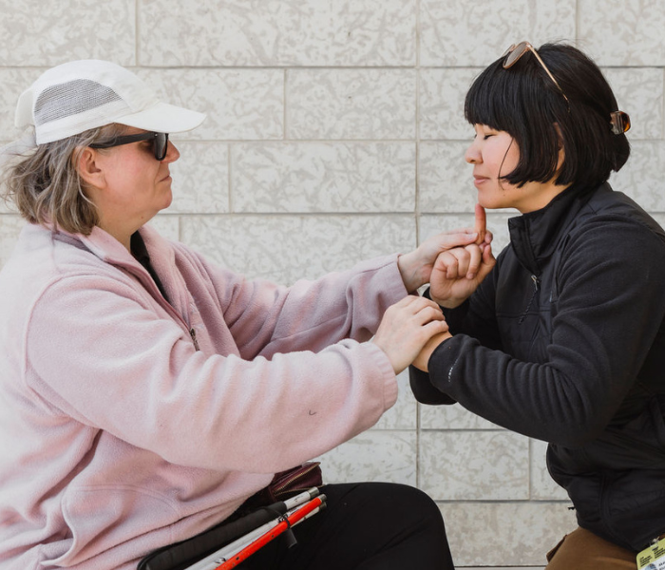
Intervenor services provide specialized communication and support to empower people who are Deafblind to live with confidence, independence, and safety. These critical services help ensure people who are Deafblind can access the information they need in a way that’s accessible to them.
American Sign Language (ASL) is a visual and gestural language used by most of the deaf community in the United States and Canada. The shape, placement, and movement of the hands, as well as facial expressions and body movements, all play important parts in conveying information.
Municipalities should plan for communication accessibility well in advance of an election. This may include providing ASL, intervenor services, real-time captioning, plain-language materials, written communication options, and staff training on communicating directly and respectfully with voters who use interpreters, intervenors, communication devices, or support persons.
Some jurisdictions have implemented a process in which voters who are Deafblind arrange for an ASL interpreter or intervenor to accompany them when voting. The intervenor service organization then invoices Elections Ontario directly for the cost of the service. This approach enables voters who are Deafblind to vote in person with the communication support they need while reducing financial barriers to participation.
If you would like more information about intervenor services, please visit CNIB Deafblind Community Services.

Key points
- Recognize that voters may have multiple disabilities that impact their ability to vote independently.
- Allow voters to choose the accommodation or support that will help them most effectively.
- Partner with service providers of ASL/LSQ interpretation and Intervenor services so that voters can use this service to vote accessibly with no additional cost to them.

Alternative voting options

Voting by special ballot
Special ballots provide an alternative voting option for electors who are unable to attend a voting location or election office in person. Where permitted by municipal election procedures, voters may be issued a special ballot package that can be completed and returned by mail or other approved methods.
A typical special ballot package includes a write-in ballot, a secrecy envelope to protect the voter's choice, and a return envelope addressed to the election office. Voting by special ballot allows electors to vote from home using their own assistive technology or with assistance from a trusted support person, where permitted.
The availability of special ballots varies by jurisdiction. While many provinces and territories permit local election authorities to offer special ballot voting, this is not always a requirement. Check with your municipality in advance to confirm this option is available.

Home visits, curbside voting, and hospital voting
Several regions are implementing other alternative voting options that help make voting more accessible by giving voters with disabilities the option of voting by curbside, via a home visit, or in hospital.
These options can help remove barriers for voters who have mobility, health, or other accessibility-related needs. By providing alternative methods of voting, municipalities can help ensure that all eligible voters have the opportunity to exercise their democratic right.
For example, the City of Toronto's Election Accessibility Plan outlines several alternative voting options.

Voting with assistance from friends, family, or a support person
People who are blind, Deafblind, or have low vision may wish to bring a trusted friend, family member, or support person to assist them with the voting process.
The right to receive assistance when voting is recognized in the Canada Elections Act under section 155 (10) and in the following provincial legislation governing municipal elections:
- Alberta – Local Authorities Election Act, section 78(3)
- British Columbia – Part 3 of the Local Government Act, section 131
- Manitoba – Municipal Councils and School Boards Election Act, section 83
- New Brunswick – Municipal Elections Act, section 38(1)
- Newfoundland and Labrador – Municipal Elections Act, section 48(1)
- Northwest Territories – Local Authorities Elections Act, section 74(1) and 74(2)
- Nova Scotia – Municipal Elections Act, section 86(1)
- Nunavut – Nunavut Elections Act, section 114
- Ontario – Municipal Elections Act, section 52, paragraph 4
- Prince Edward Island – Municipal Election Regulations (enacted under the Municipal Government Act), section 57(1)
- Quebec – An Act Respecting Elections and Referendums in Municipalities, section, section 180 and section 226
- Saskatchewan – Local Government Election Act, section 123(1)
- Yukon – Municipal Act, section 105(1)
Election officials should always communicate directly with the elector, rather than their friend, family member, or support person, unless the elector requests otherwise.
Federal and provincial election legislation generally requires a person assisting an elector to swear an oath of secrecy, confirming that they will not disclose how the elector voted. In many jurisdictions, an individual is also limited to assisting only one elector in this manner.
Key points
- Always communicate directly with the voter first – not the support person.
- Be aware that there is a trusting relationship between the voter and support person.

Telephone voting
Some regions across Canada and internationally have implemented telephone and internet voting as alternative methods of casting a ballot. These options can improve accessibility for voters who are unable to attend a voting location in person, including people who are blind, Deafblind, have low vision, or have other disabilities that make in-person voting difficult.
Telephone voting has been used in British Columbia and by several Ontario municipalities. For example:
- The City of Barrie has published its Internet and Telephone Voting Policies and Procedures for the 2026 municipal election.
- British Columbia has also published its telephone voting regulations and procedures.
Telephone voting systems typically require voters to confirm their identity using a unique personal identification number (PIN). The PIN may be included in the election information package distributed by the electoral authority or provided separately, depending on the voting process. After the voter enters their PIN, the system verifies that they have not already cast a ballot. The voter is then guided through each election question, prompted to make their selections, and asked to confirm their choices before submitting the ballot.

Online voting
While there are currently no Canadian electronic voting standards, several municipalities in Ontario and Nova Scotia have been able to offer online voting options.
In Ontario, the majority of municipalities will use electronic voting options in the 2026 local elections.
While online voting has the potential to improve accessibility by allowing some voters to cast their ballot independently and conveniently, it also introduces important security and integrity risks. Concerns related to cybersecurity, voter authentication, privacy, and the potential for interference must be carefully addressed to ensure that elections remain secure, trustworthy, and accessible for all voters.

Key points
- Consider telephone and online voting options, ensuring that any online voting platform is compliant with web accessibility legislation.

Other tools, resources, and leading practices

CNIB resources
- Blindness etiquette
- Clearing our path
- Clear print guidelines
- Inclusive language guidelines
- Step-by-step: The sighted guide technique

CNIB programs and services
- CNIB Access Labs (innovative accessibility solutions and user testing)
- CNIB Beyond Print (accessible formats)
- CNIB Come to Work (employer services)
- CNIB Deafblind Community Services
- CNIB SmartLife (assistive tech)

External election related resources
- Consumer Access Group (CAG) Position Statement on Accessible Elections
- City of Toronto Election Accessibility Plan
- Elections Canada Accessible Voting Information
- Elections Canada Accessibility Checklist
- World Blind Union - Blind People and Voting Methods

Thank you for looking into how to make the voting experience accessible for voters who are blind, Deafblind, or have low vision in your municipality. For more information, visit cnib.ca or call 1-800-563-2642.

