CNIB Lake Joe
2026 Camp Handbook

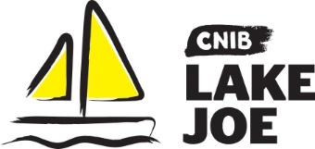
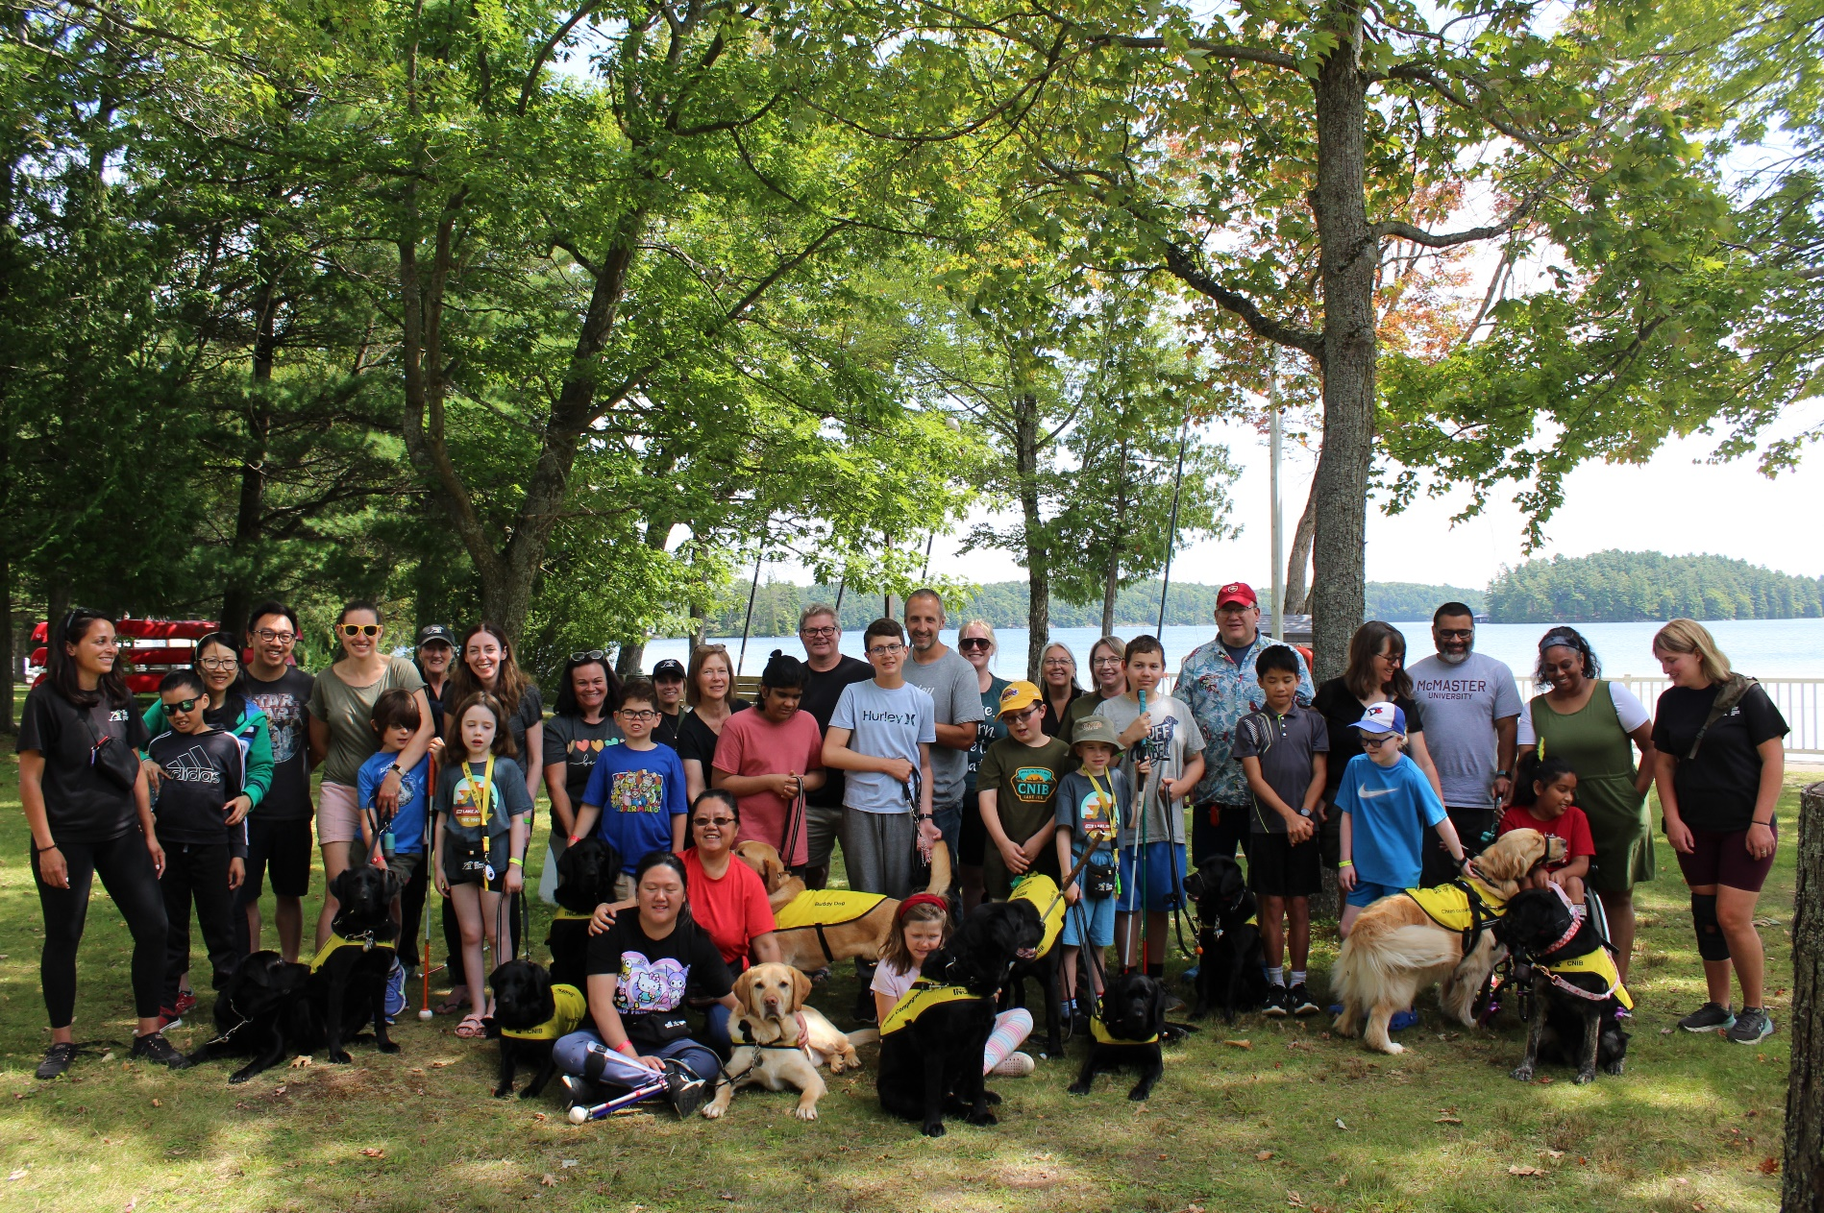

a proud member of the Ontario Camps Association, Lifesaving Society, HIGH FIVE and the Camp Safety Network
The ABC’s of CNIB Lake Joe

A Welcome to CNIB Lake Joe 3
New in 2026: Construction at CNIB Lake Joe 4
Applications & Registrations 5
Bed Bugs: prevention & treatment 9
Directions to Camp by Car 10
Food & Drink 11
Guide Dogs & Buddy Dogs 13
Health & Safety 15
iPhones & Technology 20
Packing List 21
Photos & Videos 24
Programs at CNIB Lake Joe 24
Property & Camp Amenities 29
Property: Photo Galleries 31
Rooming 32
Transportation Offered by CNIB Lake Joe 35
Tuck Shop & Online Camp Store 38
Visitors 38
Wildlife at Camp 39
Notes 40

A Welcome to CNIB Lake Joe
We are so happy to have you as part of the CNIB Lake Joe camp community! The only camp of its kind in Canada, we welcome you to a safe, fully accessible facility designed specifically for people who are blind, Deafblind or have low vision.

The CNIB Lake Joe staff team will ensure you enjoy your summer on the beautiful shores of Lake Joseph, your way. Whether you wish to rest, relax and recharge, or get pumped up while you push your personal limits, the choice is all yours.

Guests of all ages come to CNIB Lake Joe from across Canada and internationally. Many people are repeat visitors, considering CNIB Lake Joe their home away from home, a place where they enjoy summer fun and sun with friends and family.

We hope this handbook will help you get ready for your next visit to CNIB Lake Joe. We’ve tried to answer the most commonly asked questions about the application process, rooms, food, programs, travel, and more!

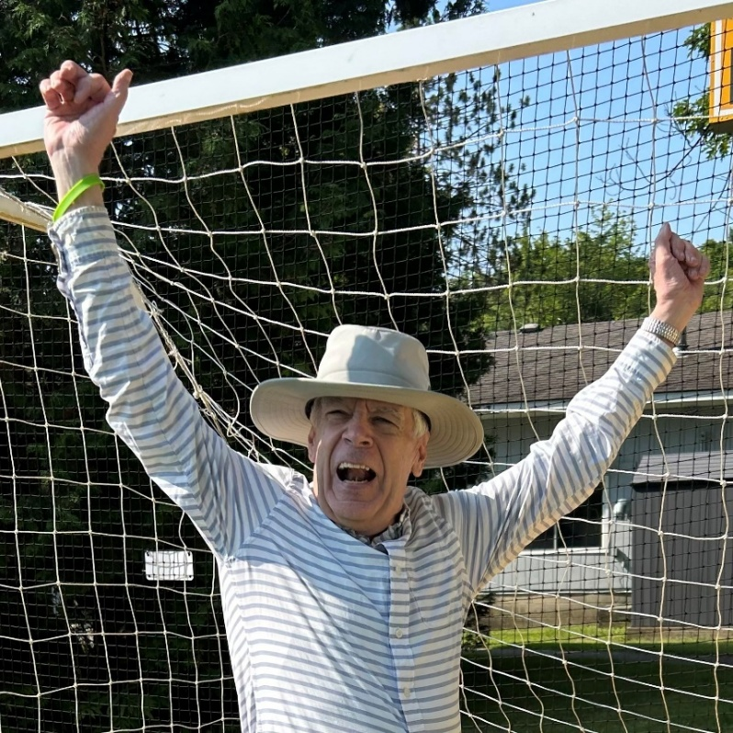

New in 2026: Construction at CNIB Lake Joe
As we celebrate 65 years of CNIB Lake Joe, we’re investing in its future by building what comes next. Construction work is now underway at Lake Joe, with upgrades that will improve the camp experience for our community for years to come.
Some camp activities may be relocated, scheduled differently, or slightly modified due to site restrictions and to ensure safety, but guests will be able to enjoy the same programming and outdoor experiences that Lake Joe has to offer.
We encourage you to visit our construction updates webpage for the latest information and answers to frequently asked questions.

Applications & Registrations
- To attend one of our exciting camp programs, please complete the CNIB Lake Joe 2026 Camp Application. If you are new to using our application system, you will be required to create an account to complete your application. If you are returning to our application system, please use your current account so don’t create duplicate accounts. If you have forgotten the password to your account, you can set-up a new password by requesting a new password on the login page.
- Choose the program/week(s) you would like to attend, select transportation needs if any, and add any additional guests to your application if you are attending camp with more than one person from the same household. Don’t forget to complete all the online forms.
- If you need a little extra help, please:
  - check out our CNIB Lake Joe: 2026 Application Tutorial Video and CNIB Lake Joe Application Guide which outlines the step-by-step processes to successfully complete your online application.
  - ask a friend/family member to assist.
  - contact CNIB Lake Joe staff (details at the bottom of each page).
  - book a one-on-one appointment (for guests with no computer access).
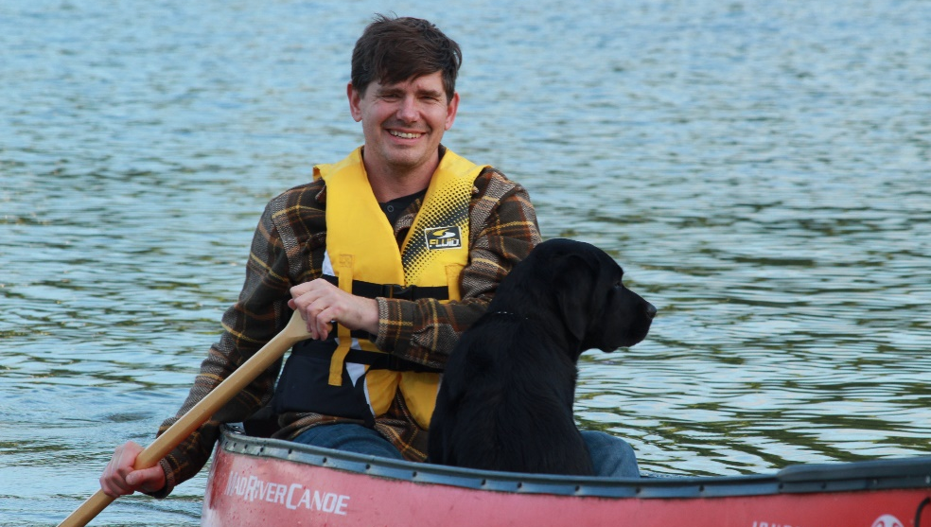

Deadlines
Step #1: Apply
- January 7: “CNIB Lake Joe 2026 In-person Program” virtual info session
- January 12: “Applying on Campbrain” virtual info session
- January 14: Applications open at 12 p.m. (noon) Eastern.
    - February 20: Applications must be received. Applications received after this date will be processed and confirmed on an ongoing basis until all remaining spots have been filled.
    - March 20: Guests will receive program confirmations.
    - If you need to cancel your application or come off a wait list, please let us know as soon as possible by emailing LakeJoe@cnib.ca, or calling 1-877-748-4028 or 705-375-2630.

Step #2: Pay the Deposit
- April 1-30: Deposits accepted. You can also make full camp payment at this time. Please note that no cheques or money orders will be cashed until after April 1.
    - April 30: If your deposit payment is not received at this time, your space will be forfeited and given to a waitlisted applicant. We will make every effort to contact you to confirm your plans before forfeiting your space.

Step #3: Pay the Balance
    - June 1: Any balance owing is due. If the full payment is not received by this date, your space will be forfeited and given to a waitlisted applicant. Any registrations after this date must be paid in full upon completion.

Methods of payment
- Credit card (preferred): Visa, Mastercard, Amex.
- Cheque and money order: payable to CNIB Lake Joe, 4 Joe Finley Way, MacTier, ON P0C 1H0, Attn: Alexis Peterson. Please write the name of the camper/program week in the memo line.

Cancellations & refunds
  - Notice of cancellations must be made in writing via email: LakeJoe@cnib.ca.
  - During the 2026 camp season, guests who feel that construction may affect their experience and wish to cancel their stay can request a full refund prior to their arrival at camp.
  - Full refunds are also provided when a guest cannot come to camp due to an illness (a doctor’s note may be required).
  - Refunds will NOT be granted when the guest must return home from camp due to following reasons:
    - misconduct;
    - not having proper supports in place to be fully independent (i.e. toileting, bathing, self-care, etc.);
    - coming to camp with an illness.
  - In these cases, any necessary transportation fees will be the responsibility of the guest.

Fees & financial assistance
- All fees are listed in the downloadable CNIB Lake Joe 2026 In-person Camp Program Guide (page 19).
- Discounted rates are available for professional caregivers (PSWs, Intervenors).
- There is often no cost to attend CNIB Partner programs. Follow-up with the specific CNIB staff member in charge of these program for full details.
- There is no cost to attend CNIBLakeJoe@Home virtual programs.
- All rates for CNIB Lake Joe camp programs are highly subsidized thanks to grants and generous donations. The “true” cost to attend one of our camp programs is approximately $2,500/week.
- Financial assistance may be available from CNIB Lake Joe for clients, their immediate family members, and any support workers/intervenors they may bring. Financial assistance is available for one program week/season. Guests need to complete the Financial Assistance Application in the registration process. Criteria includes: yearly household income level (i.e. T4, Notice of Assessment, monthly social assistance statement); if you have dependants and how many; if you are receiving outside funding, etc. Guests are encouraged to register by February 20, as financial assistance is allotted during the first round of confirmations.

Essential paperwork
    - The following forms are essential parts of your online application. No one will be permitted onsite at camp unless this information has been completed:
    - Accessibility & Rooming
    - General Waiver
    - Medical Form
    - Promo Consent
    - Financial Assistance Application (if required)

Bed Bugs: prevention & treatment
Bed bugs have become increasingly common within communal living settings such as hotels, retirement homes, university residences and camps. While bed bugs are a nuisance, they are not a public health concern. However, given that the comfort of our guests is our top priority, we have measures in place to mitigate any potential concerns and/or issues.

Guests’ role
    - Before packing, please run all belongings that are going to camp, including any bedding and sleeping bags, through the dryer for 30 minutes on high heat.
    - If you are aware of a situation in your home and/or dwelling, please inform CNIB Lake Joe of the situation before attending.

CNIB Lake Joe’s role
  - All guest rooms are thoroughly cleaned each week with linens laundered in industrial washers/dryers, if applicable.
  - We inspect our accommodations on a weekly basis between guest stays. Additionally, we have monitoring stations that are checked regularly throughout the week.
  - If there is any indication of bed bug activity, alert staff. The room/cabin will be inspected and treated immediately using an environmentally friendly, pesticide-free treatment designed to eradicate bed bugs, mold, and other microscopic household threats. The guest will be moved to a different room for the remainder of their stay and their clothing will be heat-treated.
  - Our cabins/rooms are routinely treated using Heat Assault technology throughout the season as a precautionary measure.

Directions to Camp by Car
We welcome guests from across Canada and around the world! CNIB Lake Joe is located at 4 Joe Finley Way, MacTier, Ontario

Directions from Toronto/Southern Ontario*
- Take Hwy 400 north just past Barrie to Hwy 400 extension (formerly Hwy 69)
- Continue north on Hwy 400 to exit 189 for ON-69 toward MacTier/Gravenhurst
- Merge onto Lake Joseph Road (formerly Hwy 69) past Hwy 169
- Turn right onto Joe Finley Way

*GPS often provides directions to take Hwy 407 toll road. The toll road saves approximately 10 minutes from the drive (approx. 2 hours), but at a cost. Please check a website like google.com/maps for directions or remember to adjust GPS settings.

Directions from Northern Ontario
- Take Hwy 69 south to Hwy 400 south
- Continue south on Hwy 400 to exit 207 for ON-69 toward MacTier/Gravenhurst
- Merge onto Lake Joseph Road (formerly Hwy 69)
- Turn left onto Joe Finley Way

Directions from Eastern Ontario
- Take Hwy 417 west to Bruce St/County Road 20 to Hwy 60 west
- Continue on Hwy 60 and merge onto Hwy 11 south
- Take exit 219 for Muskoka Rd 3 toward Huntsville/Aspdin
- Turn right onto Aspdin Rd/Muskoka District Road 3 (Regional Road 3 W)
- Turn right onto Hwy 141 west and turn left onto Lake Joseph Rd (formerly Hwy 69)
- Turn left onto Joe Finley Way

Parking is free but limited. Please park in one of the designated parking spaces.

Food & Drink
Bon appetit!

Nut aware facility
- Guests sometimes come to camp with severe or life-threatening allergies, and in particular, allergies to peanuts and tree nuts. CNIB Lake Joe is a “nut aware” facility and there can be no food or products onsite that contain nuts. All food served through the kitchen is carefully screened to ensure it does not contain nut or nut products. However, please note that some ingredients from our suppliers may be made or packaged in facilities that also process nuts. While we make every effort to minimize exposure, we cannot guarantee a completely nut-free environment.
- Dietary requirements and food allergies are captured on the Medical Form when you apply. Please review this document carefully as last minute adjustments may not be able to be accommodated.
- We are committed to providing safe, delicious, nutritious meals for everyone and cannot accommodate dietary restrictions based upon food preferences.
- Meals for guests who have special dietary requirements or allergies are wrapped and labelled with the guests’ name and delivered by a member of Wellness Team.

Drinking water
- The water at camp is supplied through three registered drilled wells that are inspected and monitored as per Ministry standards. Our drinking water is treated with a combination of filtration, UV light, and chlorine which is a highly effective method to ensure its safety and quality. Together, these methods create a multi-barrier approach that ensures the water is clean, safe, and free from harmful pathogens and impurities. The tap water at CNIB Lake Joe is monitored and tested according to Ministry standards and is completely safe for consumption.
- Sodium is a common element in the natural environment and is often found in food and drinking water. In drinking water, sodium can occur naturally. In Ontario, there is an aesthetic objective of 200 milligrams/litre (mg/L). Results over 20 mg/L must be reported to Public Health. In each bathroom there is a “sodium notice” posted by the sink indicating the sodium level is higher than 20 mg/L. Local sodium levels in drinking water should be taken into consideration for people on a sodium restricted diet. Our most recent testing was 24.9 mg/L. People can usually begin to taste salt when it is at 200 mg/L.

Meal service
- Where: Meals are generally served in the Dining Hall but may at times be served outside. Guests sit with friends and family at round tables that seat eight people.
- When:
  - Breakfast: 8:30 a.m.
  - Lunch: 12:30 p.m.
  - Dinner: 5:30 p.m.
- What: A typical day’s meal looks like this, with variations between menus for children & youth program weeks vs. adult & family program weeks:
  - Breakfast: hot and cold options are available. Food items may include cereal, bacon, sausage, eggs, pancakes, waffles, fruit, oatmeal, yogurt, toast/bagels.
  - Lunch: May include pizza, sandwiches, hot dogs, hamburgers, fries, soup, salad bar items.
  - Dinner: May include pasta, stir-fry, veggies, rice, potatoes.
  - Desserts!
  - Our breakfast bar and salad bar ensure everyone has food they’ll enjoy and fill-up on.
- How do I know what’s being served: Each day’s menu is written on the white board in the Welcome Centre and announced prior to each serving.
- How is food served: The way staff serve meals varies by program week. Options include family style and plated service.
- Snacks: Coffee, tea, water, fruit and a variety of breakfast cereals are available throughout the day in the Dining Hall. Snacks and drinks are also available for purchase in the CNIB Lake Joe tuck shop.
- Guests may bring their own nut free snacks to camp. Ensure that they are securely stored in containers so they will not attract pests.
- Guests may bring a cooler for their room to keep snacks cool. CNIB Lake Joe can provide ice.

Guide Dogs & Buddy Dogs
    - Guide dogs and CNIB buddy dogs are the only animals permitted onsite. Guests will indicate on their application if they plan to bring a guide dog/buddy dog to camp.
    - A thin dog bed and one dog bowl will be provided to guide dog handlers during their stay.
    - Guide dog handlers must bring their own dog food and be fully responsible for the care of their animal. Guide Dog expectations will be shared with those who are bringing a guide dog or buddy dog to camp.
    - The “Goldie, Bentley & Kodi’s Run, Rest & Relief” area is a safe space specifically for guide dogs to run, rest and relieve themselves. It is located between Cabins H & K. Garbage receptacles are provided but guests must bring their own poop bags.
    - Guide dogs/buddy dogs are permitted to relieve anywhere onsite, but handlers are expected to pick up after the animals. Outside trash receptacles should be used to dispose of poop bags.
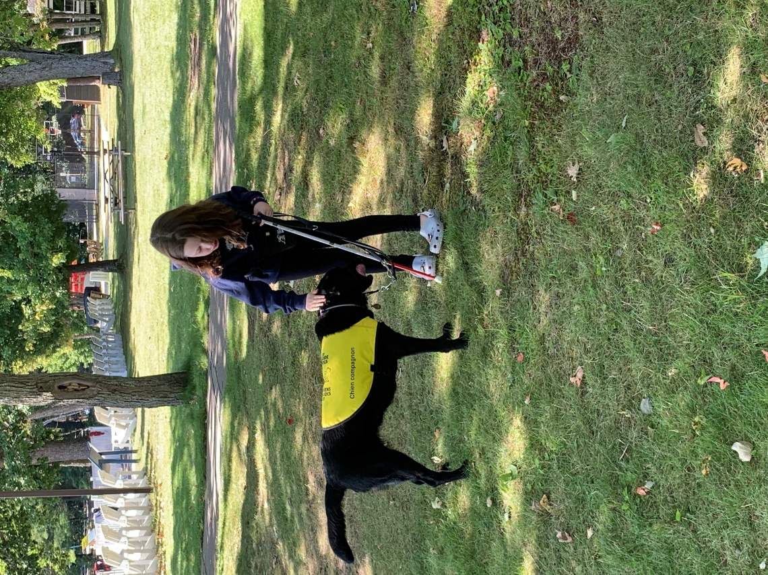
    - Please respect any guide dogs on site. Do not touch, make eye contact, or speak to a service dog when the animal is in harness. Always ask the dog’s owner first if it is okay to meet and interact with the animal. You can learn more about Guide Dog Etiquette here.

Health & Safety
At CNIB Lake Joe, the health and safety of all participants, staff, and visitors are our top priority. Our comprehensive health and safety practices are designed to provide a safe and enjoyable environment for everyone. Below, we outline our commitments and practices to ensure the well-being of our camp community.

Manager on Duty (MOD)
- We have a manager on-call 24 hours-a-day, 7 days-a-week during camp programs. If you need emergency assistance, please call 705-349-2762.

Health insurance
- All campers must have valid health insurance coverage while at camp (provincial or private). You will be asked for your provincial health card information in the Medical Form. For international and out-of-province campers, please make sure you have travel medical (or out-of-province) insurance.

Our Wellness Team
- Our Wellness Team consists of a Registered Nurse and two Wellness Assistants (student nurses) who live onsite throughout the core camp season. They work in the Wellness Centre.
- Staff from our Wellness Team will follow-up with registered guests by phone prior to arrival at camp to discuss information on the Medical Form and complete any necessary pre-camp health screenings.
- Guests will also be screened for health as they arrive to camp by members of the Wellness Team. Any guests who are symptomatic may be asked to leave.
- Wellness Team members will securely store and administer medication in accordance with provided instructions for our children and youth participants. For our adults requiring support, our Wellness Team can assist with prescribed medications (from the Wellness Centre) and can dispense over-the-counter medication if needed.
- Medications must be brought in pharmacy provided blister packs (if possible), or in the original prescription bottle with the camper’s name and dosage instructions clearly labelled. Prescription or over-the-counter medications that are not in original packaging are not permitted and will not be dispensed by our Wellness Team members.
- These staff are present at every meal, ensuring everyone with dietary requirements/allergies gets the correct meal.
- They respond to any onsite emergencies, provide first aid, and arrange for transfers to hospital (in Parry Sound) if required.

Overall safety
- Risk assessments are done on every aspect of programming. All camp activities are conducted under the guidance of trained instructors, using properly maintained equipment.
- Guests will be provided safety briefings prior to any activity and will be required to participate in safety activities which include swim tests and lifejacket/PFD fittings.
- We have high staff to camper ratios at camp. We have approximately 1 staff to 2-3 campers generally while at camp. In programs, the ratio may change to 1 staff to 8 campers, depending on the activity.
- Every staff member is a certified First Aider with CPR training.
- There are Automated External Defibrillators (AEDs) onsite. There is an AED station located in the Dining Hall and a portable unit that supports programming located in the Wellness Centre.
- Epinephrine auto-injectors (i.e. Epipen) are readily available and administered by trained staff in the event of severe allergic reactions (e.g. anaphylaxis). There is a unit available in the Dining Hall and additional ones with our Wellness Team. Guests who have severe allergies will be required to bring their epinephrine auto-injector to camp and have it with them at all times.
- Hand sanitizing stations are available throughout the site. All guests must wash and/or sanitize their hands before each meal and before and after all activities. Regular handwashing is highly encouraged.
- We are a mask-friendly environment.
- Regular drills are conducted throughout the season by staff for fire, severe weather, missing persons and other potential emergencies. Guests will be provided with a safety briefing on their first day at camp.

Contact with infectious diseases
- Guest should NOT arrive at camp if they are ill. They will be asked to return home.
- Symptomatic campers will not be permitted to participate in camp activities or programs. Campers may be asked to leave camp if they are unwell. Transportation support may be provided for those who require it.
- If guests are aware of any possible exposure to an infectious disease, such as COVID-19, chicken pox, cold, or flu virus, they must inform CNIB Lake Joe staff BEFORE they arrive at camp.
- Due to the nature of our programs, certain illnesses will have to be communicated to Public Health. Intervention by health officials may be required.
- Campers and staff must comply with current vaccination policies (Ministry of Health, Public Health) to ensure community health.
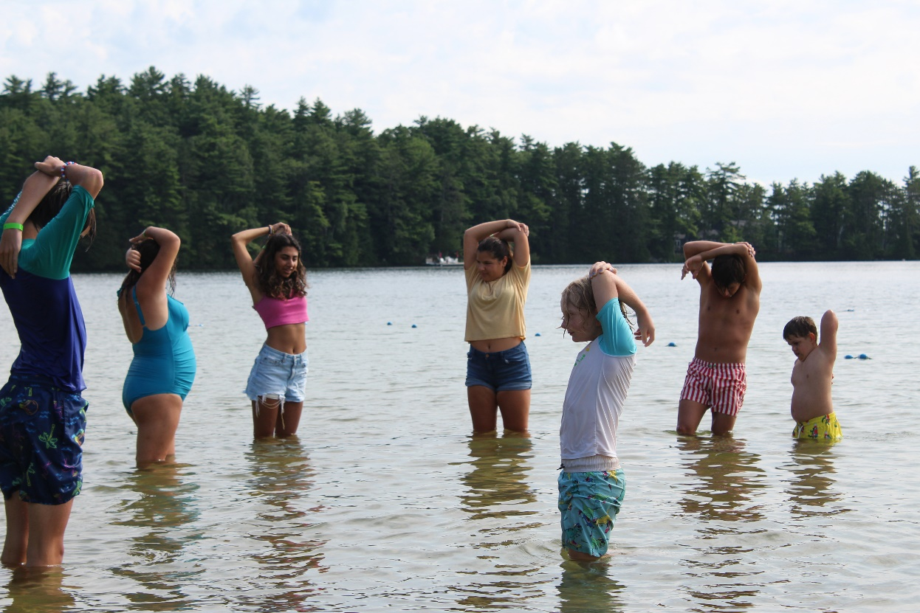

Personal Support Workers & Intervenors
  - Guests who need assistance with independence (daily living skills), mobility (e.g. lifts) and personal care while at camp will be required to bring a Personal Support Worker (PSW) or another support person who can assist them with all activities of daily living. CNIB Lake Joe staff cannot provide this type of care.
  - Guests who require the support of a Deafblind Intervenor must make arrangements separately to be supported while at camp.
  - PSWs and Intervenors need to register themselves for camp:
  - using their own CampBrain account;
  - as a ‘Support Worker or Intervenor’ on their client’s account (if working together on a regular basis or for care homes signing up on a guest’s behalf)
  - the CNIB Lake Joe: 2026 Support Worker/Intervenor App Tutorial Video and CNIB Lake Joe Support Worker/Intervenor Application Guide are helpful resources in completing your online application:
  - PSWs and Intervenors are charged a discounted rate. Financial assistance may be requested to cover this fee.

Alcohol, smoking (tobacco and cannabis) and vaping
- Guests who are legally permitted to consume (19 years of age or older) may consume alcohol, cannabis, and tobacco while at CNIB Lake Joe where permitted. Guests will be required to follow provincial laws and under the parameters outlined below.
- Responsible consumption of alcohol is permitted in guest rooms or on the porches of guest cabins. Glassware is not permitted at camp due to potential hazards. When special events are held, the appropriate permits will be obtained to specify where alcohol consumption is permitted.
- Smoking tobacco/cannabis or vaping is permitted only in the designated area. Vaping or e-cigarettes are not permitted in any indoor locations. Guests are responsible for managing odours from cannabis products which may include storing items in a scent-proof bag.
- Tampering of fire safety equipment is illegal and guests will be asked to leave and/or charged for damages.
- Due to safety concerns, individuals who are under the influence of alcohol and/or drugs will NOT be permitted to participate in programming.
- The excessive use of alcohol or cannabis is not permitted on the CNIB Lake Joe property.
- Illegal and/or illicit drugs are not permitted onsite.
- Consequences of consuming illegal drugs and/or consuming alcohol or cannabis excessively at camp may include being sent home immediately; suspension; or possible expulsion from programs.

Behaviour and Bullying Prevention
- Bullying and/or harassment is not tolerated. Any reports of bullying and/or harassment will be addressed immediately and appropriately.
- All participants and staff are expected to adhere to our code of conduct, promoting respect and inclusion.
- Counselors are trained to mediate conflicts and support positive relationships among campers.

iPhones & Technology
- CNIB Lake Joe has improved its connectivity at camp to provide enhanced accessibility for participants who rely on technology for independence. Wi-Fi is available in most of our buildings including cabins.
- Access to Wi-Fi will be provided for use by adult guests should they require it for independence.
- The following activities are strictly prohibited: accessing restricted sites and/or illicit materials; and the use of the CNIB Lake Joe network for personal gain (i.e. bitcoin farming).

Packing List
In most cases, guests will receive a specific packing list ahead of their program week, but this list covers the basics.

Clothing:
- T-shirts
- Long sleeve shirts (UV sun shirts recommended)
- Shorts
- Pants
- Sweater
- Sweatpants/trackpants
- Socks and underwear (a full week’s worth)
- Pajamas
- Rain jacket
- Wide brim hat
- Closed-toe shoes (athletic shoes preferred)
- Sandals or flip flops
- Bathing suit
- Water shoes (optional)

Toiletries (unscented if possible):
- Shampoo & conditioner
- Soap or body wash
- Toothpaste & toothbrush
- Female hygiene products
- Hairbrush, comb
- Loofah/scrub

Camp-related goodies:
- Sunscreen
- Bug spray
- Flashlight
- Reusable water bottle
- Personal protective equipment for COVID like face masks (optional)
- Swimming goggles (optional)
- Ear plugs for sleeping (optional)
- Fan (optional)
- Cooler (optional, we have free ice available on site for you)
- Personal down-time activities (i.e., books, cards, colouring books, journal, etc.)
- Tuck money (e.g., souvenirs, snacks, t-shirts, sweatshirts etc.)

Specialty items:
        - Personal accessibility equipment (like toilet risers)
        - Families with babies/young children need to bring their own pack-n-play, crib/co-sleeper, etc.

Bedding and towels:
        - Guests in our children & youth programs who are travelling to camp by ground transportation must bring bedding:
          - Pillowcase, sleeping bag or twin-size sheet set/blanket; and
          - towels (face, hand, bath and beach)
        - Children & youth guests who are travelling by train or plane will have bedding provided but NOT towels.
        - Adult and Family programs will have all bedding provided but NO towels (bring face, hand, bath and beach).

Things to leave at home:
- Weapons
- Illegal drugs (does not include prescribed and/or over the counter medication)
- Valuables
- Nut products
- Candles, hot plates, etc.

Important details:
- There is no access to laundry onsite (except for emergencies).
- There will be no town runs by CNIB Lake Joe staff for shopping trips.
        - CNIB Lake Joe’s tuck shop offers a limited collection of toiletries for sale.
        - Bring any personal independent living skills tools and accessibility devices. Lake Joe can provide a list of local vendors for purchase/rentals. You may also wish to explore the CNIB Smartlife website.
        - All luggage and bags must be tagged with the owner’s full name.
        - If you’re using CNIB Lake Joe transportation. Aim to bring one suitcase and one carry-on bag.
        - Families with babies/young children need to bring their own pack-n-play, crib/co-sleeper, etc.
- An updated packing list is sent to registered guests ahead of each program week listing any special requirements.
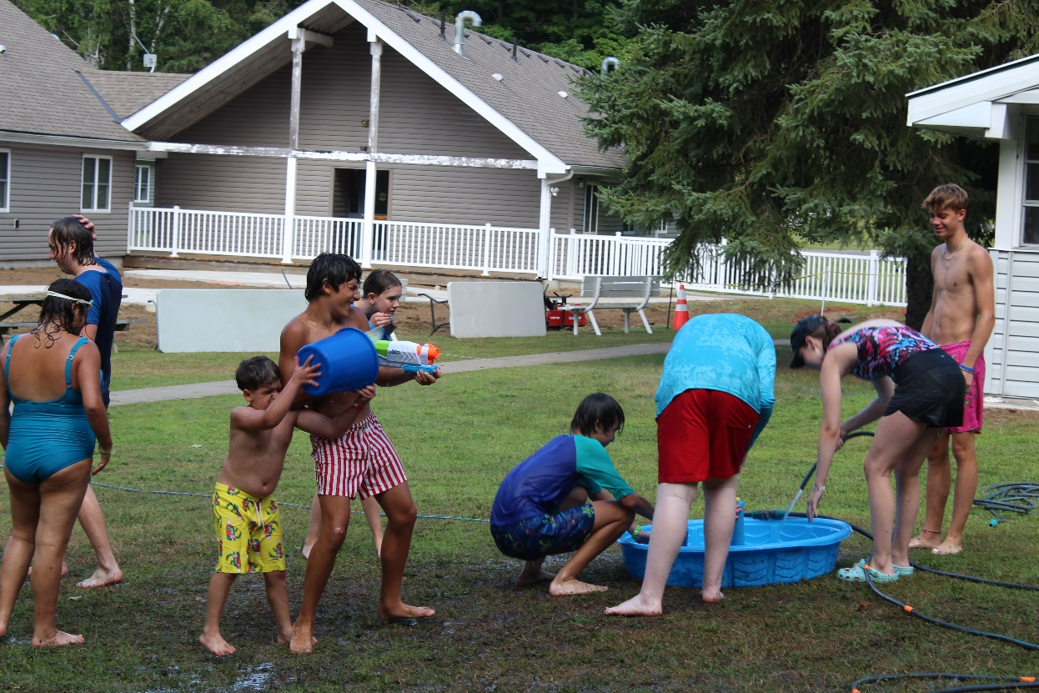

Photos & Videos
- For easy identification and in case of emergencies, staff will take a photo of each guest on arrival day and upload it to the guest’s Campbrain account.
- All guests must sign a Promo Consent Form when they register for camp. This form gives permission for CNIB Lake Joe staff/volunteers to take their photo/video for professional, organizational purposes (i.e. promotion, training, etc.). Guests may choose NOT to give permission.
- Be sure to follow us on our Facebook and Instagram for updates!

Programs at CNIB Lake Joe
Please review the CNIB Lake Joe 2026 In-person Camp Program Guide.

Tips for selecting the right program(s) for you and your family
  - Ensure you are in the correct age range.
  - Are you physically, socially and emotionally able to participate in the activities being offered or is there a better program for you?
  - Guests can apply to attend more than one week. Due to limited space and high registration numbers in some programs, we aim to place guests in their preferred program week first, and attempt to fit them into additional weeks as space permits.
  - All guests must leave camp Saturday morning at 10:00 a.m. Arrivals at camp are always Mondays, 1:30 – 4:30 p.m. There are no stayovers between program weeks.

Information sessions
    - General Information sessions are hosted every January in advance of the launch of our application process. In these online sessions, we review programs available in the upcoming season, fees, deadlines, etc. and respond to your questions.
    - Registrant Info: We invite everyone who has registered for a program to attend a virtual Info Session so that we can help you prepare for an awesome time during your particular week at camp. We host three info sessions tailored to the type of program: Adult; Children & Youth; or Family.
- Pre-camp session for children & youth: We invite all registrants in our children & youth programs to attend a virtual info / meet & greet session ahead of coming to camp in-person. This fun event gives kids (and their parents too!) the chance to meet staff, volunteers and fellow campers, ask questions, and get excited about coming to camp.
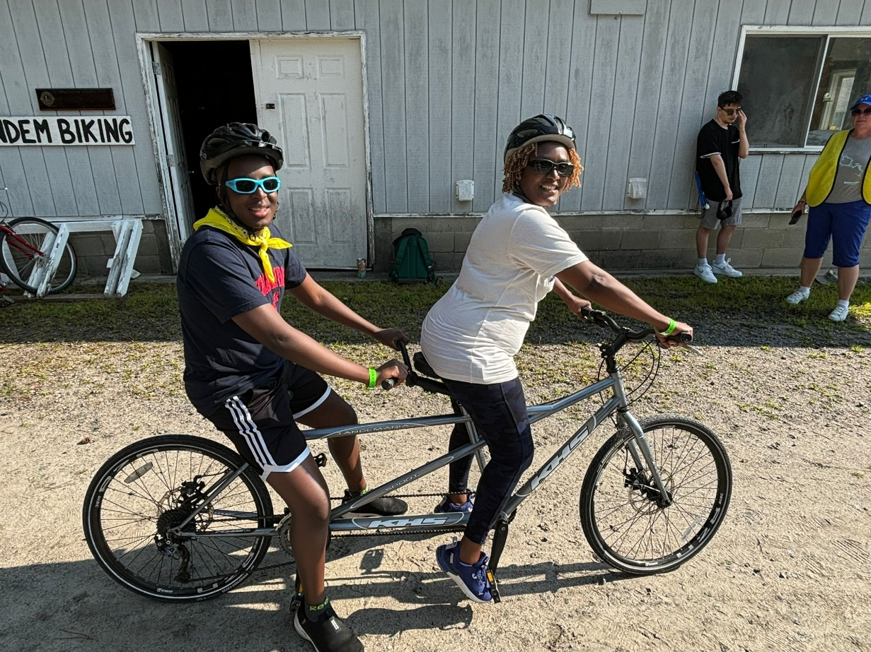

Arrival day / check-in procedure
- Guests arrive Monday afternoons between 1:30 – 4:30 p.m. and check-in at the Welcome Centre.
- Staff will welcome you and provide you with your room number and key.
- Members of the Wellness Team will meet with you to review any dietary concerns, allergies, and sign in all medications.
- Sign-up for camp activities (based on availability).
- Staff will help get you and your luggage to your room.
- Guests will have the opportunity to unpack and settle into your room.
- Swim tests are only available on arrival days (except for extenuating circumstances) and are completed by our lifeguard staff team during the afternoon.
- Programs and tours will also be offered throughout the afternoon.
- Dinner is served at 5:30 p.m.
- Participate in tours, important orientation sessions and fun evening programs.
- Evening programs after dinner will consist of meet and greet, teambuilding and camp activities.

Departure day / check-out procedure
- Guests depart Saturday morning by 10:00 a.m. from the Welcome Centre.
- Enjoy your breakfast.
- Pack your bags and ensure there’s nothing left behind in your room.
- Bring your bags to the welcome centre. Return your key to a staff member.
- Children under 18: parents/guardians who are pre-authorized (in writing) to pick-up campers at CNIB Lake Joe will be required to show ID and sign-out campers.

A typical day at camp
Time block | Activity
8:00 a.m. | Morning Music, Rise & Shine!
8:30 a.m. | Breakfast
9:30 a.m. - 12:30 p.m. | Morning programs
12:30 p.m. | Lunch
1:30 - 5:30 p.m. | Afternoon programs
5:30 p.m. | Dinner
6:30 – 9:00 p.m. | Evening programs
9:00 p.m. | Lights out (for kids)

Offsites
- There’s so much to see and do onsite at camp! In some cases, guests travel off-site as part of their scheduled program (i.e. campers in our blind hockey program travel to a local arena each morning).
- Adult guests and families, PSWs and intervenors may go offsite on their own and will be required to check-in/check-out at the Welcome Centre.

Swimming & swim tests
- In accordance with the Ontario Camps Association safety standards, each camper’s swimming ability will be assessed at the beginning of each session. We are checking the guests’ ability to:
  - Climb a ladder onto a dock and jump off;
  - Tread water for two minutes; and
  - Swim to a buoy and back without touching the ground.
- Based on the swim test, campers will be required to wear a corresponding colour bracelet:
  - Red: must wear a Personal Flotation Device (PFD) while at the waterfront
  - Yellow: must wear a PFD in deep water
  - Green: no PFD required for swimming
  - ALL swimmers, regardless of ability, are required to wear a PFD when playing on the inflatable water slide, water trampoline or while in boats. CNIB Lake Joe provides approved PFDs in a wide range of sizes.
  - Guests who wish to bring their own lifejacket/PFD will have to have them inspected by CNIB Lake Joe staff prior to use in our programs. They must be Canadian approved (Transport Canada).
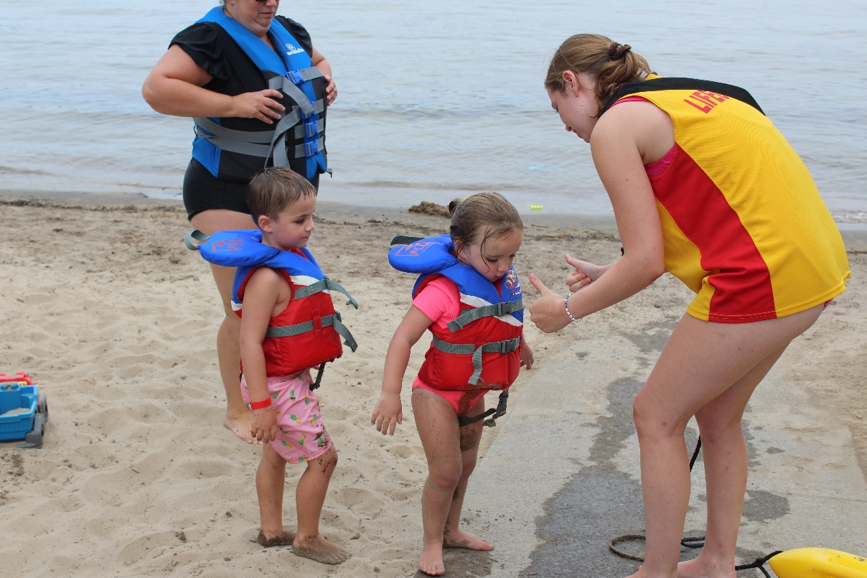

Property & Camp Amenities
There’s so much for CNIB Lake Joe guests to experience and enjoy!

- sandy beaches with a vast waterfront boasting safe swimming and paddling areas (with bright yellow bumpers), and fun inflatables and a water trampoline
- paddling equipment: voyageur canoe, canoes, kayaks, paddleboats, stand-up paddleboards
- boathouse and spacious dock with water slide
- boats: pontoon boat, sail boats, catamarans, waterski/wakeboard boat
- water sports: tubing, waterskiing, wakeboarding
- fishing
- hiking trails
- hammocks
- tandem bicycles
- 32’ climbing tower and vertical playground
- mini-golf
- archery
- multi-sport court: basketball, tennis, volleyball, etc.
- 5-a-side soccer pitch
- shuffleboard court
- campfire pit and outdoor pizza oven
- scenic gazebo
- sensory garden
- outdoor patio and picnic area
- outdoor guide dog rest, run and relief area
- Wellness Centre with nursing staff
- Multi-Sensory Room
- Dining Hall that seats 132 (max.)
- Lounge that seats 74 (max.)
- Welcome Centre with tuck shop
- Rec Hall with screened-in outdoor patio, arts & crafts, musical instruments, pottery kiln, Showdown Table, movies, reading and more!
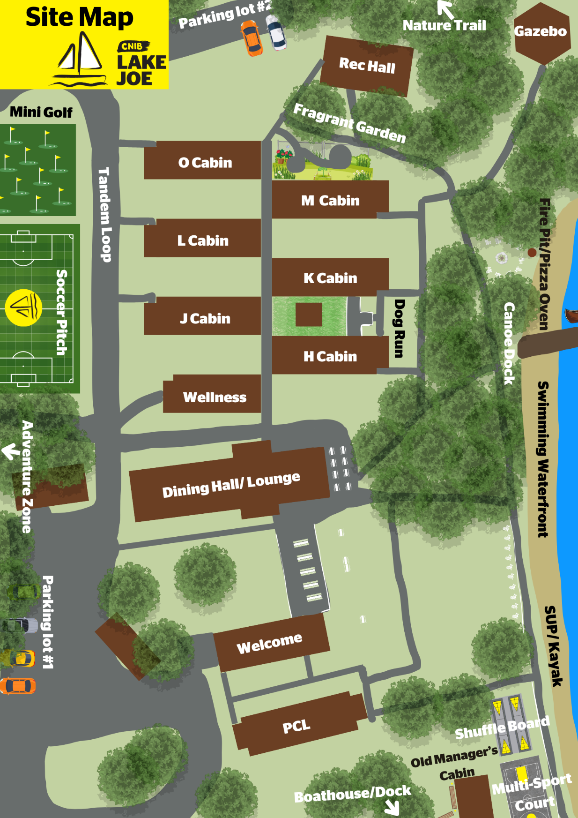

Property: Photo Galleries
Review our six Facebook photo galleries featuring everything that makes CNIB Lake Joe great:
- Welcome to CNIB Lake Joe
- CNIB Lake Joe Facilities
- CNIB Lake Joe Cabins & Rooms
- Waterfront & Water Sports
- Outdoor: Recreation & Adventure
- Outdoor: Relaxing
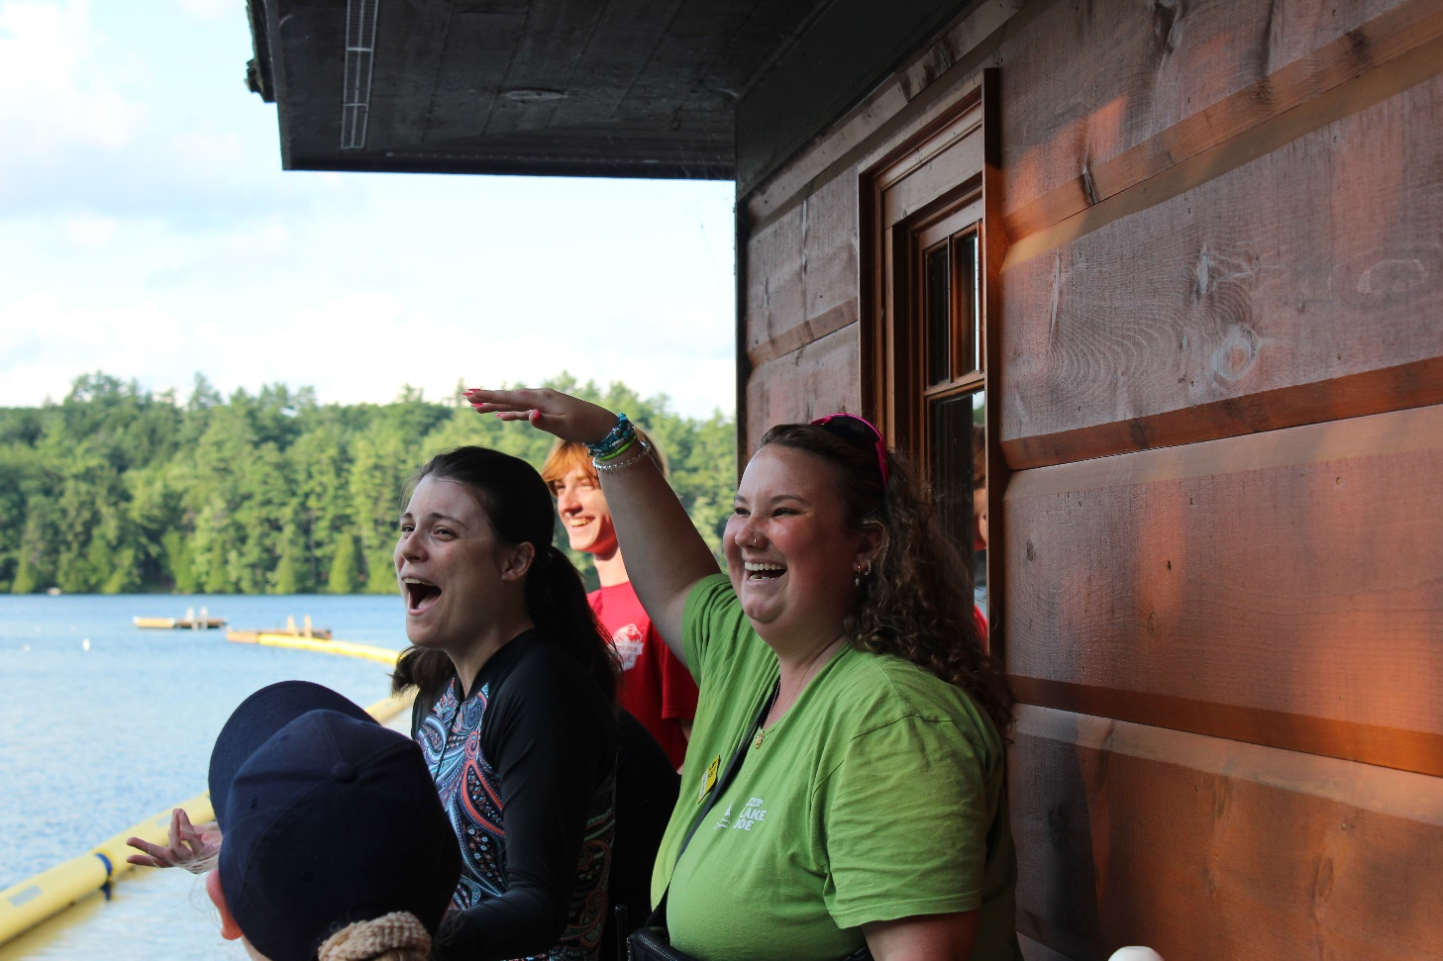

Rooming
Enjoy your stay!

About the cabins
- There are six guest cabins (Hemlock, Juniper, King Maple, Larches, Magnolia, and Oak), each with 10 rooms (7 for guests, 3 for staff/volunteers) and a screened-in porch with table and chairs.
- In total there are 84 guest beds. Guest rooms have two twin beds and a private 3-piece bathroom.

About the rooms & ensuites
- Each room has: two twin beds; two bedside tables; a chair; shelving unit; and a window with blackout privacy blinds. The rooms have electricity and Wi-Fi. New geothermal units provide cooling (centrally controlled).
- Each room’s ensuite has: a shower; toilet; pedestal sink; grab bars; liquid soap dispenser; and hooks. If you have any special accessible equipment (like toilet risers), you must bring these or rent them from local vendors.
- There are two types of “specialty rooms”:
  - Rooms with washrooms that are fully accessible for wheelchairs are available in each cabin. These washrooms have: a small, raised edge to enter the shower; a roll-in shower; and a bar beside the toilet to help when standing up from the toilet (if you need the bar to be on a specific side, please request that in your application). Some of these rooms also have an automatic door opener from outside the washroom.
  - Adjoining rooms that have a door between them (limited - often reserved for families).
- Each cabin has two rooms for CNIB Lake Joe staff/volunteers that are separate but adjacent to the campers’ rooms.

Cabin & room requests
- Unless there is an accessibility or medical requirement, we cannot guarantee a specific room selection. Please make sure you include any requirements in the “Accessibility and Rooming” form when you apply.

Cabin & roommates
      - A big part of the camp experience is meeting new friends. Participants will be placed with a roommate, and if they wish, they can indicate on their registration form if they would like to room with a certain individual. That said, both people need to indicate they want to room together.
      - Private rooms can be assigned if required due to a medical concern. A doctor’s note is required.
      - Roommates are usually assigned by gender and age (especially for children & youth programs).
      - If you want to share a room with a family member or friend, please indicate that on your registration form. We do our best to honour roommate requests.
      - We can let you know who your roommate is during check in (not in advance).
      - Due to privacy laws, we cannot disclose information about other campers’ registration details. We can’t tell you if another camper is registered, what cabin they are in, what week they might be in, or who they may have requested as roommates.
- Families attending with babies and small children need to bring their own sleeping equipment (e.g. pack-n-play, co-sleeper, etc.). Children under 6 years of age typically share a room with parents.

Scent-free environment
- Unpleasant odours and/or strong scents can be problematic, especially when people are staying in close quarters with one another. Some individuals and guide dogs may be sensitive and/or allergic to scented products like cologne, aftershave, lotion, deodorant, perfume, scent diffusers/incense, etc. In consideration of others who suffer extreme discomfort and risks to their health (i.e. anaphylaxis), the use of scented products at camp is to be avoided. While it is not possible to keep all scents out of any environment, there are many that are well within each individual’s control. As such, courtesy and consideration is requested of everyone.

Room keys
- Adult guests receive one room key for their stay at CNB Lake Joe.
      - Keys may not be lent to others or duplicated.
      - Guests will be charged an $80 fee to replace a lost key.

Transportation Offered by CNIB Lake Joe
We can’t wait to welcome you at camp!

Pick-up and drop-off locations
- We are pleased to provide round-trip transportation to camp at key transportation hubs throughout Ontario.
- Each program week will have unique transportation routes (dependant on guests’ needs).
- Additional transportation fees apply.
- During Family Weeks, we only offer transportation to/from Pearson International Airport and CoffeeTime Plaza, 215 Carlingview Drive, Etobicoke (directly across from Pearson).
    - We require a minimum of three guests to arrange pick-up/drop-off at a hub. We will work with guests to make alternate arrangements if necessary.
    - CNIB Lake Joe staff will not be onsite at these hubs. Unless the guest is completely independent, guests must plan to have someone with them while waiting for the CNIB Lake Joe vehicle to arrive.
    - Each route may have multiple stops (up to three hub locations) to pick up guests. Some trips are long. There will be bathroom breaks along the way.

Booking your travel
- On your application, indicate:
  - if you require CNIB Lake Joe ground transportation to camp, from camp, or both
  - your preferred hub
  - if you have a guide dog, use a wheelchair or walker, or have any other special needs (i.e. require child seat or booster seat)

- If you are traveling by air and require CNIB Lake Joe ground transportation, you must:
  - fly into and out of Pearson International Airport
  - be at the pick-up location by 1:00 p.m. (factoring in arrival time, collecting baggage, travelling to pick-up spot)
  - depart on Saturday after 1:00 p.m.
- If you are traveling by VIA train and require CNIB Lake Joe ground transportation, you must:
  - arrive at and leave from the Oakville or Oshawa station (we cannot pick-up from Union Station).
  - be at the pick-up location by 1:00 p.m. (factoring in arrival time, collecting baggage, travelling to pick-up spot)
  - depart on Saturday after 2:00 p.m.
- When booking flights/trains, note that you require accessibility services.
- If using Lake Joe transportation, please email your flight/train itinerary to CNIB Lake Joe staff. This is important for determining schedules and pick-up locations.
- Lake Joe does not book flights/trains. Consider asking staff at local offices for assistance.
- CNIB Lake Joe staff/volunteers will not be able to wait with guests in arrivals or departures. Arrangements for personal support must be made.

CNIB Lake Joe vehicles
    - CNIB Lake Joe’s fleet includes: a wheelchair accessible minibus that seats approx. 18 people (depending on number of wheelchairs, walkers, guide dogs, etc.); a van that seats 8 guests and an SUV. Our vehicles have a CNIB Lake Joe logo.
    - When necessary, we also use rental vehicles and book charter buses.

Communicating travel plans
    - Registrants are emailed two weeks ahead of their session with full transportation details: date and time; hub location (address and landmarks); type of vehicle; other stops on the route; and name and phone number of driver and CNIB Lake Joe staff member/volunteer.
    - It’s difficult to predict traffic and weather when transporting guests. We update guests/caregivers about any significant changes to timing.

Travel dates & times
    - Pick-ups on Mondays are usually 1:00 p.m. or later. If arriving by plane, ensure your flight lands by 1:00pm. The goal is to have everyone onsite and settled by 4:00 p.m. whenever possible.
    - Departures from camp are Saturday at 10:00 a.m.
    - Because there are multiple stops on a route with many passengers, CNIB Lake Joe can only wait 15 minutes at a stop for a late guest. Late guests who have missed their pick-up will be required to make alternate travel arrangements to get themselves to camp.

Luggage
    - All luggage must have tags with the owner’s full name.
    - We encourage guests to limit their luggage to one suitcase and one carry on.

Meals & refreshments
- We encourage guests to bring water and nut-free snacks with them for the ride to camp.
- CNIB Lake Joe provides bagged lunches (sandwich, fruit, cookie/muffin) and a bottle of water to guests for their ride back home.

Child travellers
    - During all child & youth program weeks, at least one CNIB Lake Joe staff member accompanies the driver.
    - When guests under 18 years of age are returning home, we must have the name and phone number of an adult authorized to pick-up them up. This adult will be required to show identification to the staff/driver and sign that they have picked up the child.
    - The minibus has integrated booster seats for our smaller passengers.

Tuck Shop & Online Camp Store
- Swing by the Tuck Shop at the Welcome Centre to grab your favourite snacks, toiletries, slushies and exclusive CNIB Lake Joe merch!
- From cozy hoodies to souvenirs that keep the Lake Joe memories alive, there’s something for everyone.
- The shop is open at least twice a day, so you’ll have plenty of chances to treat yourself.
- We accept cash, credit, and debit through our secure, fully accessible tap system, easy and inclusive for everyone!
- CNIB Lake Joe’s Online Camp Store features clothing and souvenirs can be viewed, ordered and shipped to your home at any time or be ordered in advance for pick-up at camp.

Visitors
- We take safety very seriously at Lake Joe and do not permit non-registered program guests onsite. CNIB Lake Joe’s adult guests are welcome to visit with non-registered friends or family offsite and simply need to check-in and out at the Welcome Centre.

Wildlife at Camp
CNIB Lake Joe is in the heart of Muskoka. The area is widely known for its stunning landscapes and pristine lakes and is a haven for diverse wildlife. At our camp, we are committed to preserving the natural beauty of Muskoka and ensuring the safety of both guests and wildlife. As part of our commitment to responsible environmental stewardship, we ask all guests to follow the guidelines below to minimize their impact on the local wildlife and ensure a safe and enjoyable experience for everyone.
- Respect Wildlife at a Distance: All wildlife, including deer, bears, birds, and smaller animals, should be observed from a safe distance. Never approach or attempt to feed animals. Feeding wildlife can alter their natural behaviors, leading to dependency on human food, which can be harmful to their health.
- Secure Food and Waste: Keep all food, snacks, and trash stored securely in designated containers. Do not leave food unattended or dispose of it improperly. Improper food storage can attract animals such as bears, raccoons, and squirrels, which may become bold and pose a risk to guests and their property. We ask that food not be left unattended in our common areas and screened-in porches as they may attract unwanted guests.

Notes

