2026 CNIB Lake Joe
Camp Programs
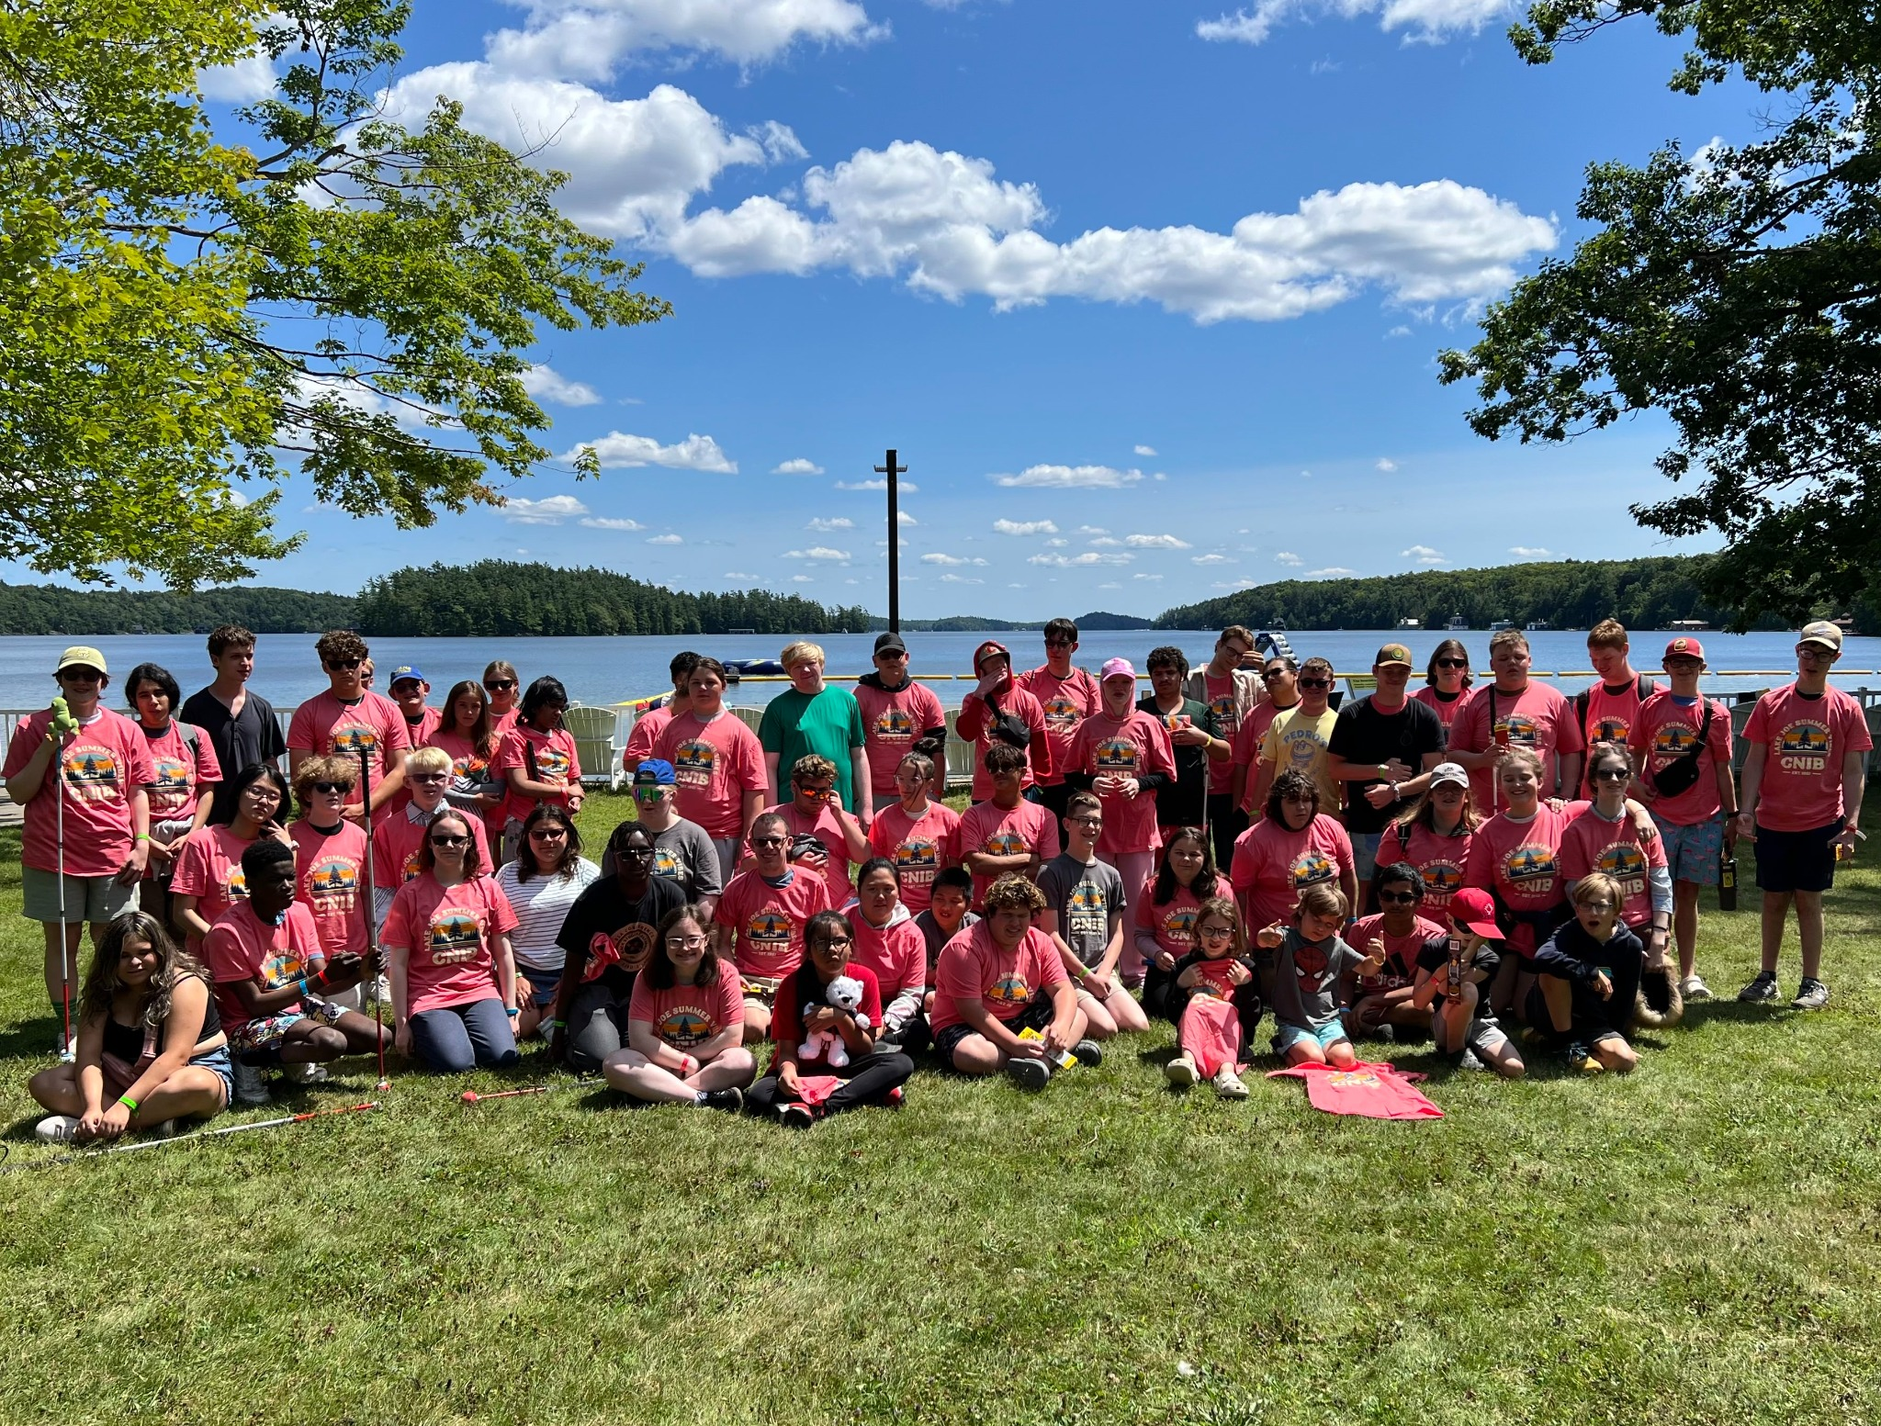
Enriching lives. Making memories. Building independence.

Table of Contents
Table of Contents 2
About CNIB Lake Joe 3
Children & Youth Programs 5
Adult Programs (19+) 11
Family Programs 15
CNIBLakeJoe@Home Virtual Programs 17
Programs Summary 18
2026 Program Fees 19
Getting to Camp 22
Application Process 25
Get Involved 27

Please note: CNIB Lake Joe may update or make changes to the 2026 schedule. Every effort will be made to keep the programs and fees as represented; however, unforeseen circumstances may result in the substitution or cancellation of a program. We appreciate your understanding and look forward to finding the perfect program for you and your family.
As we celebrate 65 years of CNIB Lake Joe, we’re investing in its future by building what comes next. Construction work is now underway at Lake Joe, with upgrades that will improve the camp experience for our community for years to come. We encourage you to visit our construction updates webpage for the latest information and answers to frequently asked questions.

About CNIB Lake Joe
We’re thrilled to share everything you need to know about the upcoming CNIB Lake Joe 2026 season!
This year, we’re celebrating 65 years of camp spirit! Since 1961, CNIB Lake Joe has offered a one-of-a-kind mix of recreation and skills development in a safe, inclusive environment for Canadians with blindness and sight loss.
Nestled in the heart of Muskoka, our 12.5-acre accessible lakefront property on Lake Joseph is a place where confidence grows and memories are made.
Proudly accredited by the Ontario Camps Association, a registered High Five organization, and an affiliated member of the Lifesaving Society and the Camp Safety Network, CNIB Lake Joe upholds the highest standards of care, quality, and safety.
In 2026, we’re offering a dynamic lineup of programs, including our popular “Partner Programs” in collaboration with CNIB Guide Dogs, Deafblind Community Services, INCA Québec, and Vision Loss Rehabilitation Canada, plus partnerships with Soccability Canada and Canadian Blind Hockey.
With fresh new programs to discover and all your favourite camp traditions returning, this season promises to be one to remember.

We can’t wait to welcome you back to Lake Joe!

“Before coming to CNIB Lake Joe, I was nervous. When I got there, I felt very excited and by the next day it became a home away from home.”
2025 camper
Here are just some of the activities you can enjoy at CNIB Lake Joe!

- Make a splash in Lake Joseph: Make waves with fishing, paddling (canoe, kayak, stand-up paddleboard), paddleboats, pontoon boat cruises, sailing, swimming, tubing, wakeboarding, waterskiing, and enjoying the water slides and trampoline.
- Get your creative juices flowing: Art, crafts, dancing, music, pottery and talent shows.
- Get active and play: Archery, basketball, beep baseball, climbing tower, hockey, hiking, mini-golf, shuffleboard, soccer, tandem-bike riding, tennis, yoga and more.
- Skill up with new adventures: Learn something new every day, all in a fun, safe and supportive environment. Who knows what skills you will master next?
- Rest and unwind in style: Relax in the multi-sensory room, enjoy a good book by the lake, hang-out in the hammock park, gather in the sensory garden and enjoy the campfire with friends – new and old. Find your perfect way to relax and recharge at your home away from home!
That’s not all! Don’t forget, there are lots of virtual programs – online and on the phone – at CNIBLakeJoe@Home where you can learn, laugh, and stay connected with your camp community year-round!

If you speak French and wish to join a CNIB Lake Joe program with fellow francophones, please contact Salma Moudrika, Program Lead, Children and Youth at salma.moudrika@inca.ca or 1-800-465-4622 ext. 236.

Si vous parlez français et souhaitez participer à un programme du CNIB Lake Joe avec d’autres francophones, veuillez communiquer avec Salma Moudrika, responsable des programmes pour enfants et jeunes, à l’adresse salma.moudrika@inca.ca ou au 1-800-465-4622, poste 236.

To apply, please visit: cniblakejoe.campbrainregistration.com

For more information, contact CNIB Lake Joe:
Email: LakeJoe@cnib.ca
Phone: 705-375-2630 | Toll Free: 1-877-748-4028
Web: cniblakejoe.ca
Address: CNIB Lake Joe, 4 Joe Finley Way, MacTier, ON P0C 1H0

Children & Youth Programs
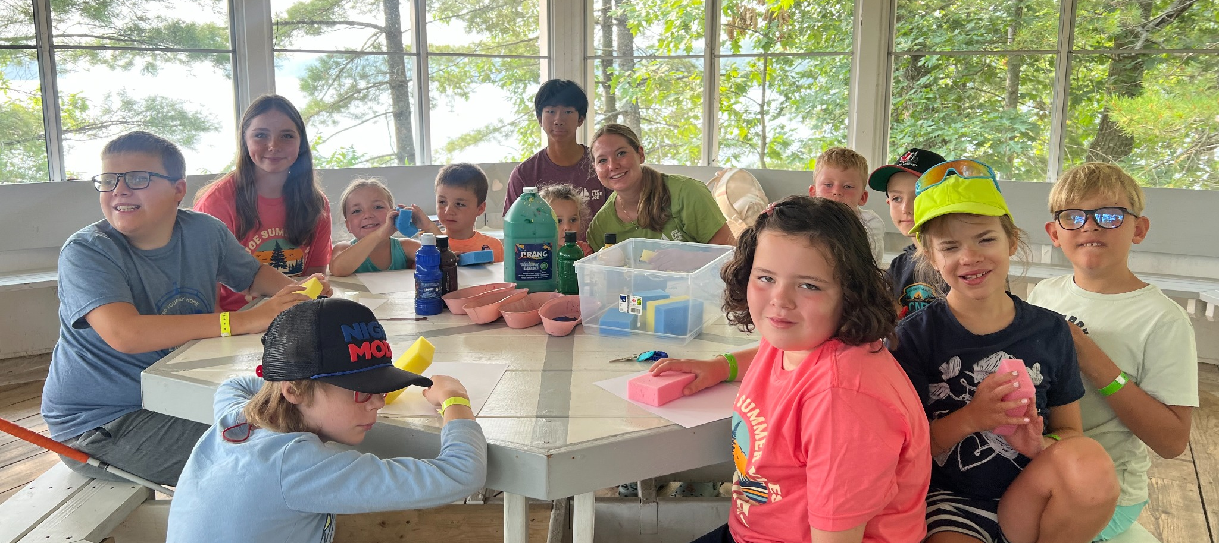
Our Children and Youth Programs are catered towards our younger guests who are blind, Deafblind, or have low vision with some programs open to sighted siblings and friends. In 2026, thanks to the incredible generosity of donors, we are excited to offer significantly subsidized rates (see our Fees section for details). Please review the “Important Program Points” included in the program descriptions for full details.

Welcome to CNIB Lake Joe’s Children & Youth Camp Programs
Pre-camp virtual orientation session
As part of the registration fee for all children and youth programs, we offer a Zoom meeting where you can meet others before camp, go over important details, learn what to expect and get answers to any questions you might have. This way, you can spend all your time at CNIB Lake Joe focused on fun, family and friends. Full details will be provided to registrants at the beginning of the season.

PLAY (Pushing Limits for Active Youth)
July 6-11, 2026 | Ages: 8-18
PLAY is the perfect program for kids who love to move, explore, and try something new! From 5-a-side soccer and archery to pottery and the climbing wall, campers will jump into a variety of adaptive sports and activities designed to build confidence and spark a lifelong love of being active.
In addition to the action and adventure, campers will take part in wellness workshops focused on healthy eating and self-care, rounding out a program that celebrates both physical fitness and overall well-being.
Note: This program is open to children and youth who are CNIB participants as well as sighted siblings and friends.

Camp Abilities
July 6-11, 2026 | Ages 8-18
Get ready to take your athletic skills to the next level with this goal-focused sports program designed to help young athletes build confidence, improve performance, and have fun! Whether you’re a seasoned competitor or trying a new sport for the first time, you’ll receive expert coaching and adaptive training to help you achieve your personal best.
Each morning, campers will focus on one of three specialized streams, led by skilled coaches: Intro to Blind Hockey; Junior Blind Hockey; or Watersports. The afternoons are open to a mix of recreation, teamwork, and adventure providing the perfect balance of focus and fun.
- Intro to Blind Hockey: New to hockey? This beginner-friendly program, offered in partnership with Canadian Blind Hockey, introduces you to the fundamentals in a safe, supportive environment. You’ll build your skills step by step, from basic skating and stickhandling to shooting and game play.
If you need equipment to participate, please contact Alexis Peterson, Coordinator, Office & Registration at alexis.peterson@cnib.ca.
- Junior Blind Hockey: Designed for players with basic skating experience, this program, also in partnership with Canadian Blind Hockey, focuses on developing core hockey techniques such as skating, stickhandling, shooting, and game strategies. You’ll have opportunities to scrimmage with peers and strengthen your abilities using both blind hockey pucks and standard pucks.
Participants must bring their own equipment, including pads, gloves, skates, helmet, neck guard, mouthguard, and stick.
- Watersports: Make a splash with this thrilling program featuring waterskiing and wakeboarding! With guidance from experienced instructors, you’ll work on mastering these exciting water sports. All equipment from water skis to wakeboards is provided.
Participants must have basic swimming skills and be able to lift themselves from the water. A skills assessment will be completed before hitting the water.
Note: This program is open to children and youth who are CNIB participants as well as sighted siblings and friends.

Summer Camp
July 27-August 1, 2026 | Ages 8-18
Experience all the excitement and traditions of summer camp with a great balance of focused activities and camp-wide fun!
Each morning, campers take part in a specialty of their choice. Options may include swimming, archery, STEM (coding and engineering), art, canoeing, wilderness skills, and more. All specialties welcome every skill level and ability.
Afternoons and evenings are packed full of fun activities so campers can experience everything Lake Joe has to offer.
Campers are grouped by age, giving them the chance to make friends, have fun, and enjoy the full camp experience together.
Note: This program is open to children and youth who are CNIB participants as well as sighted siblings and friends.

Leadership Camp
July 27-August 1, 2026 | Ages 15-18
Join a vibrant group of young leaders for an unforgettable week of growth, connection, and adventure!
This immersive program combines leadership development, skill-building workshops, and classic camp fun to help you discover your potential and step confidently into your leadership journey.
Throughout the week, participants will explore skills like public speaking, advocacy, self-awareness, and personal branding. You’ll be encouraged to share your goals, celebrate your strengths, and build the courage to lead both at camp and beyond.
When you’re not in workshops, you’ll enjoy the recreational activities that make CNIB Lake Joe so special, from team challenges to outdoor adventures, all in a safe, inclusive, and supportive environment led by experienced facilitators.
Important program point: This program is designed to equip participants with valuable leadership knowledge and skills that can be applied in all areas of life. To ensure a great fit and set participants up for success, the application for the leadership program includes additional questions that help assess the readiness for the program and leadership potential.

Counsellor-in-Training (CIT)
July 27-August 8, 2026 | Ages 15-18
Interested in being a camp counsellor? This two-week leadership program is designed to give participants hands-on training, real job experience, and the confidence to take on future staff roles all while having fun and being part of the CNIB Lake Joe community.
Through interactive workshops, skill development sessions, and in-service training, participants will gain practical knowledge of what it takes to lead at camp. From goal setting and teamwork, to building campfires and facilitating activities, you’ll learn the essentials of program planning, communication, and leadership in action.

By the end of the program, you’ll have built the skills, confidence, and experience needed to take on new challenges, and maybe even join the CNIB Lake Joe team as an official counsellor in the future!
Important program points:
- This two-week program is available for people who are blind or have low vision and their sighted peers.
- The program includes a two-night camping trip to a local provincial park where participants will take part in team-building exercises and outdoor skill development.
- Prospective participants must fill out a supplementary application and participate in an interview with program staff prior to acceptance.
- Successful completion of this program guarantees an interview for future camp staff positions but does not guarantee employment.

Partner Program: SCORE Scholars (Skills, Confidence & Opportunities through Recreation & Education)
August 1-16 (at Lake Joe from August 13-16) | Ages 16-21
CNIB's national SCORE Scholars program is a two-week summer experience that combines the joys of camp with excursions and activities geared to helping youth with sight loss learn and develop skills to pursue post-secondary education. You'll participate in an intensive leadership development component in Toronto and then visit Lake Joe to participate in fun activities like swimming, rock-wall climbing, tandem biking and water tubing. A certificate is granted upon completion.
Note: You will be required to fill out a supplementary application and participate in an interview with SCORE staff prior to being accepted into this program. For more information, please contact Rhonda Underhill-Gray at rhonda.underhill-gray@cnib.ca, or call 1-800-563-2642 or 647-535-8962.

Partner Program: CNIB Buddy Dog Camp
August 9-14, 2026 | Ages 7-16
This one-of-a-kind program is designed specifically for CNIB Buddy Dog graduates and combines buddy dog training with exciting camp activities. Throughout the week, participants will have the chance to strengthen their bond with their buddy dog while enjoying recreational activities that promote independence, confidence, and teamwork. In addition to traditional camp recreational fun, participants work with expert CNIB guide dog trainers, receiving advice and support as they continue to grow with their buddy dog.
Important Program Points:
- This program is exclusively for CNIB buddy dog graduates who are paired with their buddy dog, as well as those approved for the waitlist for a buddy dog.
- Each participant must be accompanied by a parent or guardian for the duration of the program.
- The program includes buddy dog specific training sessions, as well as recreational camp activities.
For more information about the CNIB Buddy Dog Camp or the CNIB Buddy Dog Program, contact Miriam Mas, Program Lead, Buddy and Ambassador Dog Training at miriam.mas@cnib.ca or 343-997-2498.

Partner Program: Braille Writing with Feeling
August 31-September 4, 2026 | Ages 7-16
If you love writing, this action-packed writer’s retreat for CNIB kids and teens is perfect for you. Participants will meet other young writers with sight loss from across Canada and get tips and feedback from professional writers. All participants will enjoy braille-themed and accessible activities.

Important program points:
- Prospective participants will be required to apply. Priority will be given to applicants who have entered or are planning to enter the annual CNIB Braille Creative Writing Contest.
- Participants in this program must be accompanied by a parent or guardian.
For more information and to apply, please contact Attila Mihaly, Program Coordinator at attila.mihaly@cnib.ca or 437-244-2752.

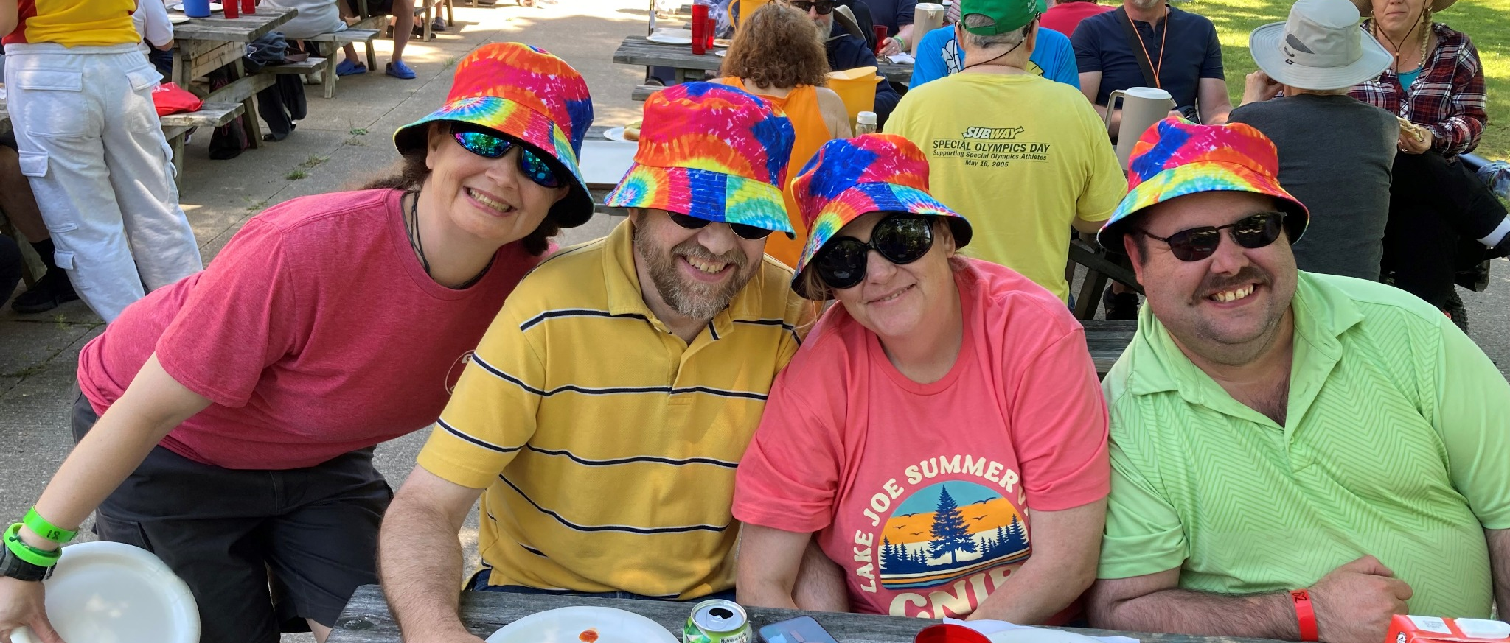
Adult Programs (19+)

Our Adult Programs are designed to connect and engage the community, whether you're a first-time guest or returning for another fun experience. Some programs include structured activities, while others have "drop-in" options. Be sure to check the detailed descriptions below to find the right fit for you.
Important program point: To attend Adult Programs, participants must be able to navigate the site with limited guidance after an initial introduction and site tour and will not require one-on-one support from staff. Participants needing additional support throughout their stay must register to come to camp with someone who will provide the level of assistance required.

Welcome to CNIB Lake Joe’s Adult Camp Programs
Pre-camp virtual orientation session
Included in the registration fee for adult programs, this Zoom meeting is your chance to meet others in advance, review housekeeping details, learn more about camp and get answers to questions so you can spend time at CNIB Lake Joe focused on fun, family and friends. Full details will be provided to registrants at the beginning of the season.

Partner Program: Guide Dogs AdvoCamp
June 4-7, 2026
AdvoCamp is CNIB’s annual event bringing together guide dog handlers from across Canada for a dynamic weekend of advocacy skill building workshops, hands-on learning, community building, and fun.
A free shuttle will be available from Pearson International Airport and the Oshawa train station for those who require a ride to camp. A 50% travel subsidy for people who reside outside of Ontario is also available on a first come first served basis.
Current guide dog handlers are welcome, with priority given to first-time AdvoCamp attendees.
Click here for more information and to register or contact advocacy@cnib.ca.

NEW! Young Adult Arts Intensive
July 13-18, 2026 | Ages: 19-35
Discover your creative potential in a week dedicated to art, connection, and self-expression! Participants will select one of three artistic specializations to explore: visual arts; performing arts; and media arts (photography/videography and podcasting). Guided by experienced instructors, you’ll immerse yourself in the arts, learn new techniques, develop your artistic voice, and collaborate with fellow creators in a supportive, inclusive and accessible environment. Participants will also have the chance to dabble in other art forms, participate in creative workshops, and enjoy all of Lake Joe’s activities.
The week will culminate in a Saturday morning art showcase where participants can share their creations and experiences with the camp community. Whatever specialization you choose, you’ll build new skills, confidence, and friendships that will inspire you long after camp ends.
Note: No previous experience in your desired stream is required. Simply bring your imagination, enthusiasm, and a willingness to try something new!

Young Adult Wilderness Trip
July 13-18, 2026 | Ages: 19-35
Ready for the ultimate summer adventure? Join Lake Joe staff and expert guides for an incredible backcountry camping experience that combines outdoor skill-building, teamwork, and exploration.
Start the week at CNIB Lake Joe with hands-on wilderness training, then set off on a 3-day, 2-night mini-expedition deep into the Canadian wilderness. Learn new skills, connect with nature, and challenge yourself in an unforgettable setting.
After your journey, return to camp to relax by the fire, share stories, and celebrate your achievements with friends who’ve shared the adventure of a lifetime!
Important program points:
- Due to the physically demanding nature of this program, participants must be able to lift and carry up to 50 lbs. and comfortably walk distances of approximately 1 km.
- As the destination sites are remote, participants must have strong Orientation & Mobility skills to safely navigate uneven terrain and routes.
- Participants must be prepared for a pre-screening interview to determine readiness and ability to participate in this unforgettable journey.
- All specific equipment will be provided by CNIB Lake Joe.

Adult Leisure Weeks, 19+
Week 1 – June 22-27, 2026
Week 2 – July 20-25, 2026
Escape to the breathtaking shores of Lake Joseph in Muskoka for a week of relaxation and adventure. This flexible program lets you design your ideal getaway, with a wide range of activities to choose from: swimming, sailing, fishing, outdoor cooking, arts and crafts, music, and more. Connect with others who share your interests while enjoying camp experiences at your own pace. With a mix of scheduled activities and drop-in programs, you’ll find the perfect balance between engaging experiences and the peaceful, rejuvenating atmosphere of Lake Joe.

NEW! Young Adult Wellness Retreat
September 9-12, 2026 | Ages: 19-35
Recharge, connect, and grow during this three-day immersive retreat designed to support holistic wellbeing. Participants will engage in a range of wellness practices like mindfulness, creative expression, physical activity, self-care, and reflection to help foster balance and overall health.
Set on the peaceful shores of CNIB Lake Joe, this retreat blends guided workshops, experiential learning, and nature-based sessions to help young adults build practical strategies for ongoing wellness. Group discussions, hands-on activities, and individual reflection time offer meaningful opportunities for connection, skill-building, and personal insight.
By the end of the retreat, participants will leave with a personalized wellness plan, a deeper understanding of themselves, and practical tools to support everyday wellbeing.

There are more programs to explore in our Family Programs section or return to our table of contents.

Family Programs
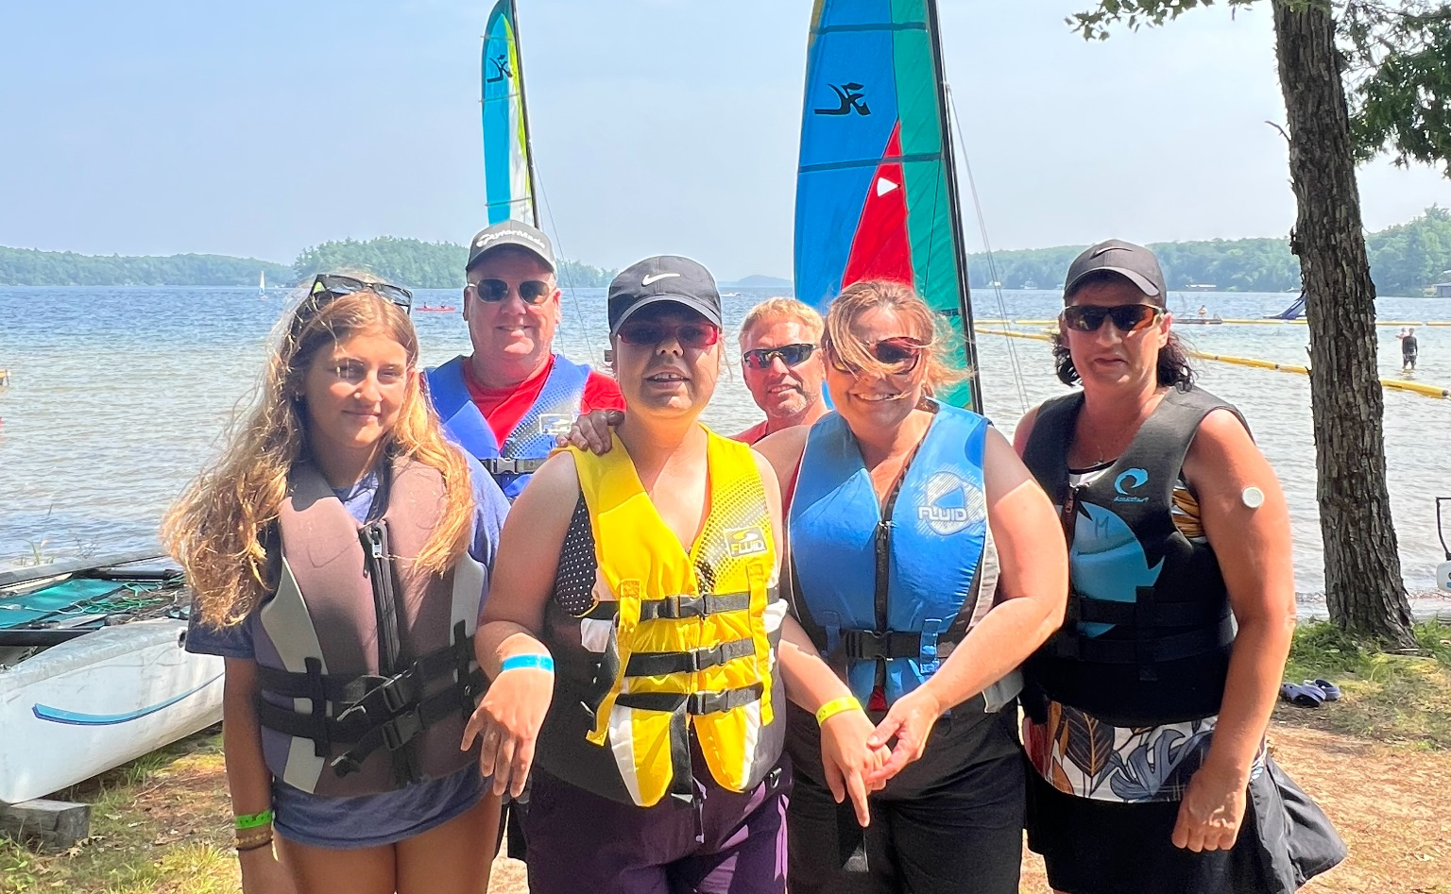
Our Family Programs give people with blindness and sight loss and their families an opportunity to enjoy everything Muskoka has to offer in a safe and inclusive environment. Activities are available for all ages and include special events designed for adults, youth and kids.

Welcome to CNIB Lake Joe’s Family Programs
Pre-camp virtual orientation session
Included in the program registration fee, you will be invited to a Zoom meeting to meet other families in advance, go over important details, and get answers to questions. This session will ensure you are fully prepared, so you can spend all your time on-site at Lake Joe focused on fun, family and friends. Full details will be provided to registrants at the beginning of the season.

Family Weeks
August 3-8, 2026 (priority for families with children with sight loss)
August 17-22, 2026
From swimming and tandem biking to fishing, lake cruises, and cozy evenings by the campfire, there’s something for every member of the family to enjoy.
Each day offers exciting kids’ and teens’ programs filled with adventure, while adults can relax, connect, and savour the peaceful pace of camp life.
Blending the comfort of a cottage getaway with the spirit of classic summer camp, Family Week creates the perfect setting for families to laugh, explore, and make lasting memories together.

There are more programs to explore in our Adult Programs section or return to our table of contents.

CNIBLakeJoe@Home Virtual Programs
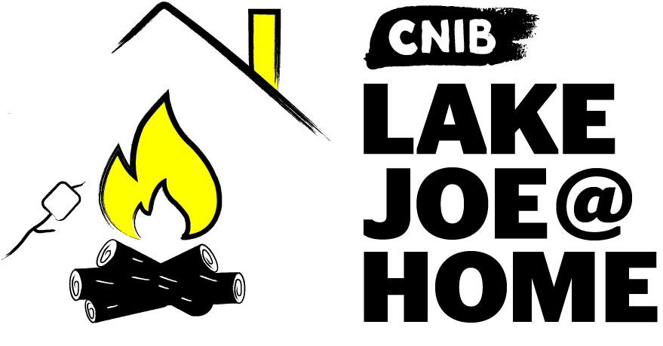

Stay connected with the CNIB Lake Joe community all year long from the comfort of your home!
If you haven’t joined us online yet, now’s the perfect time to dive into CNIBLakeJoe@Home.
Our virtual programs offer something for everyone, with opportunities to learn, laugh, and connect with friends from camp and make new ones along the way. Enjoy weekly favourites like coffee chats, virtual campfires and talent shows, plus monthly specialty sessions such as Curiosity Corner, Reading Room, and seasonal celebrations.
All programs are free and accessible by phone or computer. Pre-registration is required to participate.
And there’s always more to explore!
New CNIBLakeJoe@Home sessions are added regularly. Have an idea for a future program? Share it with us through our Virtual Suggestion Box.
Be sure to browse our online events calendar to see what’s happening in your community and stay connected with friends old and new.
For more information about CNIBLakeJoe@Home virtual programs, please contact Taylor Gaudon, Virtual Program Coordinator at taylor.gaudon@cnib.ca, or 705-408-0745.

Program Summary
To help your week run smoothly, please note that arrivals begin at 1:00 p.m. on Mondays, and departures take place at 10:00 a.m. on Saturdays.
We can’t wait to welcome you to camp!

June
- Guide Dog AdvoCamp: June 4-7
- Adult Leisure #1: June 22-27

July
- PLAY: July 6-11
- Camp Abilities: July 6-11
- NEW! Young Adult Arts: July 13-18
- Young Adult Wilderness Trip: July 13-18
- Adult Leisure #2: July 20-25
- Summer Camp: July 27-August 1
- Leadership Camp: July 27-August 1
- Counsellor-in-Training: July 27-August 8

August
- Family Week #1 (children with sight loss): August 3-8
- CNIB Buddy Dogs: August 9-14
- SCORE Scholars: August 13-16
- Family Week #2: August 17-22
- Braille: Writing with Feeling: August 31-Sept 4

September
- NEW! Young Adult Wellness: Sept 9-12

2026 Program Fees
All camp experiences include meals, accommodations, and all on-site programs and activities. Thanks to the generosity of CNIB supporters, camp costs are highly subsidized to keep registration fees as low as possible.
Further subsidies are available for participants who qualify. Please complete the Financial Assistance form when you apply.
All CNIBLakeJoe@Home virtual programs are free-of-charge year round!

Children & Youth Programs
Children & Youth Programs | Full Fee | Deposit  (due April 30) | Final Payment  (due June 1)
PLAY  July 6-11 | $160 | $50 | $110
Camp Abilities  July 6-11 | $160 | $50 | $110
Summer Camp  July 27-Aug 1 | $160 | $50 | $110
Leadership Camp  July 27-Aug 1 | $160 | $50 | $110
Counsellor-in-Training  July 27-Aug 8 | $160 | $50 | $110

Children & Youth Partner Programs
- CNIB Buddy Dogs (August 9-14): Please contact Miriam Mas at miriam.mas@cnib.ca or 343-997-2498.
- Braille Writing with Feeling Retreat (August 31-September 4): Please contact Attila Mihaly at attila.mihaly@cnib.ca or 437-244-2752.

Adult Programs
Adult Programs | Full Fee | Deposit  (due April 30) | Final Payment  (due June 1)
NEW! Young Adult Arts Intensive  July 13-18 | Ages 19-29: $530  Ages 30-35: $765 | $100 | Ages 19-29: $430  Ages 30-35: $665
Young Adult  Wilderness Trip  July 13-18 | Ages 19-35: $765 | $100 | Ages 19-35: $665
Adult Leisure Weeks  June 22-27  July 20-25 | Ages 19-29: $530  Ages 30+: $765 | $100 | Ages 19-29: $430  Ages 30+: $665
NEW! Young Adult Wellness Retreat  Sept 9-12 | Ages 19-29: $320  Ages 30-35: $460 | $100 | Ages 19-29: $220  Ages 30-35: $360

Adult Partner Programs
- CNIB Guide Dog AdvoCamp (June 4-7): $300 fee. Please contact advocacy@cnib.ca or visit the Guide Dog AdvoCamp web page.

Family Programs
Family Programs | Full Fee | Deposit  (due April 30) | Final Payment  (due June 1)
Family Weeks  August 3-8  August 17-22 | Ages 0-5: Free  Ages 6-18: $160  Ages 19-29: $530  Ages 30+: $765 | $50 for each family member | Ages 0-5: Free  Ages 6-18: $110  Ages 19-29: $480  Ages 30+: $715

Support Worker / Intervenor Fees
Support Worker / Intervenor | Full Fee | Deposit  (due April 30) | Final Payment  (due June 2)
Applicable to all weeks | $530 | $100 | $430

Getting to Camp
We welcome guests from across Canada and around the world!
CNIB Lake Joe is located at: 4 Joe Finley Way, MacTier, ON P0C 1H0

Do You Need Transportation?
We are pleased to work with you to provide transportation from Pearson International Airport and other transportation hubs throughout Ontario. Simply indicate on your registration form if you need round-trip or one-way and your preferred hub location.
Note: We require a minimum of three guests to arrange pick-up/drop-off at a hub. We will work with guests to make alternate arrangements if necessary. Each route may have multiple stops (up to three hub locations).

Travel fees: CNIB Lake Joe Adult and Children & Youth programs
Transportation Hub | Adult Fee | Children/Youth fee  (18 and under)
Barrie  (up to 100km) | One way: $30  Roundtrip: $60 | One way: $15  Roundtrip: $30
Pearson / Coffee Time Plaza / Oshawa  (101-200km) | One way: $60  Roundtrip: $120 | One-way: $30  Roundtrip: $60
Burlington, Hamilton, Kitchener  (201-300km) | One way: $80  Roundtrip: $160 | One-way: $40  Roundtrip: $80
London, Ottawa (301-400km) | One way: $110  Roundtrip: $220 | One-way: $55  Roundtrip: $110
Other  (401-500km) | One way: $150  Roundtrip: $300 | One-way: $75  Roundtrip: $150

Travel fees: CNIB Lake Joe Family Weeks
Transportation Hub | Adult Fee | Children/Youth fee  (18 and under)
Pearson / Coffee Time Plaza | One way: $45  Roundtrip: $90 | One-way: $25  Roundtrip: $50

Arriving by Car?
Please note parking is free but limited. Please park in one of the designated parking spaces.

Directions from Toronto/Southern Ontario*
- Take Hwy 400 north just past Barrie to Hwy 400 extension (formerly Hwy 69)
- Continue north on Hwy 400 to exit 189 for ON-69 toward MacTier/Gravenhurst
- Merge onto Lake Joseph Road (formerly Hwy 69) past Hwy 169
- Turn right onto Joe Finley Way
*GPS often provides directions to take Hwy 407 toll road. The toll road saves approx. 10 minutes from the drive (approx. 2 hours), but at a cost. Please check a website like google.com/maps for directions or remember to adjust GPS settings.

Directions from Northern Ontario
- Take Hwy 69 south to Hwy 400 south
- Continue south on Hwy 400 to exit 207 for ON-69 toward MacTier/Gravenhurst
- Merge onto Lake Joseph Road (formerly Hwy 69)
- Turn left onto Joe Finley Way

Directions from Eastern Ontario
- Take Hwy 417 west to Bruce St/County Road 20 to Hwy 60 west
- Continue on Hwy 60 and merge onto Hwy 11 south
- Take exit 219 for Muskoka Rd 3 toward Huntsville/Aspdin
- Turn right onto Aspdin Rd/Muskoka District Road 3 (Regional Road 3 W)
- Turn right onto Hwy 141 west and turn left onto Lake Joseph Rd (formerly Hwy 69)
- Turn left onto Joe Finley Way
Once at CNIB Lake Joe, simply head to the Welcome Centre to check-in and receive your room key. We are waiting for you!
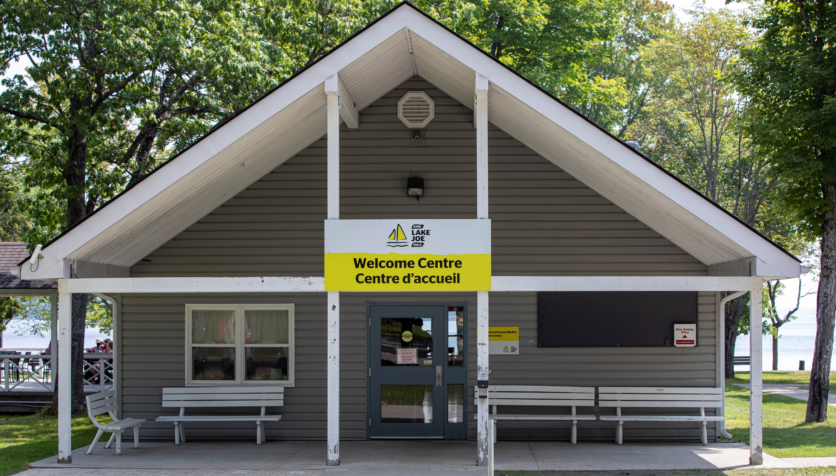

Application Process
For information and support, please email LakeJoe@cnib.ca, or call 1-877-748-4028 or 705-375-2630.

Step 1: Apply
Application opens Thursday, January 14, 2026, at 8 am Eastern time.
If you would like to apply to participate in an in-person program at CNIB Lake Joe, please complete the required online application.
If you are new to our online system, you will be required to create an account to apply. If you are returning to our online system, please login to your existing account. Forgot your password? Simply request a new one on the login page and access your existing account.
You will be asked to select the program(s) you would like to attend and, if you are attending with more than one person from your household, add these guests to your application.
Tips! Our CNIB Lake Joe: 2026 Application Tutorial video series and CNIB Lake Joe Application Guide outlines the step-by-step processes to successfully complete your 2026 online application.
Program selections and waiting lists:
- Applications received by February 20: notification of program confirmation will be provided by March 20.
- Applications received after February 20: will be confirmed on an ongoing basis until all remaining program spots have been filled.
- Once programs are filled, applications will be added to the waiting list.
- If you need to cancel your application or come off a waiting list, please let us know as soon as possible by emailing LakeJoe@cnib.ca, or calling 1-877-748-4028 or 705-375-2630.
Need a little extra help with your application? Please email us at LakeJoe@cnib.ca, or call 1-877-748-4028 or 705-375-2630 so we can set an appointment to help you with your application.

Step 2: Pay the Deposit
Deposits will be accepted between April 1 – April 30, 2026.
Starting April 1, 2026, you will be able to access the “deposit payment” section of the registration platform to pay your deposit. You are welcome to make your full payment of camp fees at this time if desired.
Paying by credit card is preferred as payments are confirmed immediately and refunds can be provided swiftly when needed.
If paying by cheque or money order, please expect delays in confirmation of your payment or with any refunds needed Make payable to “CNIB Lake Joe” and send to 4 Joe Finley Way, Mactier, ON P0C 1H0 with a note indicating the guest’s name and the program week they are attending.
Please note that cheques and money orders will not be cashed until after April 1.
If your deposit payment is not received by April 30, your space will be forfeited and given to a waitlisted applicant. We will make every effort to contact you to confirm your plans before forfeiting your space. However, guests are responsible to ensure deposits are made by April 30 to confirm registration.
If you have any concerns with paying your deposit, please email LakeJoe@cnib.ca, or call 1-877-748-4028 or 705-375-2630.

Step 3: Pay the Balance
Any balance owing is due by Monday, June 1, 2026.
After paying your deposit, the remaining camp fees are due on or by Monday, June 1, 2026. Reminder emails and phone calls will be sent to guests who have not paid their fees.
If the full payment is not received by June 1, your space will be forfeited and given to a waitlisted applicant. We will make every effort to contact you to confirm your plans before forfeiting your space.
Registrations after June 1 must be paid for in full.
Cancellations requiring refunds will have a $50 administrative fee deducted.
If you have any concerns with paying your balance, please email LakeJoe@cnib.ca, or call 1-877-748-4028 or 705-375-2630.

Helpful Resources
We strongly encourage you to visit our “Everything You Need to Get Ready for Camp” webpage. You’ll find:
- Our most current Lake Joe Camp Handbook
- CNIB Lake Joe’s documentary,“Ripples”
- A packing list
- Outlines of “typical days” for all our programs
- A video series (most under 2 minutes) that showcases our accessible programs and facilities
- Photo galleries: facilities; cabins; waterfront & watersports; outdoor recreation & adventure; areas to relax

Get Involved
We can’t wait to welcome you to CNIB Lake Joe as our guest, but there are so many ways to enjoy CNIB Lake Joe:
- Participate in CNIBLakeJoe@Home and CNIB virtual programs
- Apply to join our CNIB Lake Joe staff team or recommend someone
- Volunteer at CNIB Lake Joe and make a difference
- Attend an event (visit cniblakejoe.ca for upcoming events)
- Donate to help bring the magic of camp alive at CNIB Lake Joe
- Subscribe to the “Let’s Go: CNIB Lake Joe” e-newsletter
- Follow us on Facebook and Instagram
- Visit CNIB Lake Joe’s YouTube playlist
- Listen to our “CNIB Lake Joe on the Go” podcasts
For more information, visit cniblakejoe.ca, email LakeJoe@cnib.ca, or call 1-877-748-4028 or 705-375-2630.


CNIB Lake Joe
4 Joe Finley Way
MacTier, ON P0C 1H0
Visit: cniblakejoe.ca
Email: LakeJoe@cnib.ca
Toll Free: 1-877-748-4028
Phone: 705-375-2630

