CNIB Lake Joe
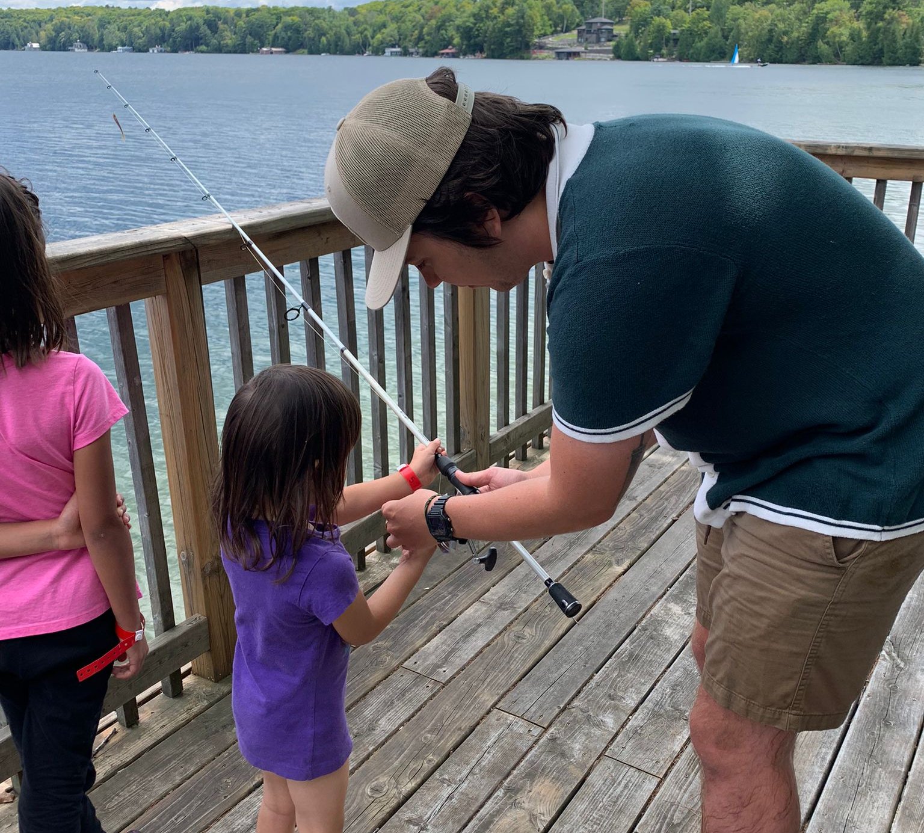
2025 Application Guide

Table of Contents
This guide will help you through the online application process for CNIB Lake Joe programs. It covers everything from logging in, to completing forms and submitting applications. You may also find our CNIB Lake Joe: 2025 Application Tutorial video series helpful.
How to Apply: CNIB Lake Joe Guests 3
How to Apply: Intervenors & Support Workers 6
How to Complete the Household Form 9
How to Complete the Accessibility & Rooming Form 11
How to Edit Household Members’ Information 14
Contact Info & Additional Resources 17

How to Apply: CNIB Lake Joe Guests

Tip! Please view the How to Apply: CNIB Lake Joe Guests video which takes you step-by-step through the CNIB Lake 2025 onlineapplication portal.

Step 1: Logging In
- Navigate to the CampBrain login page.
  - The link can be found on our website, CNIB.ca/LakeJoe or by using this link, https://cniblakejoe.campbrainregistration.com/
- Log in with your credentials or create a new user account if you don’t already have one.
  - Note: If you already have an account but forgot your password, please proceed with the "Forgot my password" button to reset your account.

Step 2: Landing Page Navigation
Upon logging in, you'll see three subsections:
- About Us & Contact Information: General information about CNIB Lake Joe.
- Start a New Application:
  - View submitted applications.
  - Continue applications in progress.
  - Click the yellow Begin button to start a new application.
- Manage People and Household Information:
  - A separate document has been created for this section.

Step 3: Season Instructions
- Review the season instructions carefully for helpful details about the application process.
- Click Continue in the bottom-right corner to proceed.

Step 4: Adding Household Members
- For returning participants:
  - Household details will auto-populate.
  - Check the box next to each name you'd like to apply for.
- For new users:
  - Click the yellow Add a Household Member button.
  - Enter details such as name, birthdate, and pronouns.
- Select the participants you want to register and click the yellow Continue button.

Step 5: Selecting Sessions
- Each selected participant will have their own tab under Select Sessions For.
- Click Show Details under a program title to view:
  - Program description.
  - Relevant sessions for the participant based on their age or eligibility.
- Add sessions by clicking the green Add to Cart button.
- Complete session details:
  - Transportation to/from camp.
  - Type of applicant.
  - Applicant age.
- Repeat this process for each household member.
- Review the cart summary to ensure all selections are correct.

Step 6: Completing Forms
- Mandatory Forms for All Participants:
  - CNIB Lake Joe General Waiver.
  - Promotional Consent Form.
  - Medical Form.
  - Financial Assistance Application (if applicable).
  - Accessibility and Rooming Form.
- Household Form:
  - Covered in a separate tutorial.
- Complete all forms before submitting the application.

Step 7: Review and Submit
- Verify all details:
  - Check Registration Items for:
    - Cart summary.
    - Completed forms.
- Use the Return to People or Return to Sessions buttons to make changes if needed.
- Once verified, click Submit in the bottom-right corner.
- A confirmation page will appear with the message Application Submitted.
  - Click View Details to review the application.

Post-Submission Options
- From the confirmation page:
  - Add more people, sessions, or options via the Add People/Sessions/Options button.
  - Download PDFs once registration is confirmed.
- To make changes to household members:
  - Click the Home button in the top-right corner.
  - Use the Manage People and Household Information tab at the bottom of the landing page.

How to Apply: Intervenors & Support Workers
This section provides step-by-step instructions for intervenors and support workers at CNIB Lake Joe to complete the application process.
Tip! Please view the How to Apply: Support Workers and Intervenors video.

Step 1: Accessing the Application
- Navigate to the CampBrain login page.
  - The link can be found on our website, CNIB.ca/LakeJoe or by using this link, https://cniblakejoe.campbrainregistration.com/
- Log in with your credentials or create a new user account if you don’t already have one.
  - Note: If you already have an account but forgot your password, please proceed with the "Forgot my password" button to reset your account.

Step 2: Starting a New Application
- After logging in, you will arrive at the landing page. This page contains contact information and details for additional resources.
- Scroll to the bottom of the page and locate the "Start a New Application" section.
- Click the yellow "Begin" button.

Step 3: Season Instructions
- Review the Season Instructions page, which outlines the necessary process and documents.
- Scroll to the bottom of the page for messages specific to intervener and support staff.
  - Note: All applications require contact details and the mandatory forms to access the Lake Joe property.
- Click "Continue" in the bottom-right corner.

Step 4: Registration as Support Staff
- In the first step, choose one of the two registration methods:
  - Use your own profile.
  - Be registered under the family profile of a client you regularly assist.
- Select your name on the profile or add a new profile if needed.
  - Ensure your date of birth is entered before proceeding.
- Optionally, add household members on this page.
- Click "Continue" in the bottom-right corner.

Step 5: Selecting Sessions
- Scroll past the adult, youth, and family program sections to find the Support and Intervener Staff section.
- Select the appropriate program type you’ll assist with:
  - Example: Adult programs.
- Click the green "Add to Cart" button once located the proper program week.
- Complete transportation details:
  - For "Transportation to Camp" and "Transportation from Camp," select "No Transportation Needed" if applicable.
- Specify your role under Applicant Support Type and select your age range.
  - (e.g., 19-29).
- Select the specific program dates you will support, then click "Add to Cart."
- Review your cart summary to ensure accuracy.
- Click "Continue" in the bottom-right corner.

Step 6: Completing Required Forms
- Fill out the following mandatory forms:
  - Household Form: General information.
  - CNIB Lake Joe General Waiver.
  - CNIB Promotional Consent Form.
  - Medical Form.

- Complete the Accessibility and Accommodations Form:
  - Page 1: Provide communication format preferences (e.g., written materials, hearing needs) and contact details.
  - Page 2: Rooming preferences and additional notes.
  - Page 3: Duration of stay details, including:
    - Client name and frequency of assistance.
    - Indicate if you’re supporting multiple clients.
    - Specify the program weeks for each client.
- Include any extra details relevant to your stay in the final section.

Final Step: Submission
- Review all completed sections for accuracy.
- Submit your application.

How to Complete the Household Form
This section outlines the steps for completing the Household Form. All applicants must fill out the Household Form, whether you are applying as an adult or on behalf of a youth.
Tip! Please view the How to Complete the Household Form video.

Step 1: Primary Household (Page 1)
- Parent or Guardian 1:
  - For adult applicants, enter your own information, including:
    - First and last name.
    - Email address.
    - Phone number.
- Parent or Guardian 2:
  - For adult applicants, this can be someone accompanying you to camp, such as:
    - A friend, family member, or support worker.
  - Note: Support workers can create their own separate accounts to fill out their forms independently.
- Mailing Address:
  - Enter the full address, including:
    - Street address, city, province, country, and postal code.

Step 2: Secondary Household (Page 1)
- If registering on behalf of a youth, the following applies:
  - Parent or Guardian 1: The person handling registration (likely the one completing the form).
  - Parent or Guardian 2: The second head of household, if applicable.
- If the family has two separate addresses:
  - Use the Secondary Household section to enter the details for the second home address, including:
    - First and last name, email address, phone number, relationship to the applicant, and mailing address.

Step 3: Gender Identity (Page 1)
- This section allows you to provide details about gender identity.
- Note: You may have already answered this in a previous step when selecting people, however, this will be a confirmation.

Step 4: Emergency Contacts (Page 2)
- Contact 1:
  - The primary person to be notified in case of an incident or emergency.
- Contact 2:
  - The secondary person will be contacted if Contact 1 is unavailable.
- Contact 3 (Optional):
  - You can add an additional contact for extra safety.

Final Step: Submission
- Review all entered information for accuracy.
- Submit the Household Form.

How to Complete the Accessibility & Rooming Form

This section walks you through how to complete the Accessibility & Rooming Form, required for each individual family member during Step 3 of the application process.
Tip! Please view the How to Complete the Accessibility & Form video.

Overview
- Form Access: Found under Step 3 (Forms) in the application process.
- For families applying for multiple members:
  - Use tabs with names to switch between members’ forms.
  - Open or hide forms using the dropdown arrow next to each household member’s name.

Page-by-Page Breakdown

Page 1: Personal Details
- Communication Preferences:
  - Specify the main registration contact:
    - Provide name, phone number, and email.
    - Option to add an additional contact.
  - Indicate preferences for written materials (e.g., font size).
- Additional Information:
  - Hearing needs.
  - Gender identity.
  - Guide dog users:
    - Indicate if bringing a guide or buddy dog to camp.
- Mobility Details:
  - Specify use of mobility devices or balance issues.

Page 2: Room Accessibility and Requests
- Roommate Requests:
  - Indicate a roommate preference if applicable and provide details.
- Session Order:
  - For multiple sessions, rank by preference.
  - If attending a single week, enter "N/A."
- Navigation:
  - Proceed by clicking Next at the bottom right.

Page 3: Intervener and Support Worker Information
- Intervener Information:
  - Indicate if bringing an intervener to Lake Joe.
  - Provide PSW and/or IV required details:
    - Name, contact information, organization details, and dates.
    - Option to add additional interveners.
- Save Option:
  - Use the Save button to save progress.
  - Note, once this information is saved you may return to this section later and adjust before submitting.

Page 4: Independent Living Skills
- Skills Assessment:
  - Identify assistance needs for:
    - Daily care, bathing/showering, toileting, medication, meals, and orientation/mobility skills.
- Options:
  - Independent: No staff assistance is required.
  - Require Assistance: Must bring a support worker if assistance is needed as Lake Joe staff can not assist in this role.

- Contact Information:
  - For questions, contact the Lake Joe office or refer to the website.
    - information is also available on the login page and landing page on CampBrain

Important Notes
- Incomplete Forms: Verify all questions are answered if unable to proceed.
- Final Step: Click Continue to save and move to the next step.

How to Edit Household Members’ Information
This section provides step-by-step instructions on adding or modifying household members and their details in the CampBrain system.
Tip! Please view the How to Edit Household Members’ Information video.

Step 1: Accessing the System
- Navigate to the CampBrain login page.
  - The link can be found on our website, CNIB.ca/LakeJoe or by using this link, https://cniblakejoe.campbrainregistration.com/
- Log in with your credentials.
  - If you forgot your password, proceed by clicking the "Forgot my password" button to reset your account.

Step 2: Managing Household Information
- On the landing page, locate the button labelled "Manage People and Household Information" at the bottom-left corner.
- Click the button to open the Household Information section.

Step 3: Navigating the Tabs
There are three tabs for editing household information:

1. Household Tab
- Lists all members in your household.
- Use this tab to view or edit member details.

2. Household Details Tab
- Update your household’s primary address and contact details.

3. Secondary Household Tab
- Modify details for a secondary household, if applicable.
Important: After making changes in any tab, click the yellow "Save" button at the bottom-left corner to ensure updates are stored.

Step 4: Editing Household Members
- Return to the Household Tab.
- Locate the list of household members. Each member has an "Edit Details" button under their name.
- Click "Edit Details" to update information such as:
  - First and last name
  - Pronouns
  - Email address
  - Phone number
- After editing, click "Save" at the bottom-left corner.

Step 5: Adding a New Household Member
- At the bottom of the page, click the yellow "Add a Child" button.
  - This button can be used to add any household member, regardless of age.
- Enter the new member’s details:
  - First and last name
  - Pronouns
  - Date of birth
  - Email address
  - Phone number
- Once all details are entered, click "Save" at the bottom-left corner.
  - If you decide not to save, click "Discard" to exit without changes.

Step 6: Changing the Head of Household
- To change the head of household, contact the CNIB Lake Joe office:
  - Send an email to the general Lake Joe account.
  - Specify the name of the person you would like as the new head of household.

Contact Info & Additional Resources
Thank you for registering with CNIB Lake Joe!
If you have further questions or concerns, please review our CNIB Lake Joe: 2025 Application Tutorial video series or contact us:
- Email: lakejoe@cnib.ca
- Phone: 705-375-2630
- Toll-Free: 1-877-748-4028
- Website: CNIB.ca/LakeJoe

