CNIB Lake Joe 2023
Camp Programs
Enriching lives. Making memories. Building independence.
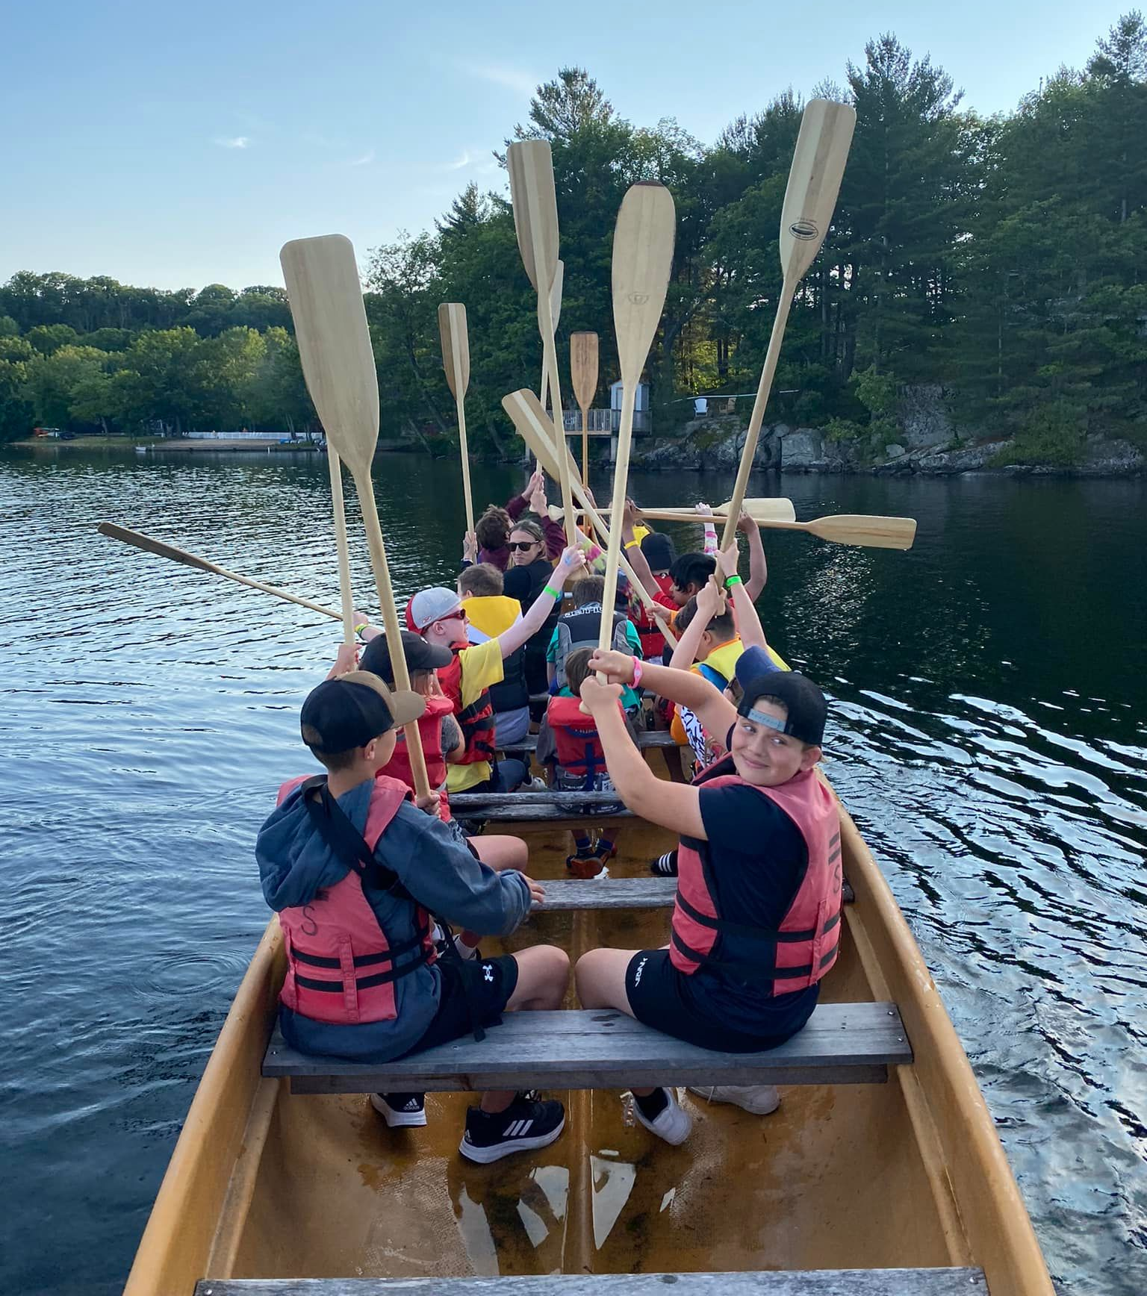

Table of Contents

About CNIB Lake Joe 3
Children & Youth Programs 5
Adult Programs (ages 19+) 10
Family Programs (all ages) 13
Holiday Programs (all ages) 14
CNIBLakeJoe@Home Virtual Programs 15
Program Summary – by date 16
Program Summary – by age 17
Fee Summary for CNIB Lake Joe Programs 18
Registration Process 21
Getting to Camp 24

Please note: CNIB Lake Joe may update or make changes to the 2023 schedule. Every effort will be made to keep the programs and fees as represented, however, unforeseen circumstances may result in the substitution or cancellation of a program. We appreciate your understanding and look forward to finding the perfect program for you and your family.

About CNIB Lake Joe

We are excited to share information about our CNIB Lake Joe 2023 season!
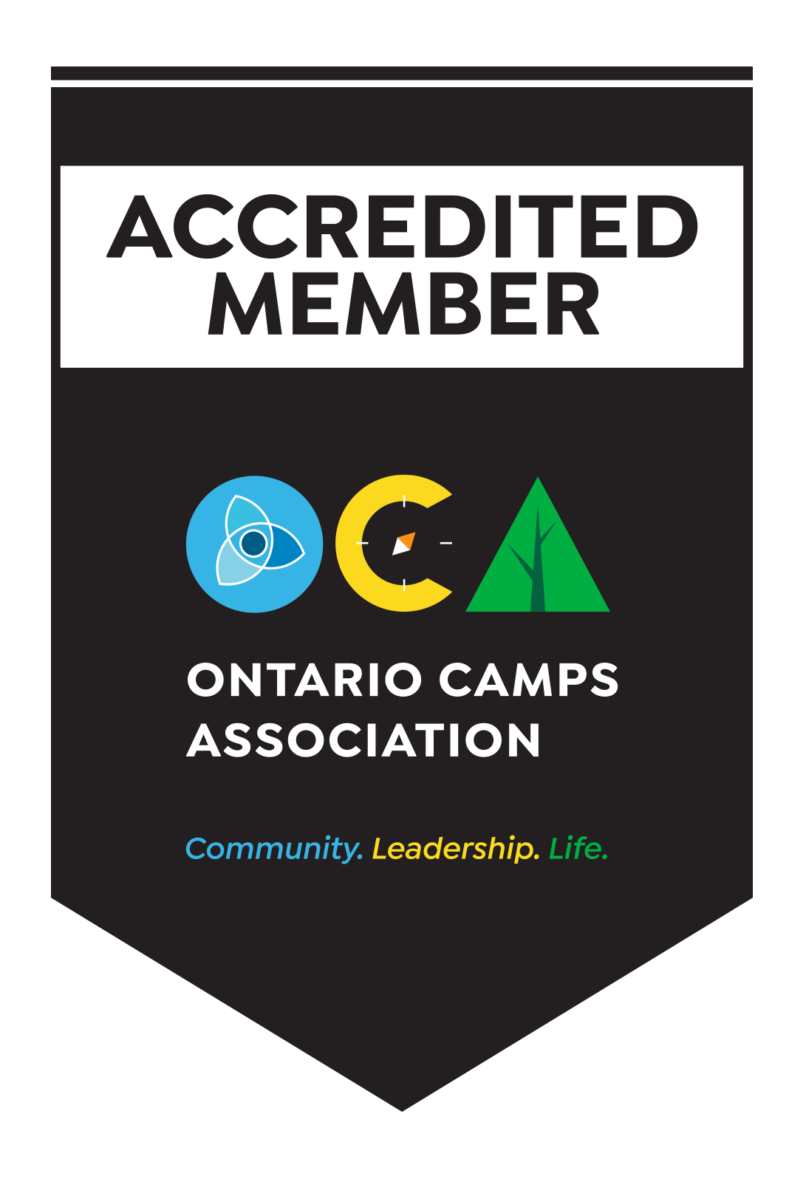
Since 1961, CNIB Lake Joe has been providing a unique blend of recreation and skills development in a safe, inclusive environment. Dedicated to providing enriching experiences for Canadians with sight loss, it's a one-of-a-kind camp in Canada. Located in the heart of Muskoka, CNIB Lake Joe is an accessible lakefront property that stretches over 12.5 acres on the northwest corner of beautiful Lake Joseph. CNIB Lake Joe is proud to be an accredited member of the Ontario Camps Association and an affiliated member of the Lifesaving Society.

This year we are excited to offer a wide range of CNIB Lake Joe camp programs PLUS “Partner Programs” in collaboration with staff teams from CNIB, Vision Loss Rehabilitation Canada, DeafBlind Community Services, and INCA Quebec. There will be NEW programs to dazzle and delight along with our classic camp programs that everyone loves. See you soon!

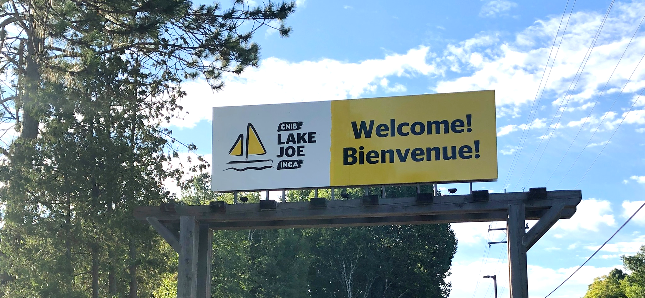
Here are just some of the activities you can enjoy at CNIB Lake Joe!

- Make a splash in Lake Joseph: fishing, paddling (canoe, kayak, stand-up paddleboard), pontoon boat cruises, sailing, swimming, tubing, waterskiing, wakeboarding, water sliding
- Get creative: music, pottery, crafts, dancing, talent shows
- Get active: climbing tower, soccer pitch, basketball, beep baseball, tennis, volleyball, shuffleboard, mini-golf, tandem-bike riding, archery, hiking, yoga, hockey and more
- Learn new skills: in a fun, safe and supportive environment
- Rest and relax: enjoy a book by the lake, visit with friends, new and old, around the campfire

Don’t forget, there are lots of virtual programs – online and on the phone at CNIBLakeJoe@Home where you can learn, laugh, and stay connected with your camp community!

To apply, please visit: cnibLakeJoe.CampBrainRegistration.com

For more information, contact CNIB Lake Joe:
Email: LakeJoe@cnib.ca
Toll Free: 1-877-748-4028
Phone: 705-375-2630
Web: cnib.ca/LakeJoe
Address: CNIB Lake Joe, 4 Joe Finley Way, MacTier, ON P0C 1H0

Children & Youth Programs

These programs are open to children and youth with sight loss. Some programs also welcome sighted siblings and friends of those with sight loss. In 2023, thanks to the incredible generosity of donors, we are able to offer deeply discounted registration rates and free transportation from specific hubs in Ontario (see Fees section for more details)!

Welcome to CNIB Lake Joe’s Children & Youth Camp Programs (virtual orientation session)
Included in the registration fee for all children & youth programs, this Zoom meeting is your chance to meet others in advance, review housekeeping details, and get answers to your questions so you can spend ALL of your time at CNIB Lake Joe focused on fun, family and friends. Full details will be provided to registrants at the beginning of the season.

Camp Abilities featuring blind hockey, 5-a-side soccer and swimming
July 3-8
Ages 8-18
This goal-based athletic program is aimed at athletic development. Participants will receive one-on-one coaching from instructors who will help guide athletes to achieve their performance goals through specialized sports programs. Participants will have the opportunity to choose from hockey, soccer or swimming as their discipline, culminating in a session-end competition.

Note: This program is open to children and youth who are CNIB participants as well as their siblings.

PLAY
July 3-8
Ages 8-18
Pushing Limits for Active Youth (PLAY) is for those who are interested in getting active and trying out new sports. From basketball to archery, Power Showdown to goalball, participants will try their hand at a variety of different sports and activities that encourage an active lifestyle. Health and wellness workshops including independence, healthy eating and personal care complement this adaptive sports program.

Note: This program is open to children and youth who are CNIB clients as well as their siblings.

Summer Camp
July 31 – August 5
Ages 8-18
Experience the excitement and tradition of summer camp in our fully accessible, waterfront facility. Learn new skills, try new activities and create new friendships, all while developing confidence and independence in a safe and supportive environment. This program includes a combination of group activities and individual choice programs, such as archery, court sports, swimming, music, art, sailing, canoeing PLUS 5-a-side soccer, mini-golf and scaling the climbing tower! Supported by experienced staff and skilled specialists, the summer camp experience will surely be a highlight for everyone!

Note: This program is open to children and youth who are participants of CNIB as well as their siblings.

Partner Program
ESL (English as a Second Language) Immersion
July 31 – August 5
Ages 8-18
French-speaking children with sight loss will be joining the Summer Camp program to have fun and make friends while practicing and perfecting their English language skills. Bonjour et bienvenue!

For more information about the ESL component of this program and to register, please contact David Trudel, Program Lead, Youth and Recreation at david.trudel@inca.ca or 438-221-9649.

Canadian Leadership Development Program (CLDP)
July 17-22
Ages 15-29
Join a group of like-minded young adults on the shores of beautiful Lake Joseph for a chance to relax, learn and have the best summer ever! This exciting week will be filled with a combination of workshops, leisure activities and social events. Learn about public speaking, advocacy, self-awareness and personal brand, all in addition to the traditional activities that make CNIB Lake Joe so special. Working with skilled facilitators, participants will have the opportunity to try new things in this fun, safe and supportive environment.

Partner Program
SCORE Scholars
July 17-22
Grades 11, 12 and 1st year post-secondary
The SCORE Scholars program is part of CNIB’s new Learning Academy, designed to help youth build independence and pre-vocational skills. This is a two-week program for youth who are preparing for post-secondary education that combines:
- The Canadian Leadership Development Program (July 17-22) at CNIB Lake Joe – see description above
- An additional week (July 22-29) in in Toronto at Seneca College and area locations.
Note: The SCORE Scholars program has specific application requirements. For more information and/or to download an application form, visit our website. If you have any questions, please contact Rhonda Underhill-Gray, Program Lead, Beyond the Classroom and SCORE at rhonda.underhill-gray@cnib.ca or 647-535-8962.

Counsellor-in-Training
July 17-22
Ages 15-19
Gain job skills while having fun at our program designed to develop leadership skills and empower youth to take an active role in camp life. This program is devoted to leadership workshops and skills development in all areas of camp. From learning about goal setting to building campfires and facilitating activities, this program is designed to help participants gain confidence and build the necessary skills to be an active member of the CNIB Lake Joe team.

Note: This opportunity is available to CNIB participants AND non-participants. Prospective participants will be required to fill out a supplementary application and participate in an interview with program staff prior to being accepted into this program. Successful completion of this program will ensure participants receive an interview for future camp staff positions but does not guarantee employment.

Partner Program
Braille-Palooza: Braille Writers’ Retreat
August 14-17
Ages: 6-19
If you love writing, this action-packed writer’s retreat for CNIB kids and teens is perfect for you. Participants will meet other young writers with sight loss from across Canada and get tips and feedback from professional writers. All participants will enjoy braille-themed and accessible activities.

Note: Prospective participants will be required to apply. Priority will be given to applicants who have entered or are planning to enter the annual CNIB Braille Creative Writing Contest. For more information and to apply, please contact Karen Brophey, Program Lead, Literacy at karen.brophey@cnib.ca or 647-302-4047.
Partner Program
CNIB Buddy Dogs
August 14-17
Ages: 7-16
CNIB Buddy Dog graduates – plus those in the process of waiting or applying for their CNIB Buddy Dog and one parent/guardian – are invited to enjoy summer camp at CNIB Lake Joe! This fun filled camp combines CNIB Buddy Dog training sessions with CNIB Lake Joe’s signature fun activities, giving children and youth participants plenty of opportunities to form lifelong friendships, develop independence, and make cherished memories. This camp allows children already paired with Buddy Dogs to deepen their bonds with their dogs. Children and families on the CNIB Buddy Dog waiting list can familiarize themselves with the dogs and the responsibilities of having one.

Note: Participants in this partner program must be a CNIB Buddy Dog graduate or applicant. To find out more about the CNIB Buddy Dog Camp or the CNIB Buddy Dog Program contact Miriam Mas, Program Lead, Buddy and Ambassador Dog Training at miriam.mas@cnib.ca or 343-997-2498.

There are more programs to explore in our Family Programs and Holiday Weeks sections!

Adult Programs (ages 19+)

Welcome to CNIB Lake Joe’s Adult Camp Programs
(virtual orientation session)
Included in the registration fee for adult programs, this Zoom meeting is your chance to meet others registered in advance, review housekeeping details, and get answers to your questions so you can spend ALL of your time at CNIB Lake Joe focused on fun, family and friends. Full details will be provided to registrants at the beginning of the season.

Partner Program
Guide Dogs AdvoCamp
June 8-11, 2023
AdvoCamp is a weekend for working guide dog teams to get together to learn, network and enjoy the beauty of CNIB Lake Joe! With a focus on access rights and advocating for yourself, the weekend also includes lots of tips for your four-legged partners and, of course, recreation and fun!

Note: For more information about this partner program, please contact Larissa Proctor, Manager, Guide Dog Advocacy at larissa.proctor@cnib.ca or 226-920-5498.

Adult Leisure
#1 June 19-24
#2 August 21-26
#3 September 5-9
Escape and spend a week on the shores of beautiful Lake Joseph in Muskoka. Choose from a variety of activities, such as swimming, sailing, fishing, outdoor cooking, art and music, allowing you to connect with others who have similar interests. Enjoy camp experiences at your leisure and end your days around the campfire with friends, new and old.

NEW Active Adult Week
July 10-15
This is your chance to pump up your heart, your muscles and your pride! Choose a sport that you want to learn more about – blind hockey, blind soccer, water sports or active living - and then lace up and dive in. Skilled facilitators and blind athletes will guide you through your sport of choice, outlining the rules, sharing important adaptations for safety and comfort, and coaching you to success. You’ll also learn about nutrition, mental wellness and how to keep up your skills and stay active wherever you are.

NEW Young Adult Week
July 10-15
Ages: 19-29
Need an escape from your busy life? A change of scenery? A chance to meet new people just like you? We invite you to join our first-ever Young Adult Week for people ages 19-29. Enjoy fun camp activities like art, music, and social and cultural outings with other like-minded people on similar journeys and make it a summer to remember.

Partner Program
Orientation & Mobility / Guide Dog Immersion
August 27 - September 1
The Orientation & Mobility / Guide Dog Immersion program is an intensive, weeklong, collaborative training program for applicants of CNIB Guide Dogs. Each day, participants will work one-on-one with Orientation & Mobility (O&M) Specialists and Guide Dog Mobility Instructors to develop and refine the skills required to be successful guide dog handlers. Guests will have the opportunity to practice in real life settings with guide dogs at CNIB Lake Joe and in downtown Parry Sound.

Note: Participants in this program must be a CNIB Guide Dogs applicant. Invitations are sent out for this program directly to applicants who may benefit from more O&M. If you are interested in applying for a CNIB Guide Dog you can find out more here: https://www.cnib.ca/en/apply-cnib-guide-dog

Canadian Leadership Development Program (CLDP)
July 17-22
Ages 15-29
Join a group of like-minded young adults on the shores of beautiful Lake Joseph for a chance to relax, learn and have the best summer ever! This exciting week will be filled with a combination of workshops, leisure activities and social events. Learn about public speaking, advocacy, self-awareness and personal brand, all in addition to the traditional activities that make CNIB Lake Joe so special. Working with skilled facilitators, participants will have the opportunity to try new things in this fun, safe and supportive environment.

There are more programs to explore in our Family Programs and Holiday Weeks sections!

Family Programs (all ages)

Welcome to CNIB Lake Joe’s Family Programs
(virtual orientation session)
Included in your program registration fee, this Zoom meeting is your chance to meet other families in advance, review housekeeping details, and get answers to your questions so you can spend ALL of your time at Lake Joe focused on fun, family and friends. Full details will be provided to registrants at the beginning of the season.

Family Week
August 7-12
Family Week gives people with sight loss and their families an opportunity to enjoy time together in the splendour of Muskoka on beautiful Lake Joseph. Go for a dip in the lake, take a tandem bike out for a spin, go fishing, cruise the lake, or relax by the campfire. There are activities available for all ages! We offer daily kids camp for the children and youth and adult evening programs with separate activities for the children. This is your chance to combine the freedom of a cottage or resort with traditional summer camp activities for the whole family to enjoy!

There are more programs to explore in our Adult Programs and Holiday Programs sections

Holiday Programs (all ages)

Welcome to CNIB Lake Joe’s Holiday Programs
(virtual orientation session)
Included in your program registration fee, this Zoom meeting is your chance to meet other families in advance, review housekeeping details, and get answers to your questions so you can spend ALL of your time at Lake Joe focused on fun, family and friends. Full details will be provided to registrants at the beginning of the season.

Holiday Week
July 24-29
Visit CNIB Lake Joe with your friends and family and enjoy camp exactly the way you like it. Instead of formal camp programming you can choose your own adventures and build your own experiences. Sample the wide array of amenities and activities and tailor your holiday time at Lake Joe to your own tastes.

There are more programs to explore in our Adult Programs and Family Programs sections

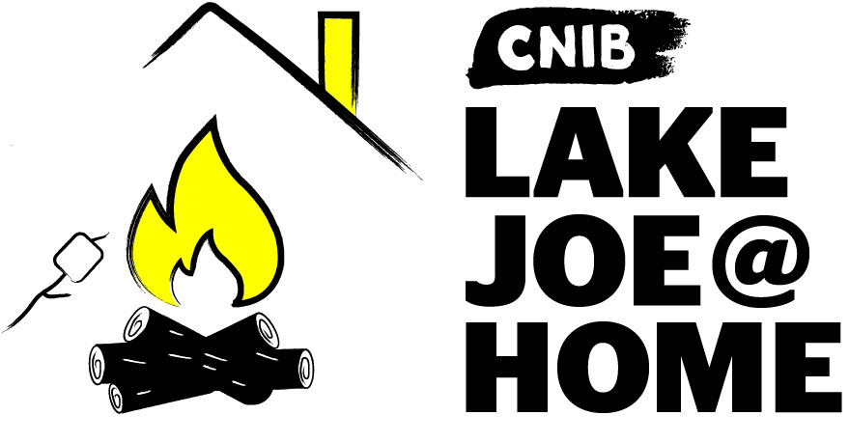

CNIBLakeJoe@Home Virtual Programs

Our virtual programs keep our camp community connected all year long. If you haven’t already participated, please visit CNIBLakeJoe@Home and join us!

We offer a wide range of programs where you can learn and laugh: weekly coffee break get-togethers, monthly specialty programs (Curiosity Corner, Reading Room, Music Trivia, Reading Room), holiday celebrations, and more.

These programs are offered at no cost to you. Pre-registration is required.

Note: You don’t have to have a computer to participate. Staff can call you to join the program by phone.

But wait, there’s more!
New CNIBLakeJoe@Home virtual sessions are always being added. If you have suggestions for future programs, please leave us a note in our Virtual Suggestion Box.

We also encourage you to check out hundreds of CNIB Foundation virtual programs to connect with friends, new and old!

For more information about CNIBLakeJoe@Home virtual programs, please contact Taylor Gaudon, Virtual Program Coordinator at taylor.gaudon@cnib.ca or call 705-375-2630,,5500.

Program Summary – by date
CNIBLakeJoe@Home virtual programs run year-round!

June
- Welcome to Lake Joe Orientation Sessions – Adults, Youth & Family/Holiday (virtual-date to be determined)
- Guide Dogs AdvoCamp: June 8-11
- Adult Leisure #1: June 19-24

July
- PLAY: July 3-8
- Camp Abilities: July 3-8
- NEW Active Adult Week: July 10-15
- NEW Young Adult Week: July 10-15
- Canadian Leadership Development Program: July 17-22
- Counselor-in-Training: July 17-22
- SCORE Scholars: July 17-22
- Holiday Week: July 24-29
- Summer Camp/ESL Immersion: July 31 – August 5

August
- Family Week: August 7-12
- CNIB Buddy Dogs: August 14-17
- Braille: Writing with Feeling: August 14-17
- Adult Leisure #2: August 21-26
- Orientation & Mobility / Guide Dog Immersion: August 27 – September 1

September
- Adult Leisure #3: September 5-9

Program Summary – by age

Children & Youth (8-29)
- Welcome to Lake Joe Orientation Session - Youth (virtual)
- Camp Abilities (ages 8-18): July 3-8
- PLAY (ages 8-18): July 3-8
- Canadian Leadership Development program (ages 15-29): July 17-22
- Counselor-in-Training (ages 15-19): July 17-22
- SCORE Scholars (Grades 11, 12 and 1st year post-secondary): July 17-22
- Summer Camp/ESL Immersion (ages 8-18): July 31-August 5
- Writing with Feeling: Braille Writers’ Retreat (ages 6-19): August 14-17
- CNIB Buddy Dogs (ages 7-16): August 14-17

Adults (19+)
- Welcome to Lake Joe Orientation Session – Adults (virtual)
- Guide Dogs AdvoCamp: June 8-11
- Adult Leisure #1: June 19-24
- NEW Young Adult Week (ages 19-29): July 10-15
- NEW Active Adult Week: July 10-15
- SCORE Scholars (Grades 11, 12 and 1st year post-secondary): July 17-22
- Canadian Leadership Development program (ages 15-29): July 17-22
- Adult Leisure #2: August 21-26
- Orientation & Mobility / Guide Dog Immersion: August 27 – September 1
- Adult Leisure #3: September 5-9

Family / All Ages
- Welcome to Lake Joe Orientation Session - Families (virtual)
- Holiday Week: July 24-29
- Family Week: August 7-12

Fee Summary for CNIB Lake Joe Programs

All camp experiences include meals, accommodations, and all on-site programs and activities. Thanks to the generosity of CNIB Foundation supporters, camp registration fees are highly subsidized to keep camp fees as low as possible. Further subsidies are available for adults who qualify.

Special discounts this year are also being offered on all CNIB Lake Joe Children & Youth Programs.

Note: All CNIBLakeJoe@Home virtual programs are free-of-charge!

For more information, visit cnib.ca/LakeJoe, email LakeJoe@cnib.ca, or call
1-877-748-4028 or 705-375-2630.

Children & Youth Programs | Full Fee | Deposit  (due May 9) | Final Fee  (due June 6)
PLAY  July 3-8 | $150 | $50 | $100
Camp Abilities  July 3-8 | $150 | $50 | $100
Canadian Leadership Development Program  July 17-22 | $150 | $50 | $100
Counselor-in-Training  July 17-22 | $150 | $50 | $100
Summer Camp / ESL Immersion  July 31-August 5 | $150 | $50 | $100
Partner Programs:
- SCORE Scholars (July 17-22): Please contact Rhonda Underhill-Gray at rhonda.underhill-gray@cnib.ca or 647-535-8962.
- ESL Immersion (July 31-August 5): Please contact David Trudel at david.trudel@inca.ca or 438-221-9649.
- Writing with Feeling: Braille Writers’ Retreat (August 14-17): Please contact Karen Brophey at karen.brophey@cnib.ca or 647-302-4047.
- CNIB Buddy Dogs (August 14-17): Please contact Miriam Mas at miriam.mas@cnib.ca or 343 997-2498.

Adult Programs | Full Fee | Deposit  (due May 9) | Final Fee  (due June 6)
Adult Leisure  Week #1: June 19-24  Week #2: August 21-26  Week #3: September 5-9 | $725 | $100 | $625
NEW Active Adult Week  July 10-15 | $725 | $100 | $625
NEW Young Adult Week  July 10-15 | $150 | $50 | $100
Partner Programs:
- Guide Dogs AdvoCamp (June 8-11): Please contact Larissa Proctor at larissa.proctor@cnib.ca or 226-920-5498.
- Orientation & Mobility / Guide Dog Immersion (August 27 – September 1): Please contact Kristen Black at kristen.black@cib.ca or 343-961-1312.

Family Programs & Holiday Weeks | Full Fee | Deposit  (due May 9) | Final Fee  (due June 6)
Holiday Week  July 24-29 | Ages 0-5: Free | $25 for each family member | Ages 0-5: Free
 | Ages 6-29: $150 |  | Ages 6-29: $125
 | Ages 30+: $725 |  | Ages 30+: $700
Family Week  August 7-12 | Ages 0-5: Free | $25 for each family member | Ages 0-5: Free
 | Ages 6-29: $150 |  | Ages 6-29: $125
 | Ages 30+: $725 |  | Ages 30+: $700

Registration Process

Step 1: Register

Registration opens Monday, January 16, 2023, at 12pm (noon) EDT.
If you would like to register for an onsite program at CNIB Lake Joe, please complete the required online registration, using the following link: https://cnibLakeJoe.CampBrainRegistration.com/

You will be asked to select the program/week you would like to attend, select transportation needs if any, and add any additional guests to your registration if you are attending camp with more than one person from the same household. No deposit or payment will be collected at this time.

Please be prepared to fill out all required forms for your registration such as medical information, accessibility information, General Waiver contract, financial assistance requests, and contact information (if needed).

If you are new to using our registration system, you will be required to create an account to complete your registration. If you have used our registration system before, please utilize your current account. If you have forgotten the password to your account, you can set-up a new password by requesting a new password on the login page. A registration tutorial video will also be provided for you to review and utilize as a resource if needed.

If the program you’ve selected has space available, you will be able to complete your registration. If the program you’ve selected is full, you will only be able to complete a waitlist submission. You are welcome to register for other available programs while having a waitlist submission. If a space becomes available for a program that you are waitlisted for, we will reach out to you to confirm your interest in the program before making any adjustments to your account. If your interest in a program changes and you no longer want to be on the waitlist, please let us know as soon as possible by submitting an email to us, or returning to the registration platform to cancel your waitlist submission.

Registrations are processed on a first come, first-serve basis so please be prepared for the registration opening. We are offering appointments to guests who need office support to complete their registrations, which can be requested by contacting our office and agreeing to a mutually available time.

Step 2: Pay the Deposit

Deposits will be accepted between April 11 - May 9, 2023.

Starting April 11, you will be able to access the deposit payment section of the registration platform to pay your deposit via credit card. Paying by credit card is the preferred method as payments are confirmed immediately, and refunds can be provided swiftly.

Alternatively, you can mail a cheque or money order, made payable to CNIB Lake Joe (4 Joe Finley Way, Mactier, ON P0C 1H0). If you are mailing in your payment, please ensure you indicate in a note which guest your payment is intended for.

If you have any concerns with paying your deposit, please contact our office in advance for information and support. You are welcome to make your full payment of camp fees at this time if you would like to.

If a deposit payment is not received within the outlined timeline, we will make every effort to contact you to confirm your plans. If we are unable to reach you, your space will be forfeited and given to the waitlist pool.

Please note that no cheques or money orders will be cashed until after April 11.

Step 3: Pay the Balance

Any balance owing is due by Tuesday, June 6, 2023.

After paying your deposit, the remaining camp fees are due on or by Tuesday, June 6, 2023.

If the full payment is not received by June 6, 2023, we will make every effort to contact you to confirm your plans. If we are unable to reach you, your space will be forfeited and given to the waitlist pool.

If you have any concerns with paying your balance, please contact our office in advance for information and support.

Any registrations after June 6, 2023, must be paid in full upon completion. We will be in contact via email or phone to remind you about these payments.

For more information or if you need assistance, visit cnib.ca/LakeJoe, email LakeJoe@cnib.ca, or call 1-877-748-4028 or 705-375-2630.

Getting to Camp

We welcome guests from across Canada and around the world!

CNIB Lake Joe is located at: 4 Joe Finley Way, MacTier, ON P0C 1H0

Arriving by Car?

Directions from Toronto/Southern Ontario*
- Take Hwy 400 north just past Barrie to Hwy 400 extension (formerly Hwy 69)
- Continue north on Hwy 400 to exit 189 for ON-69 toward MacTier/Gravenhurst
- Merge onto Lake Joseph Road (formerly Hwy 69) past Hwy 169
- Turn right onto Joe Finley Way

*GPS often provides directions to take Hwy 407 toll road. The toll road saves approximately 10 minutes from the drive (approx. 2 hours), but at a cost. Please check a website like google.com/maps for directions or remember to adjust GPS settings.

Directions from Northern Ontario
- Take Hwy 69 south to Hwy 400 south
- Continue south on Hwy 400 to exit 207 for ON-69 toward MacTier/Gravenhurst
- Merge onto Lake Joseph Road (formerly Hwy 69)
- Turn left onto Joe Finley Way

Directions from Eastern Ontario
- Take Hwy 417 west to Bruce St/County Road 20 to Hwy 60 west
- Continue on Hwy 60 and merge onto Hwy 11 south
- Take exit 219 for Muskoka Rd 3 toward Huntsville/Aspdin
- Turn right onto Aspdin Rd/Muskoka District Road 3 (Regional Road 3 W)
- Turn right onto Hwy 141 west and turn left onto Lake Joseph Rd (formerly Hwy 69)
- Turn left onto Joe Finley Way

Parking is free but limited. Please park in one of the designated parking spaces.

Do You Need Transportation?

We are pleased to work with you to provide transportation from Pearson International Airport and other transportation hubs throughout Ontario. Additional fees may apply.

Once at CNIB Lake Joe, simply head to the Welcome Centre to check-in and receive your room key. We are waiting for you!

One more thing!

We can’t wait to welcome you to CNIB Lake Joe as our guest, but there are so many ways to enjoy CNIB Lake Joe:

- Participate in CNIBLakeJoe@Home and CNIB Foundation virtual programs
- Join our staff team
- Volunteer at CNIB Lake Joe
- Attend an event (visit cnib.ca/lakejoe for upcoming events)
- Donate
- Subscribe to the “Let’s Go: CNIB Lake Joe” e-newsletter
- Follow us on Facebook and Instagram
- Visit CNIB Lake Joe’s YouTube playlist
- Listen to our “CNIB Lake Joe on the Go” podcast

For more information, visit cnib.ca/LakeJoe, email LakeJoe@cnib.ca, or call
1-877-748-4028 or 705-375-2630.

CNIB Lake Joe
4 Joe Finley Way
MacTier, ON P0C 1H0
Web: cnib.ca/LakeJoe
Email: LakeJoe@cnib.ca
Toll Free: 1-877-748-4028
Phone: 705-375-2630

