Supporting Employees with Sight Loss
A common myth is that people with sight loss cannot provide meaningful contributions to a workplace. However, the opposite is true. Individuals who are blind or partially sighted come from all walks of life and work in a wide range of industries. With minor accommodations, they can offer valuable skills to support your organization. Through this document we want to raise awareness of how businesses like yours can play an invaluable role in creating inclusive workplaces and companies that reflect the wide demographics of Canadian society.
Many people believe that blindness means complete darkness, but only one in 10 people have total sight loss. Everyone experiences sight loss differently and to varying degrees. This could include tunnel vision or loss of central vision, depth perception, sensitivity to light, and/or ability to see detail. This means that your employees with sight loss might use different strategies to complete tasks. This is often called “accommodations” and there are various laws across Canada that state people with disabilities should be accommodated.
In this quick guide we outline simple steps that you can take to provide accommodations and be an inclusive business. Specific accommodations can make a huge difference in how someone with sight loss can bring invaluable skills and make meaningful contributions at work. Many of these accommodations are easy and simple to implement.

How Can You Make a Difference in Your Business?
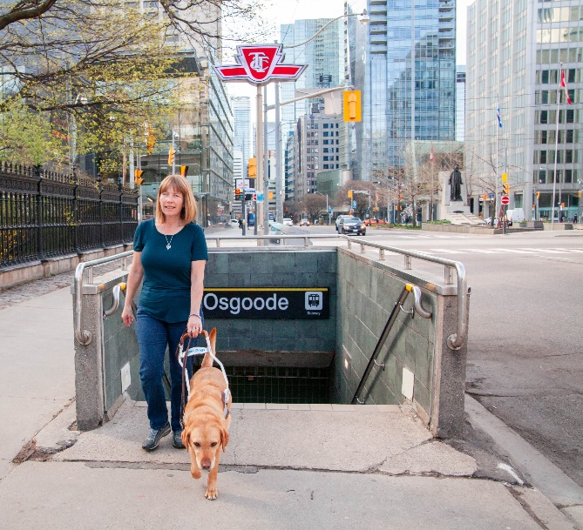
Every experience with sight loss is unique. Each person with sight loss knows their vision best and knows what accommodations will help them most effectively. We have an extensive list of things you can do, but the most important thing you can do is create space for an open conversation with your employee or future employee to determine how you can support them.

Accessible Built Environments
- Maintain barrier-free walking pathways that are clear of obstruction or obstacles.
- Add contrasting colour and texture strips on stairs.
- Ensure signage in and around the workplace is clear, not obstructed, and in an appropriate size.

Tips for a More Accessible Workplace
- Ensure overall lighting meets the specific needs of the employee, (ex. adding a lamp or removing a lightbulb from an overhead light.)
- Consider ergonomics. A person with sight loss may need to sit closer to their computer, and minor workstation setup changes can drastically improve comfort.
- Use large print/braille labels or tactile dots on equipment, tools, or facilities.
- Communicate electronically instead of using written notes.
- Be flexible about assigning tasks to different workers. Some can be more visually intensive than others.

Common Accommodation Tools and Technology
There are a wide range of accommodation tools and devices for any given occupational task. They may include different things like a handheld magnifier or software.
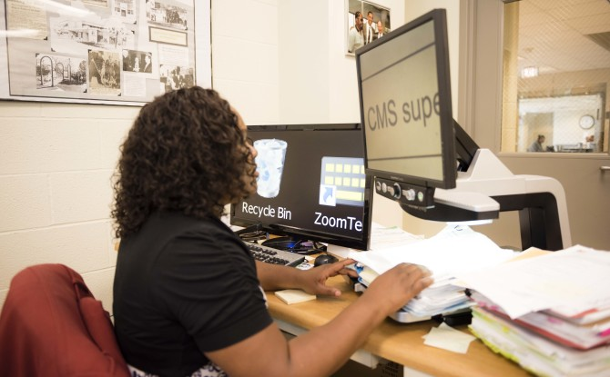
- Screen Reader – Software that reads information on a computer screen aloud to a user via a headset
- Screen magnifiers - Software programs that enlarge the visual display of a computer along with other features like changing colour contrast.
- Operating System Features Operating systems like Windows, Apple and Android all have built in accessibility features including basic magnification and screen reader options.
- Magnifiers – These come in low- and hi-tech options from a simple paperweight magnifier to a desktop video magnifier that a document can be placed on.
- Refreshable braille – These external display devices can be connected to a computer, allowing the user to read the content on their screen in braille format.
- Smartphones – These everyday devices have many accessibility features that can help with tasks like using the camera as a magnifier.

Financial assistance can be available for more expensive accommodations through various funding sources.

Accessible Hiring Process

Application Process
In a job description, distinguish between nice-to-have and actual job requirements to ensure you aren’t excluding possible candidates (ex. Is a driver’s license essential for the job?). Advertise jobs where people with sight loss can access them and make sure that application materials are available in an accessible format (Connect with CNIB if you need support in this area.). Also, consider including an equal opportunities statement in your job that states all staff involved in selection and interviews understand and embody the principles of equity and diversity.

Interviews
When notifying candidates about an interview, ask each one if there is anything they need to be able to do their best in the interview. Ask again at the start of the interview if any additional adjustments are needed (ex. A person with sight loss may want to sit facing away from a window if they have light sensitivity). When introducing yourself to someone with sight loss, say hello and wait for them to offer their hand to be shaken. And, if handing out materials, ensure there are copies available for someone with sight loss in their preferred format.
It is important to remember that if a person has not disclosed their sight loss, do not ask if they are blind. At every stage in the interview process, focus on the candidate's abilities, rather than their sight loss. They will be able to explain how they go about completing tasks and getting things done.

CNIB’s Come to Work Program
Our Come to Work program connects job seekers who are blind or partially sighted with employers who want to discover the full potential of Canada's talent. We partner with Vision Loss Rehabilitation Canada to ensure job seekers who are blind or partially sighted have pre-employment skills, including orientation and mobility (e.g., how to travel independently to and from work), independent living (e.g., how to dress for success) and technology training (e.g., how to use screen readers, smartphone apps, etc.). We also work with employment agencies to provide resources for job searching, résumé writing, and interviewing.
To become an Employer Partner, join our Talent Pool or volunteer as a mentor, contact cometowork@cnib.ca or call 1-800-563-2642.

If you would like more information about creating an accessible business, please see our comprehensive CNIB Business Education Guide.

Additional Resources and Services
- Accessible Payment Terminals
- Accessible Built Environment
- Accessible Materials
- Accessible Customer Service Video Series
- Clear Print Accessibility Guidelines
- CNIB Business to Business Services
- Canadian Guide Dog Legislation
- Sighted Guide Technique Video Series
- White Cane Factsheet

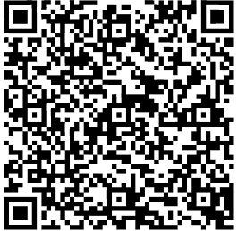
Contact us for further support on how to make your business accessible to people with sight loss.
Email: advocacy@cnib.ca
Phone: 1-800-563-2642

