Supporting Customers with Sight Loss
Businesses serve customers from all backgrounds, including people living with sight loss. Through this document we want to raise awareness of how businesses like yours can play an invaluable role in the lives of our community members.
There are many misconceptions around sight loss, and although you might believe you don’t have any customers with sight loss, keep in mind not everyone who is blind or partially sighted uses a mobility tool like a white cane or guide dog.
Many people believe that blindness means complete darkness, but only one in 10 people have total sight loss. Everyone experiences sight loss differently and to varying degrees. This could include tunnel vision or loss of central vision, depth perception, sensitivity to light, and/or ability to see detail. This means that your customers with sight loss might use different strategies to access your services and may request your assistance to do so. This is often called “accommodations” and there are various laws across Canada that state people with disabilities must be accommodated.
In this quick guide we outline simple steps that you can take to provide accommodations and be an inclusive business. Accommodations can make a huge difference in how someone with sight loss can participate in their local community, including accessing business services and products. Many of these accommodations are easy and simple to implement.

How Can You Make a Difference in Your Business?
Every experience with sight loss is unique. Each person knows their vision best and will know the accommodations they need. Different levels of assistance may be necessary to purchase items or navigate public spaces, however, this inclusive approach can benefit all your customers. Below we outline how you can offer appropriate support for someone who is blind or partially sighted.

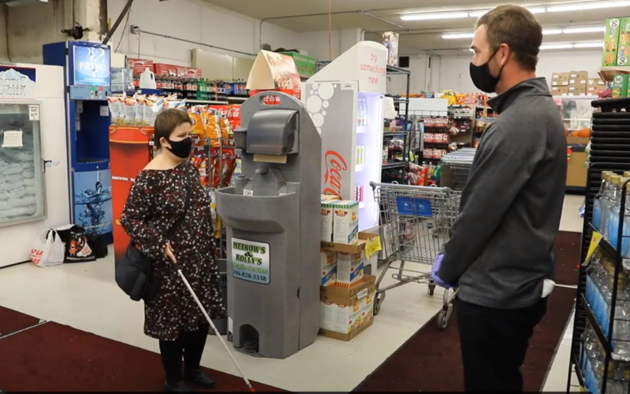
Accessible Environments
- Maintain barrier-free walking pathways that are clear of obstruction or obstacles.
- Add contrasting colour and texture strips on stairs.
- Ensure signage is clear, not obstructed, and in an appropriate size.

Guide Dog Access
- In Canada, guide dogs and their handlers are allowed access to any premises to which the public would normally have access.
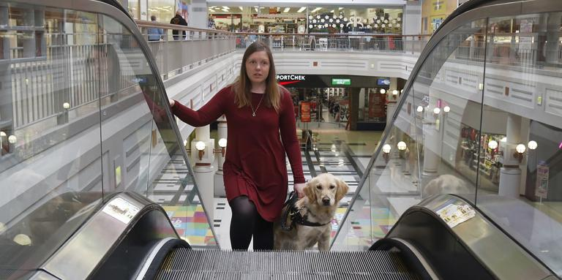
- Business owners have a responsibility to ensure the rights of guide dog teams are respected.
- If a guide dog’s behaviour is inappropriate, the business or organization has the right to ask the guide dog handler to leave.
- It is unacceptable to ask for proof that a dog is a guide dog if it is apparent that they are a guide dog (wearing a clearly marked harness, obvious that they are leading the person).
- When competing rights are an issue – such as allergies – a compromise needs to be made to maintain the rights of everyone involved.

Customer Service & Sighted Guides
All businesses should strive to offer the best customer services they can and there are specific things you can do to provide an accessible customer experience.
- All staff should receive training on how to interact with a person with sight loss. This should include how to properly describe objects, and how to effectively guide a person with sight loss.
- Do not assume that an individual needs help, but if unsure, always ask first. Customers will offer what works best for them, such as requiring a shopping cart, basket, or sighted guide.
- Introduce yourself and your position and ask if the individual needs help.
- Speak clearly and directly to the person, not to someone accompanying them.
- Never grab the customer’s arm, hand, or mobility cane, as this can be disorienting and dangerous.
- If you need to walk away for a moment, for example to go to the back room to check if something is in stock, let the person know you are leaving but will be back shortly.
- When helping a person with a guide dog, it may be helpful to navigate with a cart. This way, the person with sight loss can hold onto something and follow the store staff, while also keeping control of their guide dog.
- When interacting with a guide dog team, never touch the guide dog or guide dog harness. Do not pet, feed, or otherwise distract the guide dog.

Accessible Payment Terminals
Payment terminals are a necessity across all businesses for customers to finish their transaction, but there are several things you and your employees can do. New technology is also being developed to make the payment process more accessible.
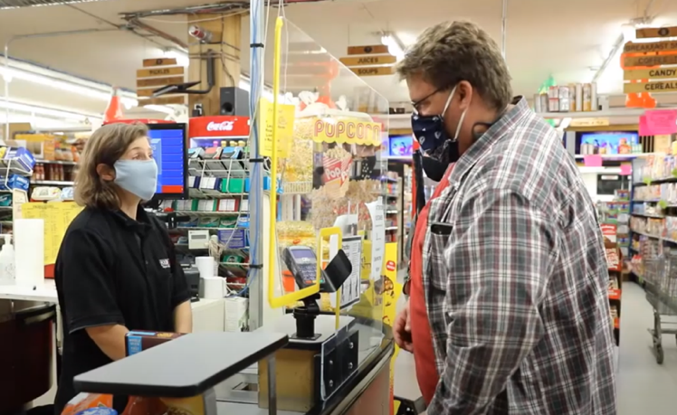
- Ask if the person requires assistance with payment, when at the checkout.
- Tell customers with sight loss what their total purchase will cost.
- Explain the layout of the payment terminal including: tap functions, the location of tactile buttons, or if it’s a touchscreen.
- Temporarily remove cover of the Point-of-Sale machine, so the customer can access the keypad.
- Identify if a plexiglass barrier is being used and where the opening is. Consider high contrast, bright tape around the edges, to identify the plexiglass barrier.

If you would like more information about creating an accessible business, please see our comprehensive CNIB Business Education Guide.

Additional Resources and Services
- Accessible Payment Terminals
- Accessible Built Environment
- Accessible Materials
- Accessible Customer Service Video Series
- Clear Print Accessibility Guidelines
- CNIB Business to Business Services
- Canadian Guide Dog Legislation
- Sighted Guide Technique Video Series
- White Cane Factsheet

Contact us for further support on how to make your business accessible to people with sight loss.
Email: advocacy@cnib.ca
Phone: 1-800-563-2642

