Self-Advocacy &
Essential Legal Information

Know Your Rights – Legal Information Handbook

August 2022
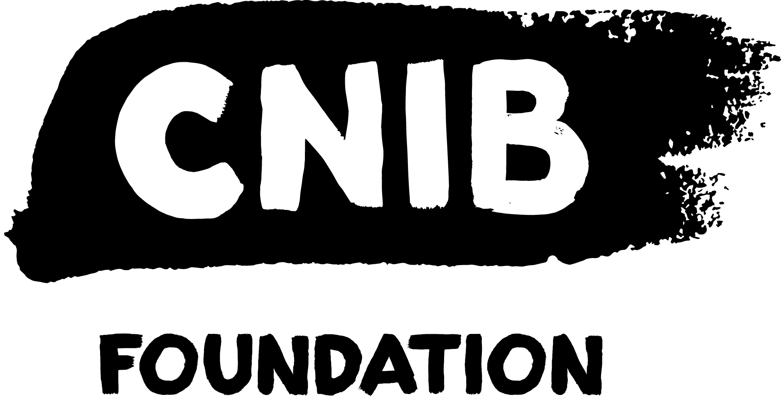
Disclaimer
This content is provided as general information and is not legal advice. If you need advice about a specific legal problem, contact a lawyer or a community legal service.
Acknowledgements
Thank you to the Law Foundation of Newfoundland and Labrador and The Law Foundation of Ontario for making the Know Your Rights – Newfoundland and Labrador Project possible. While financially supported by a grant from the Law Foundation of Newfoundland and Labrador and a grant from The Law Foundation of Ontario’s Access to Justice Fund, CNIB is solely responsible for all content.
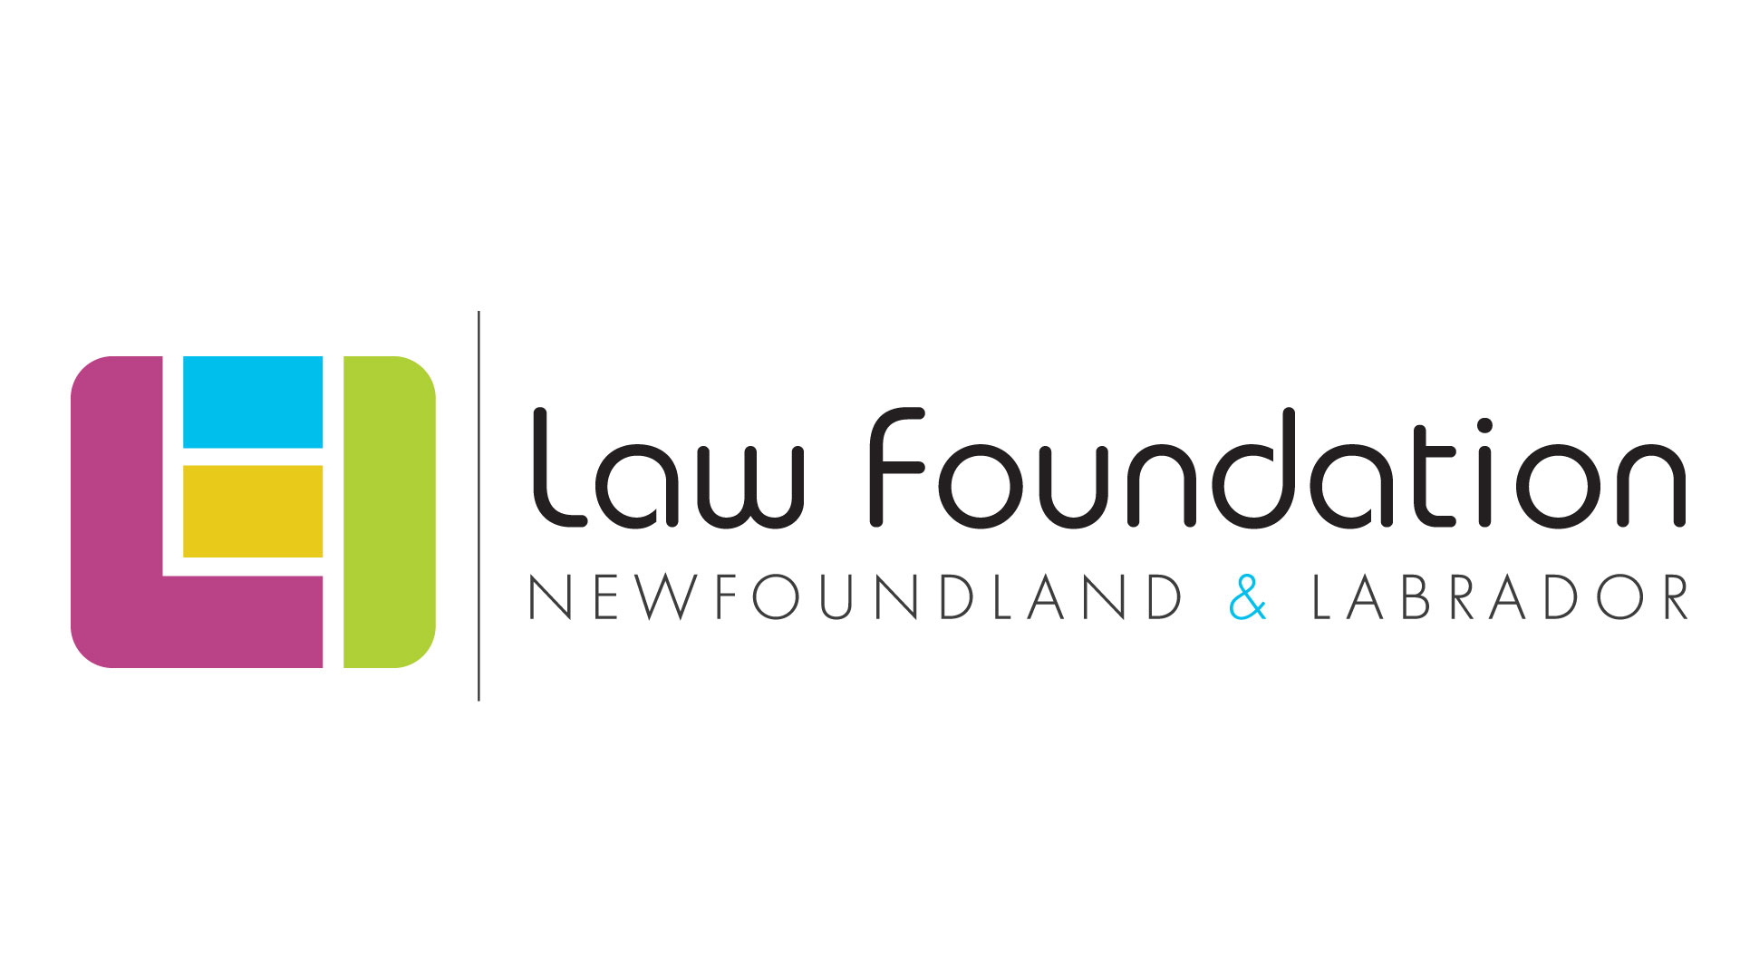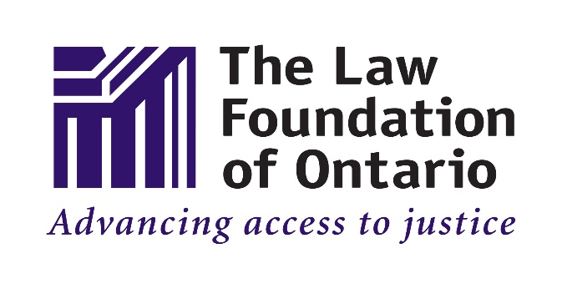
Thank you also to the Public Legal Information Association of NL (PLIAN) for their dedication and provision of in-kind legal research.
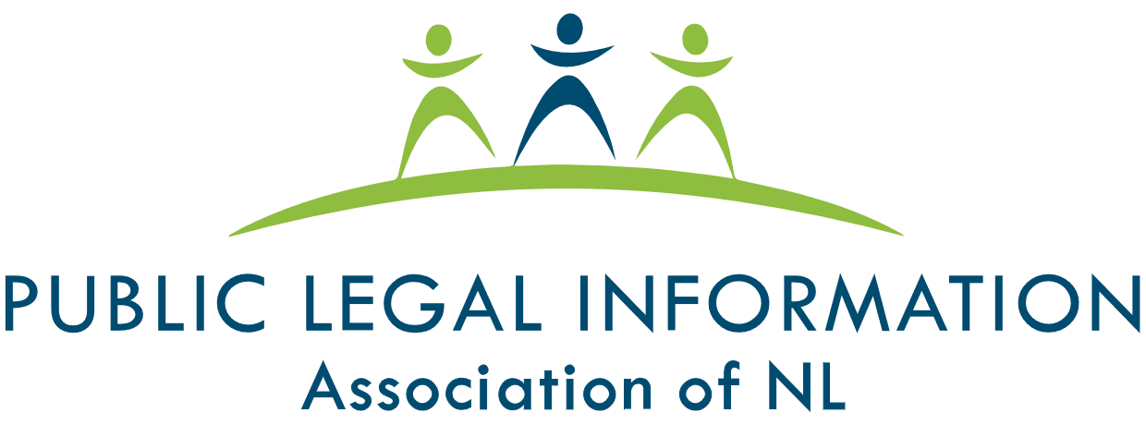
Thank you as well to the many individual volunteers who contributed to the development of this legal information handbook, particularly the Focus Group and Working Group participants.
To learn more about the Know Your Rights – Newfoundland and Labrador Project, please visit our Know Your Rights – Newfoundland and Labrador webpage.
Table of Contents
1 Self-Advocacy 5
1.1 What is Self-Advocacy? 5
1.2 What makes “Legal” Advocacy Different? 6
1.3 What does “Practicing Law” mean? 6
1.4 Legal Life Skills 8
1.5 Top Five Misconceptions about Legal Advocacy 9
1. Legal advocacy means taking someone to court 9
2. Legal advocacy means getting into a dispute 9
3. Legal advocacy means being vocal and assertive about my legal rights 10
4. You only need legal help after an issue grows into a full, adversarial dispute 11
5. It is easy to know when you have a legal problem 11
2 Getting Legal Help 13
2.1 What Kind of Legal Help do I Need? 13
“Legal Information” vs. “Legal Advice” 13
Types of Legal Help 14
2.2 Finding Reliable Legal Information 16
2.3 Find a Lawyer 17
When to look for a lawyer 17
Before you meet with a lawyer 17
How to find a lawyer 18
2.4 Connect with Community Support 19
3 Essential Legal Information 20
3.1 Key Players in the Legal System 20
Three Levels of Government 20
Courts, Boards and Tribunals 20
Lawyers 21
3.2 Key Legislation 21
Newfoundland and Labrador’s Human Rights Act 21
3.3 Other Important Legislation 24
Newfoundland and Labrador’s Service Animal Act 24
Newfoundland and Labrador’s Accessibility Act 24
Municipal By-Laws 25
The Charter of Rights and Freedoms (the “Charter”) 25
Other Federal and Provincial Laws 25
4 Getting Help 26
4.1 Legal Services and Information 26
4.2 Essential Non-Legal Services 28
4.3 Additional Resources 28
4.4 CNIB Services (Non-Legal) 29
4.5 Vision Loss Rehabilitation 30
4.6 Wayfinding 31

1 Self-Advocacy

1.1 What is Self-Advocacy?
“Advocacy” means persuading others to change their attitudes, positions, or practices related to an issue that you care about. Advocacy can have a range of goals, such as raising public awareness, getting a company to change a business practice, or creating a new law.
“Self-Advocacy” means persuading others to change their attitudes, positions, or practices related to a situation that you are personally involved in. The goal of self-advocacy is to improve your situation or to make sure you are being treated fairly.
Self-advocacy does not mean doing advocacy alone. If you are in a challenging situation, it’s likely that many people have experienced similar situations before and gained valuable knowledge and experience that could help you. You may be surprised to learn about the many resources, programs, and organizations that can help people in your situation.
In addition, there are many educational resources to help you develop advocacy skills. Important advocacy skills include:
- Defining the problems;
- Identifying your goals;
- Creating an advocacy plan/strategy;
- Writing effective emails; and
- Speaking comfortably/persuasively with people you may disagree with.
This toolkit can provide you with tips about how to become a more effective advocate. While the toolkit is Saskatchewan-based, most of the “tools” can be used anywhere.

1.2 What makes “Legal” Advocacy Different?
By “legal advocacy” we mean any kind of advocacy where it’s useful or important to have a very good understanding of the law. For example, you may need either:
- General information about what the law says or how the legal system works; or
- A detailed explanation about how the law applies to your specific situation and what legal actions you can take.
Legal advocacy is different than other kinds of advocacy in one critical way: since the law can be a very difficult and complex subject, you are going to need help finding general information about the law and accessing legal service providers.
People who you trust – like friends, family members, community workers, or non-profit organizations – can help you find general information about the law. They can also help you apply “legal life skills” to your personal situation (described further below) and connect you with legal service providers.
Only licensed lawyers can practice law in Newfoundland and Labrador. It is illegal for anyone else to practice law in Newfoundland and Labrador. However, people and organizations can provide the public with general information about the law and legal procedures.

1.3 What does “Practicing Law” mean?
Lawyers deliver legal services to their clients by giving “legal advice” and providing “legal representation”.
To explain the value of these services, we’ll make an analogy between doctors and lawyers.
We all know that doctors go through years of specialized training so they can provide medical services such as: conducting physical exams and check-ups, making a medical diagnosis, prescribing medication, and performing medical procedures. If a doctor makes a mistake, a patient could be put in danger. As a result, it’s easy to understand why only qualified and licensed doctors can provide certain medical services in Newfoundland and Labrador.
For the same reason, only qualified and licensed lawyers can provide legal services in Newfoundland and Labrador: it takes years of specialized training to learn how to provide these services safely.
The table below defines the different types of legal service and makes an analogy to a medical service that has a similar function. This analogy helps to show how:
- Just like medical services protect your health, legal services protect your legal rights; and
- Just as it’s very dangerous for medical services to be provided incorrectly, your legal problem can get much worse if legal services are provided incorrectly.

Description of a Legal Service | Analogy to a Medical Service
A lawyer applies the law to a client’s specific situation to determine what legal rights and duties that client has (called “providing legal advice”). | A doctor does a detailed physical examination of a patient to determine what medical conditions that patient has.
After applying the law to a client’s situation, a lawyer recommends what legal actions the client can take to achieve their goals (also called “providing legal advice”). | After making a medical diagnosis for a patient, a doctor recommends what treatment options are available to improve that patient’s health – for example, prescribing medication.
A lawyer serves as a client’s legal representative to help the client achieve their goals – for example, by writing letters, submitting applications, or going to court on their client’s behalf (also called “providing legal representation”). | A doctor performs a specific medical procedure on a patient to improve that patient’s health – for example, doing surgery.

1.4 Legal Life Skills
The following skills are very important when you are dealing with a potential legal problem:
- Getting things in writing;
- Keeping detailed records;
- Collecting and organizing documents;
- Writing down a clear timeline of events; and
- Prioritizing relevant information.
We call these “legal life skills” because they are essential to enabling effective legal advocacy.
Legal life skills are especially important at the early stages of self-advocacy when you are starting to think that something about your current situation is wrong or unfair. For example, keeping detailed records can help you reflect on your situation and writing down a clear timeline can help you communicate effectively with others. By using these skills, you will be in a better position to resolve potential problems before they can get bigger.
Applying these kinds of skills to your personal situation can be hard work, stressful, and emotionally draining. You should always consider reaching out to people who you trust – like friends, family members, community workers, or staff at a non-profit organization – to ask for help.
Finally, you should use these skills as much as possible before meeting with a lawyer. Since lawyers are so expensive, it’s important to make the most out of your meetings by preparing in advance as much as possible. Learn more about how to best prepare for a meeting with a lawyer by referring to the section of this Handbook, titled “Before you meet with a lawyer”.

1.5 Top Five Misconceptions about Legal Advocacy

1. Legal advocacy means taking someone to court
While legal advocacy can involve taking someone to a court or having a matter heard before a Board of Inquiry, most legal problems never go to adjudication.
The term “adjudication” means that a judge or adjudicator will formally hear and make a decision about a dispute.
An adjudicative process can be very expensive and time-consuming – it can last many months or years. As a result, many opt to resolve legal disputes before the dispute goes to a formal adjudication. Unlike TV shows, most legal advocacy is done outside of a courtroom.
That said, sometimes adjudication is the best option for challenging and correcting unfairness. And, winning a case before a court or a Board of Inquiry can lead to change for others facing similar circumstances.

2. Legal advocacy means getting into a dispute
While legal advocacy can involve getting into a dispute, not all legal advocacy is adversarial.
The term “adversarial” means “having a conflict where two sides oppose each other”.
In fact, important and impactful legal advocacy is often non-adversarial, and is instead characterized by parties working together to solve a problem or disagreement.
When dealing with a potential legal issue, a good approach is to start a collaborative discussion with the other party and then gradually become more adversarial as needed. For example, here is an approach you can take:
Step 1: Do your best to understand the other party’s concerns and try to work with them to develop a solution in a collaborative way.
Step 2: Be more formal and direct with the other party: make sure to get things in writing and use stronger (but collegial) language to express your disagreement or your desire for a specific solution. In addition, explore dispute resolution options that are not fully adversarial.
For example, “mediation” is a dispute resolution process where a neutral third party helps two opposing sides share information and work together to develop a mutually agreeable solution.
Step 3: Explore adversarial options like filing a complaint with the Newfoundland and Labrador Human Rights Commission or filing a lawsuit. While most human rights cases and lawsuits do not get adjudicated, filing a complaint or starting a lawsuit can lead to the parties resolving the matter by arriving at a settlement.
This approach is very general and does not apply to all types of problems. You should always get legal help when facing a legal problem.

3. Legal advocacy means being vocal and assertive about my legal rights
While good legal advocacy can involve being vocal and assertive about your legal rights, there are good reasons why this shouldn’t be your very first response. Consider that:
- Many potential problems arise due to ignorance or a lack of education. Educating the other party is often an efficient way to resolve a problem that could otherwise grow into a large dispute. If you start your discussions with the other party by strongly asserting your legal rights, they may feel intimidated or become defensive. This can shut down communication. Even if you are 100 percent correct about your legal rights, an assertive approach could prolong achieving the outcome that you want.
- It is often very useful to ask questions and gather information from the other party to better understand their views.
  - For example, if you are requesting an accommodation from a service provider and they tell you the accommodation is “not possible”, it would be useful to know why they think it’s not possible. Do they think that the cost is too high? If so, do they have a reasonable estimate of the cost? Do they think it’s a health and safety problem? Do they have a competing human rights claim?
- By approaching the situation collaboratively, and gathering as much information as possible, you will be better prepared to develop a strong and informed advocacy plan.

4. You only need legal help after an issue grows into a full, adversarial dispute
If possible, it’s always better to get legal help before a potential legal problem grows into a full, adversarial dispute.
Ideally, you should get legal help at the early stages of self-advocacy: when you are starting to think that something about your current situation is wrong or unfair. To help explain why, we can make an analogy to your physical health:
If you are starting to feel unwell, you will likely try to learn more about your symptoms and try to figure out what medical condition you might have. If your symptoms get worse, you will surely want to see a doctor.
In the same way, if something about your situation seems unfair, you might first try to find some general information about your legal rights. If you think the situation may get worse, it is a good idea to see a lawyer before you make any legal claims or take any legal action. The purpose of seeing a lawyer is to get a good understanding of how the law applies to your specific situation. With this knowledge, you can create a much more effective advocacy plan.

5. It is easy to know when you have a legal problem
Sometimes it can be easy to recognize that a legal problem exists, but it can be difficult to identify the specific legal issue and the steps you can take to protect your legal rights. To make an analogy with medical care: it can be easy to tell that someone is sick, but a doctor’s assistance is often required to make an accurate diagnosis and recommend an appropriate treatment plan.
Keep in mind that there are many cases where:
- People have a legal problem but don’t realize it. For example, they might think that a conflict with someone else is just a personal disagreement; or they may think it’s normal to be denied accommodations in certain settings.
- People don’t have a legal problem but think that they do.
- People have a legal problem but it’s very different than what they think it is.
In sum, with legal advocacy, you will usually need help to access legal information or legal services.

2 Getting Legal Help

2.1 What Kind of Legal Help do I Need?

“Legal Information” vs. “Legal Advice”
When you are seeking legal help, it’s very important to know the difference between “legal information” and “legal advice.”
 | What does it mean? | Who can provide it?
Legal Information | A general explanation about how the law applies to a range of possible situations.  Since a general explanation is not customized to your specific situation, it can’t tell you with certainty what specific legal rights you have or what legal actions you can take. | Anyone can create and share legal information, so it is essential for you to judge whether the information comes from a reliable and trustworthy source.
Legal Advice | A service provided by a licensed lawyer who meets with you to learn about your specific situation and then:  - Provides a detailed explanation about what specific legal rights and duties you have; and  - Recommends what specific legal actions you can take to achieve your goals. | Only a licensed lawyer can provide legal advice – it is illegal for anyone else to provide legal advice in Newfoundland and Labrador.

An analogy between doctors and lawyers can help explain the difference between legal advice and legal information:
- Just as a lawyer provides their clients with legal advice, we can say that a doctor provides their patients with “medical advice.” When you visit a doctor’s office, they conduct a detailed physical examination to determine what specific medical conditions you have and to recommend specific treatment options.
- Going to see a licensed doctor is very different than reading a general explanation about a medical condition. For example, popular sources of general medical information include WebMD, Wikipedia, YouTube, and social media. Just like legal information, it’s essential for you to judge whether the source of information is reliable and trustworthy. For example, reliable sources of medical information include the Government of Newfoundland and Labrador’s Health and Wellness webpage; 811 HealthLine; the Public Health Agency of Canada; and MedlinePlus, a public education website run by the National Institutes of Health.
Reliable sources of legal information are listed in the section of this handbook titled, “Finding Reliable Legal Information”.

Types of Legal Help
This section identifies and explains six kinds of legal help, listed from the easiest to the most difficult to access.

Legal Information
Legal information means a general explanation about how the law applies to a range of possible situations. Since anyone can create and share legal information, it’s important for you to judge whether information comes from a reliable and trustworthy source. Reliable sources of legal information are listed in the section of this handbook titled, “Finding Reliable Legal Information”.

Connect to Community Supports
Since the law can be difficult to understand at times, you may need help finding reliable legal information and accessing legal services. A good first step is to connect with community supports, such as non-profit organizations, advocacy groups, or peer support groups. People in these organizations can help you develop an advocacy plan, which can include connecting with legal resources. More information about community supports is available in the section of this Handbook titled, “Connect with Community Support”.

Referral to a Legal Professional
To access legal services, you need to find a legal professional who has experience relevant to your legal challenge, and who can provide services either free-of-charge or for a price that is within your budget. It often takes a significant amount of work to find a specific legal clinic, law firm, or individual lawyer who meet these criteria.
It’s important to ask for recommendations or referrals to specific lawyers from friends, community supports, and other legal professionals. You may need to follow up with multiple referrals before you find a lawyer that you are able to work with.
More information on how to find a lawyer is available in the section of this Handbook titled, “Find a Lawyer”.

Summary Legal Advice
“Summary legal advice” is a service that can only be provided by a licensed lawyer. You receive a short consultation with a lawyer who listens to your story, provides you with legal advice, and who may refer you to other legal services. After this short consultation, there is no ongoing commitment for that lawyer to provide you with legal advice.
If seeing a lawyer is like seeing a doctor, then getting summary legal advice is like “going to a walk-in clinic”. When you go to a walk-in clinic, a doctor meets with you for a short time to provide you with a diagnosis and treatment options or refers you to other medical services. After this short consultation, there is no ongoing commitment for that doctor to provide you with medical care.

Legal Advice
“Legal advice” is a service that can only be provided by a licensed lawyer. The lawyer meets with you to learn about your specific situation and then:
- Provides a detailed explanation about what specific legal rights and duties you have; and
- Recommends what specific legal actions you can take to achieve your goals.
Legal advice is often provided as an ongoing service until your issue is resolved or until you have used up your budget for legal services. Information on how to make the most of your time with a lawyer is available in the section of this Handbook titled, “Before you meet with a lawyer”.

Legal Advice and Legal Representation
In addition to providing legal advice, a lawyer can also represent you – for example, by writing letters to other parties on your behalf, submitting applications for you, or serving as your legal representative in court or before a Board of Inquiry.

2.2 Finding Reliable Legal Information
When you search for legal information, it’s up to you to determine whether the source is trustworthy and reliable. At minimum, you should make sure that the legal information you trust:
- Applies to Newfoundland and Labrador;
- Was published within the last few years (or sooner if the law has changed);
- Is authored by an organization with an established reputation – for example, the government, a legal clinic, or a well-known nonprofit.
Some reliable sources for legal information in Newfoundland and Labrador include:
- Newfoundland and Labrador Human Rights Commission
- Public Legal Information Association of NL (PLIAN)
- CNIB’s Know Your Rights – Newfoundland and Labrador Project

2.3 Find a Lawyer

When to look for a lawyer
If possible, it’s always better to get legal help before a potential legal issue grows into a full, adversarial dispute. Ideally, you should look for a lawyer at the early stages of self-advocacy when you are starting to think that something about your current situation is wrong or unfair.
Make sure you work with a licensed lawyer to protect yourself from getting incorrect legal advice. If you have a bad experience with a licensed legal professional, you can file a complaint with the Law Society of Newfoundland and Labrador. In addition, licensed lawyers are required to carry insurance so clients can be compensated if they are financially harmed by a lawyer’s mistake.

Before you meet with a lawyer
Since legal services are very expensive, you’ll want to make the most of the time you spend with a lawyer.
If you aren’t eligible for free legal services, you’ll need to pay for some or all of your legal costs. Some lawyers may agree to work at a discount or may even agree to work for free (also referred to as pro bono) because your case relates to issues that they care about.
To get the best value for your money, try to prepare as much as possible before meeting with a lawyer. You may find the following resources helpful:
- The Law Society of Newfoundland and Labrador’s website contains helpful information about finding a lawyer, choosing the right lawyer, and preparing for your first meeting with a lawyer.
Like all service providers, under Newfoundland and Labrador human rights laws, lawyers are required to provide you with accommodations for your disability, up to the point of undue hardship, at no additional cost to you.

How to find a lawyer
The Law Society of Newfoundland and Labrador has a lawyer directory, which provides an up-to-date list of lawyers practising in the province of Newfoundland and Labrador. The lawyer directory allows you to search for a lawyer by firm/organization, city, first or last name, languages spoken or practise area. Lawyers’ contact information is available via this service, which allows you to contact lawyers directly.
The Public Legal Information Association of NL (PLIAN) also provides a lawyer referral service, wherein the public is provided with referrals to lawyers from across the province. Lawyers registered with PLIAN’s referral service offer individuals 30-minute legal consults at a flat rate of $40.00, with no legal obligation beyond the 30-minute consult.
Some lawyers in Newfoundland and Labrador may also offer free or low-cost initial consultations during which they may provide you with summary legal advice. You can look at lawyers' webpages or phone their offices to determine if they offer this service
If you have a very low income and your matter relates to criminal law, family law, or another area of law covered by Legal Aid NL, then you may be eligible for legal services through Legal Aid NL.
You can also ask for recommendations or referrals to specific lawyers from friends, community supports, and other legal professionals. You may need to follow up with multiple referrals before you find a lawyer you are able to work with.
When searching for a lawyer, it’s important to keep in mind that you will be looking for a legal professional who has relevant experience and who can provide services either free of charge or for a price that falls within your budget. It often takes a significant amount of work to find a specific legal clinic, law firm, or individual lawyer who meet both criteria.
Unfortunately, there are many cases where people do not qualify for free or discounted legal services and cannot afford a lawyer. If you find yourself in a situation like this, it’s very important to reach out to community supports.
If you are considering representing yourself, please refer to the following resources.
- The Provincial Court of Newfoundland and Labrador has developed various resources for self-represented litigants
- The Law Society of Newfoundland and Labrador has compiled a number of external links to assist self-represented litigants
- The National Self-Represented Litigants Project (NSRLP) has developed a resource, titled: “Navigating the Justice System: A Guide for Self-Represented Litigants with Disabilities”.
You can also contact the Newfoundland and Labrador Human Rights Commission. Commission staff cannot provide you with legal advice, however, they can assist you with better understanding your rights and some of the options that are available to you. They can also provide you with referrals to community and government organizations and can assist you with self-advocacy.

2.4 Connect with Community Support
When seeking out community supports, here are some broad categories of organizations to consider:
- Pan-Disability groups, including:
  - March of Dimes
  - Easter Seals Newfoundland and Labrador
  - Centres for Independent Living
- Disability-specific groups, including:
  - CNIB
  - Alliance for Equality of Blind Canadians
  - Canadian Council of the Blind
  - Canadian Deafblind Association
  - Canadian Helen Keller Centre
- Issue-specific groups, including:
  - Atlantic Provinces Special Education Authority (APSEA)
  - A11y
- The media, including national news, local news, and social media.
- Organizations with public profiles, including large charities, large corporations, local businesses, industry organizations, and professional associations.

For more ideas, contact CNIB, visit your local library, or access 211 Newfoundland and Labrador online, by email at 211nl-lb@findhelp.ca, or by calling 2-1-1.

3 Essential Legal Information
This section summarizes information that you should know about:
- Key Players in the Legal System
- Key Legislation: Newfoundland and Labrador’s Human Rights Act
- Other Important Legislation

3.1 Key Players in the Legal System

Three Levels of Government
The federal, provincial and municipal levels of government each have many departments and agencies. Each level of government has different areas of control (or areas of “jurisdiction”).

Courts, Boards and Tribunals
There are both federal and provincial courts. Each level of court has different areas of control (or areas of “jurisdiction”).
In addition, each level of government can create boards or tribunals that operate like courts and are specialized in certain topics.

Lawyers
Only licensed lawyers can provide legal services. While legal services are very expensive, some legal professionals offer services at discounted rates or even for free (also referred to as pro bono). The legal profession is regulated by the Law Society of Newfoundland and Labrador. The Law Society is the only body that can determine who may become a lawyer in the province of Newfoundland and Labrador.
Additionally, the Law Society of Newfoundland and Labrador has a tool people can use to find a lawyer. You can also make a complaint about a lawyer to the Law Society of Newfoundland and Labrador.

3.2 Key Legislation
Newfoundland and Labrador’s Human Rights Act is the provincial legislation that protects against discrimination in many areas of public life based on disability.
It’s important to have a basic understanding of how this law works because it comes up so often in legal advocacy.
Keep in mind that this handbook only provides a basic explanation about how human rights laws work. If you need to apply these laws to your specific situation, then it’s essential that you speak with a lawyer and obtain legal advice.

Newfoundland and Labrador’s Human Rights Act

How does the Human Rights Act protect your rights?
The Human Rights Act gives you important legal rights:
- You have the right to be free from discrimination because of your disability in most areas of public life.
- You have the right to have an equal level of access as anyone else to accommodations, services, goods and facilities that are offered to the public, without discrimination because of your disability.
- You have the right to file a human rights complaint with the Newfoundland and Labrador Human Rights Commission without fear of reprisal/punishment
The Human Rights Act does not:
- Create detailed rules that describe exactly what is considered “accommodation”, and “undue hardship” in a range of situations or sectors.

The Newfoundland and Labrador Human Rights Commission
The Newfoundland and Labrador Human Rights Commission is an independent government agency that is responsible for protecting human rights in Newfoundland and Labrador and administering the province’s Human Rights Act.
The Commission generally becomes involved in matters when it receives complaints from the public about discrimination and harassment. Upon accepting a complaint, the Commission will often attempt to work with the parties to assist them with reaching a resolution. This process is referred to as a “pre-complaint”. If the matter is not resolved during the “pre-complaint” process, then the parties will be offered an opportunity to participate in early mediation. If the parties decline or the matter remains unresolved after mediation, then a Human Rights Specialist will be assigned to investigate the complaint. Once the investigation is complete, Human Rights Commissioners will review the complaint and all of the evidence and will decide whether to dismiss the complaint or refer it to a Commission-directed mediation and/or a Human Rights Hearing. If the matter proceeds to a hearing, an Adjudicator will decide whether discrimination occurred and will issue an order to correct it.
For more information about the complaint process, visit the Newfoundland and Labrador Human Rights Commission’s website or contact the Commission online, by phone at 1-800-563-5808 (toll-free) or by email at humanrights@gov.nl.ca.
The Commission also makes efforts to stop discrimination by promoting human rights and providing training and education to service providers, employers, and the general public.

Key Concepts: Discrimination, Duty to Accommodate, and Undue Hardship
“Discrimination” occurs when a service provider or employer treats you differently or unfairly because of your disability, and this differential treatment causes you harm.
When a service provider has a “duty to accommodate”, it means that the service provider is legally required to provide you with the supports/accommodations you need to receive the same level of service as anyone else. The term "accommodation" is not easily defined and will vary from case-to-case, however, accommodations should be customized to meet your needs and designed to promote the following principles: respect for dignity, individualization, integration and full participation.
The duty to accommodate, however, does have a limit and this limit is called "undue hardship". “Undue hardship” is a legal term. It means that if a service provider can show that it is very difficult for them to provide you with a certain type of accommodation, then they don’t have to provide it.
It’s usually difficult for a service provider to claim undue hardship because they have to show clear, direct evidence of undue hardship that is not based upon assumptions or stereotypes. The determination of what constitutes undue hardship is case-specific, however, commonly considered factors include:
- Whether the cost of the accommodation is so high that it will significantly interfere with the service provider's ability to operate;

- Whether the accommodation will create serious health and safety risks; and
- The impact of the accommodation on other people and programs.
Even if a service provider shows that a certain type of accommodation will create undue hardship for them, they may still have a legal duty to provide you with the next best type of accommodation.

3.3 Other Important Legislation

Newfoundland and Labrador’s Service Animal Act
Under Newfoundland and Labrador’s Service Animal Act, you cannot be denied access to accommodations, services and facilities that are normally available to the public because you are accompanied by a service animal, such as a guide dog.
If this happens to you, ask to speak to a manager or the owner of the business immediately. Explain that you are only asking them to comply with the law and that there are penalties for breaking the law. If they still refuse, you have several options available to you. You can consider contacting:
- The police (at a non-emergency number) who have the power to investigate and charge individuals and corporations for violations of the Service Animal Act. Some police officers may not be aware of their authority to enforce the Service Animal Act, so you may need to inform them.
- Community organizations, like CNIB, who can provide you with support
- A by-law enforcement officer, depending on the type of business
- A human rights lawyer to see what additional options may be available to you

Newfoundland and Labrador’s Accessibility Act
Newfoundland and Labrador’s Accessibility Act became law on December 3, 2021. The purpose of the Accessibility Act is to improve accessibility by identifying, preventing and removing barriers that prevent people with disabilities from fully participating in public life. The Act applies to areas of public life that are governed by the provincial government, such as healthcare, education, municipal and provincial transportation, and others.

Since the enactment of the Accessibility Act, an Accessibility Standards Advisory Committee has been developed to make recommendations regarding the establishment and content of accessibility standards, which will be included within the Act’s Regulations.
For more information about the Accessibility Act, visit the Government of Newfoundland and Labrador’s Accessibility Act webpage.

Municipal By-Laws
In municipalities, there are often various by-laws involving snow removal, building and property upkeep, etc. Therefore, contacting municipal by-law enforcement can sometimes be part of an effective legal advocacy plan.
If you need to understand how municipal by-laws apply to your specific situation, then it’s essential that you get legal advice from a lawyer.

The Charter of Rights and Freedoms (the “Charter”)
The Charter of Rights and Freedoms is part of Canada’s constitution. Section 15 of the Charter says, among other things, that the government must not discriminate based on disability in its laws or programs.
The law related to Charter enforcement is very complex. You need to invest a lot of time, research, and education before you can understand the potential benefits and drawbacks of Charter litigation. For most legal issues, Charter litigation is not an appropriate advocacy strategy. If you are very interested in learning more about Charter litigation, you can do research on your own or talk to a lawyer.
The Government of Canada’s Guide to the Charter of Rights and Freedoms provides a basic introduction to the Charter.

Other Federal and Provincial Laws
It is important to keep in mind that many other federal or provincial laws (that have not been mentioned in this handbook) can impact your legal advocacy strategy, depending on the specific details of your situation. This is another reason why it’s important to speak to a lawyer and get legal advice as early as possible.

4 Getting Help

4.1 Legal Services and Information
Legal Aid NL
Legal Aid NL provides legal services to low-income earners in Newfoundland and Labrador. In order to receive services from Legal Aid NL, you must meet their eligibility requirements.
To apply for Legal Aid and/or to learn more, visit Legal Aid NL’s Frequently Asked Questions webpage.

The Public Legal Information Association of Newfoundland and Labrador (PLIAN)
PLIAN is an independent non-profit organization and registered charity dedicated to educating Newfoundlanders and Labradorians about the law.
As part of its commitment to increasing and improving access to justice, PLIAN provides free legal information on a variety of topics on its website, including (but not limited to) residential tenancies, family law, and wills and estates.
PLIAN also operates the Legal Information Line and Lawyer Referral Service. Through this service, callers can receive general legal information and assistance with navigating the legal system. Clients can also receive referrals to lawyers who are registered with the Lawyer Referral Service. Lawyers who register with this service provide clients with an initial 30-minute consultation at a cost of $40.00 (taxes included).
If you are in Newfoundland, you may contact the Legal Information Line and Lawyer Referral Service as follows:
- Via telephone at: 1-888-660-7788 (toll free) or 709-722-2643
- Via email at: info@publiclegalinfo.com or a2j@publiclegalinfo.com
If you are in Labrador, you may contact the Legal Information Line and Lawyer Referral Service as follows:
- Via telephone at: 709-896-5235
- Via email at: labrador@publiclegalinfo.com
The Newfoundland and Labrador Human Rights Commission
The Newfoundland and Labrador Human Rights Commission is an independent government agency that is responsible for protecting human rights in Newfoundland and Labrador and administering the province’s Human Rights Act.
The Commission investigates and resolves human rights complaints, provides individuals, groups and organizations with legal information about human rights, and prevents discrimination through education and learning.
The Commission also creates various public education resources (including Guidelines and Frequently Asked Questions pages) to assist people in Newfoundland and Labrador with better understanding their rights.
For more information about the complaint process, visit the Newfoundland and Labrador Human Rights Commission’s website or contact the Commission online, by phone at 1-800-563-5808 (toll-free), or by email at humanrights@gov.nl.ca. Commission staff cannot provide legal advice, however, they can help you understand your legal rights and options. They can also assist with self-advocacy or refer you to other community or government services.
The Canadian Human Rights Commission
The Canadian Human Rights Commission deals with complaints under the Canadian Human Rights Act. For federally regulated services and activities, you may be able to bring a complaint about discrimination based on disability to the Canadian Human Rights Commission.

4.2 Essential Non-Legal Services
Office of the Citizens’ Representative

The Office of the Citizens’ Representative provides a province-wide ombudsman service.
The primary work of the Office of the Citizens’ Representative is to accept complaints from citizens who feel they have been treated unfairly by government offices and agencies. The Office of the Citizens’ Representative investigates complaints against provincial government departments and other agencies that are overseen by the provincial government.
The Office of the Citizens’ Representative can also undertake complaints that study how governmental policies, procedures, and actions can affect a large number of people. These are called systemic complaints and can result in recommendations that have a much broader impact.
You may contact the Office of the Citizens’ Representative by phone at 1-800-559-0079 (toll-free) or by email at citrep@gov.nl.ca to discuss a concern or make a complaint.

211 Newfoundland and Labrador
211 Newfoundland and Labrador is a free service that operates 24 hours a day, seven days a week. It exists to connect individuals to government, health and social services that are available across Newfoundland and Labrador.
In addition to searching on the 211 Newfoundland and Labrador website, there are various ways to contact 211 Newfoundland and Labrador, including calling 2-1-1 to talk with a representative about the service you require.

4.3 Additional Resources
For additional resources relating to specific topic areas (for example, employment or housing), visit the Legal Information Handbook Section of the Know Your Rights – Newfoundland and Labrador webpage.

4.4 CNIB Services (Non-Legal)
We’re here to help – contact CNIB for more services, support, and resources. Some ways we can assist include:
- CNIB Virtual Programs
  - CNIB offers a range of free virtual programs for children, youth, adults and families.
  - You can access a list of CNIB’s national virtual program offerings on CNIB’s website.
  - You can access a list and schedule of CNIB Newfoundland and Labrador’s virtual program offerings on CNIB – Newfoundland and Labrador’s website.
- Technology Training
  - Join CNIB tech leads from across the country for programming that highlights the suite of programs, apps, products and services that will help empower you to achieve your personal and professional goals.
- Virtual Vision Mate
  - The Virtual Vision Mate program exists to address the feelings of isolation that many people with sight loss experience. Through the Virtual Vision Mate program, Canadians who are blind or partially sighted are connected with sighted volunteers to engage in virtual, weekly conversations.
- CNIB Online SmartLife Store
  - CNIB SmartLife is an interactive retail experience that gives people with disabilities hands-on access to the latest breakthroughs in assistive technologies, as well as tried-and-true favourites.
  - SmartLife’s goal is not necessarily to sell products but to give customers the skills and confidence they need to make the most out of assistive tools that can help them lead better lives.

- CNIB's Advocacy Staff
  - CNIB's Advocacy staff can assist clients with advocating for themselves and understanding their human rights in Newfoundland and Labrador.
- CNIB's Guide Dog Program
  - CNIB’s Guide Dog Program can assist guide dog handlers with advocating for themselves and understanding their rights. This program also provides public education to organizations about the rights of guide dog users.
- CNIB’s PREP (Practical Readiness for Employment and Post-Secondary) Program
  - CNIB provides assistance with post-secondary education and employment planning, as well as ongoing support. To learn more about CNIB’s PREP Program, you can contact CNIB’s St. John’s office by phone at 1-709-754-1180 or by email at infonl@cnib.ca.

4.5 Vision Loss Rehabilitation
Vision Loss Rehabilitation Canada (VLRC) is a not-for-profit national healthcare organization and the leading provider of rehabilitation therapy and healthcare services for individuals with sight loss. VLRC provides people with the practical skills they need to live safely and independently. VLRC’s services are tailored to the unique needs and goals of each person. VLRC’s services include, but are not limited to:
- Assistance with navigating new environments and using mobility tools
- Assistance with maximizing remaining vision with optical and non-optical devices
- Assistance with developing or restoring key daily living skills, such as learning new ways to cook, shop and manage your home
- Assistance with accessing information and using technology

VLRC has offices located in St. John’s, Grand Falls-Windsor and Corner Brook. You can contact VLRC by phone at:
- St. John’s or Grand Falls-Windsor Office - 709-754-1180
- Corner Brook Office - 709-639-9167 ext. 5850 or 5851

4.6 Wayfinding
Wayfinding refers to technological tools that assist partially sighted, blind and Deafblind persons with navigation and orientation. Such tools include:
- BlindSquare: a GPS-app developed for people with sight loss that describes the environment and announces points of interest and street intersections.
- Key 2 Access: a pedestrian mobility app that allows users to wirelessly request crossing at intersections without having to locate the button on the pole. It also allows users to wirelessly open doors and obtain information about indoor spaces.
- Access Now: a map application that shares accessibility information for locations based on users' feedback.
- Be My Eyes: a volunteer-based app that connects people with sight loss to sighted volunteers, who can assist with tasks such as checking expiry dates, distinguishing colors, reading instructions or navigating new surroundings.
- The American Foundation for the Blind, which provides an overview of some of the apps that are available to assist consumers with reading items such as product labels and menus.



cnib.ca | info@cnib.ca | 1-800-563-2642

