Housing
Know Your Rights – Legal Information Handbook


August 2022
Disclaimer
This content is provided as general information and is not legal advice. If you need advice about a specific legal problem, contact a lawyer or a community legal service.
Acknowledgements
Thank you to the Law Foundation of Newfoundland and Labrador and The Law Foundation of Ontario for making the Know Your Rights – Newfoundland and Labrador Project possible. While financially supported by a grant from the Law Foundation of Newfoundland and Labrador and a grant from The Law Foundation of Ontario’s Access to Justice Fund, CNIB is solely responsible for all content.
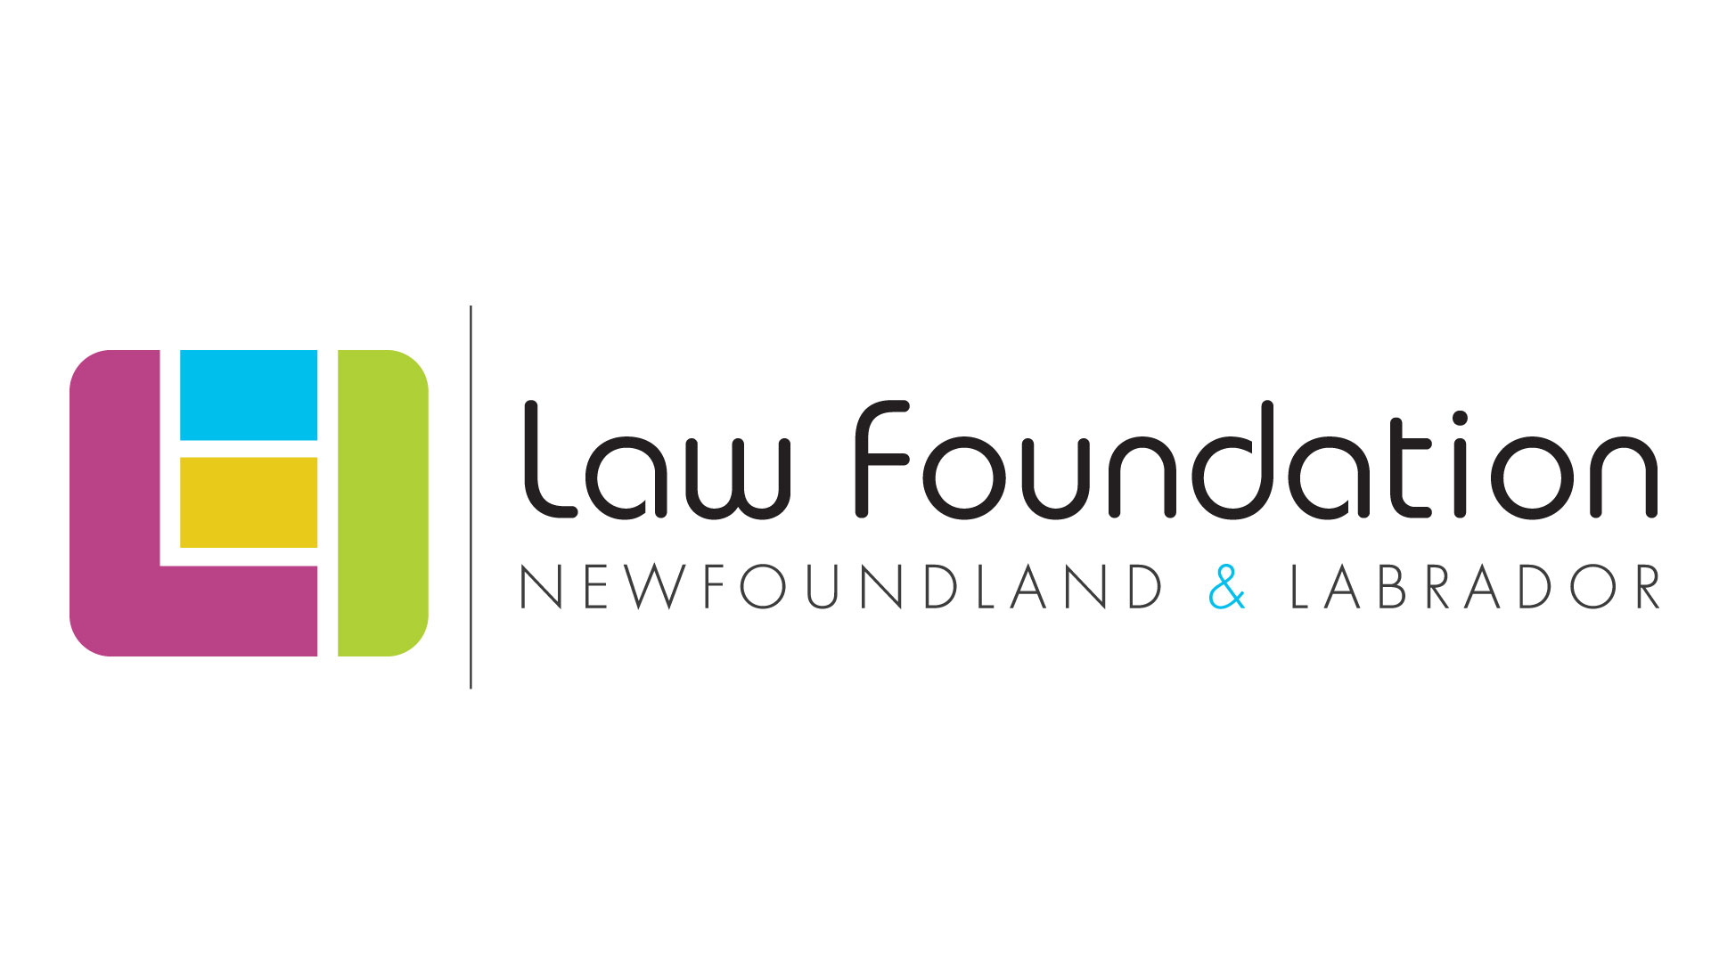
Thank you also to the Public Legal Information Association of NL (PLIAN) for their dedication and provision of in-kind legal research.
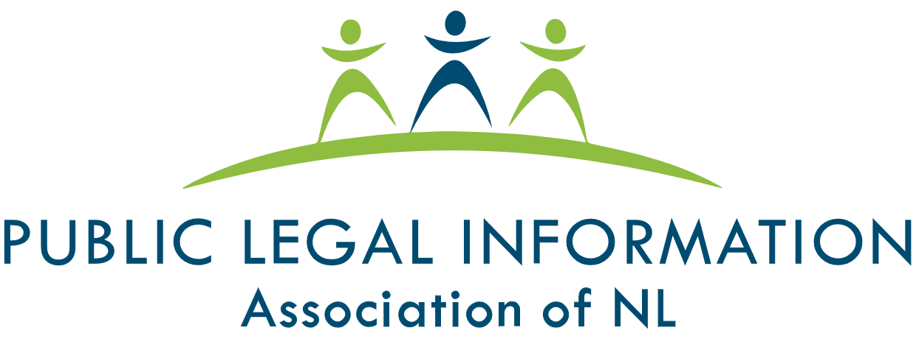
Thank you as well to the many individual volunteers who contributed to the development of this legal information handbook, particularly the Focus Group and Working Group participants.
To learn more about the Know Your Rights – Newfoundland and Labrador Project, please visit our Know Your Rights – Newfoundland and Labrador webpage.
Table of Contents
My Legal Rights 5
Q: What legal rights do I have when it comes to housing in Newfoundland and Labrador? 5
Duty to Accommodate and Undue Hardship 6
Q: Are there any housing arrangements where I don’t have important legal rights? 7
Q: Where do my legal rights come from? 7
Q: Who must comply with Newfoundland and Labrador’s housing laws? 8
Q: What can I do to enforce my legal rights? 8
Common Scenarios 10
Looking for Housing 10
Q: I’m trying to complete a housing application form, but it is not in an accessible format. What can I do? 10
Q: Am I required to disclose my sight loss to a potential landlord? 10
Q: I believe that my housing application was denied because of my sight loss. What can I do? 11
Q: What if I was denied housing because I have a guide dog? 11
Getting Accommodations 12
Q: I'd like to make changes to my residence to accommodate my sight loss. Is my housing provider required to make these accommodations? 12
Q: The amenities/facilities in the building that I live in (e.g., laundry, etc.) are not accessible to people with sight loss. What can I do? 12
Q: Do I have to pay for my housing-related accommodations? 13
Q: My housing provider communicates important information about the building (such as fire alarm testing, repairs, or temporary water shut-off) in an inaccessible format. For example, using posters in common areas or by distributing printed flyers. What can I do? 13
Q: My housing provider says that my requested accommodations conflict with another law or policy. For example, a policy in a Condominium’s by-laws. Does this mean that the accommodations can't be made? 14
Getting Help 15
Legal Services and Information 15
Essential Non-Legal Services 17
CNIB Services (Non-Legal) 17
Vision Loss Rehabilitation 19
Wayfinding 19

My Legal Rights

Q: What legal rights do I have when it comes to housing in Newfoundland and Labrador?
A: Under Newfoundland and Labrador human rights laws, people with disabilities have important legal rights when it comes to most types of rental housing in Newfoundland and Labrador. These rights include:
- The right to equal treatment in housing where you live, or want to live, without discrimination because of your disability. Your right to equal treatment applies to:
  - the process of looking for housing,
  - the rules and procedures related to your housing,
  - the general enjoyment and use of your unit and premises,
  - the maintenance and repairs of your unit and premises, and
  - the services and facilities related to your housing.
- The right to receive accommodations for your disability from housing providers, up to the point of undue hardship. This right applies to your private living space and to communal areas shared by all residents, such as laundry rooms, foyers, elevators, pools, and outdoor spaces.
- The right to be free from harassment by your housing provider.
- The right to not be discriminated against by a housing provider because you rely upon a service animal, such as a guide dog. What this means it that a housing provider cannot:
  - Refuse to rent to you because you rely upon a service animal, such as a guide dog
  - Apply a no pets policy to service animals
  - Deny you an opportunity to view a unit because you rely on a service animal
  - Prevent you from accessing a common area that’s customarily available to other tenants or residents
  - Charge you a fee for your guide dog
Under Newfoundland and Labrador’s Residential Tenancies Act, tenants have additional legal rights, such as the right to privacy and reasonable enjoyment of the residential premises, common areas and property. To learn more about tenants’ rights under the Residential Tenancies Act, visit Digital Government and Service NL’s webpage, titled Landlord & Tenant.

Duty to Accommodate and Undue Hardship
A housing provider’s “duty to accommodate” means that they are legally required to provide you with the supports you need to equally access and enjoy your living space and common areas, like anyone else. The term "accommodation" is not easily defined and will vary from case-to-case, however, the development and implementation of accommodations is an individualized process that takes into account the specific needs and circumstances of the person requiring the accommodation.
The duty to accommodate, however, does have a limit and this limit is called "undue hardship". “Undue hardship” is a legal term. It means that if a housing provider can show that it is very difficult for them to provide you with a certain type of accommodation, then they don’t have to provide it.
It’s usually difficult for a housing provider to claim undue hardship because they have to show clear, direct evidence of undue hardship that is not based upon assumptions or stereotypes. The determination of what constitutes undue hardship is case-specific, however, some of the commonly considered factors include:
1. Whether the cost of the accommodation is so high that it will significantly interfere with the
housing provider's ability to operate. When calculating cost, consideration should also be
given to outside sources of funding, e.g. grants or subsidies;
2. Whether the accommodation will create serious health and safety risks; and
3. The impact of the accommodation on others.
Even if a housing provider shows that a certain type of accommodation will create undue hardship for them, they may still have a legal duty to provide you with the next best type of accommodation.

Q: Are there any housing arrangements where I don’t have important legal rights?
A: Yes. Newfoundland and Labrador’s Human Rights Act does not apply to situations in private residences where the tenant and landlord will be sharing living areas, such as a kitchen. That said, if the private residence is operating a bed and breakfast, or the landlord is renting out a self-contained unit within the home, for example, a basement apartment with separate eating and living areas, then the Human Rights Act will apply.
Also, while the Residential Tenancies Act applies to most rental housing in Newfoundland and Labrador, there are certain types of living situations in which the Residential Tenancies Act will not apply. These include (among others):
- Temporary shelters
- Cooperative housing
- Private residences where the landlord is sharing a kitchen and bathroom with the tenant
To learn more about the Residential Tenancies Act and living arrangements that it does not apply to, visit the Public Legal Information Association of Newfoundland and Labrador’s legal information page, titled Tenants.

Q: Where do my legal rights come from?
A: In Newfoundland and Labrador, your legal rights with respect to housing come from a variety of laws, including:
- Newfoundland and Labrador’s Human Rights Act, which prohibits discrimination based on disability in most areas of public life, including housing.
- Newfoundland and Labrador’s Service Animal Act, which prohibits discrimination against people who rely upon service animals, such as guide dogs.
- Common Law – Laws that are made by the decisions of Courts, Boards and Tribunals.
- Newfoundland and Labrador’s Residential Tenancies Act, which governs the relationship between landlords and tenants, sets out some of their rights and responsibilities, and regulates matters such as rent increases, etc.
- Newfoundland and Labrador’s Buildings Accessibility Act, which is designed to create greater accessibility and ensure that people with disabilities have equal access to apartment-type buildings and others. The Act applies to the construction of new buildings and to the reconstruction or renovation of older buildings.
- Newfoundland and Labrador’s Co-operatives Act, which governs the operation of housing cooperatives and other cooperatives within the province of Newfoundland and Labrador.
- Newfoundland and Labrador’s Condominium Act, 2009, which governs the ownership and operation of condominium corporations in Newfoundland and Labrador

Q: Who must comply with Newfoundland and Labrador’s housing laws?
A: Newfoundland and Labrador’s housing laws apply to almost everyone who supplies or receives housing services in the province of Newfoundland and Labrador. This includes:
- Tenants
- Landlords, including individual and corporate landlords
- Representatives of landlords, such as real estate agents and building managers
- Condominium corporations and cooperative housing corporations and their boards of directors.
- The Newfoundland and Labrador government and its agencies.

Q: What can I do to enforce my legal rights?
A: If you feel you have been unfairly discriminated against by a housing provider, there are things you can do to stand up for yourself.
In general, you should first try to resolve your concerns by speaking with the people who are directly involved in an informal and collaborative way.
For more resources on self-advocacy, please visit the Self-Advocacy and Essential Legal Information Handbook on CNIB’s Know Your Rights – Newfoundland and Labrador webpage.
If your concerns cannot be addressed through collaborative discussions, you should consider consulting with a lawyer who practices human rights or housing law to see if any of the following options are appropriate:
- An application to the Residential Tenancies Office
- A complaint to the applicable municipality and their bylaw enforcement units or the police.
This particular option may be available in circumstances where your rights under the Service Animal Act are violated.
- A complaint to the Newfoundland and Labrador Human Rights Commission
- A claim before a Newfoundland and Labrador Court.
You can also contact staff at the Newfoundland and Labrador Human Rights Commission by phone at 1-800-563-5808 (toll-free), by email at humanrights@gov.nl.ca, or online. Staff cannot provide you with legal advice, however, they can help you understand your legal rights and options. They can also assist with self-advocacy or refer you to other community or government services.

Common Scenarios
Even though there are laws to protect you from being discriminated against, people with disabilities still face barriers to being treated equally when it comes to housing.
This section describes barriers that are commonly experienced and suggests practical next steps. Keep in mind that in most situations, you should try to resolve your concerns by speaking with the people who are directly involved in an informal and collaborative way.

Looking for Housing

Q: I’m trying to complete a housing application form, but it is not in an accessible format. What can I do?
A: Housing providers should develop an application process that does not unreasonably exclude individuals or groups based on disability.
You have the right to request that the form be provided in an accessible format, as an accommodation for your disability. By disclosing your disability and making a request for accommodation, you trigger the housing provider’s legal duty to accommodate you up to the point of undue hardship.
If you do not want to disclose your disability to the housing provider before you apply for the unit, you can ask a friend, support person, or intervenor to request the form for you. You may reach out to CNIB for assistance with this as well.

Q: Am I required to disclose my sight loss to a potential landlord?
A: You are not legally required to share any information with your prospective landlord about your sight loss.
However, if you require accommodations for your disability, you will need to provide them with enough information to understand the accommodations you require.
Your housing provider has the right to obtain information from you about your disability so they can provide an appropriate accommodation. If the housing provider asks for medical documentation about your disability, you should only provide the information that is necessary to explain your need for accommodation. You are not required to tell your housing provider your exact diagnosis; and you are not required to give information to your housing provider that is not related to your need for accommodations.
If your prospective landlord asks you questions about your sight loss and then denies your housing application because of your answers; or, if after reviewing the information you provide them, they refuse to rent to you, this could be discrimination.
You should consider consulting with a lawyer who practices human rights or housing law to see what options are available to you.

Q: I believe that my housing application was denied because of my sight loss. What can I do?
A: Sometimes there are clear signs that you are being discriminated against when looking for housing. For example:
- When a housing provider asks intrusive and inappropriate questions,
- When a housing provider makes statements that are offensive or based on false stereotypes, or
- When a housing provider says they cannot rent a unit to you because of your sight loss.
When the signs of discrimination are not as clear, it can be harder to prove that you were discriminated against.
Before deciding what to do, it’s important to understand how the law applies to your specific situation, even if the signs of discrimination are not obvious. You should consider consulting with a lawyer who practices human rights or housing law to see what options are available to you.

Q: What if I was denied housing because I have a guide dog?
A: A housing provider cannot refuse to rent you a self-contained unit because you have a guide dog. If this happens to you, your legal rights under Newfoundland and Labrador’s Service Animal Act may have been violated.
In response, you may want to file a complaint with the police who have the authority to investigate and lay charges in this type of situation. Some police officers may not be aware of their authority to enforce the Service Animal Act, so you may need to inform them.
If you are denied housing because you rely upon a guide dog, you should also consider consulting with a lawyer who practices human rights or housing law to see what other options may be available to you. You can also reach out to CNIB for additional support.

Getting Accommodations

Q: I'd like to make changes to my residence to accommodate my sight loss. Is my housing provider required to make these accommodations?
A: Under Newfoundland and Labrador human rights laws, housing providers have a legal duty to provide you with accommodations for your disability up to the point of undue hardship. Housing providers are also obligated to pay for the accommodation and to provide it in a timely manner.
Your housing provider has the right to obtain information from you about your disability so they can provide an appropriate accommodation. If your housing provider asks for medical documentation about your disability, it is only necessary for you to provide medical documentation that is relevant to your need for accommodations.
It’s important to remember that selecting an appropriate accommodation is a collaborative process. As a tenant requesting an accommodation, you have a legal duty to collaborate with your housing provider to help them select an appropriate accommodation.
If your request for accommodation is denied, you should consider consulting with a lawyer who practices human rights or housing law to see what options are available to you.

Q: The amenities/facilities in the building that I live in (e.g., laundry, etc.) are not accessible to people with sight loss. What can I do?
A: When it comes to common areas in buildings, such as laundry rooms, pools, etc., you are entitled to have an equal level of access to those areas as any other resident in the building.
If this is an issue, you might begin by bringing your concern to the attention of your landlord or building manager. Housing providers have a legal duty to provide you with accommodations for your disability up to the point of undue hardship. Advising your housing provider of your disability and your need for accommodations triggers their legal obligation to provide you with accommodations.
For more resources on self-advocacy, please visit the Self-Advocacy and Essential Legal Information Handbook on CNIB’s Know Your Rights – Newfoundland and Labrador webpage.
It’s important to remember that selecting an appropriate accommodation is a collaborative process. As a tenant requesting an accommodation, you have a legal duty to collaborate with your housing provider to help them select an appropriate accommodation.
If your request for accommodations is denied, you should consider consulting with a lawyer who practices human rights or housing law to see what options are available to you.

Q: Do I have to pay for my housing-related accommodations?
A: No. Your housing provider cannot make you pay for accommodations for your disability. It is your housing provider’s legal obligation to provide you with accommodations up to the point of undue hardship. It’s also your housing provider’s responsibility to pay for the accommodations.

Q: My housing provider communicates important information about the building (such as fire alarm testing, repairs, or temporary water shut-off) in an inaccessible format. For example, using posters in common areas or by distributing printed flyers. What can I do?
A: You may wish to speak with your housing provider about receiving these communications in an accessible format. You can provide the housing provider with examples of how they may do so, including email, accessible .pdf, or Microsoft Word documents.
If the housing provider resists your request, consider advising them that you are asking for the information to be provided to you in accessible format, as an accommodation. Your housing provider has a legal duty to provide you with accommodations for your disability up to the point of undue hardship.
If your concern remains unaddressed, you should consider consulting with a lawyer who practices human rights or housing law to see what options are available to you.

Q: My housing provider says that my requested accommodations conflict with another law or policy. For example, a policy in a Condominium’s by-laws. Does this mean that the accommodations can't be made?
A: Unless expressly stated, human rights law prevails over other conflicting laws. Furthermore, housing providers are expected to be flexible when applying rules and procedures. For example, housing providers cannot apply a ‘no pets’ policy to service animals, such as guide dogs. They are also required to provide you with accommodations for your disability up to the point of undue hardship.
If you are told that your requested accommodation conflicts with another law or policy and therefore, cannot be accommodated, you should consider consulting with a lawyer who practices human rights or housing law to see what options are available to you.

Getting Help

Legal Services and Information
Legal Aid NL
Legal Aid NL provides legal services to low-income earners in Newfoundland and Labrador. In order to receive services from Legal Aid NL, you must meet their eligibility requirements.
To apply for Legal Aid and/or to learn more, visit Legal Aid NL’s Frequently Asked Questions webpage.
The Public Legal Information Association of Newfoundland and Labrador (PLIAN)
PLIAN is an independent non-profit organization and registered charity dedicated to educating Newfoundlanders and Labradorians about the law.
As part of its commitment to increasing and improving access to justice, PLIAN provides free legal information on a variety of topics on its website, including residential tenancies.
PLIAN also operates the Legal Information Line and Lawyer Referral Service. Through this service, callers can receive general legal information and assistance with navigating the legal system. Clients can also receive referrals to lawyers who are registered with the Lawyer Referral Service. Lawyers who register with this service provide clients with an initial 30-minute consultation at a cost of $40.00 (taxes included).
If you are in Newfoundland, you may contact the Legal Information Line and Lawyer Referral Service as follows:
- Via telephone at: 1-888-660-7788 (toll free) or 709-722-2643
- Via email at: info@publiclegalinfo.com or a2j@publiclegalinfo.com
If you are in Labrador, you may contact the Legal Information Line and Lawyer Referral Service as follows:
- Via telephone at: 709-896-5235
- Via email at: labrador@publiclegalinfo.com
The Newfoundland and Labrador Human Rights Commission
The Newfoundland and Labrador Human Rights Commission is an independent government agency that is responsible for protecting human rights in Newfoundland and Labrador and administering the province’s Human Rights Act.
The Commission investigates and resolves human rights complaints, provides individuals, groups and organizations with legal information about human rights, and prevents discrimination through education and learning.
The Commission also creates various public education resources (including Guidelines and Frequently Asked Questions pages) to assist people in Newfoundland and Labrador with better understanding their rights.
For more information about the complaint process, visit the Newfoundland and Labrador Human Rights Commission’s website or contact the Commission online, by phone at 1-800-563-5808 (toll-free), or by email at humanrights@gov.nl.ca. Commission staff cannot provide legal advice, however, they can help you understand your legal rights and options. They can also assist with self-advocacy or refer you to other community or government services.
Residential Tenancies Office
The Residential Tenancies Office is responsible for mediating and adjudicating disputes between landlords and tenants. In circumstances where the matter goes to adjudication, the adjudicator has the authority to order various remedies.
You can contact the Residential Tenancies Office by phone at 709-729-2608 or 1-877-829-2608 (toll-free within Newfoundland and Labrador) or by email at landlordtenant@gov.nl.ca.
The Government of Newfoundland and Labrador’s webpage, titled Landlord & Tenant provides tenants and landlords with guides, applications, forms and resources related to residential tenancies and applications to the Residential Tenancies Office.

Essential Non-Legal Services
Office of the Citizens’ Representative

The Office of the Citizens’ Representative provides a province-wide ombudsman service.
The primary work of the Office of the Citizens’ Representative is to accept complaints from citizens who feel they have been treated unfairly by government offices and agencies. The Office of the Citizens’ Representative investigates complaints against provincial government departments and other agencies that are overseen by the provincial government.
The Office of the Citizens’ Representative can also undertake complaints that study how governmental policies, procedures, and actions can affect a large number of people. These are called systemic complaints and can result in recommendations that have a much broader impact.
You may contact the Office of the Citizens’ Representative by phone at 1-800-559-0079 (toll-free) or by email at citrep@gov.nl.ca to discuss a concern or make a complaint.

CNIB Services (Non-Legal)
We’re here to help – contact CNIB for more services, support, and resources. Some ways we can assist include:
- CNIB Virtual Programs
  - CNIB offers a range of free virtual programs for children, youth, adults and families.
  - You can access a list of CNIB’s national virtual program offerings on CNIB’s website.
  - You can access a list and schedule of CNIB Newfoundland and Labrador’s virtual program offerings on CNIB – Newfoundland and Labrador’s website.
- Technology Training
  - Join CNIB tech leads from across the country for programming that highlights the suite of programs, apps, products and services that will help empower you to achieve your personal and professional goals.
- Virtual Vision Mate
  - The Virtual Vision Mate program exists to address the feelings of isolation that many people with sight loss experience. Through the Virtual Vision Mate program, Canadians who are blind or partially sighted are connected with sighted volunteers to engage in virtual, weekly conversations.
- CNIB Online SmartLife Store
  - CNIB SmartLife is an interactive retail experience that gives people with disabilities hands-on access to the latest breakthroughs in assistive technologies, as well as tried-and-true favourites.
  - SmartLife’s goal is not necessarily to sell products but to give customers the skills and confidence they need to make the most out of assistive tools that can help them lead better lives.
- CNIB's Advocacy Staff
  - CNIB's Advocacy staff can assist clients with advocating for themselves and understanding their human rights in Newfoundland and Labrador.
- CNIB's Guide Dog Program
  - CNIB’s Guide Dog Program can assist guide dog handlers with advocating for themselves and understanding their rights. This program also provides public education to organizations about the rights of guide dog users.

Vision Loss Rehabilitation
Vision Loss Rehabilitation Canada (VLRC) is a not-for-profit national healthcare organization and the leading provider of rehabilitation therapy and healthcare services for individuals with sight loss. VLRC provides people with the practical skills they need to live safely and independently. VLRC’s services are tailored to the unique needs and goals of each person. VLRC’s services include, but are not limited to:
- Assistance with navigating new environments and using mobility tools
- Assistance with maximizing remaining vision with optical and non-optical devices
- Assistance with developing or restoring key daily living skills, such as learning new ways to cook, shop and manage your home
- Assistance with accessing information and using technology
VLRC has offices located in St. John’s, Grand Falls-Windsor and Corner Brook. You can contact VLRC by phone at:
- St. John’s or Grand Falls-Windsor Office - 709-754-1180
- Corner Brook Office - 709-639-9167 ext. 5850 or 5851

Wayfinding
Wayfinding refers to technological tools that assist partially sighted, blind and Deafblind persons with navigation and orientation. Such tools include:
- BlindSquare: a GPS-app developed for people with sight loss that describes the environment and announces points of interest and street intersections.
- Key 2 Access: a pedestrian mobility app that allows users to wirelessly request crossing at intersections without having to locate the button on the pole. It also allows users to wirelessly open doors and obtain information about indoor spaces.
- Access Now: a map application that shares accessibility information for locations based on users' feedback.
- Be My Eyes: a volunteer-based app that connects people with sight loss to sighted volunteers, who can assist with tasks such as checking expiry dates, distinguishing colors, reading instructions or navigating new surroundings.
- The American Foundation for the Blind, which provides an overview of some of the apps that are available to assist consumers with reading items such as product labels and menus.



cnib.ca | info@cnib.ca | 1-800-563-2642

