Education
Know Your Rights – Legal Information Handbook


August 2022
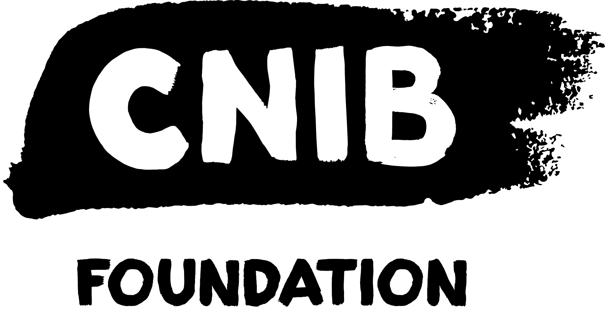
Disclaimer
This content is provided as general information and is not legal advice. If you need advice about a specific legal problem, contact a lawyer or a community legal service.
Acknowledgements
Thank you to the Law Foundation of Newfoundland and Labrador and The Law Foundation of Ontario for making the Know Your Rights – Newfoundland and Labrador Project possible. While financially supported by a grant from the Law Foundation of Newfoundland and Labrador and a grant from The Law Foundation of Ontario’s Access to Justice Fund, CNIB is solely responsible for all content.
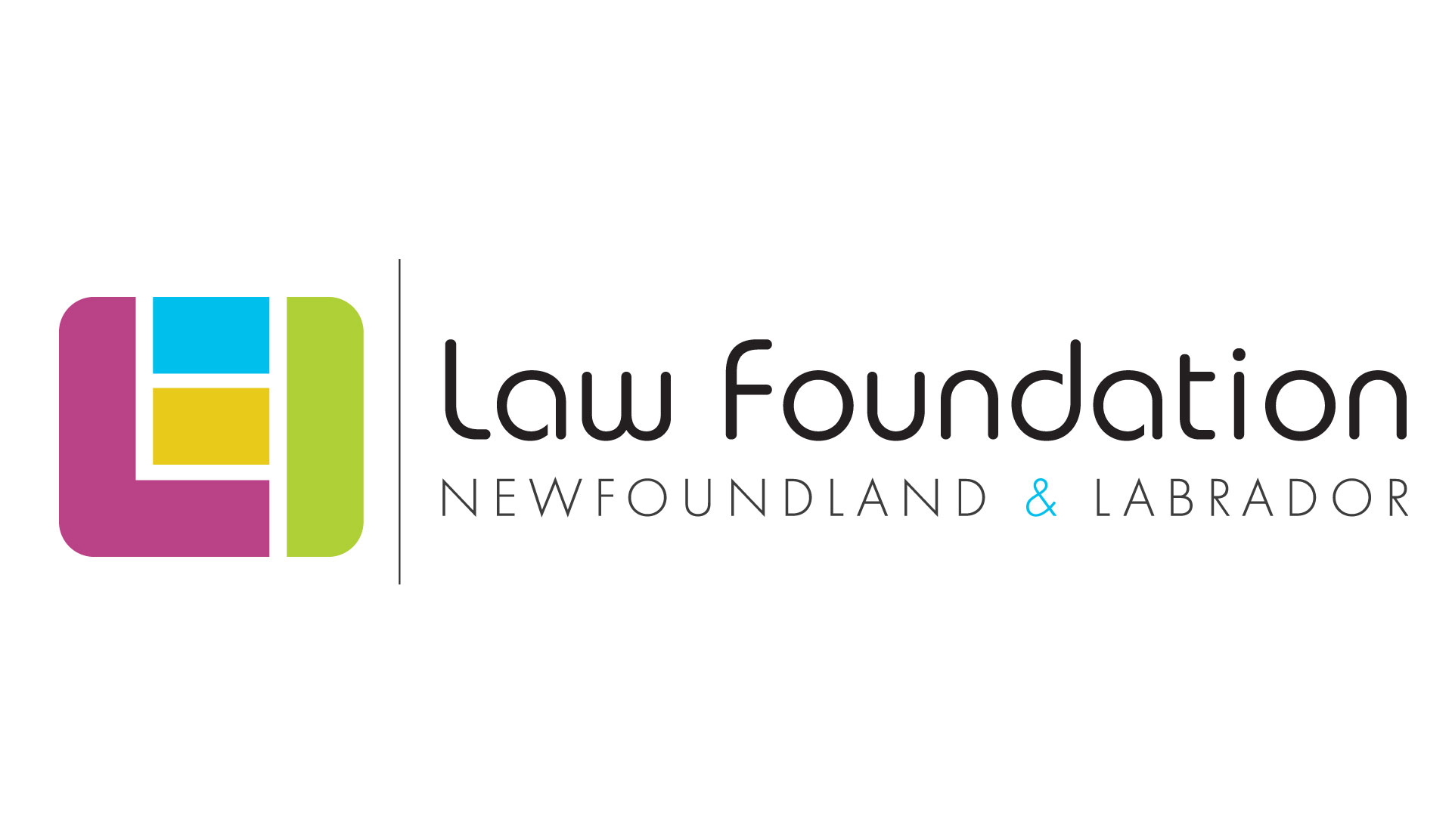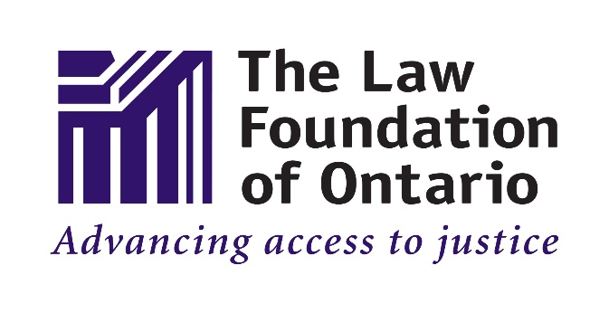
Thank you also to the Public Legal Information Association of NL (PLIAN) for their dedication and provision of in-kind legal research.
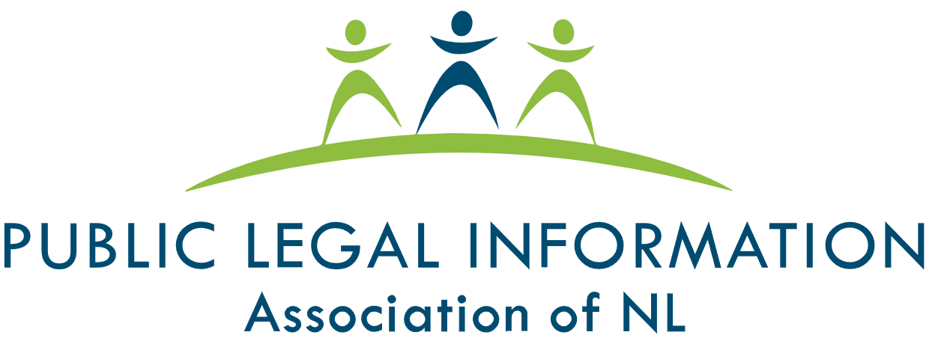
Thank you as well to the many individual volunteers who contributed to the development of this legal information handbook, particularly the Focus Group and Working Group participants.
To learn more about the Know Your Rights – Newfoundland and Labrador Project, please visit our Know Your Rights – Newfoundland and Labrador webpage.

Table of Contents
My Legal Rights 5
Q: What legal rights do I have when it comes to education in Newfoundland and Labrador? 5
Duty to Accommodate & Undue Hardship 5
Q: Where do my legal rights come from? 6
Q: Who must comply with Newfoundland and Labrador’s laws related to education? 7
Q: What can I do to enforce my legal rights? 7
Common Scenarios 9
Elementary and Secondary School 9
Q: My child will be starting school. What can I do to ensure that my child's sight loss is accommodated? 9
Q: The school board implemented an accommodation plan to support my child's sight loss. I don’t agree with the school board's approach to accommodations. What can I do? 11
Parents with Sight Loss 12
Q: My child's school has sent me written information that is not in an accessible format. Due to my sight loss, I'm unable to read the communication. What can I do? 12
Post-secondary Programs 12
Q: I've been accepted to a post-secondary institution, but I'm uncertain about what steps I need to take to have my sight loss accommodated. 12
Q: Despite my requests, I have not received the accommodations that I require. What can I do? 14
Q: My post-secondary institution has advised me that I am required to secure and pay for my own accommodations. Is this true? 15
Q: The accommodations that have been put in place by my post-secondary institution are inadequate. Am I entitled to receive alternative/upgraded accommodations? 16
Getting Help 16
Legal Services and Information 16
Essential Non-Legal Services 18
Library Services 20
CNIB Services (Non-Legal) 20
Vision Loss Rehabilitation 22
Wayfinding 23

My Legal Rights

Q: What legal rights do I have when it comes to education in Newfoundland and Labrador?
A: Under Newfoundland and Labrador laws, people with disabilities have important legal rights when it comes to education.
Students' Rights
- You have the right to receive an education equal to your peers without discrimination because of your disability.
- You have the right to receive accommodations for your disability from your educational institution up to the point of undue hardship.
- You have the right to challenge administrative decisions made about you by schools, school boards and other educational institutions
Parents/Guardians' Rights
- Parents have the right to be informed of their child’s attendance, behaviour and progress
- Parents have the right to request that they be consulted with respect to their child’s education program. In general, teachers are expected to comply with this request
- Parents have the right to appeal decisions made by school officials
- Parents with disabilities have the right to receive accommodations from their child's school up to the point of undue hardship

Duty to Accommodate & Undue Hardship
An educational institution’s legal “duty to accommodate” means that they are legally required to provide you with the supports you need to receive an equal level of education to your peers. The term “accommodation” is not easily defined and will vary from case-to-case, however, accommodations should be customized to meet your needs.
The duty to accommodate, however, has a limit and this limit is called "undue hardship. “Undue hardship” is a legal term. It means that if an educational institution can show that it is very difficult for them to provide you with a certain type of accommodation, then they don’t have to provide it.
It’s usually difficult for an educational institution to claim undue hardship because they have to show clear, direct evidence of undue hardship that is not based upon assumptions or stereotypes. While the determination of what constitutes undue hardship is case-specific, some of the commonly considered factors include:
1. Whether the cost of the accommodation is so high that it will interfere with the educational institutions ability to operate.
2. Whether the accommodation will create serious health and safety risks.
3. The overall size of the educational institution.
Even if an educational institution shows that a certain type of accommodation will create undue hardship for them, they may still have a legal duty to provide you with the next best type of accommodation.

Q: Where do my legal rights come from?
A: Your legal rights relating to education in Newfoundland and Labrador come from the following laws:
- Newfoundland and Labrador’s Human Rights Act, which prohibits discrimination based on disability in most areas of public life, including education. Newfoundland and Labrador’s Human Rights Act applies to all educational institutions in Newfoundland and Labrador, including elementary and secondary schools (both public and private) and post-secondary institutions.
- Newfoundland and Labrador’s Schools Act, 1997, which governs public schools and elements of private schools in Newfoundland and Labrador.
- Common Law – Laws that are made by the decisions of Courts, Boards and Tribunals.
Your legal rights relating to post-secondary education come from a variety of different laws, including:
- Newfoundland and Labrador’s Human Rights Act
- Newfoundland and Labrador’s Memorial University Act
- Newfoundland and Labrador’s College Act, 1996
- Newfoundland and Labrador’s Private Training Institutions Act

Q: Who must comply with Newfoundland and Labrador’s laws related to education?
A: Students and staff, schools, educational institutions, and the Newfoundland and Labrador government are required to comply with Newfoundland and Labrador’s education laws. This includes:
- People: Deans, professors, principals, vice-principals, teachers, other school officials, parents/guardians and students
- Schools:
  - Primary and secondary schools (private and public)
  - School Boards
- Universities and colleges, including private colleges, trade schools, and professional accreditation courses
- Newfoundland and Labrador’s provincial government, including the Department of Education

Q: What can I do to enforce my legal rights?
A: If you feel you or your child have been unfairly discriminated against by an educational institution, there are things you can do to stand up for yourself.
In general, you should first try to resolve your concerns by speaking with the people who are directly involved in an informal and collaborative way.
For more resources on self-advocacy, please visit the Self-Advocacy and Essential Legal Information Handbook on CNIB’s Know Your Rights – Newfoundland and Labrador webpage.
If your concerns can't be addressed through collaborative discussions, you should consider consulting with a lawyer who practices human rights or education law to determine whether any of the following options are appropriate:
- A complaint to the Newfoundland and Labrador Human Rights Commission
- A complaint to the Newfoundland and Labrador Teachers’ Association
- A complaint to the Office of the Citizens’ Representative
The Office of the Citizens’ Representative can investigate complaints against provincial government departments and other agencies that are overseen by the provincial government, including educational institutions.
- A claim before a Newfoundland and Labrador Court
You can also contact staff at the Newfoundland and Labrador Human Rights Commission by phone at 1-800-563-5808 (toll-free), by email at humanrights@gov.nl.ca, or online. Staff cannot provide you with legal advice, however, they can help you understand your legal rights and options. They can also assist with self-advocacy or refer you to other community or government services.
Additionally, you may want to consider contacting the Office of the Child and Youth Advocate - Newfoundland & Labrador.

Common Scenarios
Even though there are laws to protect you from being discriminated against, people with disabilities still face barriers to receiving an education that is equal to their peers.
This section describes barriers that are commonly experienced and suggests practical next steps. Keep in mind that in most situations, you should first try to resolve your concerns by speaking with the people who are directly involved in an informal and collaborative way.

Elementary and Secondary School

Q: My child will be starting school. What can I do to ensure that my child's sight loss is accommodated?
A: All children in Newfoundland and Labrador have the right to receive an education that is equal to their peers without discrimination because of disability.

Plan Ahead
When preparing to register your child for school, it’s important to plan ahead. Contact your child’s school or the appropriate regional office in advance of enrollment to discuss the ways in which your child's disability can be accommodated.
The School's Duty to Accommodate
Upon learning of your child's disability, either through you bringing it to their attention, or through an educator's observations, the school becomes legally obligated to accommodate your child up to the point of undue hardship.
When discussing your child's sight loss and requesting accommodations, it’s important for you to provide the school with as much information about your child's disability as is necessary to establish your child's need for accommodations and to ensure that appropriate accommodations are provided.
In most cases, schools are expected to provide children with individual accommodations that allow for the child's full participation and integration in the classroom environment. Examples of accommodations may include:
- Receiving school materials in an accessible format
- The use of assistive technology
- Adaptations to teaching strategies
- Changes to the built environment
- Services from an itinerant teacher
When communicating with the school, it’s important to keep in mind that your relationship with the school will be long lasting and that collaboration is key to ensuring that your child thrives in an educational environment.
To learn more about accommodations in school settings, visit the Department of Education’s Exceptionality webpage.

Children and Self-Advocacy
Once your child has been registered for school, encourage your child to advocate for themselves by letting you and their teacher know when they're having difficulties due to their sight loss. This will be helpful in determining whether adjustments need to be made to accommodations and how to best meet their current and future educational needs.

Q: The school board implemented an accommodation plan to support my child's sight loss. I don’t agree with the school board's approach to accommodations. What can I do?

A: Schools are required to develop and implement accommodations that will best meet your child's needs up to the point of undue hardship. Schools are not legally obligated to ensure that your child's accommodation is "perfect" or to provide your child with your “preferred” accommodation because there may be an alternative accommodation that responds to your child's needs just as well.
If the school or school board proposes an accommodation that you have concerns about or disagree with, consider requesting a meeting with your child's teacher, vice-principal or principal to better understand or to challenge the position of the school. As a parent, you have the right to request that you be consulted about your child’s education program. If this request is not accommodated or the matter is not resolved, consider following up with the school board about your concerns.
For more resources on self-advocacy, please visit the Self-Advocacy and Essential Legal Information Handbook on CNIB’s Know Your Rights – Newfoundland and Labrador webpage.
It’s important to keep in mind that you have the right to appeal decisions made by school officials. The appeal process will vary depending upon which school official made the decision, however, the timeline for appealing decisions is generally brief (15 days from the day that you are informed of the decision).
In such circumstances, consider consulting with a lawyer who practices education or human rights law to see what options may be available to you. You can also contact CNIB, the Office of the Child and Youth Advocate - Newfoundland & Labrador, and/or Atlantic Provinces Special Education Authority (APSEA) for additional support.

Parents with Sight Loss

Q: My child's school has sent me written information that is not in an accessible format. Due to my sight loss, I'm unable to read the communication. What can I do?
A: As a parent, the school has a legal duty to accommodate your sight loss up to the point of undue hardship. Once you've made your sight loss known to the school, you can request that the school communicate with you using accessible formats, such as:
- Email
- Accessible .pdf documents
- Microsoft Word documents

Post-secondary Programs

Q: I've been accepted to a post-secondary institution, but I'm uncertain about what steps I need to take to have my sight loss accommodated.
A: Like elementary and secondary schools, post-secondary institutions have a duty to accommodate students’ disabilities up to the point of undue hardship.
Unlike elementary and secondary schools, however, post-secondary institutions will not review your educational process to see if you need accommodation. Post-secondary students carry more responsibility to advocate for themselves to ensure they receive the accommodation they need.
When registering at a post-secondary institution, it’s important to be proactive. Many post-secondary institutions (including the College of North Atlantic and Memorial University) have an accessibility services department or provide accessibility services through a student services department. Contact your school’s accessibility department as soon as possible, and as early as when you accept an offer of admission, so that you can start the process of securing accommodations right away. In circumstances where your post-secondary institution doesn’t have an accessibility services department, consider contacting the institution directly, and as soon as possible, to discuss accommodations.
When you inform your post-secondary institution of your disability, it triggers their legal duty to accommodate you up to the point of undue hardship. Your institution may ask for medical documentation about your disability. While they have a right to ask for this information, you only need to provide information that explains your need for accommodations. You are not required to tell them your exact diagnosis and you are not required to provide information that is not related to your need for accommodations.
It’s important to remember that selecting appropriate accommodations is a collaborative process. As a student requesting an accommodation, you have a duty to work with your educational institution to help them select an appropriate accommodation. You will need to work closely with the post-secondary institution to ensure that the accommodations are sufficient and that they are implemented in a timely manner.

Self-Advocacy Tips for Post-Secondary Students
Here are some helpful tips to keep in mind when advocating for yourself in a post-secondary setting:
- If you are 21 or younger, consider informing the Atlantic Provinces Special Education Authority (APSEA) of your plans. If you meet APSEA's eligibility criteria, APSEA can be helpful in facilitating your transition from high school to a post-secondary institution.
- Inform the post-secondary institution about your need for accommodations as early as possible to ensure there's enough time to develop and implement the most appropriate accommodations.
- You are expected to know what kinds of accommodations you require to receive an equal education to your peers.
- Emailing or introducing yourself to your instructors in advance of the class start date can help make the class accessible from the start.
- If you need the course materials to be adapted or transcribed, be proactive. Determine what materials you’ll need well in advance of the start date and coordinate transcription services as soon as possible
- Many post-secondary institutions have Accessibility Services departments that coordinate accommodations for students with accessibility needs. These departments can also assist you by connecting you with other resources – for example, bursaries and grants for people with disabilities.

Q: Despite my requests, I have not received the accommodations that I require. What can I do?
A: Under Newfoundland and Labrador law, educational institutions have a legal duty to provide you with accommodations for your sight loss up to the point of undue hardship. Educational institutions are also expected to deal with any accommodation requests promptly.
Many post-secondary institutions have an Accessibility Services department that should be able to assist you with securing accommodations. If you find, however, that you are still not receiving appropriate accommodations in a timely manner, you may want to meet in person with your instructor or the department / faculty administration to discuss your concerns. Consider reiterating your need for accommodations with a written request. If the issue remains unresolved, consider following-up with the post-secondary institution's internal supervisory body.
Keep in mind that in situations where there are delays with implementing the most appropriate accommodation, post-secondary institutions still have a duty to provide you with a temporary or “next best” accommodation to ensure your educational needs are met in the interim.
For more resources on self-advocacy, please visit the Self-Advocacy and Essential Legal Information Handbook on CNIB’s Know Your Rights – Newfoundland and Labrador webpage.
If your concerns are not resolved, consider consulting with a lawyer who practices education or human rights law to see what options may be available to you. You can also contact CNIB and/or Atlantic Provinces Special Education Authority (APSEA) for additional support.

Q: My post-secondary institution has advised me that I am required to secure and pay for my own accommodations. Is this true?
A: The development and implementation of accommodations is a collaborative process that will involve you, your post-secondary institution, and in some cases, third-party professionals. While you are expected to know what kind of accommodations you require, this does not mean that you are responsible for securing accommodations on your own. That said, you may be responsible for certain aspects of your accommodation plan, such as applying for grant funding or following up with certain people to ensure accommodations are in place.
Many post-secondary institutions (including the College of North Atlantic and Memorial University) have an Accessibility Services Department that should be able to assist you with the accommodation process. You can also contact CNIB and/or Atlantic Provinces Special Education Authority (APSEA) for additional support.
When it comes to the cost of accommodations, your post-secondary institution has a legal duty to provide you with accommodations up to the point of undue hardship, at no cost to you. That said, to assist in the accommodation plan, you may be expected to apply for financial assistance, including government grants that are offered to students with disabilities.
If your post-secondary institution refuses to provide and/or pay for your accommodations, consider speaking with a lawyer, who practices human rights or education law about the legal options that may be available to you. You can also contact CNIB and/or Atlantic Provinces Special Education Authority (APSEA) for additional support.

Q: The accommodations that have been put in place by my post-secondary institution are inadequate. Am I entitled to receive alternative/upgraded accommodations?

A: Yes. The educational institution's legal duty to accommodate you up to the point of undue hardship continues throughout the time that you are a student at the educational institution. It generally only ends when you leave the educational institution or no longer require accommodations.

If you have received accommodations that are no longer working, it’s important to advise your educational institution of the issues as soon as possible so that steps can be taken to develop and implement new/upgraded accommodations that will meet your needs. Keep in mind that the development of accommodations is a collaborative process that will involve you, the educational institution, and in some cases, third party professionals.
In circumstances where there will be delays with implementing the most appropriate accommodation, postsecondary institutions still have a duty to provide you with a temporary or “next best” accommodation to ensure your educational needs are met in the interim.

Getting Help

Legal Services and Information
Legal Aid NL
Legal Aid NL provides legal services to low-income earners in Newfoundland and Labrador. In order to receive services from Legal Aid NL, you must meet their eligibility requirements.
To apply for Legal Aid and/or to learn more, visit Legal Aid NL’s Frequently Asked Questions webpage.
The Public Legal Information Association of Newfoundland and Labrador (PLIAN)
PLIAN is an independent non-profit organization and registered charity dedicated to educating Newfoundlanders and Labradorians about the law.
As part of its commitment to increasing and improving access to justice, PLIAN provides free legal information on a variety of topics on its website, including (but not limited to) residential tenancies, family law, and wills and estates.
PLIAN also operates the Legal Information Line and Lawyer Referral Service. Through this service, callers can receive general legal information and assistance with navigating the legal system. Clients can also receive referrals to lawyers who are registered with the Lawyer Referral Service. Lawyers who register with this service provide clients with an initial 30-minute consultation at a cost of $40.00 (taxes included).
If you are in Newfoundland, you may contact the Legal Information Line and Lawyer Referral Service as follows:
- Via telephone at: 1-888-660-7788 (toll free) or 709-722-2643
- Via email at: info@publiclegalinfo.com or a2j@publiclegalinfo.com
If you are in Labrador, you may contact the Legal Information Line and Lawyer Referral Service as follows:
- Via telephone at: 709-896-5235
- Via email at: labrador@publiclegalinfo.com
The Newfoundland and Labrador Human Rights Commission
The Newfoundland and Labrador Human Rights Commission is an independent government agency that is responsible for protecting human rights in Newfoundland and Labrador and administering the province’s Human Rights Act.
The Commission investigates and resolves human rights complaints, provides individuals, groups and organizations with legal information about human rights, and prevents discrimination through education and learning.
The Commission also creates various public education resources (including Guidelines and Frequently Asked Questions pages) to assist people in Newfoundland and Labrador with better understanding their rights.
For more information about the complaint process, visit the Newfoundland and Labrador Human Rights Commission’s website or contact the Commission online, by phone at 1-800-563-5808 (toll-free), or by email at humanrights@gov.nl.ca. Commission staff cannot provide legal advice, however, they can help you understand your legal rights and options. They can also assist with self-advocacy or refer you to other community or government services.

Essential Non-Legal Services
Office of the Citizens’ Representative

The Office of the Citizens’ Representative provides a province-wide ombudsman service.
The primary work of the Office of the Citizens’ Representative is to accept complaints from citizens who feel they have been treated unfairly by government offices and agencies. The Office of the Citizens’ Representative investigates complaints against provincial government departments and other agencies that are overseen by the provincial government.
The Office of the Citizens’ Representative can also undertake complaints that study how governmental policies, procedures, and actions can affect a large number of people. These are called systemic complaints and can result in recommendations that have a much broader impact.
You may contact the Office of the Citizens’ Representative by phone at 1-800-559-0079 (toll-free) or by email at citrep@gov.nl.ca to discuss a concern or make a complaint.

Office of the Child and Youth Advocate of Newfoundland and Labrador
The Office of the Child and Youth Advocate of Newfoundland and Labrador is an independent office of the House of Assembly, whose job is to ensure that children’s rights are respected and protected. Some of the services offered by the Office of the Child and Youth Advocate include:
- Individual advocacy
- Systemic advocacy
- Investigating and reviewing complaints
- Providing education on children’s rights
You may contact the Office of the Child and Youth Advocate by phone at (709) 753-3888 or 1 (877) 753-3888 (toll-free) or by email at office@ocya.nl.ca.
To learn more, visit the Office of the Child and Youth Advocate’s Frequently Asked Questions page.
Atlantic Provinces Special Education Authority (APSEA)
APSEA is an inter-provincial agency that is jointly funded by the governments of New Brunswick, Nova Scotia, Prince Edward Island and Newfoundland and Labrador.
APSEA provides free support to students, aged 0-21, who have hearing loss and/or sight loss. To determine if you are eligible to receive services from APSEA, you can refer to their Eligibility for Service page on their website.
APSEA provides support in many different forms, including:
- in-school and in-classroom support to improve accommodations
- advocating for students within school settings
- developing resources for educators that work with children and youth who have sight loss
APSEA also has a Production and Library Services department that provides students with alternate format materials to support their instructional needs.
The Government of Newfoundland and Labrador’s Department of Education
The Department of Education provides leadership and direction with respect to early childhood development, regulated childcare, the kindergarten to grade 12 education system, public libraries, and post-secondary education.
The Department of Education’s website contains a list of guidelines, policies and practices regarding the education of children in kindergarten through grade 12. It also contains information regarding exceptionalities and a Handbook for Parents of Children with Exceptionalities.
You may contact the Department of Education by phone at (709) 729-5097 or by email at education@gov.nl.ca.
National Educational Association of Disabled Students (“NEADS”)
National Educational Association of Disabled Students (“NEADS”) is a national charity that advocates for full access to education and employment for post-secondary students with disabilities. Among many other resources, NEADS offers a guide on how to enhance the accessibility of post-secondary institutions.

Library Services
The Centre for Equitable Library Access and National Network for Equitable Library Service provide information about library services that are available to Canadians with print disabilities.

CNIB Services (Non-Legal)
We’re here to help – contact CNIB for more services, support, and resources. Some ways we can assist include:
- CNIB provides teachers and other school officials with education and instruction in Unified English Braille and best practices to use when interacting with people who have sight loss.
- Children and Youth Programs
  - Helps participants develop self-advocacy skills as they pursue their education.
- CNIB Virtual Programs
  - CNIB offers a range of free virtual programs for children, youth, adults and families.
  - You can access a list of CNIB’s national virtual program offerings on CNIB’s website.
  - You can access a list and schedule of CNIB Newfoundland and Labrador’s virtual program offerings on CNIB – Newfoundland and Labrador’s website.
- Technology Training
  - Join CNIB tech leads from across the country for programming that highlights the suite of programs, apps, products and services that will help empower you to achieve your personal and professional goals.
- Virtual Vision Mate
  - The Virtual Vision Mate program exists to address the feelings of isolation that many people with sight loss experience. Through the Virtual Vision Mate program, Canadians who are blind or partially sighted are connected with sighted volunteers to engage in virtual, weekly conversations.
- CNIB Online SmartLife Store
  - CNIB SmartLife is an interactive retail experience that gives people with disabilities hands-on access to the latest breakthroughs in assistive technologies, as well as tried-and-true favourites.
  - SmartLife’s goal is not necessarily to sell products but to give customers the skills and confidence they need to make the most out of assistive tools that can help them lead better lives.
- CNIB's Advocacy Staff
  - CNIB's Advocacy staff can assist clients with advocating for themselves and understanding their human rights in Newfoundland and Labrador.

- CNIB's Guide Dog Program
  - CNIB’s Guide Dog Program can assist guide dog handlers with advocating for themselves and understanding their rights. This program also provides public education to organizations about the rights of guide dog users.
- CNIB’s PREP (Practical Readiness for Employment and Post-Secondary) Program
  - CNIB provides assistance with post-secondary education and employment planning, as well as ongoing support. To learn more about CNIB’s PREP Program, you can contact CNIB’s St. John’s office by phone at 1-709-754-1180 or by email at infonl@cnib.ca.

Vision Loss Rehabilitation
Vision Loss Rehabilitation Canada (VLRC) is a not-for-profit national healthcare organization and the leading provider of rehabilitation therapy and healthcare services for individuals with sight loss. VLRC provides people with the practical skills they need to live safely and independently. VLRC’s services are tailored to the unique needs and goals of each person. VLRC’s services include, but are not limited to:
- Assistance with navigating new environments and using mobility tools
- Assistance with maximizing remaining vision with optical and non-optical devices
- Assistance with developing or restoring key daily living skills, such as learning new ways to cook, shop and manage your home
- Assistance with accessing information and using technology
VLRC has offices located in St. John’s, Grand Falls-Windsor, and Corner Brook. You can contact VLRC by phone at:
- St. John’s or Grand Falls-Windsor Office - 709-754-1180
- Corner Brook Office - 709-639-9167 ext. 5850 or 5851

Wayfinding
Wayfinding refers to technological tools that assist partially sighted, blind and Deafblind persons with navigation and orientation. Such tools include:
- BlindSquare: a GPS-app developed for people with sight loss that describes the environment and announces points of interest and street intersections.
- Key 2 Access: a pedestrian mobility app that allows users to wirelessly request crossing at intersections without having to locate the button on the pole. It also allows users to wirelessly open doors and obtain information about indoor spaces.
- Access Now: a map application that shares accessibility information for locations based on users' feedback.
- Be My Eyes: a volunteer-based app that connects people with sight loss to sighted volunteers, who can assist with tasks such as checking expiry dates, distinguishing colors, reading instructions or navigating new surroundings.
- The American Foundation for the Blind, which provides an overview of some of the apps that are available to assist consumers with reading items such as product labels and menus.



cnib.ca | info@cnib.ca | 1-800-563-2642

