Built Environment
Know Your Rights – Legal Information Handbook



June 2022
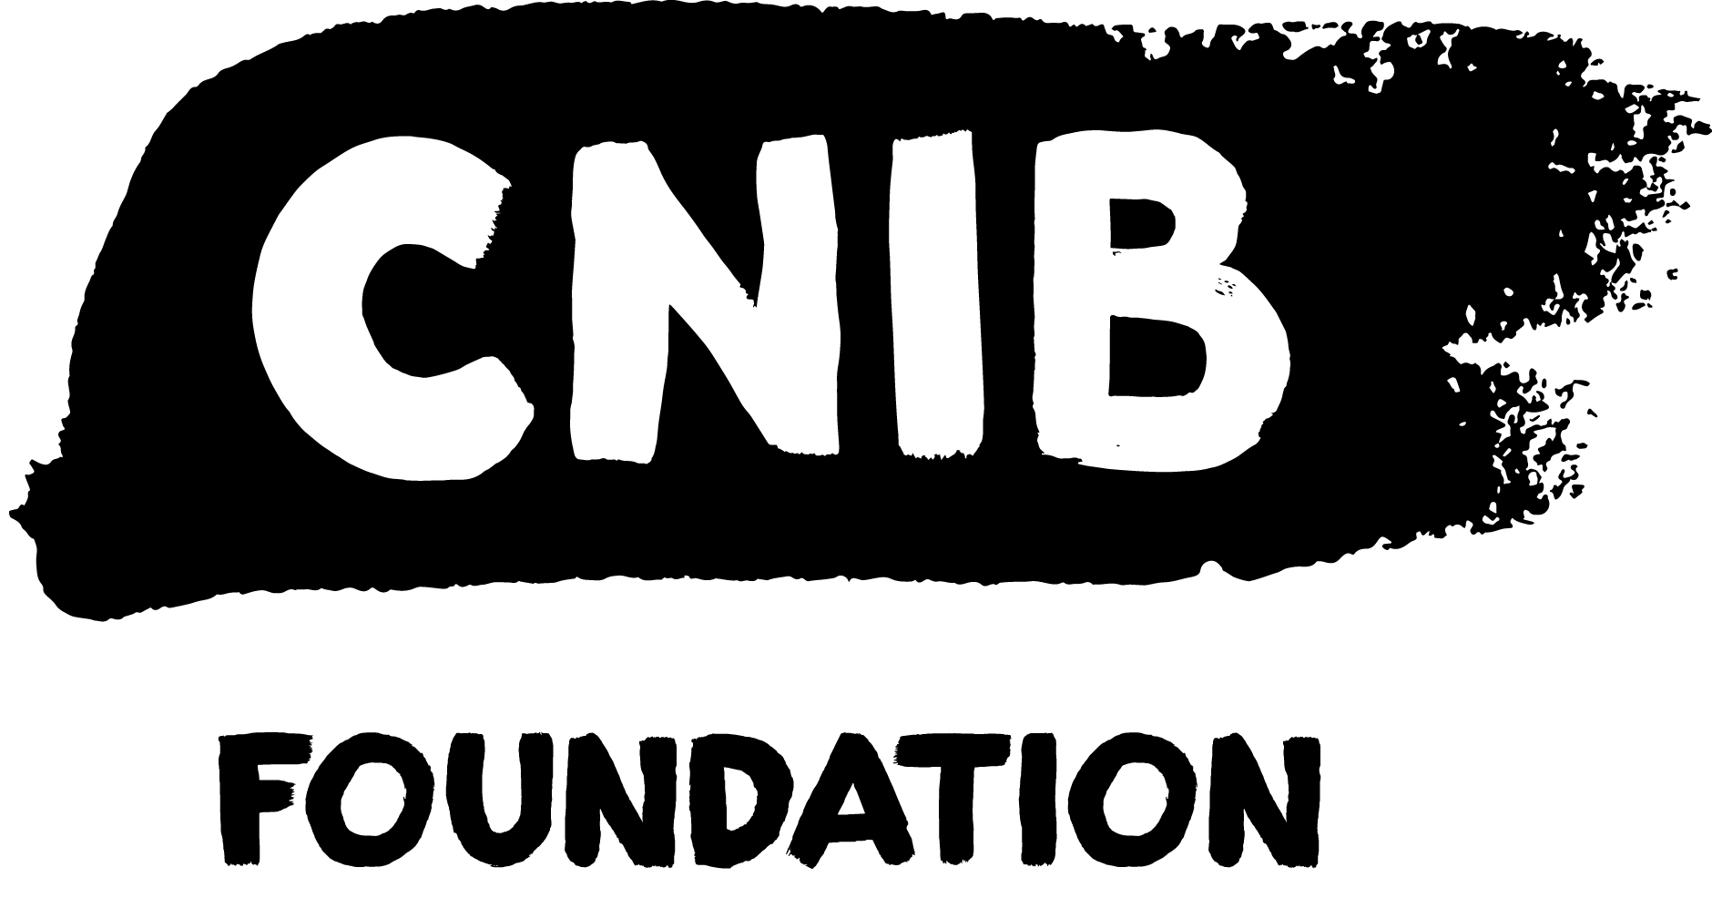
Disclaimer
This content is provided as general information and is not legal advice. If you need advice about a specific legal problem, contact a lawyer or a community legal service.
Acknowledgements
Thank you to the Law Foundation of Prince Edward Island and The Law Foundation of Ontario for making the Know Your Rights – Prince Edwards Island Project possible. While financially supported by a grant from the Law Foundation of Prince Edward Island and a grant from The Law Foundation of Ontario’s Access to Justice Fund, CNIB is solely responsible for all content. 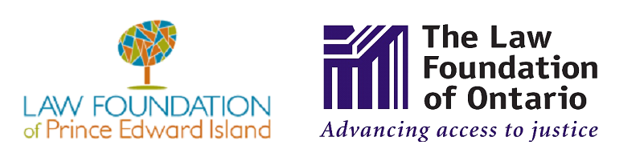
Thank you also to the wonderful teams at McInnes Cooper and Pro Bono Students Canada for their dedication and provision of in-kind legal research and writing.

Thank you as well to the many individual volunteers who contributed to the development of this legal information handbook, particularly the Focus Group and Working Group participants.
To learn more about the Know Your Rights – Prince Edward Island Project, please visit our Know Your Rights – Prince Edward Island webpage.

Table of Contents
My Legal Rights 4
Q: What is the "built environment"? 4
Q: What legal rights do I have when it comes to the built environment in Prince Edward Island (“PEI”)? 4
Q: Where do my legal rights come from? 5
Q: Who must comply with PEI laws relating to the built environment? 6
Q: What can I do to enforce my legal rights? 6
Common Scenarios 7
Q: The Audible Pedestrian Signal (APS) at a crosswalk isn't working. What can I do? 8
Q. In my residential area, I am unable to walk safely down the sidewalk or road, as barriers (such as piled up snow, parked cars, etc.) frequently block my route. What can I do? 8
Q: An outdoor public space that I often use (for example, an outdoor eating area, park, trail, or parking lot) has features that are hazardous and inaccessible. What can I do? 9
Q: I often find that public buildings, such as museums, stadiums, universities, etc. are inaccessible to people with sight loss. For example, in some instances there is no tactile surface to identify staircases and escalators, and in other cases, the elevators do not have audio signals/accessible buttons. This makes it difficult and hazardous to orient myself and navigate safely through these buildings. What can I do? 10
Getting Help 11
Legal Resources 11
Essential Non-Legal Resources 13
CNIB Programs 14
Vision Loss Rehabilitation Canada 15
Wayfinding 15

My Legal Rights

Q: What is the "built environment"?
A: The term "built environment” refers to the many kinds of places, structures and facilities that we live in or use. Examples of the built environment include cities, towns, neighbourhoods, buildings, urban spaces, parks, roads, and walkways.
This handbook will focus on the built environment in public spaces.
To learn more about your legal rights related to housing specifically, please visit the housing section of the Know Your Rights – Prince Edward Island webpage.

Q: What legal rights do I have when it comes to the built environment in Prince Edward Island (“PEI”)?
A: Under PEI laws, people with disabilities have important legal rights when it comes to accessing the built environment:
- You have the right to have a level of access equal to anyone else regarding most public places in the built environment, without discrimination because of your disability.
- In many cases, you have the right to receive accommodations for your disability from the person or organization who is responsible for the public place, up to the point of undue hardship.
- You cannot be denied services or denied access to spaces that are normally available to the public because you are accompanied by a service animal, such as a guide dog.

Duty to Accommodate & Undue Hardship
Under Prince Edward Island human rights laws, you have the right to have an equal level of access to all buildings and public spaces that are generally open to the public.
If an organization has a “duty to accommodate”, it means that they are legally required to provide you with the supports you need to have an equal level of access to a public building or space as anyone else.
“Undue hardship” is a legal term. Generally speaking, it means that if a service provider can show that it is very difficult to provide a certain type of accommodation, then they don’t need to provide it.
It’s important to note that it is not enough for a service provider to simply claim undue hardship. A service provider must show clear evidence of undue hardship. Their evidence can relate to factors such as:
1. Whether the cost of the accommodation is so high that it would significantly interfere with their ability to operate. When calculating cost, they must also consider outside sources of funding, such as grants or subsidies from government programs.
2. Whether the accommodation would create serious health and safety risks for their operations.
3. Whether there have been past unsuccessful efforts to accommodate.
4. Whether the accommodation would compromise the purpose of the service or facility.
However, even if an organization can show that a certain type of accommodation would create undue hardship, they may still have a legal duty to provide you with another type of accommodation.

Q: Where do my legal rights come from?
A: Your legal rights come from a variety of different laws, including:
- PEI’s Human Rights Act, which prohibits discrimination based on disability in most areas of public life, including “services and facilities”, to which members of the public have access. The term “facilities” is not defined in the Act, but could include locations like public parks, recreation centres, malls, stores, government buildings, etc.
- PEI has adopted the National Building Code of Canada into its Building Codes Act, which applies to the design, construction, erection, placement, use and occupancy of new buildings; as well as the alteration, demolition, reconstruction and relocation. The Act ensures all buildings meet minimum standards for public health, fire protection, structural sufficiency, and accessibility for people with disabilities.
- The National Building Code of Canada aims to ensure that buildings can be approached, entered, and used by persons with physical or sensory disabilities.
- Common Law – Laws that are made by the decisions of Courts, Panels or Tribunals.

Q: Who must comply with PEI laws relating to the built environment?
A: The PEI Human Rights Act prohibits discrimination with respect to any service, accommodation, facility, benefit, or program available or accessible to the public.
Examples of services that form part of the built environment include stores, theatres, sports facilities, government buildings, food banks, and schools.
Individuals and organizations that build, maintain, or provide services to the public in the built environment in PEI must comply with PEI laws relating to the built environment, including:
- Individual owners, employers, and employees
- Private businesses such as stores or restaurants
- Non-profit organizations
- Government organizations like municipalities, ministries, and agencies

Q: What can I do to enforce my legal rights?
A: If you feel that you have been unfairly discriminated against when accessing or trying to access part of the built environment, there are things you can do to stand up for yourself.
In general, you should first try to resolve your concerns by speaking with the people and organizations who are directly involved in an informal and collaborative way.
For more resources on self-advocacy, please visit the Self-Advocacy and Essential Legal Information Handbook on CNIB’s Know Your Rights – Prince Edward Island webpage.
If your concerns can't be addressed through collaborative discussions, you should consider consulting with a lawyer who practices human rights law to determine whether any of the following options are appropriate:
- A formal complaint with the company, building manager, or government body in charge of the space.
- A complaint to your local municipal government regarding enforcement of bylaws and policies.
- A complaint to the PEI Human Rights Commission.
- A complaint to the Canadian Human Rights Commission.
- A complaint to the PEI Ombudsperson.
The PEI Ombudsperson investigates complaints from people who feel that they have been treated unfairly by (among others) officers or employees of the government, municipalities, Health PEI, and council members. Before making a complaint to the PEI Ombudsperson, you should first try to resolve your issue through any complaint process offered by the organization involved.
- A claim before a PEI Court.
You can also contact the PEI Human Rights Commission by phone at 902-368-4180. Commission staff cannot offer opinions on the outcome of your complaint, nor can they advise as to whether it will be successful, however, they can provide information as to what the law states and how it may apply to a given situation.

Common Scenarios
Even though there are laws to protect you from discrimination, people with disabilities still face barriers to having an equal level of access to the built environment.
This section describes barriers that are commonly experienced and suggests practical next steps. Keep in mind that in most situations, you should first try to resolve your concerns by speaking with the people who are directly involved in an informal and collaborative way.

Q: The Audible Pedestrian Signal (APS) at a crosswalk isn't working. What can I do?
A: Audible Pedestrian Signals (“APS”) are becoming more common in PEI. Municipalities are responsible for making repairs to traffic lights and APS systems, so if you find an APS that’s not working, consider reporting the problem to the Public Works department of the municipality.
If your city or municipality does not have a dedicated Public Works department, contact the city or municipality’s general phone line, and advise them that you are calling to report an accessibility hazard in a public space.
You can also contact 2-1-1 PEI. It maintains a database of contact information and related services for most municipalities in PEI and may be able to connect you with the appropriate department.

Q. In my residential area, I am unable to walk safely down the sidewalk or road, as barriers (such as piled up snow, parked cars, etc.) frequently block my route. What can I do?
A: Municipal governments are responsible for maintaining sidewalks and roadways. You may wish to contact the city or municipal clerk’s office to report your concern.
You can also contact 2-1-1 PEI. It maintains a database of contact information and related services for most municipalities in PEI and may be able to connect you with the appropriate department.
In preparation for reporting your concern, you may wish to take pictures of the barriers that prevent you from walking safely in your neighbourhood. This will provide the city or municipality with a clear sense of issue and help them determine whether the barriers are the result of any by-law infractions.
For more resources on self-advocacy, please visit the Self-Advocacy and Essential Legal Information Handbook on CNIB’s Know Your Rights – Prince Edward Island webpage.
If your issue remains unresolved, you may wish to consult with a lawyer who practices human rights law to discuss the options that might be available to you. You can also reach out to CNIB for additional support.

Q: An outdoor public space that I often use (for example, an outdoor eating area, park, trail, or parking lot) has features that are hazardous and inaccessible. What can I do?
A: Under PEI’s Human Rights Act all members of the public are entitled to have equal access and enjoyment of facilities and services that are normally available to the public without discrimination because of disability. This includes outdoor public spaces.
If you want to try to address the issue or advocate for change, try to find out what organization owns or manages the outdoor space. For example, if you are concerned about areas inside of a local park that are inaccessible, try to find out whether the park is owned by your municipality, a government agency or some other organization. 2-1-1 PEI may be able to assist with this.
Once you have determined which organization owns or manages the outdoor space, contact the organization directly to discuss a resolution and ongoing accommodations. If this doesn't help, you can gradually escalate your complaint – for example, through an official complaint process or to higher levels of management.
For more resources on self-advocacy, please visit the Self-Advocacy and Essential Legal Information Handbook on CNIB’s Know Your Rights – Prince Edward Island webpage.
Community organizations, like CNIB, may have experience with the issue you’re facing and may be able to support you in developing an advocacy plan or helping you speak with the owners of an outdoor space in a collaborative way.
If your concerns remain unresolved, consider consulting with a human rights lawyer to see what options may be available to you.

Q: I often find that public buildings, such as museums, stadiums, universities, etc. are inaccessible to people with sight loss. For example, in some instances there is no tactile surface to identify staircases and escalators, and in other cases, the elevators do not have audio signals/accessible buttons. This makes it difficult and hazardous to orient myself and navigate safely through these buildings. What can I do?
A: There are now many technological tools that can help people navigate and orient themselves within buildings.
If these kinds of technological tools don’t meet your needs and you require immediate assistance, you may wish to approach or contact an employee or manager of the building for assistance. When you speak with an employee or manager, explain the difficulties you are experiencing and the support you require to safely navigate through the building. When you disclose your disability to an employee, you trigger that organization’s legal duty to accommodate you to the point of undue hardship. If the employee or manager is reluctant to provide assistance, you can politely remind them of your right to be accommodated.
In circumstances where you will be frequenting the building often, consider contacting the organization directly to explore ongoing accommodation options. If your request for accommodations is refused, you can gradually escalate your complaint – for example, through an official complaint process. Many government organizations and large private companies have a designated person responsible for accessibility who can assist you.
For more resources on self-advocacy, please visit the Self-Advocacy and Essential Legal Information Handbook on CNIB’s Know Your Rights – Prince Edward Island webpage.
If your concerns remain unresolved, consider consulting with a lawyer about the options that may be available to you.
Note: PEI has adopted the National Building Code of Canada into its Building Codes Act to ensure that all buildings meet minimum standards in regards to (among other things) accessibility for people with disabilities. The Building Codes Act includes specific accessibility requirements and applies to the design, construction, erection, placement, use and occupancy of new buildings. It also applies to the alteration, demolition, reconstruction and relocation of buildings that existed prior the enactment of the Building Codes Act.

Getting Help

Legal Resources
PEI Human Rights Commission
The PEI Human Rights Commission is an independent office of the government of PEI that is responsible for receiving and investigating complaints of discrimination to determine if PEI’s Human Rights Act has been contravened.
Before filing a complaint with the Commission, the Commission’s website suggests you first read their guide for making complaints
The Commission also educates the public about human rights through seminars and workshops; and, prepares and distributes Fact Sheets to assist the public in understanding PEI’s Human Rights Act.
You can contact the PEI Human Rights Commission by phone at 902-368-4180. Commission staff cannot offer opinions on the outcome of your complaint, nor can they advise as to whether it will be successful, however, they can provide information as to what the law states and how it may apply to a given situation.
The Law Society of PEI
The Law Society of PEI oversees the legal profession in PEI. The Law Society is the only body that is authorized to determine who may become a lawyer in the province, and is responsible for responding to complaints about lawyers. The Law Society also has a find a lawyer tool that enables the public to search for lawyers.

Community Legal Information (CLI)
The Community Legal Information (CLI) is a not-for-profit organization that provides legal information and education to residents of PEI. CLI develops programs and resources to help individuals better understand PEI’s legal system, and how to resolve their legal issues.
CLI can help members of the public by providing general legal information, suggesting resources, and telling people about different options for obtaining legal advice.
CLI also operates the Law Inquiry Line in addition to offering lawyer referrals. Individuals who contact CLI can receive:
- legal information,
- referrals to law-related agencies, and
- referrals to lawyers, when appropriate. Individuals who contact the Lawyer Referral Service will receive a referral to a lawyer, who will provide a 45-minute consult at a cost of $25.00.
CLI can be contacted through its website or by telephone at 902-892-0853 or 1-800-240-9798.
Legal Aid PEI
Legal Aid PEI provides legal services to low-income PEI residents in the areas of criminal law, family law, and some civil law matters, including child protection law, involuntary hospitalization under mental health laws, guardianship, and adult protection. Depending on the availability of resources, some assistance may be offered in other civil law areas as well.
When determining whether individuals are eligible for Legal Aid services, Legal Aid PEI considers several factors, including:
- Financial eligibility (which varies, depending on income and family size),
- Urgency and seriousness of the legal needs,
- Coverage and resources of the Legal Aid Program, and
- The individual’s ability to obtain legal assistance if Legal Aid is refused.

PEI Supreme Courts
The PEI Supreme Courts website provides general information about how Courts in PEI operate, and what to expect if you are attending Court.
It also provides information about the Pro Bono Legal Advice Clinic (for Self-Represented Litigants) Prince Edward Island. The Pro Bono Legal Advice Clinic is a free-of-charge legal clinic for self-represented individuals whose family or civil law matter is before the Supreme Court of Prince Edward Island or the Prince Edward Island Court of Appeal. The clinic is held every Wednesday from 9:00AM – 12:00PM at the Sir Louis Henry Davies Law Courts, 42 Water Street, Charlottetown. People who access this service can meet with a lawyer for a 45-minute consultation. Appointments can be scheduled by phone at 902-368-6005, 902-892-0853 or 1-800-240-9798.

Essential Non-Legal Resources
PEI Ombudsperson
The PEI Ombudsperson is an independent office of the Legislative Assembly of PEI. The Ombudsperson conducts independent, impartial and non-partisan investigations of complaints against:
- Boards, commissions, associations and other bodies,
- Health PEI,
- Municipalities,
- Council members,
- Board members, and
- Officers and employees of the Government
The PEI Ombudsperson aims to promote fairness and transparency in the public sector, find fair resolutions, and make recommendations to improve the practices of public agencies.

PEI 211
PEI 211 is a free, confidential service that operates 24 hours a day, seven days a week. It exists to connect individuals to government, health and social services that are available across PEI. The service helps residents of PEI who are looking to find the right community or social resource, but do not know where to start. Individuals can also contact 2-1-1 to report some by-law infractions.
In addition to searching on the 211 PEI website, there are various ways for people to contact PEI 211, including calling 2-1-1 to talk with trained professionals to help identify the services that they need.
Services are grouped together into various categories, including (among others) legal, education and disabilities.

CNIB Programs
We’re here to help – contact CNIB for more programs, support, and resources. Some ways we can assist include:
- CNIB Virtual Programs
  - CNIB offers a range of free virtual programs for children, youth, adults and families.
  - You can access a list of CNIB’s virtual program offerings on CNIB’s website. You can also find a list and schedule of PEI’s virtual program offerings on CNIB’s PEI website.
- Technology Training
  - Join CNIB tech leads from across the country for programming that highlights the suite of programs, apps, products and services that will help empower you to achieve your personal and professional goals.
- Virtual Vision Mate
  - The Virtual Vision Mate program exists to address the feelings of isolation that many people with sight loss experience. Through the Virtual Vision Mate program, people who are blind or partially sighted are connected with sighted volunteers to engage in virtual, weekly conversation.
- CNIB SmartLife
  - CNIB SmartLife is an interactive retail experience that gives people with disabilities hands-on access to the latest breakthroughs in assistive technologies, as well as tried-and-true favourites.
  - SmartLife’s goal is not necessarily to sell products but is to give customers the skills and confidence they need to make the most out of assistive tools that can help them lead better lives.
- CNIB Guide Dogs
  - CNIB Guide Dogs can assist guide dog handlers with advocating for themselves and understanding their rights. This program also provides public education to organizations to provide knowledge about the rights of guide dog users.

Vision Loss Rehabilitation Canada
Vision Loss Rehabilitation Canada (“VLRC”) is a not-for-profit national healthcare organization and the leading provider of rehabilitation therapy and healthcare services for individuals with vision loss. VLRC’s services are tailored to the unique needs and goals of each person they assist. Specifically, VLRC certified specialists provide a range of services that help individuals with vision loss lead more independent, active lives.
You can contact VLRC’s PEI office by phone at 902-566-2580.

Wayfinding
Wayfinding refers to technological tools that assist people who are blind, partially sighted or Deafblind with navigation and orientation. Such tools include:
- BlindSquare: a GPS-app developed for people with sight loss that describes the environment and announces points of interest and street intersections.
- Key 2 Access: a pedestrian mobility app that allows users to wirelessly request crossing at intersections without having to locate the button on the pole. It also allows users to wirelessly open doors and obtain information about indoor spaces.
- Access Now: a map application that shares accessibility information for locations based on users' feedback.
- Be My Eyes: a volunteer-based app that connects people with sight loss to sighted volunteers, who can assist with tasks such as checking expiry dates, distinguishing colors, reading instructions or navigating new surroundings.
- The American Foundation for the Blind, which provides an overview of some of the apps that are available to assist consumers with reading items such as product labels and menus.



cnib.ca | info@cnib.ca | 1-800-563-2642

