The Built Environment
Know Your Rights – Legal Information Handbook


August 2022
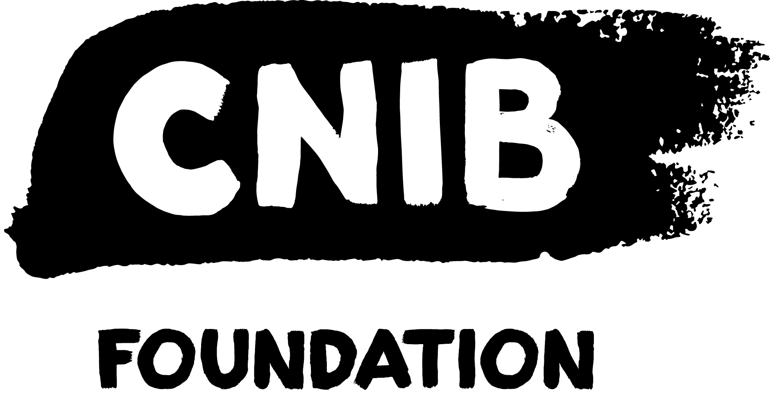
Disclaimer
This content is provided as general information and is not legal advice. If you need advice about a specific legal problem, contact a lawyer or a community legal service.
Acknowledgements
Thank you to the Law Foundation of Newfoundland and Labrador and The Law Foundation of Ontario for making the Know Your Rights – Newfoundland and Labrador Project possible. While financially supported by a grant from the Law Foundation of Newfoundland and Labrador and a grant from The Law Foundation of Ontario’s Access to Justice Fund, CNIB is solely responsible for all content.
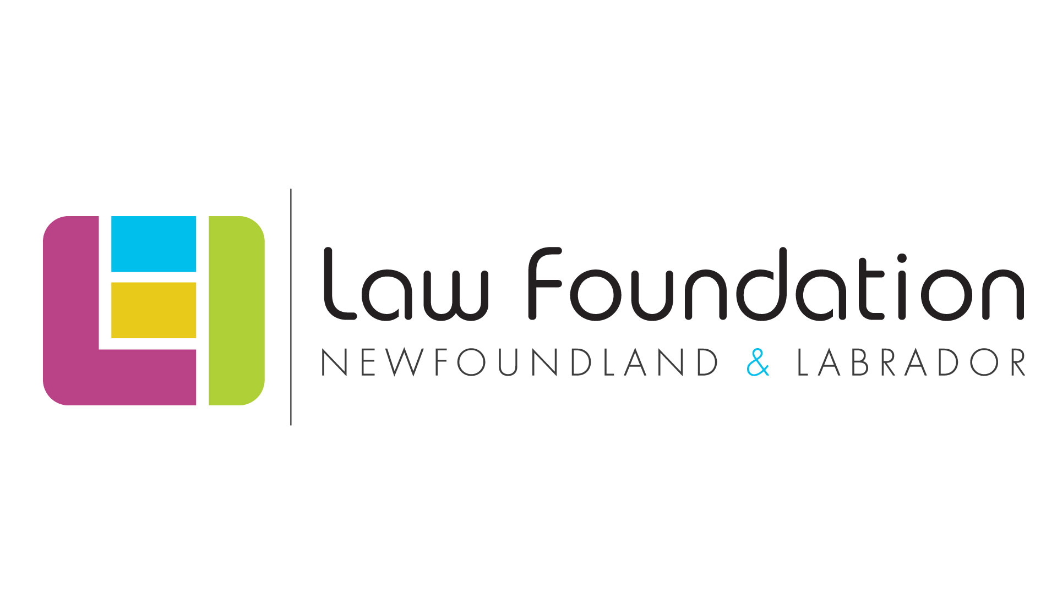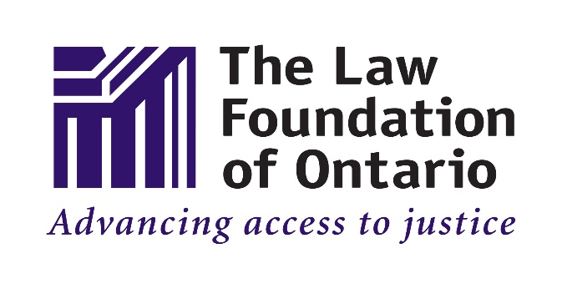
Thank you also to the Public Legal Information Association of NL (PLIAN) for their dedication and provision of in-kind legal research.
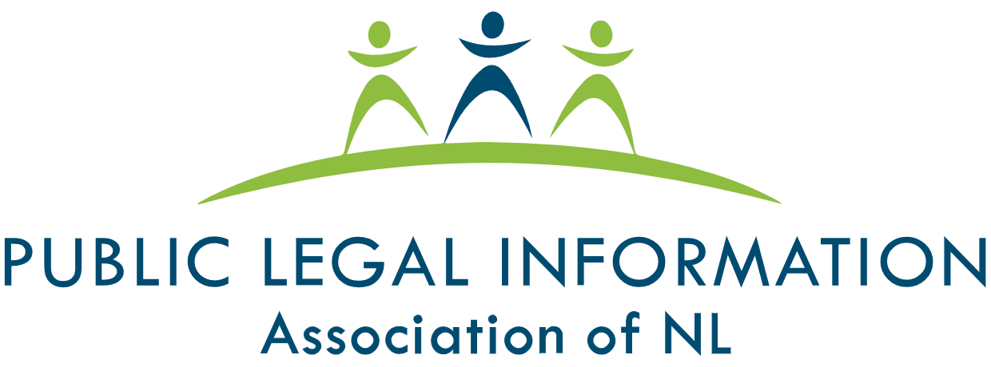
Thank you as well to the many individual volunteers who contributed to the development of this legal information handbook, particularly the Focus Group and Working Group participants.
To learn more about the Know Your Rights – Newfoundland and Labrador Project, please visit our Know Your Rights – Newfoundland and Labrador webpage.
Table of Contents
My Legal Rights 4
Q: What is the "built environment"? 4
Q: What legal rights do I have when it comes to the built environment in Newfoundland and Labrador? 4
Duty to Accommodate & Undue Hardship 4
Q: Where do my legal rights come from? 5
Q: Who must comply with Newfoundland and Labrador's laws relating to the built environment? 6
Q: What can I do to enforce my legal rights? 6
Common Scenarios 8
Outdoor Spaces 8
Q: The Accessible Pedestrian Signal (APS) at a crosswalk isn't working. What can I do? 8
Q: An outdoor public space that I use (for example, an outdoor eating area, park, trail, or parking lot) has features that are hazardous and inaccessible. What can I do? 8
Inside Buildings 9
Q: Due to my sight loss, I sometimes have difficulty orienting myself in buildings. What can I do? 9
Q: The elevator that I use in a building doesn't have accessible buttons. What can I do? 10
Construction & Hazards 11
Q: Temporary construction barriers are obstructing a sidewalk/building entrance that I commonly use. I do not feel safe navigating through the construction site. What can I do? 11
Q: I'm unable to use a sidewalk because it's blocked by a hazard, such as piled up snow. What can I do? 11
Getting Help 13
Legal Services and Information 13
Essential Non-Legal Services 15
CNIB Services (Non-Legal) 15
Vision Loss Rehabilitation 17
Wayfinding 17
More Resources 18

My Legal Rights

Q: What is the "built environment"?
A: The term "built environment" refers to the many kinds of places, structures and facilities that we live in or use. Examples of the built environment include cities, towns, neighbourhoods and all kinds of buildings, urban spaces, parks, roads, and walkways.
This handbook will focus on the built environment in public spaces.
To learn more about your legal rights related to housing specifically, please visit the Housing Legal Information Handbook on our Know Your Rights – Newfoundland and Labrador webpage.

Q: What legal rights do I have when it comes to the built environment in Newfoundland and Labrador?
A: Under Newfoundland and Labrador laws, people with disabilities have important legal rights when it comes to accessing the built environment:
- You have the right to have an equal level of access as anyone else to most public places in the built environment, without discrimination because of your disability.
- You have the right to receive accommodations for your disability from the person or organization who is responsible for the public place, up to the point of undue hardship.
- You cannot be denied services or denied access to spaces that are normally available to the public because you are accompanied by a service animal, such as a guide dog.

Duty to Accommodate & Undue Hardship
If an organization has a “duty to accommodate”, it means that they are legally required to provide you with the supports you need to have an equal level of access to a public building or space as anyone else.
The term "accommodation" is not easily defined and will vary from case-to-case, however, accommodations should be customized to meet your needs.
The duty to accommodate, however, does have a limit and this limit is called "undue hardship". “Undue hardship” is a legal term. It means that if an organization can show that it is very difficult for them to provide you with a certain type of accommodation, then they don’t have to provide it.
It’s usually difficult for an organization to claim undue hardship because they have to show clear, direct evidence of undue hardship that is not based upon assumptions or stereotypes. While the determination of what constitutes undue hardship is case-specific, commonly considered factors include:
- Whether the cost of the accommodation is so high that it will significantly interfere with the organization's ability to operate; and
- Whether the accommodation will create serious health and safety risks.
Even if an organization shows that a certain type of accommodation will create undue hardship for them, they may still have a legal duty to provide you with the next best type of accommodation.

Q: Where do my legal rights come from?
A: Your legal rights come from a variety of different laws, including:
- Newfoundland and Labrador’s Human Rights Act, which prohibits discrimination based on disability in most areas of public life, including places where “accommodation, services or facilities” are provided to the public. The term “facilities” includes locations like public parks, recreation centres, malls, stores, government buildings, etc.
- Newfoundland and Labrador’s Service Animal Act, which prohibits discrimination against people who rely upon service animals, such as guide dogs.
- The Canadian Human Rights Act, which prohibits discrimination based on disability in most areas of public life where the federal government has authority.
- Common Law – Laws that are made by the decisions of Courts, Boards and Tribunals.
These laws may also be relevant to your situation:
- The Buildings Accessibility Act, which applies to the construction of new buildings and to the reconstruction or renovation of older buildings. The purpose of this Act is to create greater accessibility and ensure that people with disabilities have equal access to public buildings, apartment-type buildings, hotels and building links.
- The National Building Code of Canada, which aims to ensure that buildings subject to the code can be approached, entered, and used by persons with physical or sensory disabilities.
- Newfoundland and Labrador’s Accessibility Act, which is designed to improve accessibility by identifying, preventing and removing barriers in various area of public life, including the built environment.
To learn more about the Accessibility Act, visit the Government of Newfoundland and Labrador’s Accessibility Act webpage.
- The Accessible Canada Act, which is a Federal law that is designed to remove and prevent barriers in various areas of public life, including federally regulated parts of the built environment.
- Municipal by-laws, policies and guidelines

Q: Who must comply with Newfoundland and Labrador's laws relating to the built environment?
A: People and all kinds of organizations that build, maintain or provide services to the public in the built environment in Newfoundland and Labrador, including:
- Individual owners and employees
- Private businesses and non-profits
- Government organizations like municipalities, ministries, and agencies

Q: What can I do to enforce my legal rights?
A: If you feel you have been unfairly discriminated against when accessing or trying to access part of the built environment, there are things you can do to stand up for yourself.
In general, you should first try to resolve your concerns by speaking with the people and organizations who are directly involved in an informal and collaborative way.
For more resources on self-advocacy, please visit the Self-Advocacy and Essential Legal Information Handbook on CNIB’s Know Your Rights – Newfoundland and Labrador webpage.
If your concerns can’t be addressed through collaborative discussions, you may want to consider consulting with a lawyer, who specializes in human rights law to see if any of the following options are appropriate:
- A formal complaint with the company, building manager, or government body in charge of the space.
- A complaint to your local municipal government regarding enforcement of bylaws or policies.
- A complaint to the Newfoundland and Labrador Human Rights Commission
- A complaint to the Canadian Human Rights Commission
- A complaint to the Office of the Citizens’ Representative
The Office of the Citizens’ Representative can investigate complaints against provincial government departments and other agencies that are overseen by the provincial government.
- A claim before a Newfoundland and Labrador Court.
- A complaint to the police at a non-emergency number (in circumstances where your rights under the Service Animal Act are violated)
You can also contact staff at the Newfoundland and Labrador Human Rights Commission by phone at 1-800-563-5808 (toll-free), by email at humanrights@gov.nl.ca, or online. Staff cannot provide you with legal advice, however, they can help you understand your legal rights and options. They can also assist with self-advocacy or refer you to other community or government services.

Common Scenarios
Even though there are laws to protect you from discrimination, people with disabilities still face barriers to having an equal level of access to the built environment.
This section describes barriers that are commonly experienced and suggests practical next steps. Keep in mind that, in most situations, you should first try to resolve your concerns by speaking with the people who are directly involved in an informal and collaborative way.

Outdoor Spaces

Q: The Accessible Pedestrian Signal (APS) at a crosswalk isn't working. What can I do?
A: If you find an APS that’s not working, consider reporting the problem to your municipality as soon as possible. Municipalities are generally responsible for making repairs to traffic lights and APS systems.
If you live in the city of St. John’s, you can report your concern to Access St. John's by calling 3-1-1 or 709-754-2489. You can also contact 211 Newfoundland and Labrador, which may be able to connect you with the appropriate service.

Q: An outdoor public space that I use (for example, an outdoor eating area, park, trail, or parking lot) has features that are hazardous and inaccessible. What can I do?
A: Under Newfoundland and Labrador laws, all members of the public are entitled to have an equal level of access as anyone else to facilities and services that are normally available to the public without discrimination because of disability. This includes outdoor public spaces.
If you’d like to try to address the issue or advocate for change, try to find out what organization owns or manages the outdoor space. For example, if you are concerned about areas inside of a local park that are inaccessible, try to find out whether the park is owned by your municipality or some other organization. 211 Newfoundland and Labrador may be able to assist with this.
Once you have determined which organization owns or manages the outdoor space, contact the organization directly to discuss a resolution and ongoing accommodations. If this doesn't help, you can gradually escalate your complaint – for example, through an official complaint process or to higher levels of management.
For more resources on self-advocacy, please visit the Self-Advocacy and Essential Legal Information Handbook on CNIB’s Know Your Rights – Newfoundland and Labrador webpage.
Community organizations, like CNIB, may have experience with the issue you’re facing and may be able to support you in developing an advocacy plan or helping you speak with the owners of an outdoor space in a collaborative way.
If your concerns remain unresolved, consider consulting with a human rights lawyer to see what options are available to you.

Inside Buildings

Q: Due to my sight loss, I sometimes have difficulty orienting myself in buildings. What can I do?
A: There are now many technological tools that can help people navigate and orient themselves within buildings. If these kinds of technological tools don’t meet your needs, you should approach an employee or manager of the building for assistance.
When you speak with an employee or manager, explain that you are having trouble with navigation or orientation because of your sight loss. Explain what assistance you require in as much detail as possible. When you disclose your disability to an employee, you trigger that organization’s legal duty to accommodate you up to the point of undue hardship.
If the employee or manager is reluctant or refuses to accommodate you, you can politely remind them that they have a legal duty to provide you with accommodations so that you’re able to experience an equal level of access to the building as anyone else.
If this does not help, you can gradually escalate your complaint – for example, through an official complaint process or to the organization’s management team.
For more resources on self-advocacy, please visit the Self-Advocacy and Essential Legal Information Handbook on CNIB’s Know Your Rights – Newfoundland and Labrador webpage.
If your concerns remain unaddressed, consider consulting with a human rights lawyer to see what options are available to you. You can also connect with CNIB to develop an advocacy strategy.

Q: The elevator that I use in a building doesn't have accessible buttons. What can I do?
A: There are now many technological tools that can help people use services, like elevators, that might otherwise be inaccessible. If these kinds of technological tools don’t meet your needs, your next steps will likely depend on how often you use this particular elevator.
If you use the elevator only rarely (for example, if you are visiting the building for a one-time meeting), consider asking for help from those around you to locate building staff, like a security guard, employee, or building manager. When you speak with building staff, explain that you are having trouble with the elevator because of your sight loss. Explain what assistance you require in as much detail as possible. When you disclose your disability to an employee, you trigger that organization’s legal duty to accommodate you to the point of undue hardship.
If you use the elevator more frequently (for example, you often have business meetings in a particular building), consider contacting building management directly to explore options for ongoing accommodation. If this does not help, you can gradually escalate your complaint – for example, to an organization’s management team or through an official complaint process. Many government organizations and large private companies have a designated person responsible for accessibility who can assist you.
For more resources on self-advocacy, please visit the Self-Advocacy and Essential Legal Information Handbook on CNIB’s Know Your Rights – Newfoundland and Labrador webpage.
If your concerns remain unresolved, consider consulting with a lawyer who practises human rights law to see what options may be available to you. You can also connect with community organizations, like CNIB, to develop an advocacy strategy.

Construction & Hazards

Q: Temporary construction barriers are obstructing a sidewalk/building entrance that I commonly use. I do not feel safe navigating through the construction site. What can I do?
A: Since the laws about accessibility around construction sites are complex, you may need to get help from a lawyer to know what your legal rights are in this type of situation. That said, there are some steps you can begin to take on your own.
As a first step, you may want to try to find out what organizations are involved in the construction – for example, the name of the construction company and the name of the building’s owner or manager. Other organizations might also be relevant to your situation, for example:
- If the building is your place of work, your employer may have a duty to help you secure an appropriate accommodation.
- If you visit the building to access a particular store or service, that service provider may have a duty to help you secure an appropriate accommodation.
You may also want to contact the municipality to learn more about by-law or building permit requirements related to accessibility around construction sites.
This information can help a legal professional determine what laws apply to your specific situation. Community organizations, like CNIB, may also have advocacy experience with the issue you’re facing and may be able to support you in developing an advocacy plan.

Q: I'm unable to use a sidewalk because it's blocked by a hazard, such as piled up snow. What can I do?
A: In Newfoundland and Labrador, municipalities are generally responsible for maintaining the safety of their sidewalks and roads. That said, if snow is piled up on a sidewalk in front of a commercial building, then the owner/lessee of the building may be responsible for the removal of the snow.
Immediate Assistance
In circumstances where the concern is immediate, contact the municipality to report your concern.
If you live in the city of St. John’s, you can report your concern to Access St. John's by calling 3-1-1 or 709-754-2489. You can also contact 211 Newfoundland and Labrador, which may be able to connect you with the appropriate service.
When you speak with a customer service representative, explain that you want to speak with someone about a potentially hazardous accessibility issue in a public space. The customer service representative will either address your concern or connect you with the appropriate person.
Ongoing Advocacy
If the blocked sidewalk remains an ongoing issue, contact the municipality to explore possible resolutions and ongoing accommodation. In such circumstances, a bylaw enforcement officer may be able to assist. If this does not help, you can gradually escalate your complaint – for example, to an official complaint process.
For more resources on self-advocacy, please visit the Self-Advocacy and Essential Legal Information Handbook on CNIB’s Know Your Rights – Newfoundland and Labrador webpage.
If your concerns remain unaddressed, consider consulting with a human rights lawyer to see what options are available to you. You can also connect with community organizations, like CNIB, to develop an advocacy strategy.

Getting Help

Legal Services and Information
Legal Aid NL
Legal Aid NL provides legal services to low-income earners in Newfoundland and Labrador. In order to receive services from Legal Aid NL, you must meet their eligibility requirements.
To apply for Legal Aid and/or to learn more, visit Legal Aid NL’s Frequently Asked Questions webpage.
The Public Legal Information Association of Newfoundland and Labrador (PLIAN)
PLIAN is an independent non-profit organization and registered charity dedicated to educating Newfoundlanders and Labradorians about the law.
As part of its commitment to increasing and improving access to justice, PLIAN provides free legal information on a variety of topics on its website, including (but not limited to) residential tenancies, family law, and wills and estates.
PLIAN also operates the Legal Information Line and Lawyer Referral Service. Through this service, callers can receive general legal information and assistance with navigating the legal system. Clients can also receive referrals to lawyers who are registered with the Lawyer Referral Service. Lawyers who register with this service provide clients with an initial 30-minute consultation at a cost of $40.00 (taxes included).
If you are in Newfoundland, you may contact the Legal Information Line and Lawyer Referral Service as follows:
- Via telephone at: 1-888-660-7788 (toll free) or 709-722-2643
- Via email at: info@publiclegalinfo.com or a2j@publiclegalinfo.com
If you are in Labrador, you may contact the Legal Information Line and Lawyer Referral Service as follows:
- Via telephone at: 709-896-5235
- Via email at: labrador@publiclegalinfo.com
The Newfoundland and Labrador Human Rights Commission
The Newfoundland and Labrador Human Rights Commission is an independent government agency that is responsible for protecting human rights in Newfoundland and Labrador and administering the province’s Human Rights Act.
The Commission investigates and resolves human rights complaints, provides individuals, groups and organizations with legal information about human rights, and prevents discrimination through education and learning.
The Commission also creates public education resources (including Guidelines and Frequently Asked Questions pages) to assist people in Newfoundland and Labrador with better understanding their rights.
For more information about the complaint process, visit the Newfoundland and Labrador Human Rights Commission’s website or contact the Commission online, by phone at 1-800-563-5808 (toll-free), or by email at humanrights@gov.nl.ca. Commission staff cannot provide legal advice, however, they can help you understand your legal rights and options. They can also assist with self-advocacy or refer you to other community or government services.
The Canadian Human Rights Commission
The Canadian Human Rights Commission deals with complaints under the Canadian Human Rights Act. For federally regulated services and activities, you may be able to bring a complaint about discrimination based on disability to the Canadian Human Rights Commission.

Essential Non-Legal Services
Office of the Citizens’ Representative

The Office of the Citizens’ Representative provides a province-wide ombudsman service.
The primary work of the Office of the Citizens’ Representative is to accept complaints from citizens who feel they have been treated unfairly by government offices and agencies. The Office of the Citizens’ Representative investigates complaints against provincial government departments and other agencies that are overseen by the provincial government.
The Office of the Citizens’ Representative can also undertake complaints that study how governmental policies, procedures, and actions can affect a large number of people. These are called systemic complaints and can result in recommendations that have a much broader impact than those flowing from individual complaints.
You may contact the Office of the Citizens’ Representative by phone at 1-800-559-0079 (toll-free) or by email at citrep@gov.nl.ca to discuss a concern or make a complaint.

211 Newfoundland and Labrador
211 Newfoundland and Labrador is a free service that operates 24 hours a day, seven days a week. It exists to connect individuals to government, health and social services that are available across Newfoundland and Labrador.
In addition to searching on the 211 Newfoundland and Labrador website, there are various ways to contact 211 Newfoundland and Labrador, including calling 2-1-1 to talk with a representative about the service you require.

CNIB Services (Non-Legal)
We’re here to help – contact CNIB for more services, support, and resources. Some ways we can assist include:

- CNIB Virtual Programs
  - CNIB offers a range of free virtual programs for children, youth, adults and families.
  - You can access a list of CNIB’s national virtual program offerings on CNIB’s website.
  - You can access a list and schedule of CNIB Newfoundland and Labrador’s virtual program offerings on CNIB – Newfoundland and Labrador’s website.
- Technology Training
  - Join CNIB tech leads from across the country for programming that highlights the suite of programs, apps, products and services that will help empower you to achieve your personal and professional goals.
- Virtual Vision Mate
  - The Virtual Vision Mate program exists to address the feelings of isolation that many people with sight loss experience. Through the Virtual Vision Mate program, Canadians who are blind or partially sighted are connected with sighted volunteers to engage in virtual, weekly conversations.
- CNIB Online SmartLife Store
  - CNIB SmartLife is an interactive retail experience that gives people with disabilities hands-on access to the latest breakthroughs in assistive technologies, as well as tried-and-true favourites.
  - SmartLife’s goal is not necessarily to sell products but to give customers the skills and confidence they need to make the most out of assistive tools that can help them lead better lives.
- CNIB's Advocacy Staff
  - CNIB's Advocacy staff can assist clients with advocating for themselves and understanding their human rights in Newfoundland and Labrador.

- CNIB's Guide Dog Program
  - CNIB’s Guide Dog Program can assist guide dog handlers with advocating for themselves and understanding their rights. This program also provides public education to organizations about the rights of guide dog users.

Vision Loss Rehabilitation
Vision Loss Rehabilitation Canada (VLRC) is a not-for-profit national healthcare organization and the leading provider of rehabilitation therapy and healthcare services for individuals with sight loss. VLRC provides people with the practical skills they need to live safely and independently. VLRC’s services are tailored to the unique needs and goals of each person. VLRC’s services include, but are not limited to:
- Assistance with navigating new environments and using mobility tools
- Assistance with maximizing remaining vision with optical and non-optical devices
- Assistance with developing or restoring key daily living skills, such as learning new ways to cook, shop and manage your home
- Assistance with accessing information and using technology
VLRC has offices located in St. John’s, Grand Falls-Windsor, and Corner Brook. You can contact VLRC by phone at:
- St. John’s or Grand Falls-Windsor Office - 709-754-1180
- Corner Brook Office - 709-639-9167 ext. 5850 or 5851

Wayfinding
Wayfinding refers to technological tools that assist partially sighted, blind and Deafblind persons with navigation and orientation. Such tools include:
- BlindSquare: a GPS-app developed for people with sight loss that describes the environment and announces points of interest and street intersections.
- Key 2 Access: a pedestrian mobility app that allows users to wirelessly request crossing at intersections without having to locate the button on the pole. It also allows users to wirelessly open doors and obtain information about indoor spaces.
- Access Now: a map application that shares accessibility information for locations based on users' feedback.
- Be My Eyes: a volunteer-based app that connects people with sight loss to sighted volunteers, who can assist with tasks such as checking expiry dates, distinguishing colors, reading instructions or navigating new surroundings.
- The American Foundation for the Blind, which provides an overview of some of the apps that are available to assist consumers with reading items such as product labels and menus.

More Resources
CNIB Clearing Our Path
CNIB Clearing our Path is a manual for architects, designers, building owners, planners and others interested in making indoor and outdoor spaces universally accessible.



cnib.ca | info@cnib.ca | 1-800-563-2642

