The Built Environment
Know Your Rights – Legal Information Handbook


March 2021
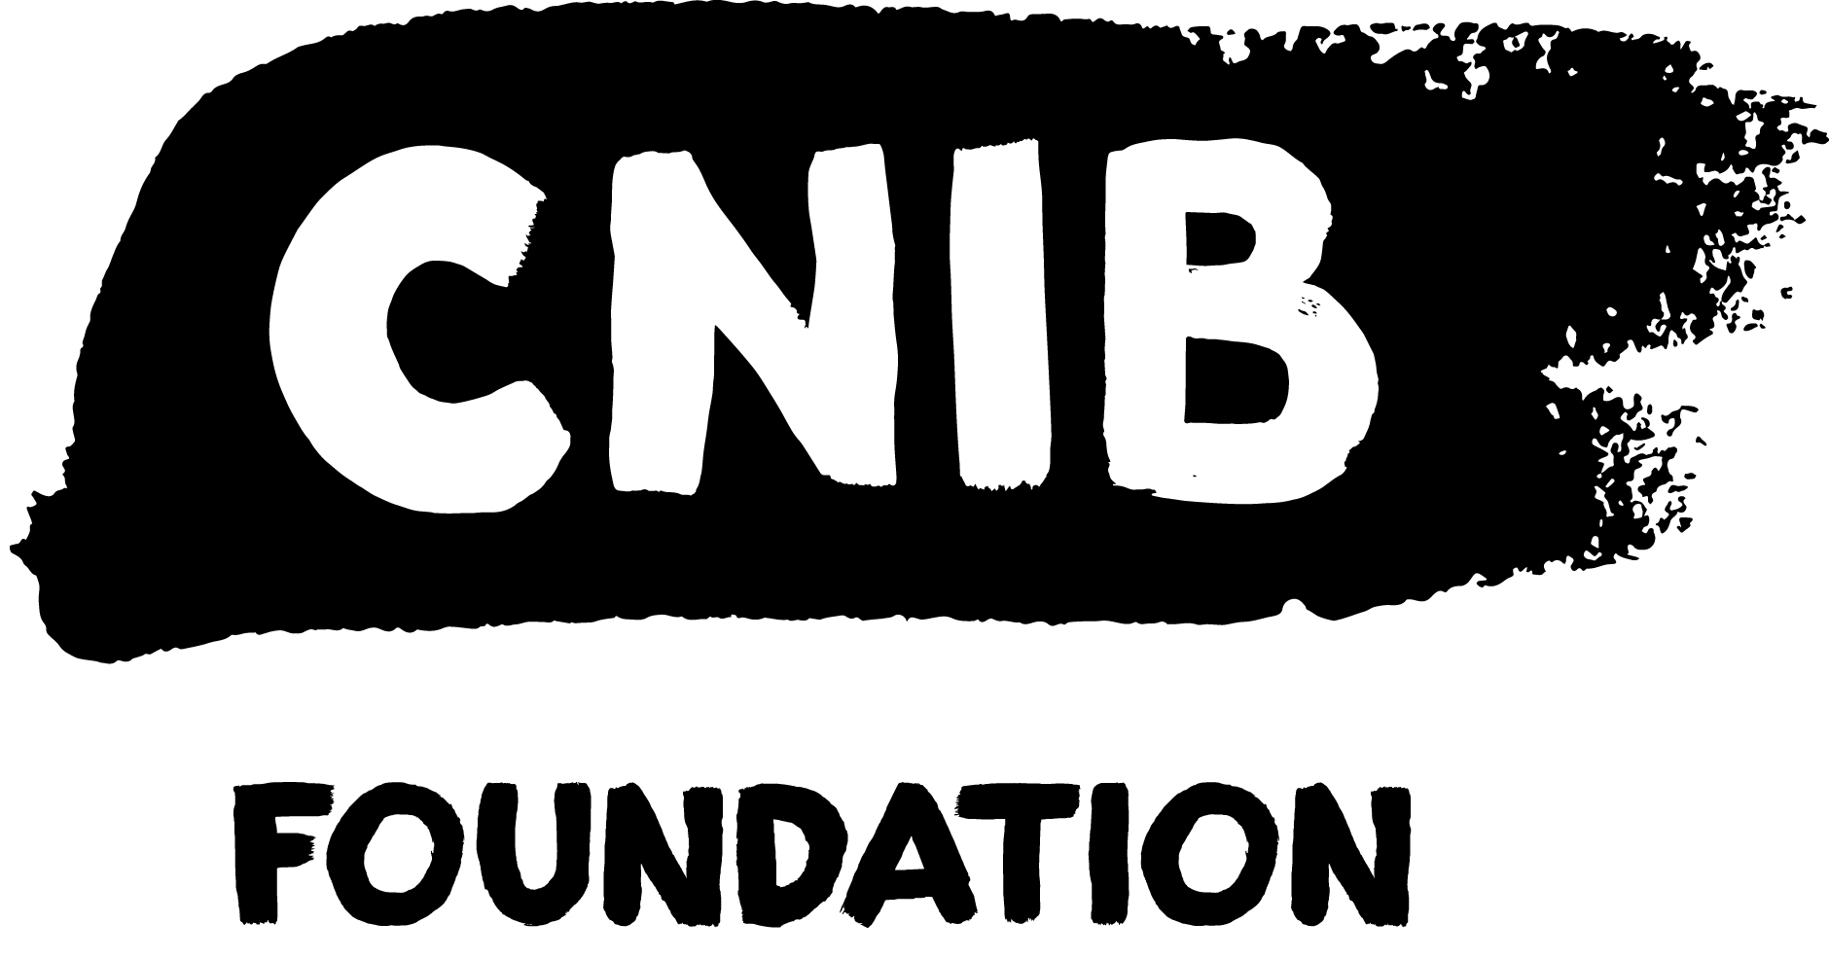
Disclaimer
This content is provided as general information and is not legal advice. If you need advice about a specific legal problem, contact a lawyer or a community legal clinic.
Acknowledgements
Thank you to the New Brunswick Law Foundation and The Law Foundation of Ontario for making the Know Your Rights – New Brunswick Project possible. While financially supported by a grant from the New Brunswick Law Foundation and a grant from The Law Foundation of Ontario’s Access to Justice Fund, CNIB is solely responsible for all content.
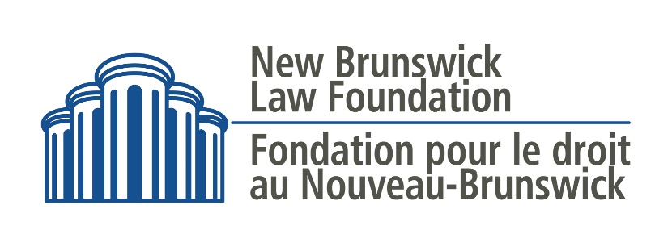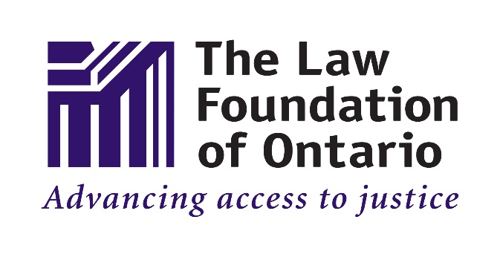
Thank you also to the wonderful teams at McInnes Cooper and Pro Bono Students Canada for their dedication and provision of in-kind legal research and writing.
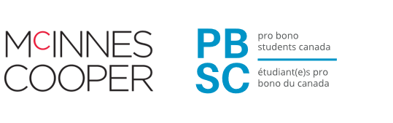
Thank you as well to the many individual volunteers who contributed to the development of this legal information handbook, particularly the Focus Group and Working Group participants.
To learn more about the Know Your Rights – New Brunswick Project, please visit our Know Your Rights – New Brunswick webpage.

Table of Contents
My Legal Rights 5
Q: What is the "built environment"? 5
Q: What legal rights do I have when it comes to the built environment in New Brunswick? 5
Duty to Reasonably Accommodate & Undue Hardship 5
Q: Where do my legal rights come from? 6
Q: Who must comply with New Brunswick's laws relating to the built environment? 7
Q: What can I do to enforce my legal rights? 7
Common Scenarios 9
Outdoor Spaces 9
Q: The Accessible Pedestrian Signal (APS) at a crosswalk isn't working. What can I do? 9
Q: An outdoor public space that I use (for example, an outdoor eating area, park, trail, or parking lot) has features that are hazardous and inaccessible. What can I do? 9
Inside Buildings 10
Q: Due to my sight loss, I sometimes have difficulty orienting myself in buildings. What can I do? 10
Q: The elevator that I use in a building doesn't have accessible buttons. What can I do? 11
Construction & Hazards 12
Q: Temporary construction barriers are obstructing a sidewalk/building entrance that I commonly use. I do not feel safe navigating through the construction site. What can I do? 12
Q: I'm unable to use a sidewalk because it's blocked by a hazard. What can I do? 12
Getting Help 14
Legal Services and Information 14
Fredericton Legal Advice Clinic, Inc. (FLAC) 14
The New Brunswick Legal Aid Services Commission 14
University of New Brunswick (UNB) Legal Clinic 15
Public Legal Education and Information Service of New Brunswick (PLEIS-NB) 15
The New Brunswick Human Rights Commission 16
The Canadian Human Rights Commission 16
Essential Non-Legal Services 17
Ombud N.B. 17
Premier's Council on Disabilities 17
CNIB Services (Non-Legal) 17
• CNIB Virtual Programs 17
• Technology Training 18
• Virtual Vision Mate 18
• CNIB Online SmartLife Store 18
• CNIB's Advocacy Staff 18
• CNIB's Guide Dog Program 19
Vision Loss Rehabilitation 19
Wayfinding 20
More Resources 20

My Legal Rights

Q: What is the "built environment"?
A: The term "built environment" refers to the many kinds of places, structures and facilities that we live in or use. Examples of the built environment include cities, towns, neighbourhoods and all kinds of buildings, urban spaces, parks, roads, and walkways.
This handbook will focus on the built environment in public spaces.
To learn more about your legal rights related to housing specifically, please visit the Housing Legal Information Handbook on CNIB’s Know Your Rights – New Brunswick webpage.

Q: What legal rights do I have when it comes to the built environment in New Brunswick?
A: Under New Brunswick laws, people with disabilities have important legal rights when it comes to accessing the built environment:
- You have the right to have a level of access equal to anyone else regarding most public places in the built environment, without discrimination because of your disability.
- You have the right to receive accommodations for your disability from the person or organization who is responsible for the public place, up to the point of undue hardship.
- You cannot be denied services or denied access to spaces that are normally available to the public because you are accompanied by a service animal, such as a guide dog.

Duty to Reasonably Accommodate & Undue Hardship
If an organization has a “duty to reasonably accommodate”, it means that they are legally required to provide you with the supports you need to have an equal level of access to a public building or space as anyone else.
The term "reasonable accommodation" is not easily defined and will vary from case-to-case, however, accommodations should be customized to meet your needs.
The duty to reasonably accommodate, however, does have a limit and this limit is called "undue hardship". “Undue hardship” is a legal term. It means that if an organization can show that it is very difficult for them to provide you with a certain type of accommodation, then they don’t have to provide it.
It’s usually difficult for an organization to claim undue hardship because they have to show clear, direct evidence of undue hardship that is not based upon assumptions or stereotypes. While the determination of what constitutes undue hardship is case-specific, the more commonly considered factors include:
- Whether the cost of the accommodation is so high that it will significantly interfere with the organization's ability to operate. When calculating cost, consideration should also be given to outside sources of funding, e.g. grants or subsidies from government programs;
- Whether the accommodation will create serious health and safety risks; and
- The impact of the accommodation on other people and programs.
Even if an organization shows that a certain type of accommodation will create undue hardship for them, they may still have a legal duty to provide you with the next best type of accommodation.
Some Important Points about Accommodations:
The development and implementation of accommodations is a collaborative process that involves the organization, the individual seeking accommodations, and in some cases, third-party professionals. While accommodations are expected to be reasonable, they are not expected to be perfect. What this means is that if reasonable accommodations are offered, but declined, then it's possible that the organization will be found to have met its "duty to reasonably accommodate".

Q: Where do my legal rights come from?
A: Your legal rights come from a variety of different laws, including:
- The New Brunswick Human Rights Code, which prohibits discrimination based on disability in most areas of public life, including places where “accommodation, services or facilities” are provided to the public. The term “facilities” includes locations like public parks, recreation centres, malls, stores, government buildings, etc.
- The Canadian Human Rights Act which prohibits discrimination based on disability in most areas of public life where the federal government has authority.
- Common Law – Laws that are made by the decisions of Courts and Tribunals.
These laws may also be relevant to your situation:
- The Building Code Administration Act which regulates the design, construction, alteration, replacement and demolition of buildings in New Brunswick, and sets out requirements for barrier-free building designs.
- The National Building Code of Canada aims to ensure that buildings subject to the code can be approached, entered, and used by persons with physical or sensory disabilities.
- The Accessible Canada Act is a Federal law that is designed to remove and prevent barriers in various areas of public life, including federally regulated parts of the built environment.
- Municipal bylaws, policies and guidelines

Q: Who must comply with New Brunswick's laws relating to the built environment?
A: People and all kinds of organizations that build, maintain or provide services to the public in the built environment in New Brunswick, including:
- Individual owners and employees
- Private businesses and non-profits
- Government organizations like municipalities, ministries, and agencies

Q: What can I do to enforce my legal rights?
A: If you feel you have been unfairly discriminated against when accessing or trying to access part of the built environment, there are things you can do to stand up for yourself.
In general, you should first try to resolve your concerns by speaking with the people and organizations who are directly involved in an informal and collaborative way.
For more resources on self-advocacy, please visit the Self-Advocacy and Essential Legal Information Handbook on CNIB’s Know Your Rights – New Brunswick webpage.
If your concerns can’t be addressed through collaborative discussions, you may want to consider consulting with a lawyer, who specializes in human rights law to see if any of the following options are appropriate:
- A formal complaint with the company, building manager, or government body in charge of the space.
- A complaint to your local municipal government regarding enforcement of bylaws or policies.
- A complaint to the New Brunswick Human Rights Commission
- A complaint to the Canadian Human Rights Commission
- A complaint to the Ombud N.B.
The Ombud N.B. can investigate provincial government departments and other agencies overseen by the provincial government. Before making a complaint to the Ombud N.B., however, you should first try to resolve your issue through any complaint process offered by the organization involved.
- A claim before a New Brunswick Court.
You can also contact the New Brunswick Human Rights Commission by phone at 1-888-471-2233 (toll-free) or by email at hrc.cdp@gnb.ca to speak with staff about how the New Brunswick Human Rights Code may or may not apply to your situation.

Common Scenarios
Even though there are laws to protect you from discrimination, people with disabilities still face barriers to having an equal level of access to the built environment.
This section describes barriers that are commonly experienced and suggests practical next steps. Keep in mind that, in most situations, you should first try to resolve your concerns by speaking with the people who are directly involved in an informal and collaborative way.

Outdoor Spaces

Q: The Accessible Pedestrian Signal (APS) at a crosswalk isn't working. What can I do?
A: If you find an APS that’s not working, consider reporting the problem to your municipality. Municipalities are generally responsible for making repairs to traffic lights and APS systems. When you speak with a customer service representative, explain that you want to speak with someone about a potentially hazardous accessibility issue in a public space. The customer service representative will either address your concern or connect you with the appropriate person.

Q: An outdoor public space that I use (for example, an outdoor eating area, park, trail, or parking lot) has features that are hazardous and inaccessible. What can I do?
A: Under New Brunswick’s human rights laws, all members of the public are entitled to have equal access and enjoyment of facilities and services that are normally available to the public without discrimination because of disability. This includes outdoor public spaces.
If you want to try to address the issue or advocate for change, try to find out what organization owns or manages the outdoor space. For example, if you are concerned about areas inside of a local park that are inaccessible, try to find out whether the park is owned by your municipality or some other organization.
Once you have determined which organization owns or manages the outdoor space, contact the organization directly to discuss a resolution and ongoing accommodations. If this doesn't help, you can gradually escalate your complaint – for example, through an official complaint process or to higher levels of management.
For more resources on self-advocacy, please visit the Self-Advocacy and Essential Legal Information Handbook on CNIB’s Know Your Rights – New Brunswick webpage.
Community organizations, like CNIB, may have experience with the issue you’re facing and may be able to support you in developing an advocacy plan or helping you speak with the owners of an outdoor space in a collaborative way.
If your concerns remain unresolved, consider consulting with a human rights lawyer to see what options are available to you. You can also connect with CNIB to develop an advocacy strategy.

Inside Buildings

Q: Due to my sight loss, I sometimes have difficulty orienting myself in buildings. What can I do?
A: There are now many technological tools that can help people navigate and orient themselves within buildings. If these kinds of technological tools don’t meet your needs, you should approach an employee or manager of the building for assistance.
When you speak with an employee or manager, explain that you are having trouble with navigation or orientation because of your sight loss. Explain what assistance you require in as much detail as possible. When you disclose your disability to an employee, you trigger that organization’s legal duty to reasonably accommodate you up to the point of undue hardship.
If the employee or manager is reluctant or refuses to accommodate you, you can politely remind them that they have a legal duty to provide you with reasonable accommodations so that you’re able to experience an equal level of access to the building as anyone else.
If this does not help, you can gradually escalate your complaint – for example, through an official complaint process or to the organization’s management team.
For more resources on self-advocacy, please visit the Self-Advocacy and Essential Legal Information Handbook on CNIB’s Know Your Rights – New Brunswick webpage.
If your concerns remain unaddressed, consider consulting with a human rights lawyer to see what options are available to you. You can also connect with CNIB to develop an advocacy strategy.

Q: The elevator that I use in a building doesn't have accessible buttons. What can I do?
A: There are now many technological tools that can help people use services, like elevators, that might otherwise be inaccessible. If these kinds of technological tools don’t meet your needs, your next steps will likely depend on how often you use this particular elevator.
If you use the elevator only rarely (for example, if you are visiting the building for a one-time meeting), consider asking for help from those around you to locate building staff, like a security guard, employee, or building manager. When you speak with building staff, explain that you are having trouble with the elevator because of your sight loss. Explain what assistance you require in as much detail as possible. When you disclose your disability to an employee, you trigger that organization’s legal duty to reasonably accommodate you to the point of undue hardship.
If you use the elevator more frequently (for example, you often have business meetings in a particular building), consider contacting building management directly to explore options for ongoing accommodation. If this does not help, you can gradually escalate your complaint – for example, through an official complaint process or to an organization’s management team. Many government organizations and large private companies have a designated person responsible for accessibility who can assist you.
For more resources on self-advocacy, please visit the Self-Advocacy and Essential Legal Information Handbook on CNIB’s Know Your Rights – New Brunswick webpage.
If your concerns remain unresolved, consider consulting with a lawyer to see what options may be available to you. You can also connect with community organizations, like CNIB, to develop an advocacy strategy.

Construction & Hazards

Q: Temporary construction barriers are obstructing a sidewalk/building entrance that I commonly use. I do not feel safe navigating through the construction site. What can I do?
A: Since the laws about accessibility around construction sites are complex, you may need to get help from a lawyer to know what your legal rights are in this type of situation. That said, there are some steps you can begin to take on your own.
As a first step, you may want to try to find out what organizations are involved in the construction – for example, the name of the construction company and the name of the building’s owner or manager. Other organizations might also be relevant to your situation, for example:
- If the building is your place of work, your employer may have a duty to help you secure an appropriate accommodation.
- If you visit the building to access a particular store or service, that service provider may have a duty to help you secure an appropriate accommodation.
You may also want to contact the municipality to learn more about bylaw or building permit requirements related to accessibility around construction sites. For example, there may be requirements related to:
- notification of sidewalk closures.
- compliance with municipal accessibility design standards related to pedestrian safety.
This information can help a legal professional determine what laws apply to your specific situation. Community organizations, like CNIB, may also have advocacy experience with the issue you’re facing and may be able to support you in developing an advocacy plan.

Q: I'm unable to use a sidewalk because it's blocked by a hazard. What can I do?
A: In New Brunswick, municipalities are generally responsible for maintaining the safety of sidewalks and roads within municipalities and the provincial government’s department of Transportation and Infrastructure is generally responsible for maintaining the safety of sidewalks and roads outside of municipalities.
Immediate Assistance
In circumstances where the concern is immediate, contact the municipality or one of the Department of Infrastructure and Transportation’s District Offices. When you speak with a customer service representative, explain that you want to speak with someone about a potentially hazardous accessibility issue in a public space. The customer service representative will either address your concern or connect you with the appropriate person.
Ongoing Advocacy
If the blocked sidewalk remains an ongoing issue (for example, unplowed snow continues to be a barrier), contact the municipality or one of the Department of Infrastructure and Transportation’s District Offices to explore possible resolutions and ongoing accommodation. If this does not help, you can gradually escalate your complaint – for example, to an official complaint process.
For more resources on self-advocacy, please visit the Self-Advocacy and Essential Legal Information Handbook on CNIB’s Know Your Rights – New Brunswick webpage.
If your concerns are still not addressed, consider consulting with a human rights lawyer to see what options are available to you. You can also connect with community organizations, like CNIB, to develop an advocacy strategy.

Getting Help

Legal Services and Information

Fredericton Legal Advice Clinic, Inc. (FLAC)
FLAC is a non-profit organization that works with volunteer legal professionals to provide legal information and advice to low-income earners in New Brunswick.
The lawyers who volunteer with FLAC practice in a variety of areas of law and can provide 30-minute free-of-charge consults to self-represented individuals.
For information about upcoming clinic dates and to request an appointment, visit FLAC's website or contact FLAC at (506) 476-0024.

The New Brunswick Legal Aid Services Commission
The New Brunswick Legal Aid Services Commission provides legal services to low-income earners in New Brunswick. In order to receive services from Legal Aid New Brunswick:
- You must meet their financial eligibility criteria - Financial eligibility will be based upon a number of things, including gross family income, allowable deductions, and household size;
- Your legal matter must relate to family law, criminal law, or public trustee services; and
- Your matter must have merit. In other words, there should be a reasonable likelihood of attaining the desired result.
For more information about the services offered by The New Brunswick Legal Aid Services Commission or to apply for Legal Aid, visit their website or contact your local Legal Aid office.

University of New Brunswick (UNB) Legal Clinic
The UNB Legal Clinic provides free legal services to individuals who do not qualify for Legal Aid and cannot afford to pay for legal representation. The UNB Legal Clinic provides legal services in the areas of employment law, tenant law and social benefits.
The hours of operation are Monday to Friday, 8:00 a.m. to 4:00 p.m. The UNB Legal Clinic can be contacted by email at lawclinic@unb.ca.

Public Legal Education and Information Service of New Brunswick (PLEIS-NB)
PLEIS-NB is a non-profit, non-government, charitable organization which exists to educate, inform, and empower individuals through law-related education.
PLEIS-NB provides free legal information on a variety of topics on its website, including, You and Your Rights and Going to Court.
PLEIS-NB does not provide legal advice, however, it does provide the public with the following services:
- Family Law Information Line - 1-888-236-2444: This is a toll-free family law information line that provides answers to general questions related to accessing the family law system. It is important to keep in mind that staff cannot provide legal advice or comment on your specific situation.
- Family Law Workshops for Self-represented litigants: These workshops are held in various locations and cover different topics, such as changing child support, etc. They also provide the public with information about practical steps, such as starting a family law action, completing forms, etc.
- Speakers’ Bureau: PLEIS-NB collaborates with the Canadian Bar Association – NB Branch to connect the public with lawyers who are willing to speak with groups free of charge about particular legal topics.

The New Brunswick Human Rights Commission
The New Brunswick Human Rights Commission is a provincial government agency that was created to help enforce the rights people have under the New Brunswick Human Rights Code.
The New Brunswick Human Rights Commission promotes human rights and the principles of equality through public legal education. It has created various public education resources (including Guidelines and Frequently Asked Questions pages) to assist people in New Brunswick with better understanding their rights.
The New Brunswick Human Rights Commission is also responsible for administering the mechanism for complaint intake and resolution.
For information about the complaint process, visit the New Brunswick Human Rights Commission's website or contact the Commission by phone at 1-888-471-2233 (toll-free) or by email at hrc.cdp@gnb.ca. Commission staff can provide you with information about the human rights complaint process. They can also discuss how the New Brunswick Human Rights Code may or may not apply to your situation.
The Canadian Human Rights Commission
The Canadian Human Rights Commission deals with complaints under the Canadian Human Rights Act. For federally regulated parts of the built environment, you may be able to bring a complaint about discrimination based on disability to the Canadian Human Rights Commission.

Essential Non-Legal Services

Ombud N.B.
Ombud N.B. is an independent officer that is responsible for investigating complaints from the public about New Brunswick government services. The Ombud N.B. investigates complaints against provincial government departments and other agencies that are overseen by the provincial government.
You may contact Ombud N.B. to discuss a concern, or make a complaint regarding government services.

Premier's Council on Disabilities
The Premier's Council on Disabilities was established to improve the lives of people with disabilities. It is responsible for (among other things) advising the government on the status of persons with disabilities. Its website contains a range of resources, services and directories for people with disabilities.

CNIB Services (Non-Legal)
We’re here to help – contact CNIB for more services, support, and resources. Some ways we can assist include:

CNIB Virtual Programs
  - CNIB offers a range of free virtual programs for children, youth, adults and families.
  - You can access a list of CNIB’s national virtual program offerings on CNIB’s website.
  - You can access a list and schedule of CNIB New Brunswick’s virtual program offerings on CNIB – New Brunswick's Website.

Technology Training
  - Join CNIB tech leads from across the country for programming that highlights the suite of programs, apps, products and services that will help empower you to achieve your personal and professional goals.

Virtual Vision Mate
  - The Virtual Vision Mate program exists to address the feelings of isolation that many people with sight loss experience. Through the Virtual Vision Mate program, Canadians who are blind or partially sighted are connected with sighted volunteers to engage in virtual, weekly conversations.

CNIB Online SmartLife Store
  - CNIB SmartLife is an interactive retail experience that gives people with disabilities hands-on access to the latest breakthroughs in assistive technologies, as well as tried-and-true favourites.
  - SmartLife’s goal is not necessarily to sell products but to give customers the skills and confidence they need to make the most out of assistive tools that can help them lead better lives.

CNIB's Advocacy Staff
  - CNIB's Advocacy staff can assist clients with advocating for themselves and understanding their human rights in New Brunswick

CNIB's Guide Dog Program
  - CNIB’s Guide Dog Program can assist guide dog handlers with advocating for themselves and understanding their rights. This program also provides public education to organizations about the rights of guide dog users.

Vision Loss Rehabilitation
Vision Loss Rehabilitation Canada (VLRC) is a not-for-profit national healthcare organization and the leading provider of rehabilitation therapy and healthcare services for individuals with sight loss. VLRC provides people with the practical skills they need to live safely and independently. VLRC’s services are tailored to the unique needs and goals of each person. VLRC’s services include, but are not limited to:
- Assistance with navigating new environments and using mobility tools;
- Assistance with maximizing remaining vision with optical and non-optical devices;
- Assistance with developing or restoring key daily living skills, such as learning new ways to cook, shop and manage your home;
- Assistance with accessing information and using technology;
- Assistance with post-secondary education and employment planning, and ongoing support;
VLRC has offices located in Moncton, Fredericton and Beresford. You can contact VLRC’s New Brunswick branch by email at infonb@vlrehab.ca or by phone at:
- VLRC’s Beresford Office – (506) 546-9922
- VLRC’s Fredericton Office – (506) 458-0060
- VLRC’s Moncton Office – (506) 857-4240

Wayfinding
Wayfinding refers to technological tools that assist partially sighted, blind and Deafblind persons with navigation and orientation. Such tools include:
- BlindSquare: a GPS-app developed for people with sight loss that describes the environment and announces points of interest and street intersections.
- Key 2 Access: a pedestrian mobility app that allows users to wirelessly request crossing at intersections without having to locate the button on the pole. It also allows users to wirelessly open doors and obtain information about indoor spaces.
- Access Now: a map application that shares accessibility information for locations based on users' feedback.
- Be My Eyes: a volunteer-based app that connects people with sight loss to sighted volunteers, who can assist with tasks such as checking expiry dates, distinguishing colors, reading instructions or navigating new surroundings.
- The American Foundation for the Blind, which provides an overview of some of the apps that are available to assist consumers with reading items such as product labels and menus.

More Resources
CNIB Clearing Our Path
CNIB Clearing our Path is a manual for architects, designers, building owners, planners, standard bodies and others interested in making indoor and outdoor spaces universally accessible.



Web / Site Web : cnib.ca / inca.ca
Email / Courriel : info@cnib.ca / info@inca.ca
Toll Free / Sans frais : 1-800-563-2624

