Built Environment
Know Your Rights – Legal Information Handbook

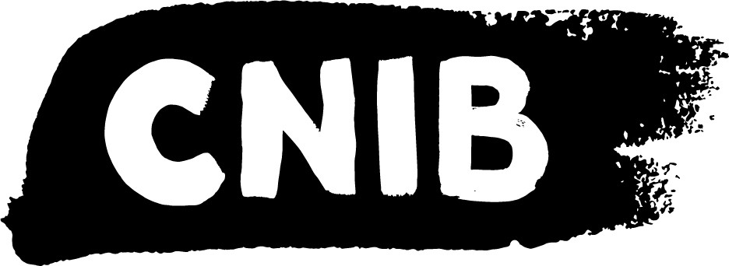

Last Reviewed January 2022

Disclaimer
This content is provided as general information and is not legal advice. If you need advice about a specific legal issue, contact a lawyer.
Acknowledgements
Thank you to the Manitoba Law Foundation for making the Know Your Rights project possible. While financially supported by The Law Foundation of Manitoba, CNIB is solely responsible for all content. | 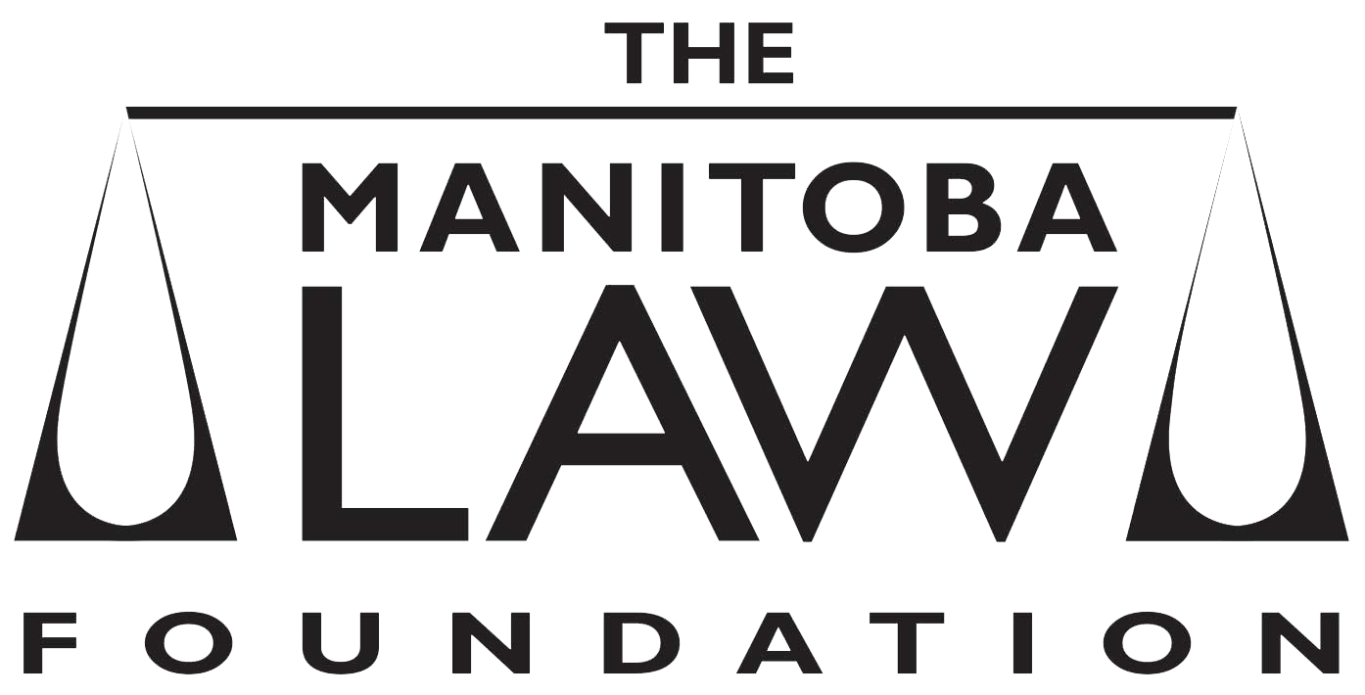
Thank you to the Community Legal Education Association (CLEA) for completing the legal research that ensured this Legal Information Handbook is accurate for Manitoba.
Thank you to the many volunteers and institutional collaborators who contributed to developing this legal information handbook, specifically the Focus Group and Working Group participants.
To learn more about the Know Your Rights project, please visit us at cnib.ca/KnowYourRights.

.

Table of Contents
My Legal Rights 4
Q: What is the "built environment"? 4
Q: What legal rights do I have when it comes to the built environment in Manitoba? 4
Q: Where do my legal rights come from? 5
Q: Who must comply with Manitoba laws relating to the built environment? 6
Q: What can I do to enforce my legal rights? 7
Common Scenarios 9
Outdoor Spaces 9
Q: The Audible Pedestrian Signal (APS) at a crosswalk isn't working. What can I do? 9
Q. In my residential area, I am unable to walk safely down the sidewalk or road, as barriers (such as piled up snow, parked cars, etc.) frequently block my route. What can I do? 9
Q: An outdoor public space that I often use (for example, an outdoor eating area, park, trail, or parking lot) has features that are hazardous and inaccessible. What can I do? 10
Inside Buildings and Signage 11
Q: I often find that public buildings, such as museums, stadiums, universities, etc. are inaccessible to people with sight loss. For example, in some instances there is no tactile surface to identify steps/curbs, staircases and escalators, and in other cases, the elevators do not have audio signals/accessible buttons. This makes it difficult and hazardous to orient myself and navigate safely through these buildings. What can I do? 11
Q. Are Manitoba businesses and government organizations required to make their signage accessible to people with sight loss? 13
Construction & Hazards 14
Q: Temporary construction barriers are obstructing a sidewalk/building entrance that I commonly use. I do not feel safe navigating through the construction site. What can I do? 14
Resources 15
Legal Resources 15
Essential Non-Legal Resources 19
CNIB Programs 20
Vision Loss Rehabilitation Canada 21
Wayfinding 22

My Legal Rights

Q: What is the "built environment"?
A: The term "built environment” refers to the many kinds of places, structures and facilities that we live in or use. Examples of the built environment include cities, towns, neighbourhoods, buildings, urban spaces, parks, roads, and walkways.
This handbook will focus on the built environment in public spaces. To learn more about your legal rights related to housing specifically, please visit the housing section of the Know Your Rights website.

Q: What legal rights do I have when it comes to the built environment in Manitoba?
A: Under Manitoba laws, people with disabilities have important legal rights when it comes to accessing the built environment:
- You have the right to have a level of access equal to anyone else regarding most public places in the built environment, without discrimination because of your disability.
- In many cases, you have the right to receive accommodations for your disability from the person or organization who is responsible for the public place, up to the point of undue hardship.
- You cannot be denied services or denied access to spaces that are normally available to the public because you are accompanied by a service animal, such as a guide dog.

Duty to Accommodate & Undue Hardship
Under the Manitoba Human Rights Code, you have the right to equal access to all buildings that are generally open to the public. Service providers have a duty to provide accommodations to ensure your ability to access buildings, to the point of undue hardship.
“Undue hardship” is a legal term. Generally speaking, it means that if a service provider can show that it is very difficult to provide a certain type of accommodation, then they don’t need to provide it.
It is important to note that it is not enough for a service provider to simply claim undue hardship. A service provider must show clear evidence of undue hardship. Their evidence can relate to factors such as:
1. Whether the cost of the accommodation is so high that it would significantly interfere with their ability to operate. When calculating cost, they must also consider outside sources of funding, such as grants or subsidies from government programs.
2. Whether the accommodation would create serious health and safety risks for their operations.
3. Whether there have been past unsuccessful efforts to accommodate.
However, even if an organization can show that a certain type of accommodation would create undue hardship, they may still have a legal duty to provide you with the next best type of accommodation.

Q: Where do my legal rights come from?
A: Your legal rights come from a variety of different laws, including:
- Manitoba’s Human Rights Code, which prohibits discrimination based on disability in most areas of public life, including places where “accommodations, services or facilities” are provided to the public. The term “facilities” includes locations like public parks, recreation centres, malls, stores, government buildings, etc.
- Manitoba’s The Buildings and Mobile Homes Act applies to the construction, erection, placement, alteration, repair, renovation, demolition, relocation, removal, occupancy, or change in occupancy of any building or addition to a building. The Act requires municipalities in Manitoba to adopt and enforce the codes and standards established, adopted, or enforced under the Act, such as the National Building Code of Canada, 2010 and the Manitoba Building Code.
- The Accessibility for Manitobans Act
  - The Accessibility for Manitobans Act applies to most organizations in Manitoba, including government, for-profit and not-for-profit organizations.
  - The Accessibility for Manitobans Act requires the government of Manitoba to create Accessibility Standards that focus on five key areas of daily living. The Accessibility Standards set out detailed minimum accessibility requirements in the following contexts:
    - Customer Service
    - Employment
    - Information and Communications
    - Design of Public Spaces
    - Transportation
  - At the time of writing, the government has yet to complete the Design of Public Spaces Accessibility Standard, but has published Recommendations for an Accessibility Standard for the Design of Public Spaces for the Minister of Families. Once completed, the Design of Public Spaces Standard will address access to those areas outside the jurisdiction of the Manitoba Building Code, such as sidewalks, pathways, parks, and other aspects of the public environment that we design and construct.

Q: Who must comply with Manitoba laws relating to the built environment?
A: Manitoba’s Human Rights Code prohibits discrimination with respect to any service, accommodation, facility, benefit, or program available or accessible to the public.
Examples of services that form part of the built environment include stores, theatres, sports facilities, government buildings, food banks, and schools.
Individuals and organizations that build, maintain, or provide services to the public in the built environment in Manitoba must comply with Manitoba laws relating to the built environment, including:
- Individual owners, employers, and employees
- Private businesses
- Non-profit organizations
- Government organizations like municipalities, ministries, and agencies

Q: What can I do to enforce my legal rights?
A: If you are confronted by accessibility barriers in the built environment, there are steps you can take to challenge these barriers.
In general, you should first try to resolve your concerns by speaking with the people and organizations who are directly involved in an informal and collaborative way.
For more resources on self-advocacy, please visit the Self-Advocacy section of the Know Your Rights webpage.
If your concerns can’t be addressed through collaborative discussions, you may want to consider:
- Filing a formal complaint with the company, building manager, or government body in charge of the space.
- A complaint to your local municipal government regarding enforcement of Buildings and Mobile Homes Act, and its regulations. CNIB may be able to assist you in connecting with the relevant municipal department.
- A complaint to the Manitoba Ombudsman. The Ombudsman investigates complaints from people who feel that they have been treated unfairly by departments or agencies of the Manitoba government, or by a municipal government within Manitoba, which includes:
  - Crown corporations (for example, Manitoba Hydro)
  - boards and commissions that are directly or indirectly responsible to the government
  - local government districts, planning districts, and conservation districts
  - colleges (Red River College and Assiniboine Community College)
  - regional health authorities
- A complaint to the Manitoba Human Rights Commission.
You do not need to hire a lawyer to make these complaints but may wish to consult with one if your complaint is not resolved or to determine other options that may be available to you, including suing the other party.

Common Scenarios
Even though there are laws to protect you from discrimination, people with disabilities still face barriers to equal access to the built environment.
This section describes barriers that are commonly experienced and suggests practical next steps. Keep in mind that, in most situations, you should first try to resolve your concerns by speaking with the people who are directly involved in an informal and collaborative way.

Outdoor Spaces

Q: The Audible Pedestrian Signal (APS) at a crosswalk isn't working. What can I do?
A: Audible Pedestrian Signals (“APS”) are becoming more common. Municipalities are responsible for making repairs to traffic lights and APS systems, so if you find an APS that’s not working, consider reporting the problem to the Public Works department of the municipality.
For example, in Winnipeg, you can make a report at any time by calling 311, or emailing 311@winnipeg.ca.
If your city or municipality does not have a dedicated Public Works department, contact the city or municipality’s general phone line, and advise them that you are calling to report an accessibility hazard in a public space.

Q. In my residential area, I am unable to walk safely down the sidewalk or road, as barriers (such as piled up snow, parked cars, etc.) frequently block my route. What can I do?
A: Municipal governments are responsible for maintaining sidewalks and roadways. You may wish to contact the city or municipal clerk’s office to report your concern.
In preparation for reporting your concern, you may wish to take pictures of the barriers that prevent you from walking safely in your neighbourhood. This will provide the city or municipality with a clear sense of issue, and help them discern whether the barriers are the result of any by-law infractions.
If the barrier is not remedied, you may wish to reach out to CNIB. CNIB has advocacy experience with such issues, and may be able to support you in developing an advocacy plan.
Finally, while you do not need to hire a lawyer to take these steps, you may wish to consult with one if your complaint is not resolved. It is possible to file a complaint with the Manitoba Human Rights Commission against the city or municipality, but it would be helpful to obtain legal advice in advance of doing so.

Q: An outdoor public space that I often use (for example, an outdoor eating area, park, trail, or parking lot) has features that are hazardous and inaccessible. What can I do?
A: While the Buildings and Mobile Homes Act and its regulations set standards for the inside of buildings, Manitoba does not currently have standards for other areas, such as outdoor spaces. Manitoba’s Human Rights Code, does, however, require organizations that provide services to the public to accommodate your disability up to the point of undue hardship.
If you want to try to address the issue or advocate for change, you should first try to find out what organization owns or manages the outdoor space. For example, if you are concerned about areas inside of a local park that are inaccessible, try to find out whether the park is owned by your municipality, a government agency, or some other organization.
It may also be helpful to try to find out:
- when the outdoor space was built;
- when it last had major renovations; and
- whether any major renovations are planned in the future.
Keep in mind that effective self-advocacy does not always have to include forcefully asserting your legal rights. Community organizations, like CNIB, will have advocacy experience with the issue you’re facing and may be able to support you in developing an advocacy plan or helping you speak with the owners of an outdoor space in a collaborative way.

The Accessibility for Manitobans Act
The Accessibility for Manitobans Act was enacted in 2013 with the goal of removing barriers affecting persons with disabilities in Manitoba, by 2023. The Act requires the government of Manitoba to create Accessibility Standards that focus on five key areas of daily living, one of which is Design of Public Spaces.
At the time of writing, the government has yet to complete the Design of Public Spaces Accessibility Standard, but has published Recommendations for an Accessibility Standard for the Design of Public Spaces for the Minister of Families. Once completed, the Design of Public Spaces Standard will deal with access to those areas outside the jurisdiction of the Manitoba Building Code, such as sidewalks, pathways, parks, and other aspects of the public environment that we design and construct.
For more information on the Accessibility for Manitobans Act, please refer to the Self-Advocacy and Essential Legal Information section of the Know Your Rights webpage.

Inside Buildings and Signage

Q: I often find that public buildings, such as museums, stadiums, universities, etc. are inaccessible to people with sight loss. For example, in some instances there is no tactile surface to identify steps/curbs, staircases and escalators, and in other cases, the elevators do not have audio signals/accessible buttons. This makes it difficult and hazardous to orient myself and navigate safely through these buildings. What can I do?
A: The Buildings and Mobile Homes Act applies to the construction, erection, placement, alteration, repair, renovation, demolition, relocation, removal, and occupancy of any building or addition to a building in Manitoba. The Act requires Manitoba municipalities to adopt and enforce the codes and standards established, adopted, or enforced under the Act.
The Manitoba Building Code specifically outlines the following requirements for public buildings:
- All pedestrian entrances are to be barrier-free, meaning that individuals can approach, enter, and make use of the building and its facilities without assistance.
- An interior barrier-free path of travel must be provided to access floors served by escalators or moving walks. The route from the escalator or inclined moving walk to the barrier-free path of travel that leads from floor to floor must be clearly indicated by appropriate signs.
The Building Code does not make specific mention of accessible elevators, but individual municipalities may have enacted by-laws or policies that address this. For example, the City of Winnipeg has created an Accessibility Design Standard to address accessibility requirements for the design and construction of new facilities, as well as the retrofit, alteration or addition to existing facilities, owned, leased or operated by the City of Winnipeg. This document has an entire section on accessible elevators.
Owners of public buildings, or those that control the property, are required to comply with the Act, Building Code, and municipal by-laws and policies. Local municipal authorities are responsible for enforcement of these rules.
Additionally, Manitoba’s Human Rights Code prohibits discrimination in the provision of services. Discrimination may occur where a person with a disability cannot access services, in a building, that are otherwise accessible to the public.
To begin, you may wish to approach or contact an employee or manager of the building for assistance. When you speak with an employee or manager, explain that you are having trouble with navigation or orientation inside the building because of your sight loss. Explain what assistance you require in as much detail as possible.
When you disclose your disability to an employee, you trigger that organization’s legal duty under the Human Rights Code to accommodate you to the point of undue hardship. If the employee or manager is reluctant or refuses to accommodate you, you may wish to remind them that they have a duty to provide you with reasonable accommodations so that you’re able to experience an equal level of service as anyone else.
If this does not help, you can gradually escalate your complaint – for example, through an official complaint process or to an organization’s management team. Government organizations and large private companies may have a designated person responsible for accessibility who can assist you.
You may also want to consult with a lawyer to see what options you have, including filing a complaint with the Manitoba Human Rights Commission.
Additionally, the accessibility barriers may be the result of a Building Code violation. You may also consider contacting the city clerk's office or your local city or town to report the accessibility issue.
Finally, there are now many technological tools that can help people navigate and orient themselves within buildings.

Q. Are Manitoba businesses and government organizations required to make their signage accessible to people with sight loss?
A: The Manitoba Building Code specifically requires accessible signage to be present on public buildings, as follows:
- Signs incorporating the international symbol of accessibility shall be installed to indicate the location of barrier-free facilities.
- Specific spatial requirements for room identification signage; as well as requirements for raised text, graphics, and braille for room identification signage.
- Specific spatial requirements for directional signage; as well as requirements for raised text, graphics, and braille for directional signage.
- Signs incorporating the symbol of accessibility for persons with hearing disabilities shall be installed to indicate the location of facilities for persons with hearing disabilities.
If you encounter signage that is not accessible, you may wish to approach or contact an employee or manager of the building and advise them of the issue.
You may also consider contacting the city clerk's office or your local municipality to report the accessibility issue, and/or consult with a lawyer about filing a complaint with the Manitoba Human Rights Commission.

Construction & Hazards

Q: Temporary construction barriers are obstructing a sidewalk/building entrance that I commonly use. I do not feel safe navigating through the construction site. What can I do?
A: The Building Code does not make specific mention of ensuring accessibility with respect to temporary construction barriers, but individual municipalities may have enacted by-laws or policies that address this. For example, the City of Winnipeg has created an Accessibility Design Standard to address accessibility requirements for the design and construction of new facilities, as well as the retrofit, alteration or addition to existing facilities, owned, leased or operated by the City of Winnipeg. The Standard specifically identifies that temporary construction barriers can hinder accessibility and be hazardous. As such, it outlines design requirements for temporary construction barriers.
You may want to try to find out what organizations are involved in the construction – for example, the name of the construction company and the name of the building’s owner or manager. Other organizations might also be relevant to your situation:
- If the building is your place of work, your employer may have a duty to help you secure an appropriate accommodation.
- If you visit the building to access a particular store or service, that service provider may have a duty to help you secure an appropriate accommodation.
You may also want to contact your city clerk's office or your municipality to learn more about bylaw or building permit requirements related to accessibility around construction sites. For example, there may be requirements related to:
- notification of sidewalk closures
- compliance with municipal accessibility design standards related to pedestrian safety
Keep in mind that effective self-advocacy does not always have to include forcefully asserting your legal rights. Community organizations, like CNIB, may have advocacy experience with the issue you’re facing and may be able to support you in developing an advocacy plan or helping you speak with the owners of an outdoor space in a collaborative way.

Resources

Legal Resources
Manitoba Human Rights Commission
The Manitoba Human Rights Commission is an independent office of the government of Manitoba that is responsible for receiving and investigating complaints of discrimination to determine if the Human Rights Code has been contravened.
For information on filing a complaint with the Commission, the Commission’s website provides direction on how to start the process and a Guide to Filing a Complaint.
The Commission also educates the public about human rights through seminars and workshops; and, prepares and distributes Guidelines and Fact Sheets to assist the public in understanding the Code.

The Law Society of Manitoba
The Law Society of Manitoba oversees the legal profession in Manitoba. The Law Society is the only body that is authorized to determine who may become a lawyer in the province, and is responsible for responding to complaints about lawyers. The Law Society also has a Lawyer Lookup tool that enables the public to search for lawyers.

Infojustice
Infojustice is a legal information centre committed to promoting access to justice in French. By providing information, support and referral services, Infojustice helps French-speaking individuals understand and respond to the various legal situations they face in their everyday lives.
Infojustice provides the following services:
- consultations via telephone and email, or in person if appropriate,
- courthouse or tribunal accompaniment,
- referrals to relevant organizations and resources, and
- referrals to French-speaking lawyers.
For contact information, visit the Infojustice website.

Community Legal Education Association
The Community Legal Education Association (CLEA) is a not-for-profit organization that provides legal information and education to Manitobans. CLEA develops programs and resources to help individuals better understand Manitoba’s legal system, and how to resolve their legal issues.
CLEA can help members of the public by providing general legal information, suggesting resources, and telling people about different options for obtaining legal advice.
CLEA also operates the Law Phone-In and Lawyer Referrals Program. Through this program, individuals can receive:
- legal information and advice,
- referrals to law-related agencies, and
- referrals to lawyers, when appropriate.
The Law Phone-In and Lawyer Referral Program allows Manitobans to call or email with legal questions, and staff lawyers will attempt to provide information, or connect them to a lawyer who can.
If you are referred to a lawyer through this program, your first consultation, up to half an hour will be free. This service is free and available to all Manitobans.

Legal Aid Manitoba
Legal Aid Manitoba provides legal services to low-income Manitobans. To qualify for services from Legal Aid Manitoba:
- You must meet their financial eligibility criteria; and
- Your case must have merit. To learn more about how Legal Aid Manitoba determines whether a case has merit, please refer to their qualification criteria.

Public Interest Law Centre
The Public Interest Law Centre (PILC) is an independent office of Legal Aid Manitoba. PILC represents clients at all levels of the court system; and, before boards, administrative tribunals and legislative committees.
PILC selects cases on the basis of social significance, legal merit and the availability of resources. Applications for public interest law cases will only be approved if:
- Funding is available to pursue the matter throughout the proceedings.
- There is a reasonable likelihood of success.
- The matter will impact a systemic issue in the law, or will impact a segment of the population of Manitoba.
- Clients meet Legal Aid Manitoba’s financial eligibility criteria.

The University of Manitoba Community Law Centre
The University of Manitoba Community Law Centre primarily handles summary conviction criminal offences, but may also assist with Highway Traffic Act offences, small claims cases involving consumer problems, and Manitoba Public Insurance disputes.

Legal Help Centre
The Legal Help Centre (LHC) provides legal information and assists self-represented litigants with certain non-urgent legal matters. LHC operates the following clinics:
- Drop-In Clinics
- Family Claw Clinics
- Consumer Protection Clinics
To qualify:
- You must not be eligible for Legal Aid
- You must not already have a lawyer assisting you
- You must meet LHC’s financial eligibility guidelines

Accessibility for Manitobans Act Website
The Accessibility for Manitobans Act website offers a helpful overview of the Accessibility for Manitoba Act and Accessibility Standards.

Manitoba Courts
The Manitoba Courts website provides general information about how Courts in Manitoba operate, and what to expect if you are attending Court. There is also a helpful resource on attending Court as a self-represented person.

Manitoba Law Reform Commission
The Manitoba Law Reform Commission is an independent law reform agency. Its role is to improve, modernize and reform the law and administration of justice in Manitoba.
Projects of law reform are initiated in response to the public, the legal profession, and Manitoba’s Minister of Justice and Attorney General. The Commission carries out research and consultation and makes formal recommendations for law reform to the Minister of Justice and Attorney General.
Publications produced by the Commission, and Information about the Commission’s current projects, are available online.

Essential Non-Legal Resources
The Manitoba Ombudsman
The Manitoba Ombudsman is an independent office of the Legislative Assembly of Manitoba. The Ombudsman conducts independent, impartial and non-partisan investigations of complaints regarding the following issues:
- access to information and privacy matters,
- the fairness of government actions or decisions, and
- serious “wrongdoings” by the government.
Complaints may be related to any act, decision, recommendation, or omission relating to a matter of administration by any department or agency of the provincial or a municipal government.
For information on filing a complaint with the Manitoba Ombudsman, please refer to the information and guidelines outlined on the Ombudsman’s website.

Manitoba 211
Manitoba 211 is a free, confidential service that operates 24 hours a day, seven days a week. It exists to connect individuals to government, health and social services that are available across Manitoba. The service helps Manitobans who are looking to find the right community or social resource, but do not know where to start.
In addition to searching on the 211 Manitoba website, there are various ways for people to contact Manitoba 211, including calling 2-1-1 to talk with trained professionals to help identify the services that they need.
Services are grouped together into the following categories:
- Emergency Resources
- Covid-19 Information
- Food and Clothing
- Housing and Homelessness
- Health
- Mental Health
- Employment
- Newcomers
- Children and Parenting
- Youth

CNIB Programs
We’re here to help – contact CNIB for more programs, support, and resources. Some ways we can assist include:
- CNIB Virtual Programs
  - CNIB offers a range of free virtual programs for children, youth, adults and families.
  - You can access a list of CNIB’s virtual program offerings on CNIB’s website.
  - You can access a list and schedule of CNIB Manitoba’s program offerings on CNIB Manitoba’s website.
- Technology Training
  - Join CNIB tech leads from across the country for programming that highlights the suite of programs, apps, products and services that will help empower you to achieve your personal and professional goals.
- Virtual Vision Mate
  - The Virtual Vision Mate program exists to address the feelings of isolation that many people with sight loss experience. Through the Virtual Vision Mate program, people who are blind or partially sighted are connected with sighted volunteers to engage in virtual, weekly conversation.

- CNIB SmartLife
  - CNIB SmartLife is an interactive retail experience that gives people with disabilities hands-on access to the latest breakthroughs in assistive technologies, as well as tried-and-true favourites.
  - SmartLife’s goal is not necessarily to sell products but is to give customers the skills and confidence they need to make the most out of assistive tools that can help them lead better lives.
- CNIB Advocacy Team
  - The CNIB Advocacy Team can assist participants with advocating for themselves and understanding their rights. You can contact us at advocacy@cnib.ca if you have questions.
- CNIB Guide Dogs
  - CNIB Guide Dogs can assist guide dog handlers with advocating for themselves and understanding their rights. This program also provides public education to organizations to provide knowledge about the rights of guide dog users.

Vision Loss Rehabilitation Canada
Vision Loss Rehabilitation Canada (“VLRC”) is a not-for-profit national healthcare organization and the leading provider of rehabilitation therapy and healthcare services for individuals with vision loss. VLRC’s services are tailored to the unique needs and goals of each person they assist. Specifically, VLRC certified specialists provide a range of services that help individuals with vision loss lead more independent, active lives.
Contact information for VLRC’s Manitoba offices is available in the “Locations” section of the VLRC website.

Wayfinding
Wayfinding refers to technological tools that assist people who are blind, partially sighted or Deafblind with navigation and orientation. Such tools include:
- BlindSquare: a GPS-app developed for people with sight loss that describes the environment and announces points of interest and street intersections.
- Key 2 Access: a pedestrian mobility app that allows users to wirelessly request crossing at intersections without having to locate the button on the pole. It also allows users to wirelessly open doors and obtain information about indoor spaces.
- Access Now: a map application that shares accessibility information for locations based on users' feedback.
- Be My Eyes: a volunteer-based app that connects people with sight loss to sighted volunteers, who can assist with tasks such as checking expiry dates, distinguishing colors, reading instructions or navigating new surroundings.
- The American Foundation for the Blind, which provides an overview of some of the apps that are available to assist consumers with reading items such as product labels and menus.



Web / Site Web : cnib.ca / inca.ca
Email / Courriel : info@cnib.ca / info@inca.ca
Toll Free / Sans frais : 1-800-563-2624

