

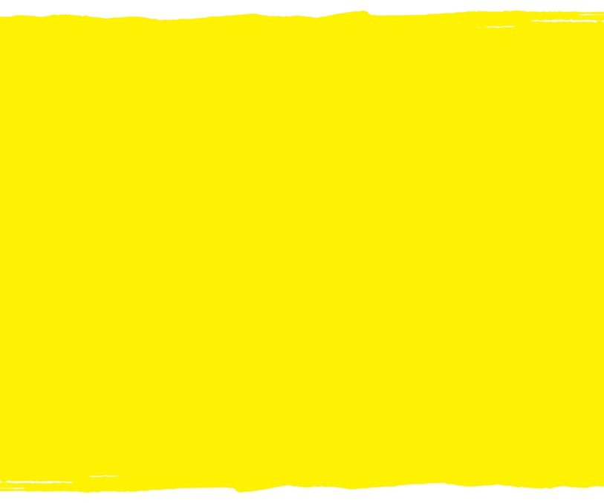
Built Environment
Know your rights! — Guide to legal information


Last updated: August 11, 2021

Important
The information in this guide is of a general nature, and should not be taken as legal advice. If you require information about a specific legal issue, you should contact a lawyer or a legal aid clinic.

Acknowledgements
CNIB wants to thank the volunteers and numerous contributors to this guide to legal information. For additional information about the Know your rights! project, please go at cnib.ca/en/support-us/advocate/quebec-advocacy/know-your-rights.

CNIB would also like to express its gratitude for the financial support provided by the Fonds d’études notariales de la Chambre des notaires du Québec.

Table of contents
General issues 4
What are my rights in regard to the built environment in Quebec? 4
How can I stand up for my rights in regard to the built environment? 6
Specific issues 6
An Accessible Pedestrian Signal at a pedestrian crossing is not working. What can I do? 6
An outdoor public space I often use (for example an outdoor patio, park, pathway or parking lot) has some dangerous obstacles making it inaccessible. What can I do? 7
The elevator I use in a building does not have accessible buttons. What can I do? 8
Temporary construction barriers are obstructing a sidewalk / building entrance I often use. I do not feel safe making my way through the work zone. What can I do? 8

This document covers the area of the built environment. A number of general and specific issues are addressed. The document also includes some of the laws and sections in them that will be useful to you in standing up for your rights in regard to housing whenever they are not respected.

General issues
This section covers general issues about rights when it comes to housing, as well as specific recourses available to you. For information about general recourses, you can consult the document entitled Advocacy and Essential Legal Information.

What are my rights in regard to the built environment in Quebec?

Internationally
The Convention on the Rights of Persons with Disabilities was signed by Canada in 2010.
Article 9 of the Convention calls on States Parties to consider certain measures related to the built environment:
- “To enable persons with disabilities to live independently and participate fully in all aspects of life, States Parties shall take appropriate measures to ensure to persons with disabilities access, on an equal basis with others, to the physical environment, to transportation, to information and communications, including information and communications technologies and systems, and to other facilities and services open or provided to the public, both in urban and in rural areas. These measures, which shall include the identification and elimination of obstacles and barriers to accessibility, shall apply to, inter alia:
  - Buildings, roads, transportation and other indoor and outdoor facilities, including schools, housing, medical facilities and workplaces;
  - (…)
- States Parties shall also take appropriate measures to:
  - Develop, promulgate and monitor the implementation of minimum standards and guidelines for the accessibility of facilities and services open or provided to the public;
  - Ensure that private entities that offer facilities and services which are open or provided to the public take into account all aspects of accessibility for persons with disabilities;
  - (…)
  - Provide in buildings and other facilities open to the public signage in Braille and in easy to read and understand forms;
  - Provide forms of live assistance and intermediaries, including guides, readers and professional sign language interpreters, to facilitate accessibility to buildings and other facilities open to the public;
(…)”

Nationally
Certain structures are under federal jurisdiction, but the provincial government also has an important say in the matter of the built environment. In Quebec, the Building Act has a strong bearing on the matter. The Régie du bâtiment du Québec introduces rules on accessibility and ensures their implementation in new constructions or when renovations are made. See accessibilité des bâtiments aux personnes handicapées (French version only). Since 2005, the Régie has been working in collaboration with the Office des personnes handicapées du Québec.

How can I stand up for my rights in regard to the built environment?
Please note that there are also general recourses. You will find them in the document entitled Advocacy and Essential Legal Information.

Filing a complaint with the municipality
Depending on the municipality, you can file a complaint concerning the built environment so that the municipality can have the situation corrected to accommodate you. Most of the time, the procedure for filing a complaint is readily available on the municipal website. If not, you can simply call them to find out more.

Specific issues
This section covers specific situations and certain rights in regard to the built environment that can be trampled.

An Accessible Pedestrian Signal at a pedestrian crossing is not working. What can I do?
The ministère des Transports has introduced a standard concerning Accessible Pedestrian Signals, in particular audible pedestrian signals. They are now required to meet several criteria to ensure their safe and effective use, and must, of course, be in working order. Municipalities are responsible for implementing those standards.
Thus, when an Accessible Pedestrian Signal is not working, you can contact the municipality to let it know that it has to be repaired. You can send an email or call, and some municipalities have a special number to call when the matter concerns public safety.

An outdoor public space I often use (for example an outdoor patio, park, pathway or parking lot) has some dangerous obstacles making it inaccessible. What can I do?
Different rules apply to the different types of public spaces, and are subject to different laws. Some types of spaces are required to meet accessibility standards for disabled people, but it depends on the type of building they belong to.
In general, municipalities are responsible for administering accessibility to their different outdoor public places. Therefore, you can contact the municipality in which that inaccessible or dangerous space is to let it know about the situation and to find out how to deal with the particular problem you encountered.
Because there is no mandatory uniform standard for all public places, and different rules may apply, it may be difficult to figure out what to do. It might be a good idea to contact a legal professional to better guide you in your particular case.

The elevator I use in a building does not have accessible buttons. What can I do?
If the elevator is one that you use daily, for example in your condominium or your workplace, you could request a reasonable accommodation to have the buttons in braille. The accommodation must not impose an excessive constraint on the building owner.

Temporary construction barriers are obstructing a sidewalk / building entrance I often use. I do not feel safe making my way through the work zone. What can I do?
The Régie du bâtiment du Québec has a guide setting out barrier-free design standards for disabled persons. The purpose of those standards is to guarantee accessibility to those buildings for everyone. The guide applies to all buildings except for certain types, such as homes and industrial buildings that are not intended to be occupied on a daily or permanent basis. Therefore, it is necessary, for example, that you have adequate access to the entrance of a municipal building. If the entrance to the building you need to access is obstructed due to temporary construction, you can consult the guide to determine whether it applies to the building in question, or contact the municipality for help in finding a solution.
In regard to sidewalks, section 78 of the Municipal Powers Act provides that work done to construct or reconstruct a sidewalk must facilitate access to the sidewalk by handicapped persons. Thus, municipalities are required to provide you access to a sidewalk despite the presence of temporary construction work.
In addition, some cities, such as Québec City, have their own guides to ensure universal access. Québec City’s guide specifies the need to maintain access when work is underway, including access on sidewalks.
If a sidewalk you use is obstructed by temporary construction that limits your access, contact the municipality to have it correct the problem.

When your rights are not respected, stand up for them!

We hope this guide will help you stand up for your rights as they relate to education. We believe that you are in the best position to defend your rights. When your rights are not respected, you have the right to stand up for them and to make sure that others Know your Rights.

CNIB is here for you. Since its inception in 1918, CNIB has undertaken a variety of advocacy initiatives to break down barriers for people who are blind and to advocate for an inclusive society.

Please feel free to contact us for referrals and to take advantage of our services.
DroitsDevant@inca.ca
1 800 465-4622

Visit the campaign website for information on other rights:

cnib.ca/en/support-us/advocate/quebec-advocacy/know-your-rights
Join the conversation on social media by using the tagline:
#KnowyourRights

Together, enforce the rights of blind people!

This Convention was adopted by the United Nations on December 13, 2006, and ratified by Canada on March 11, 2010 and by Quebec on March 10, 2010. For comments on this Convention, see V. A. Boujeka, La convention des Nations unies relative aux droits des personnes handicapées et son protocole facultatif, RDSS sept-oct. 2007, n° 5, p. 799.

