Education
Know Your Rights – Legal Information Handbook

Last Reviewed on September 2019
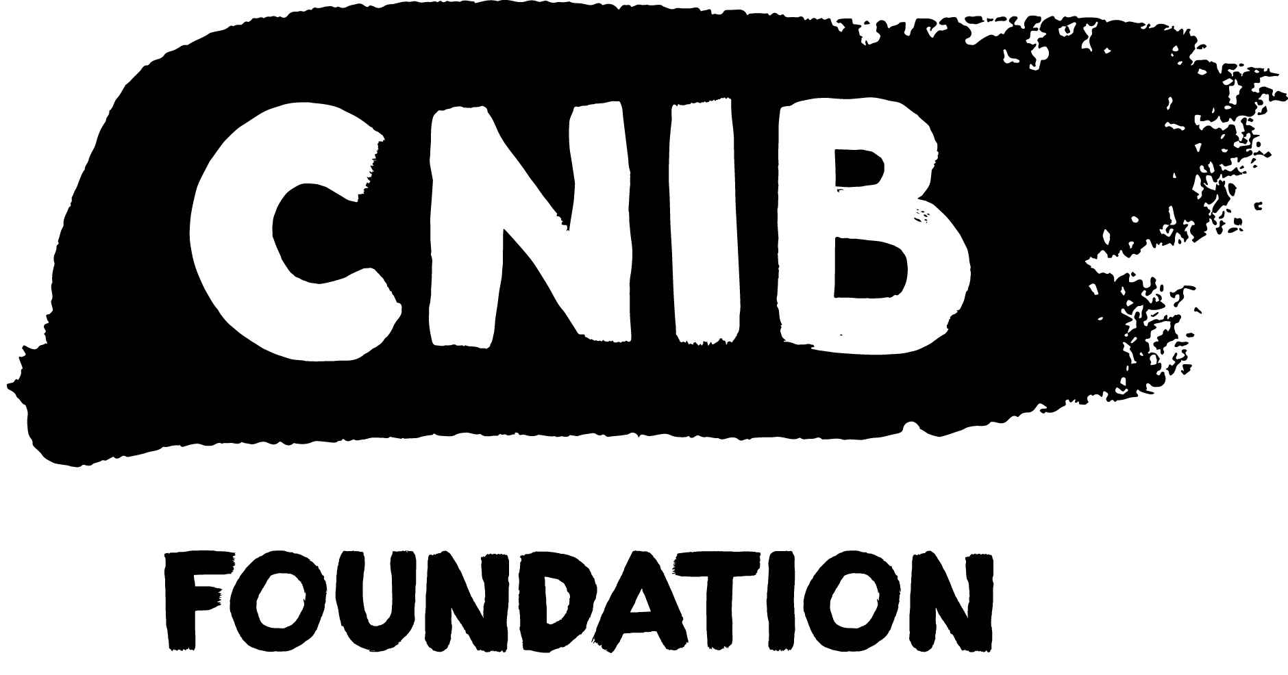
Disclaimer
This content is provided as general information and is not legal advice. If you need advice about a specific legal problem, contact a lawyer or a community legal clinic.
Acknowledgements
Thank you to the many volunteers and institutional collaborators who contributed to developing this legal information handbook. To learn more about the Know Your Rights project, please visit us online.
Thank you to the Law Foundation of Ontario for making the Know Your Rights project possible. While financially supported by The Law Foundation of Ontario, the CNIB is solely responsible for all content.
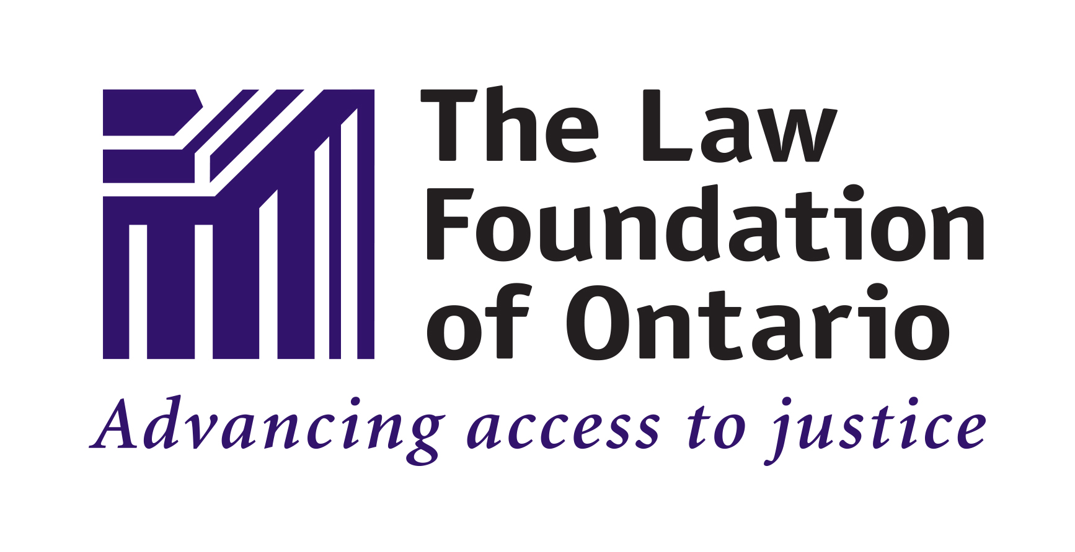

Table of Contents
My Legal Rights 5
Q: What legal rights do I have when it comes to education in Ontario? 5
Duty to Accommodate & Undue Hardship 5
The Rights of Parents or Guardians 6
Q: Where do my legal rights come from? 6
Q: Who must comply with Ontario laws related to education? 7
Q: What can I do to enforce my legal rights? 8
Common Scenarios 9
Elementary and Secondary School 9
Q: My child will be starting school. What can I do to ensure that my child's sight loss is accommodated? 9
Plan Ahead 9
The School’s Duty to Accommodate 9
Next Steps 10
Q: The school board implemented an accommodation plan to support my child's sight loss. I don’t agree with the school board's approach to accommodations. What can I do? 10
The School’s Duty to Accommodate 11
What is Undue Hardship? 11
Parents with Sight Loss 12
Q: My child's school has sent me written information that is not in an accessible format. Due to my sight loss, I'm unable to read the communication. What can I do? 12
Postsecondary Programs 12
Q: I've been accepted to a postsecondary institution, but I'm uncertain about what steps I need to take to have my sight loss accommodated. 12
Tips on Advocating for Yourself 13
Q: Despite my requests, I have not received the accommodations that I require. What can I do? 14
Getting Help 15
CNIB Services 15
Legal Services 15
Legal Aid Ontario 15
Ontario’s Community Legal Clinics 16
Pro Bono Ontario 16
The Human Rights Legal Support Centre 16
ARCH Disability Law Centre 16
Justice for Children and Youth 17
Legal & Practical Information 17
Key Resources 17
Elementary/Secondary Resources 18
Postsecondary Resources 18

My Legal Rights

Q: What legal rights do I have when it comes to education in Ontario?
A: Under Ontario laws, people with disabilities have important legal rights when it comes to education:
- You have the right to receive an education equal to your peers without discrimination because of your disability.
- You have the right to receive accommodations for your disability from your educational institution up to the point of undue hardship.

Duty to Accommodate & Undue Hardship
An educational institution’s “duty to accommodate” means that they are legally required to provide you with the supports you need to succeed in the education sector. However, the duty to accommodate has a limit and this limit is called "undue hardship."
“Undue hardship” is a legal term. It means that if an educational institution can show that it is very difficult for them to provide you with a certain type of accommodation (because of high costs or health and safety risks), then they don’t have to provide it.
It’s usually difficult for an educational institution to claim undue hardship because they have to show clear evidence of undue hardship. Their evidence must relate to these two factors:
1. Whether the cost of this type of accommodation is so high that it will significantly interfere with their ability to operate their institution/business. When calculating cost, they must also consider outside sources of funding, e.g. grants or subsidies from government programs.
2. Whether this type of accommodation is going to create serious health and safety risks for their operations.
Even if an educational institution shows that a certain type of accommodation will create undue hardship for them, they still have a legal duty to provide you with the next best type of accommodation.
- You have the right to challenge administrative decisions made about you by schools, school boards and other educational institutions
- A child with disabilities has the right to receive appropriate special education programs and services at no additional cost to their parents or guardians who reside in Ontario.

The Rights of Parents or Guardians
- Parents or guardians with disabilities have the right to receive communications from schools in accessible formats, e.g. parent guides, report cards, consent forms, schedules, or newsletters
- Parents or guardians of a child with disabilities have the right to be consulted about the accommodations that are necessary to meet their child's educational needs
- Students over the age of 16 and parents or guardians of a child with disabilities have rights during the Identification, Placement and Review Committee process. Parents or guardians can also appeal the decision.

Q: Where do my legal rights come from?
A: Your legal rights relating to primary and secondary education come from a variety of different laws including:
- Ontario’s Human Rights Code which prohibits discrimination based on disability in most areas of public life, including education.
- The Accessibility for Ontarians with Disabilities Act (also known as the AODA) which requires almost all organizations in Ontario, including educational institutions, to meet minimum accessibility requirements when providing services. Note that the AODA does not yet have accessibility requirements that are specific to the education sector. For more information about the AODA, see the Essential Legal Information Handbook.
- The Education Act – which governs how public schools deliver services in Ontario and creates a process for placing students who are identified as “exceptional” in Ontario’s primary and secondary public school system.
Your legal rights relating to postsecondary education come from a variety different laws including:
- Ontario’s Human Rights Code
- Accessibility for Ontarians with Disabilities Act
- The Ministry of Training, Colleges and Universities Act
- The Ontario College of Trades and Apprenticeship Act
- The Private Career Colleges Act

Q: Who must comply with Ontario laws related to education?
A: Students and staff, schools, educational institutions, and the Ontario government are required to comply with Ontario's education laws. This includes:
- People: Deans, professors, principals, vice-principals, teachers, other school officials, parents/guardians and students
- Schools:
  - Early childhood pre-schools, i.e. daycares
  - Primary and secondary schools (public and private) including French-language schools
While very few parts of the Education Act apply to private primary and secondary schools, Ontario’s Human Rights Code applies to all private schools and can take priority over any policies or procedures that private schools create.
  - School Boards
  - Special schools such as hospital schools, care and treatment programs
- Universities and colleges including private colleges, trade schools, and professional accreditation courses
- Government ministries, such as the Ministry of Education and the Ministry of Training, Colleges and Universities
- Professional bodies such as the Ontario College of Teachers and the College of Early Childhood Educators

Q: What can I do to enforce my legal rights?
A: If you feel you or your child have been unfairly discriminated against by an educational institution, there are things you can do to stand up for yourself.
In general, you should first try to resolve your concerns by speaking with the people who are directly involved in an informal and collaborative way.
For more resources on self-advocacy, please visit the Self-Advocacy section of the Know Your Rights website.
If your concerns can’t be addressed through collaborative discussions, you should consider consulting with a lawyer who specializes in human rights or education issues to see if any of the following options are appropriate:
- An appeal to the Ontario Special Education Tribunal
- A complaint to the Ontario College of Teachers or the College of Early Childhood Educators
- A complaint to the Ministry of Colleges and Universities
- A complaint to the Ontario Ombudsman
- An application to the Human Rights Tribunal of Ontario
- A claim before an Ontario Court
- An appeal before the Child and Family Services Review Board

Common Scenarios
Even though there are laws to protect you from discrimination, people with disabilities still face barriers to receiving an education that is equal to their peers.
This section describes barriers that are commonly experienced and suggests practical next steps. Keep in mind that in most situations, you should first try to resolve your concerns by speaking with the people who are directly involved in an informal and collaborative way.

Elementary and Secondary School

Q: My child will be starting school. What can I do to ensure that my child's sight loss is accommodated?
A: All children in Ontario have the right to receive equal treatment with respect to education without discrimination because of disability. This includes the right to receive meaningful access to education and the benefits of education. Once a school board is made aware of your child's disability, the school board has a duty to accommodate your child's needs up to the point of undue hardship.

Plan Ahead
It is critical to plan ahead. Before registering your child for school, consider whether your child's needs can be met within a regular school environment or whether your child's needs would best be met at a school that is specific to children with sight loss. Here is more information about schools directed to children with sight loss.

The School’s Duty to Accommodate
The school’s duty to accommodate is triggered when the school is made aware of your child's disability. It is important for you to provide the school with as much information about your child's disability as is necessary to establish your child's need for accommodations and to ensure that appropriate accommodations are provided. Keep in mind that your relationship with the school board will be long-lasting and that collaboration is key to ensuring that your child thrives in an educational environment.
When considering your options, you may wish to contact the school or school board in advance of enrollment to discuss the ways in which your child's disability can be accommodated.
In most cases, schools are expected to provide children with individual accommodations that allow for the child's full participation and integration in the classroom environment. Examples of accommodations include:
- Support from a transcriber and/or an educational assistant
- Support from an orientation and mobility instructor
- Receiving school materials in an accessible format
- The use of accessibility equipment (e.g. text to speech technology)
- The use of a guide dog
- Modifications to the curriculum
- Changes to the built environment (e.g. coloured ribbons or textured flooring to identify staircases, etc.)

Next Steps
Once your child has been registered for school, encourage your child to advocate for themselves by letting you and their teacher know when they're having difficulties due to their sight loss. This will be helpful in determining whether adjustments need to be made to accommodations and how to best meet their current and future educational needs.

Q: The school board implemented an accommodation plan to support my child's sight loss. I don’t agree with the school board's approach to accommodations. What can I do?
A: If the school or school board proposes an accommodation that you have concerns about or disagree with, it's important to share these concerns with school officials. The development and implementation of accommodations is a collaborative process that will involve you, school officials and in many cases, your child.
Consider requesting a meeting with your child's teacher, vice-principal or principal to better understand or to challenge the position of the school. If this request is not accommodated or the matter is not resolved, request to meet with a superintendent or school board official to discuss your concerns.

The School’s Duty to Accommodate
Schools are required to develop and implement accommodations that will “best” meet your child's needs up to the point of undue hardship. It’s important to keep in mind that schools are not legally obligated to ensure that your child's accommodation is "perfect" or to provide your child with your “preferred” accommodation because there may be an alternative accommodation that responds to your child's needs just as well.
If it will take a lot of time to develop and implement the “best” accommodation, the school or school board has a duty to provide an alternative or “next best” temporary accommodation to ensure that your child's interim educational needs are met.
When you are being consulted on accommodations for your child, keep in mind that an appropriate accommodation is informed by these principles:
- Respect to dignity
- Individualization
- Integration
- Full participation

What is Undue Hardship?
"Undue hardship” is a legal term explained above. However, in the context of education, these additional factors may also be considered when determining whether an accommodation will create undue hardship for a school:
- Whether the accommodation infringes upon the protected rights of other people, and whether other accommodations may be more appropriate given the competing rights of others
- Whether there is no additional accommodation that will allow the student to fulfill the necessary academic requirements
- Whether the student and parent or guardian have participated in the accommodation process - you also have a duty to cooperate with the school/school board around identifying, developing and implementing accommodations that meet your or your child's needs

Parents with Sight Loss

Q: My child's school has sent me written information that is not in an accessible format. Due to my sight loss, I'm unable to read the communication. What can I do?
A: You can make a request to the school to communicate with you using an accessible format, e.g. email, accessible pdf, or Microsoft Word documents.
The school has a legal duty to provide you with a reasonable accommodation for your disability under Ontario’s Human Rights Code. In addition, the school is obligated under the Accessibility for Ontarians with Disabilities Act to communicate with you in an accessible format.

Postsecondary Programs

Q: I've been accepted to a postsecondary institution, but I'm uncertain about what steps I need to take to have my sight loss accommodated.
A: When enrolling in a postsecondary institution, it is your responsibility to inform the institution about your need for accommodations.
This may be a significant change for you because in high school, your teachers may have been proactive in finding ways to ensure that your educational needs were being met. In postsecondary institutions, however, students are expected to be their own advocates.
When you inform your postsecondary institution of your disability, it triggers their legal duty to provide you with reasonable accommodations.
Your postsecondary institution has the right to get enough information from you about your disability, so they can select an appropriate accommodation. If your postsecondary institution asks for medical documentation about your disability, you should provide the information that is necessary to explain your need for accommodations. You are not required to tell them your exact diagnosis and you are not required to provide information that is not related to your need for accommodations.
It’s important to remember that selecting an appropriate accommodation is a collaborative process. As a student requesting an accommodation, you have a legal duty to collaborate with your educational institution to help them select an appropriate accommodation. You will need to work closely with the educational institution to ensure that the accommodations are sufficient and that they are implemented within a timely manner.

Tips on Advocating for Yourself
Here are some helpful tips to keep in mind when advocating for yourself in a postsecondary setting:
- Inform the postsecondary institution about your need for accommodations as early as possible to ensure there’s enough time to develop and implement the most appropriate accommodations
- You are expected to know what kinds of accommodations you require to receive an equal education to your peers
- Emailing or introducing yourself to your instructors in advance of the class start date can help make the class accessible from the start
- If you need the course materials to be adapted or transcribed, be proactive. Determine what materials you’ll need well in advance of the start date and coordinate transcription services as soon as possible
- Many postsecondary institutions have Accessibility Services departments that coordinate accommodations for students with accessibility needs. These departments can also assist you by connecting you with other resources – for example, OSAP bursaries and grants for people with disabilities

Q: Despite my requests, I have not received the accommodations that I require. What can I do?
A: As a “service provider” under Ontario’s Human Rights Code, educational institutions have a legal duty to provide reasonable accommodations for your disability up to the point of undue hardship.
Many postsecondary institutions have an Accessibility Services department that should be able to assist you with securing accommodations.
However, if you are still not receiving appropriate accommodations in a timely manner, you may want to meet in person with your instructor or the department / faculty administration to discuss your concerns. Consider reiterating your need for accommodations with a written request. If the issue remains unresolved, consider following-up with the postsecondary institution's internal supervisory body.
Keep in mind that in situations where there are delays with implementing the most appropriate accommodation, postsecondary institutions still have a duty to provide you with a temporary or “next best” accommodation to ensure your educational needs are met in the interim.

Getting Help

CNIB Services
We’re here to help – contact CNIB for more services, support and resources. Some ways we can assist include:
- Providing teachers and other school officials with education and instruction in Unified English Braille and best practices to use when interacting with people who have sight loss
- Children and Youth Programs help participants gain knowledge and develop social skills as they pursue their education.
- CNIB's Advocacy Staff can assist clients with advocating for themselves and understanding their rights with respect to education in Ontario. They can also provide education to schools, school boards, postsecondary institutions, etc. about the rights of people with sight loss

Legal Services

Legal Aid Ontario
Legal Aid Ontario provides legal services to low-income Ontarians. In order to receive services from Legal Aid Ontario:
- You must meet their financially eligibility criteria; and
- Your problem must fall in one of these areas: domestic violence, family law, immigration and refugee law, criminal law, or poverty law.
Even if you don’t meet these two requirements, you call Legal Aid Ontario’s toll-free hotline and a representative can refer you to other organizations or agencies that can help you with your legal problem.

Ontario’s Community Legal Clinics
In Ontario, legal help is available to low-income people through 73 independent community legal clinics, including 13 specialty clinics. To get the contact information for your regional community clinic visit this website.

Pro Bono Ontario
Pro Bono Ontario is a non-profit that provides a toll-free legal advice hotline to help people with their legal needs. By calling their hotline, you can speak to a lawyer for 30 minutes about a civil law matter (they do not provide advice for problems related to family law or criminal law)

The Human Rights Legal Support Centre
The Human Rights Legal Support Centre (also known as HRLSC) is an independent agency, funded by the government of Ontario, to provide legal services to individuals who have experienced discrimination. They have a toll-free hotline where you can get:
- Legal assistance in completing an application to the Human Rights Tribunal of Ontario
- Legal advice about how to address the discrimination that you experienced

ARCH Disability Law Centre
ARCH Disability Law Centre (also called ARCH) is a specialty legal clinic that practices exclusively in disability rights law. ARCH has a toll-free hotline where you can get:
- up to 30 min of free, confidential legal advice
- referrals to organizations that can provide you with further help
If you meet eligibility certain criteria, ARCH may be able to provide you with additional legal services.

Justice for Children and Youth
Justice for Children and Youth provides select legal representation to low-income children and youth in Toronto and vicinity. It is a non-profit legal aid clinic that specializes in protecting the rights of those facing conflicts with the legal system, education, social service or mental health systems.

Legal & Practical Information

Key Resources
- Advocacy for Inclusion is a website funded by the Government of Canada and Community Living Ontario that provides an overview of important topics about education advocacy in Canada. It offers knowledge and tools for families and students who are seeking inclusive education and supports that are needed to access it.
- VIEWS for the Visually Impaired is a non-profit organization that advocates and provides opportunities for children, youth and young adults with sight loss. As part of its efforts to advocate for young people, it provides parents with education and support around advocating for their children in the school setting.
- AERO, Alternative Education Resources for Ontario, provides information about free-of-charge braille, large print, digital audio, and e-text resources that are available to elementary, secondary, and postsecondary students in Ontario. These resources are also available to students who are enrolled in approved private vocational schools in Ontario.
- The Provincial and Demonstration Schools Branch (also called PDSB) is the provincial homepage for information about schools in Ontario that provide curriculum to school-aged children who are deaf and/or blind.
- The Centre for Equitable Library Access and National Network for Equitable Library Service provide information about library services that are available to Canadians with print disabilities.
- The Ontario Ombudsman provides information on how it can help address or investigate unresolved complaints with various educational institutions.

Elementary/Secondary Resources
- ARCH Disability Law Centre is a community legal clinic in Ontario that specializes in disability rights law. They have created many helpful resources for students and parents, including:
  - Advocacy Toolkit - Service Animals in Schools in Ontario in elementary and secondary school settings.
  - Guide – Human Rights and Education in Ontario: A general guide for students in elementary and secondary school settings.
  - Advocacy Toolkit – Your Right to not be Excluded from School in Ontario provides information if you are being excluded from elementary or secondary school because of your disability.
- School Advocacy Hamilton is a resource created by the Hamilton Community Legal Clinic that provides helpful tips and support for parents advocating on behalf of school-aged children.
- Easterseals provides programs and services to children and youth with physical disabilities across Ontario, to help them achieve greater independence, accessibility and integration. Their website provides education and support for parents of children who have physical disabilities. They also have helpful information about making the transition from secondary to postsecondary schools.

Postsecondary Resources
- Transition Resource Guide is a website funded by the Government of Ontario to assist students with transitioning from secondary school to postsecondary school.
- National Educational Association of Disabled Students (NEADS) is a national charity that advocates for full access to education and employment for post-secondary students with disabilities. Among many other resources, it has a guide on how to enhance accessibility of postsecondary institutions.
- Accessible Campus provides information about accessibility at universities across the province of Ontario. This site also provides resources to assist educators and administrators with creating more accessible learning environments.

Web / Site Web : cnib.ca / inca.ca
Email / Courriel : info@cnib.ca / info@inca.ca
Toll Free / Sans frais : 1-800-563-2624

