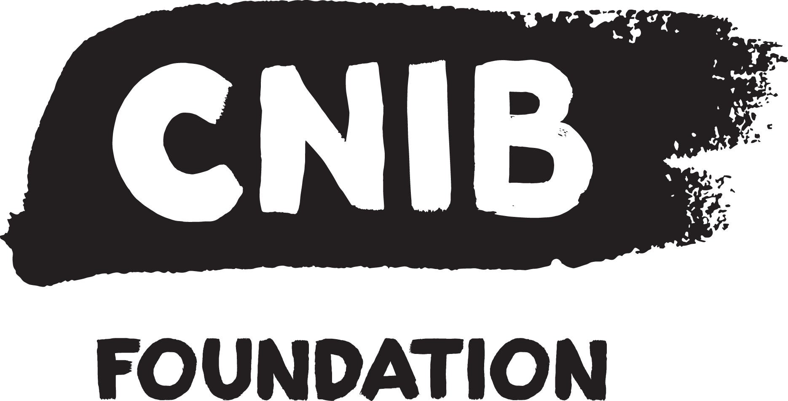

5 mai 2017
+

PROGRAM FOR

SPONSORS AND

EXHIBITORS

Friday, May 10 2019

Le Concorde Hotel
1225 Cours du Général de Montcalm
Québec, (Québec) G1R 4W6

CNIB Foundation - 2085 Parthenais, Montréal, (Québec) H2K 3T1
Phone. : 514 934-4622 – Fax : 514 934-2131 - cnib.ca

ContenTS

ABOUT TECHNOVISION+ 3
WHY PARTICIPATE IN TECHNOVISION+ ? 4
GENERAL INFORMATION 5
Program 5
SPONSORSHIP ROGRAM 6
EXHIBITOR PROGRAM 8
GIVE A PRESENTATION 9
SPONSORSHIP CONTRACT 11
EXHIBITOR contraCT 12
QUEBEC CITY : SO MUCH TO DISCOVER! 13

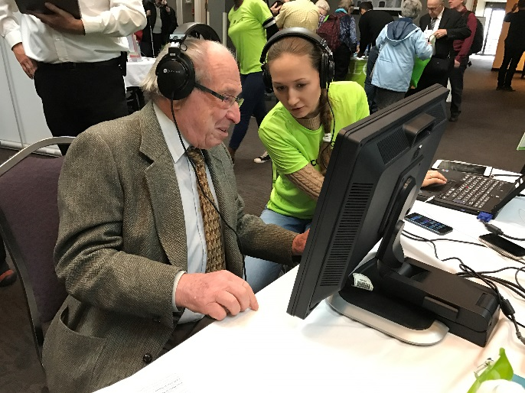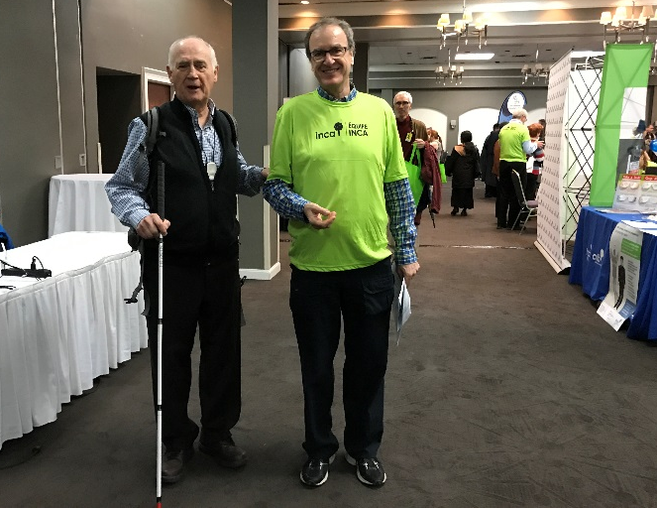

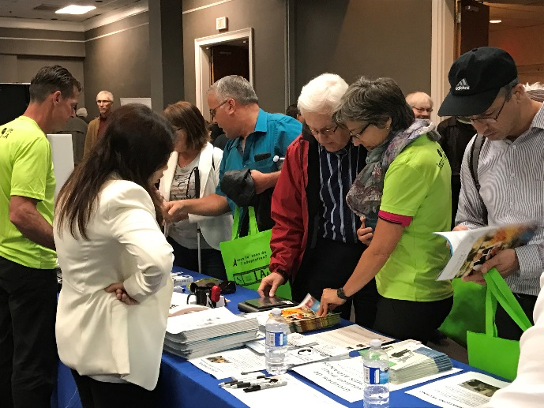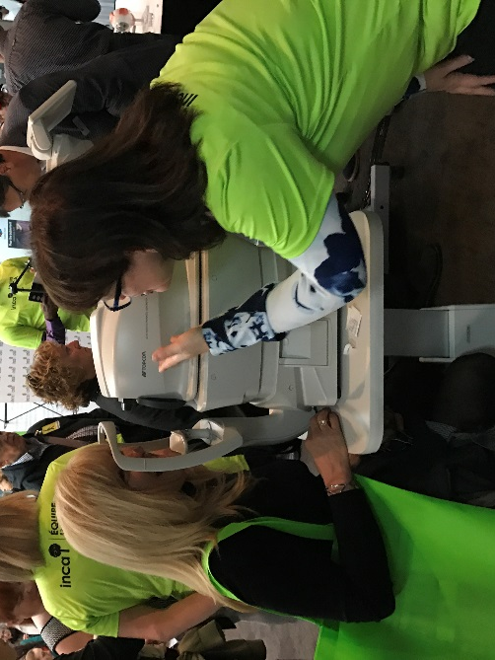

ABOUT TECHNOVISION+

Organized by CNIB Quebec for over 17 years, TechnoVision+ is the largest trade show devoted to adapted technology for people living with total or partial vision loss. It is an essential event for vision health.

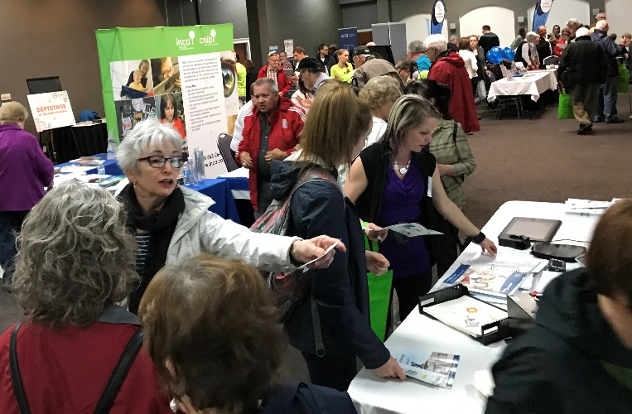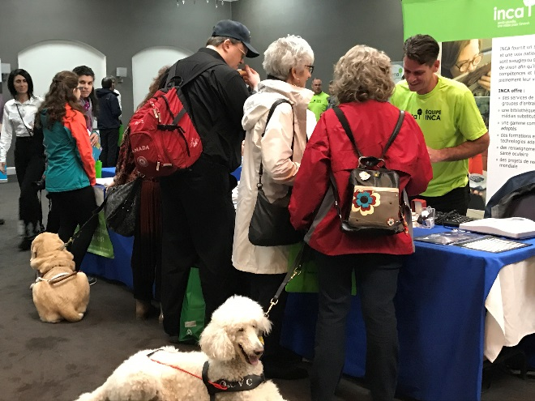
This year, TechnoVision+ is back in the Greater Québec, at Le Concorde Hotel downtown Quebec city.

Held every two years, this show is open to the general public as well as people living with vision loss and their families, adapted technology companies, vision health professionals, community organizations, rehabilitation centres, and vision health students.
Once again, TechnoVision+ 2019 will be offering free eye-disease screening in conjunction with Topcon, Canada’s largest distributor of ophthalmic equipment.
We are also offering new sponsorship opportunities for the Trial Zone and distribution of the floor plan and program in braille, with a view to boosting visibility for your organization, increasing traffic at your booth and enhancing our visitors’ experience.

***New this year, we will be collecting used smartphones donations as part of our Phone it Forward program. Companies who donate more than 20 cellular phones will be offered additional exposure. ***

In addition to providing the broadest range of vision health information available, TechnoVision+ is an opportunity for all participants to listen to presentations, see and try products and services for people living with vision loss and, especially, to discover the latest adapted technologies on the market.

Our wish is for an active, independent and satisfying life for everyone!
Together, change what it's mean to be blind today
encouraging inclusion with our services and assistive technology.

WHY PARTICIPATE IN TECHNOVISION+ ?

Every two years, this event brings together people who are concerned about vision health and those who are affected by it. Taking part in this trade show is an ideal way to promote your business and your image, make new contacts, and expand your database.

Participating in TechnoVision+ means…
- An opportunity to make contacts among your target clienteles, including the CNIB community of nearly 11,000 clients
- State-of-the-art information about the business and new sales and partnership opportunities
- Introducing new services and products (direct feedback from clients, new sales, etc.)
- Meeting new prospects and securing client loyalty
- Honing your competitive edge and increasing your institution’s visibility
- Learning about new trends or needs
Over the years, our event has become a must, a main source of information to help participants see beyond vision loss. The show is made possible by the invaluable support of our sponsors and partners.

Celebrating 100 years in 2018, the CNIB Foundation is a non-profit organization driven to change what it is to be blind today.
We deliver innovative programs and powerful advocacy that empower people impacted by blindness to live their dreams and tear down barriers to inclusion. Our work as a blind foundation is powered by a network of volunteers, donors and partners from coast to coast

SOME FACTS…
- 75% of vision loss cases can be prevented or treated.
- Every 12 minutes, a Canadian begins to lose their sight.
- Over 100,000 Quebecers are living with partial or total vision loss, and nearly half of them are age 65 and over.
- Vision loss costs Quebecers $2.6 billion every year.
- Every minute, 3 people contact the CNIB for information, advice or support.

CNIB Quebec offers psychosocial services, adapted-technology training, scholarships, audio books, a boutique of adapted products, and promotes public education, research and prevention of vision loss.

S FAITS…

GENERAL INFORMATION

Event Date | Friday, May 10 2019
Time | 9 h 30 am à 6 h 30 pm
Location | Le Concorde Hotel  1225 Cours du Général de Montcalm  Québec (QC) G1R 4W6
Exhibition Room | Salle Borduas-Krieghoff
Meeting Room | Salle Suzor-Côté
Parking | 18 $ a day – 25 $ with the night at the hotel

Program

New this year | VIP networking Preview event  The evening preceding the Trade show (Thursday evening) interested exhibitors will have an additional opportunity to show their products and services to special guests.
Door Prize | 1 draw in am and 1 in pm
Grand Prize Draw | 1 draw in p.m.
Presentations | Schedule : 10 h am à 6 h pm (times available for a maximum of 7 presentations).  Given the previous event’s success, our partners are invited to give presentations on the following program topics:  - Adapted technologies  - Quality of life  - Vision health  Please let us know what topic you would like to discuss if it is not in the above list. Send your suggestions to valerie.duchatel@inca.ca.  Presentation length: 30 to 45 minutes maximum, followed by a 15-minute question period

SPONSORSHIP ROGRAM

Register BY APRIL 15, 2019

(Prizes are in Canadian dollars and include all taxes)

Take advantage of the Special
CNIB room rate
At Le concorde HOTAL CALL 1 800-463-5256,
AND MENTION
inca-salon technovision - code 659198

SPEAKER Sponsor (exclusive) $ 6,500

- Named speaker in all our publicity for TechnoVision+ 2019, including press releases, advertising, poster, program, invitations, INCA-Flash and CNIB-Flash newsletters sent to our clients and vision loss organizations, etc.
- Your logo on our volunteers’ shirts
- Your logo on bags distributed to all participants
- Possibility of welcoming attendees at the opening
- Press release announcing that you are giving a presentation at TechnoVision+ 2019
- 15x15 island in the middle of the exhibition room including 4 tables and 8 chairs
- 4 120-volt electrical outlets
- Internet access
- Acknowledgement and thanks from the microphone desk twice a day during the show
- Two places for the luncheon with the CNIB Quebec Executive Director, Board members and other guests of honour
- Article on our website, introducing you as a TechnoVision+ 2019 speaker with your logo, a link to your company’s website and a brief description (300 words) of your business
- Your logo in the Sponsors section on our website
- Participation to the VIP networking Preview event on Thursday night (for 2) with the Executive Director, the members of the Quebec CNIB Foundation Advisory Board, politicians and other special guests.

PARTNER Sponsor (maximum 2) $4,900
- Listed as a TechnoVision+ 2019 partner in all our publicity for the show, including press releases, advertising, poster, program, invitations, INCA-Flash and CNIB-Flash newsletters sent to our clients and vision loss organizations, etc.
- Possibility of putting promotional items in the bags distributed to all visitors
- 15x15 island with 4 tables and 8 chairs
- 4 120-volt electrical outlets
- Internet access
- Acknowledgement and thanks from the microphone desk twice a day during the show.
- Two places for the luncheon with the CNIB Quebec Executive Director, Board members and other guests of honour
- Your logo, a link to your company’s website and a brief description (300 words) of your business on the CNIB Quebec website
- Your logo in the Sponsors section on our website

TRIAL ZONE Sponsor (exclusive) $ 3,500
- Mentioned as the Trial Zone sponsor in the program and all Trial Zone-related advertising; this area will be advertised as a major new feature at TechnoVision+ 2019
- Large booth with 2 tables, 2 chairs, two 120-volt electrical outlets, Internet access and a rest area with a viewing station where visitors can try applications: this will draw traffic to your table.
- Zone identified with your company’s colours
- Your logo in the Sponsors section of the poster, our website, invitations and the INCA-Flash and CNIB-Flash newsletters sent to our clients and to vision loss organizations

CONFERENCE ROOM Sponsor (exclusive) $ 3,500
- Mentioned as the Conferences sponsor in the program and all conference-related advertising;
- Large booth with 2 tables, 2 chairs, two 120-volt electrical outlets, Internet access at the entrance of the conference room that will have a lot trafic.
- Zone identified with your company’s colours
- Your logo in the Sponsors section of the program, the poster, our website, invitations and the INCA-Flash and CNIB-Flash newsletters sent to our clients and to vision loss organizations

ACCESSIBILITY Sponsor (exclusive) $ 2,000 + braille documents
- Listed as the supplier of braille documents for TechnoVision+ 2019 on the invitations
- Booth at the trade show entrance (2 tables for your booth, 1 table for handing out the presentation program and floor plan in braille)
- Your name on the exhibition floor plans and programs distributed in braille
- Acknowledgement from the microphone desk during the show

COFFEE BREAK Sponsor (2 max by coffee-breaké) $ 500 each
Sponsorship of two Health Breaks (in the morning and afternoon) may be provided by one or two sponsors, with the following benefits:
- Special acknowledgement from the microphone desk during the coffee break
- Logo on the coffee break table with acknowledgement “Coffee break courtesy of [company name]”
- Your logo in the Sponsors section of the poster, our website, invitations and the INCA-Flash and CNIB-Flash newsletters sent to our clients and vision loss organizations.

Note: A promotional rate is available if both coffee breaks are provided by the same sponsor. For more information about the coffee breaks, contact the Consultant, Communications and Philanthropy, Sarah Rouleau, at sarah.rouleau@inca.ca or call (514) 934-4622, extension 233.

DRAW Sponsor min value $ 100

Acknowledgement from the microphone desk when the prize is drawn and a brief description of the prize. Sponsors of prizes worth more than $1000 will be mentioned on the invitations and in the program.

EXHIBITOR PROGRAM

Register by MARCH 15, 2019

(Prices are in Canadian dollars and include all taxes)
Take advantage of the Special
CNIB room rate
At Le concorde HOTAL CALL 1 800-463-5256,
AND MENTION
inca-salon technovision - code 659198

LARGE BOOTH Sponsors $3,000
- 12x12 booth with 2 tables and 4 chairs
- Up to 2 120-volt electrical outlets
- Internet access
- Your logo in the Sponsors section of the poster, our website, invitations and the INCA-Flash and CNIB-Flash newsletters sent to our clients and to vision loss organizations

EXTRA Sponsors $1,500
- 10x10 booth with one table and 2 chairs
- Internet access
- Your logo in the Sponsors section of the poster, our website, invitations and the INCA-Flash and CNIB-Flash newsletters sent to our clients and to vision loss organizations

COMPANY / GOVERNMENT INSTITUTION Booth $1,250
- 10x10 booth with one table and 2 chairs
- Internet access

NPO Booth $400
- 10x10 booth with one table and 2 chairs
- Internet access

NPO Island $200
- Table and 2 chairs in the NPO island
- Internet access
- Exhibitors must bring their own banners, promotional materials, power bars, extension cords, and all computer equipment required. These items will not be supplied by the hotel or CNIB.

LATE REGISTRATION - EXHIBITORS
MARCH 15 TO APRIL 15, 2019

LARGE BOOTH Sponsor | 3150 $
EXTRA Sponsor | 1650 $
COMPANY / GOVERNMENT INSTITUTION Booth | 1400 $
NPO Booth | 600$
NPO Island | 350$

GIVE A PRESENTATION

Exhibitors may give a presentation during the trade show, providing additional visibility and a voice to describe a product in more detail, share their expertise or present their services. Proposed presentations should be relevant to the following topics:

- Adapted technologies
- Quality of life and independence
- Vision health

A maximum of 7 presentations will begin at 10 a.m. and end around 6 p.m.
We are open to other proposals, as we wish to make this event a resounding success!
To ensure that the presentations are diversified, please complete the form below.
PLEASE NOTE THAT:
- Presentations will be chosen for diversity and their appeal to the most participants.
- Presentations will last 30 to 45 minutes maximum and be followed by a 15-minute question period.
- You will be informed by email if your presentation is selected.
- Only forms that are entirely completed will be considered.
- Only forms sent by the March 15, 2019, deadline will be considered.
- The first forms we receive will have an advantage over the others.
Presentation topic:

Adapted technologies
Quality of life and independence
Santé visuelle — Les maladies oculaires courantes (DMLA, Rétinopathie diabétique, Glaucome)
Other (specify ):
Preferred time : Morning Afternoon
PRESENTATION TITLE :
First Name, Last Name:
Organization:

Title :
Phone :

Email :

Biography (about 200 words)
Check here if you attached your short biography to this form
Description of the presentation (about 400 words)
Check here if you attached the brief description of your presentation to this form

Thank you for sending your proposal to valerie.duchatel@inca.ca
or faxing it to (514) 934-2131 by April 1, 2019.
Also please tell us about topics that you would like
to discuss if they are not in the above list.
EXHIBITION FLOOR PLAN
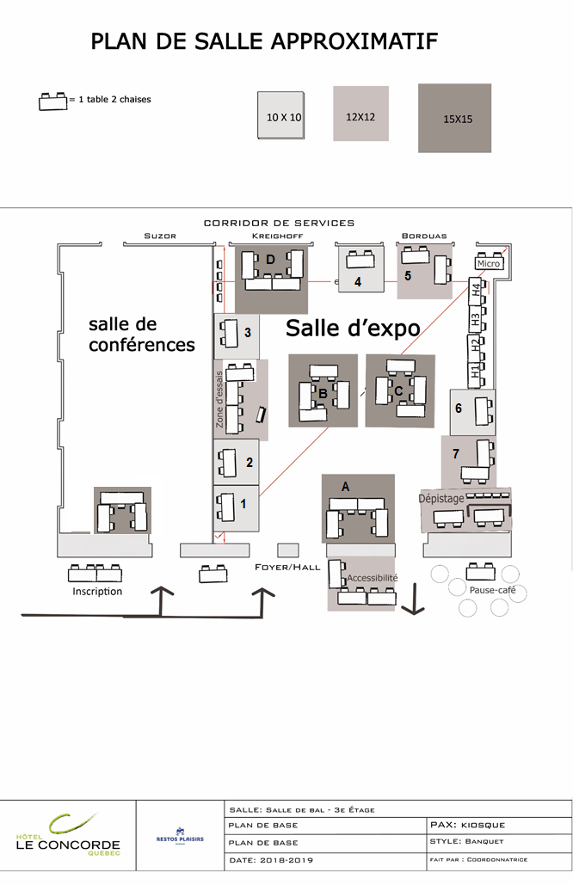

SPONSORSHIP CONTRACT

(BLOCKS CAPITALS PLEASE)
Company name :
Contact :
Adress :

City :
Province :
Postal code :

Phone :
Fax :

Email :
Our company wishes to be a TechnoVision+ 2019 sponsor:

Speaker ($6,500)
Partner ($4,900)
Media Partner ($4,900)

Conference Room (3 500$)
Accessibility ($1,000)
Trial Zone ($3,500)

Coffee break a.m. ($1,000)
Coffee break p.m. ($1,000)
Draw ( $ value )

Total payable: $ [all taxes included].
I would like to give cellphone for Phone it Foward. Nbre: (Visibility for donation of 25+)
Description of draw prize:
Payment method:
Cheque attached (corporate cheque or bank draft) payable to “CNIB Quebec”, mention “TechnoVision+ 2019”
Credit Card

Visa
MasterCard
American Express

Credit card number : Expiry date: /

Cardholder’s first and family names:
This form shall serve as a firm reservation. Your space will be confirmed after this reservation form is received.
All fees must be sent to us with this reservation form. An invoice will be sent when your reservation is confirmed.
The sponsor agrees to send the corporate logo, description, advertising or image, as applicable, in GIF, PNG or JPEG format, to the following address: sarah.rouleau@inca.ca .
I have read and understand the above conditions and the terms in the TechnoVision+ 2019 Program for sponsors and exhibitors.

Date : Signature of authorized representative:
Please sign and return sponsor and exhibitor contracts by:
Fax: (514) 934-2131 or email: sarah.rouleau@inca.ca
Attention: Ms. Sarah Rouleau
Phone: (514) 934-4622, extension 233 OR 1 800-465-4622, extension 233

EXHIBITOR contraCT

(BLOCKS CAPITALS PLEASE)
Company name :
Contact :
Adress :

City :
Province :
Postal code:

Phone :
Fax :

Email :
If you choose more than one booth, use the space below to indicate your first and second choices (see the exhibition floor plan):
1st choice: Booth 1 Booth 2 2nd choice : Booth 1 Booth 2
Electrical outlets required
Large booth 12X12 and logo in the Sponsor section ($3,000)
Extra 10X10 and logo in the Sponsor section ($1,500)
Government institution / company ($1,250)
NPO booth 10X10 ($400)
NPO island ($200)
Late registration (February 15-March 15): + $150
Total payable: $ [all taxes included]
I would like to give cellphone for Phone it Foward. Nbre: (Visibility for donation of 25+)
Payment method:
Cheque attached (corporate cheque or bank draft) payable to “CNIB Quebec”, mention “TechnoVision+ 2019”
Credit Card

Visa
MasterCard
American Express

Credit card number : Expiry date: /

Cardholder’s first and family names:

Booths will be sold on a first-come, first-served basis.
This form shall serve as a firm reservation. Your space will be confirmed after this reservation form is received.
All fees must be paid by cheque to the order of “CNIB Quebec” and sent to us with this reservation form. An invoice will be sent when your reservation is confirmed.
The exhibitor agrees to send the corporate logo, description, advertising or image, as applicable, in GIF, PNG or JPEG format, to the following address: sarah.rouleau@inca.ca .
I have read and understand the above conditions and the terms in the TechnoVision+ 2019 Program for sponsors and exhibitors.
Date : Signature of authorized representative:
For CNIB Quebec use

Date contract received: Booth number assigned:

QUEBEC CITY : SO MUCH TO DISCOVER!

YOUR STAY AT LE CONCORDE QUÉBEC Hotel

Take advantage of CNIB Quebec’s special rate of $135 (taxes and fees not included) and stay at the Concorde Hotel, 1225 Cours du Général de Montcalm, ,where the exhibition is being held. Just phone 418-647-2222 or au 1 800-463-5256 to make your reservation and mention code : 659198 before April 10, 2019.

Located downtown Quebec on the well-known Grande Allée street, The Concorde Hotel Quebec est à quelques minutes de marche des attractions et attraits touristiques majeurs du Vieux-Québec tels que le Musée de la Civilisation, la Place d'Youville, Les Plaines d'Abraham, le Parlement, le Petit Champlain et bien d'autres. Son imposante structure procure une vue imprenable sur le fleuve Saint-Laurent et sur la ville. Les nombreux restaurants autour de l'établissement permettent de vivre expérience culinaire hors du commun. www.hotelleconcordequebec.com

How to get easily at the Concorde Hotel ?
From the airport: $35 taxi.
From down-town Train-station : $10 taxi.
In bus : Take line 800 (bus RTC), and stop at Grand Théâtre Street. Walk 500 m by Des Amériques Street and then turn left on Grande Allée Street.

Le Concorde Québec Hotel Services
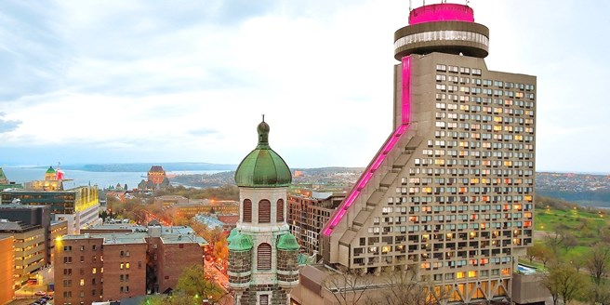
- Pool
- Spa
- Gym
- Restaurants (a turning one at the top! )
- High-speed wireless Internet
- Conference rooms
- Parking and Valet-Parking

